SITE SURVEY REPORT

WORLD MOBILE SITES SURVEY_ZANZIBAR

Site name: | Haille Selassie Secondary School
Site address:
Date: | 27/11/2021
Participants: | Name | Signature
SSW Engineer | Emmanuel Edward

Contents
1. General Information 3
1.1 Site Info: 3
2. SITE INFRASTRUCTURE 4
2.1 Pole Installation: 4
2.2 Solar Power System 5
2.3 Antenna system info: 5
3. Required quantities of Installation materials – Kit 7
4. Potential Challenges 8
5. REGULATORY COMPLIANCE CHECKS 9
6. RECOMMENDATIONS 9
7. SURVEYOR REVIEWER INFROMATION 10
APPENDIX 11
MAPS 11

1. GENERAL INFORMATION

1.1 Site Info:

Site location and GPS Coordinates | Site is located at Benjamin Mkapa Road, Stone town.
Site location and GPS Coordinates | Latitude: -6.9’55’’  Long:39.11’15’’ | Longitude: 39.11’33’’ |  | Altitude:
Site Type and Ownership | Type: Secondary School |  | Owner’s name: Government/Public owned
Contact person for Site details: | Name: |  | Telephone:
Is a special permit required for site access? | Yes The head of school should be notified prior to accessing the site |  | No ☐
Site access time:  (day x hours) | 7x24  Subject to permission | 5x8 ☐ |  | Other (state):
Ease of vehicular access: | Normal | Difficult ☐ |  | Very Difficult ☐
Ease of vehicular access: | Hard-standing ☐ | Gravel ☐ |  | To be constructed ☐
Route instructions (if required):
Describe the Site/Service Area: | The school is a public school owned by the government located along the Benjamin Mkapa Road. It is one of the oldest schools hence renovation and reconstruction is ongoing. Opposite the school there is a Public square, the ministry of Tourism is few km away. In addition there is State University of Zanzibar-Vuga Campus about 270m away by road.  The school is a one storey building comprises of classrooms, computer room, offices among others surrounding the ground. The roof is covered by galvanized steel, however there is a balcony which can be used for pole and solar installation
Potential Beneficiaries | - Occupants of the school  - Government institutions/Ministry offices  - Members of the community and business personnel  - Nearby university campus
Comments: | - The site is accessible on all days with prior notice to the school with the exception of special occasions such as the National examinations  - The school buildings are under renovations/re constructions. Hence before installation it should be confirmed if there will be no reconstruction at the particular proposed location.

2. SITE INFRASTRUCTURE

2.1 Pole Installation:

Required  Infrastructure: | POLE INSTALLATION
Pole Location | Rooftop as shown in the photos
Pole Location | Latitude: -6.9’55’’ | Longitude: 39°11’ 33’’ | Altitude: -1.6m
Pole type (recommend required height) | Counter weight h= 4m | Wall mounted: ☐ | Other ☐
Describe if foundations is needed/rooftop/ground based | Foundation is not required
Describe Roof/Mounting surface conditions | The balcony is a flat surfaced area a bit weary, hence renovation may take place.
Comments: | There are trees in front of the school hence a rooftop pole installation is recommended.

2.2 Solar Power System

Required Infrastructure: | SOLAR POWER SYSTEM INSTALLATION
Solar power system Panel Location | Panel location: Rooftop | The solar panels will be located along the pole location
Solar Panel coordinates | Latitude: -6° 9’ 55’’ | Longitude: 39°11’ 33’’ | Altitude: -1.6m
Solar panel mounting | Position: Rooftop | Type: Metallic mounting required.
Battery and Controller location | Computer room | It is located at the ground floor
Comments:

2.3 Antenna system info:

Antenna/Access Point:
Antenna model / height:
Coverage | AP to provide coverage to the school and nearby government offices , hotels and other business nearby
Antenna Mounting  (Type and height of the pole | 4meters pole with counter weight support
Availability/Location of backhaul fiber and connectivity options | Fiber connectivity is recommended
Comments | AP that supports:  - Dual bands i.e. 2.4GHz and 5GHz.  - MU-MIMO technology and at least 802.11ac for 5GHZ and 802.11n for 2.4GHz is recommended.

3. SITE PHOTOS - Sketch of the Site Location, Pole Location and the required antenna attachment

3.1: Site Physical location:

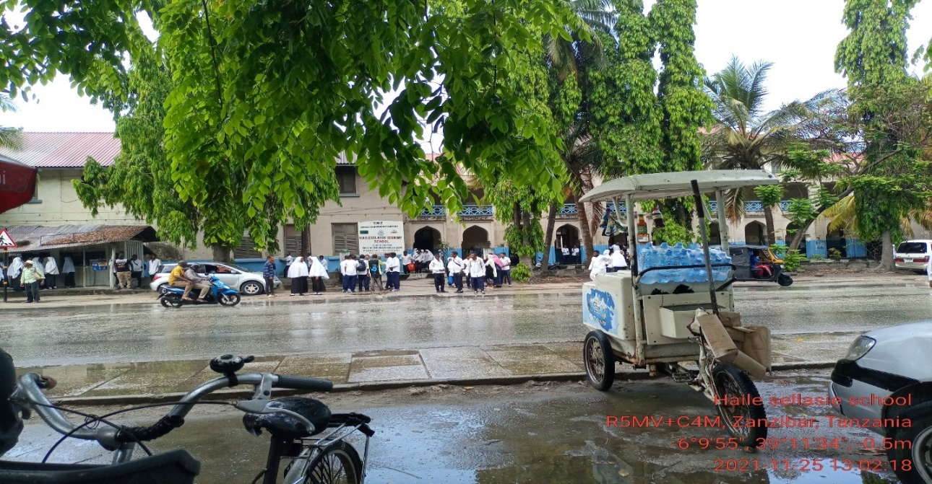

Haille Selassie Secondary School outside view

3.2: The Pole and Solar panel location:

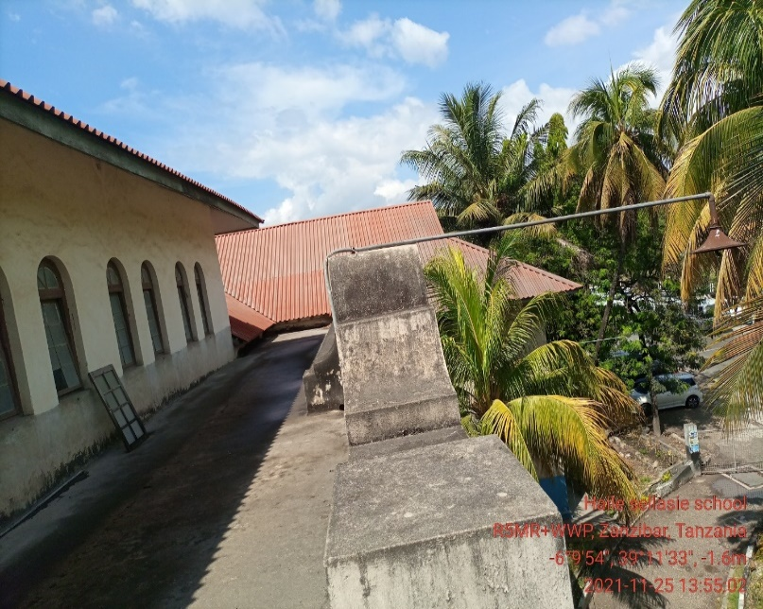  Proposed location for Pole (Ground bas | 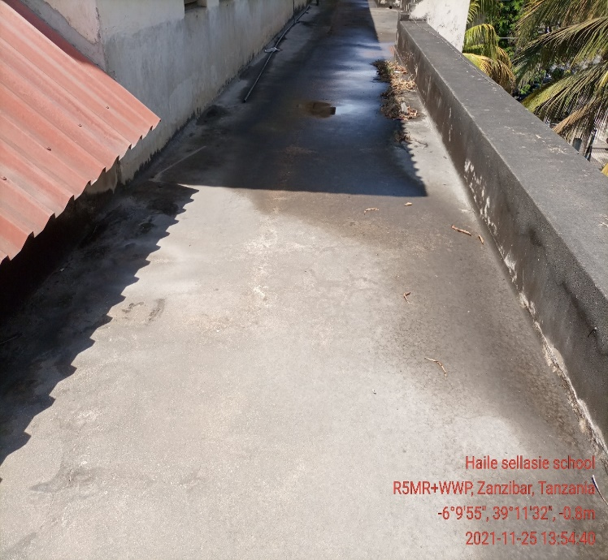  Solar Panel proposed location

3.3: Equipment room

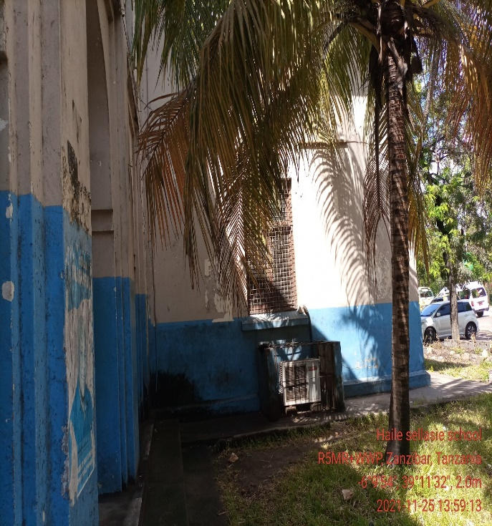  Battery, controller’s location. | 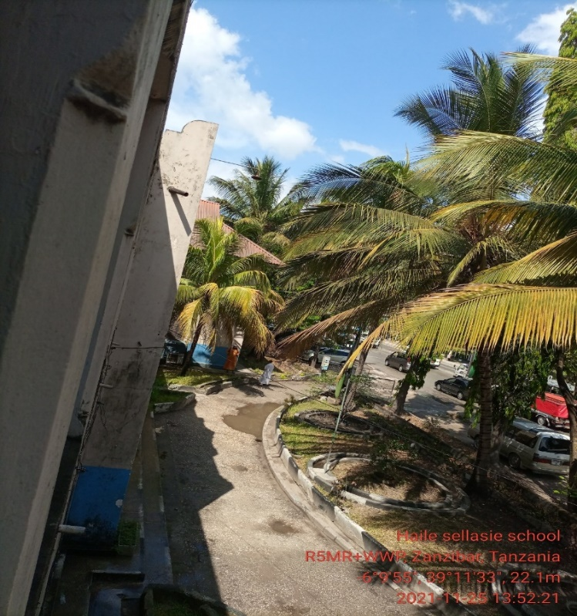  Computer room.

4. REQUIRED QUANTITIES OF INSTALLATION MATERIALS – KIT #

S/N | Material/Equipment | Specifications | Unit | Quantity
1 | Pole | 1 Counter weight type. | Meters | 1
2 | Mounting type (Antenna) | Counter weight support
3 | Cables | CAT 6 Outdoor | Meters
4 | POE |  | PC | 1
5 | Extension cable |  | PC | 1
6 | Connector | RJ45 |  | 2
7 | Socket outlet |  |  | 1
8 | Plug |  |  | 1
9 | DC cable red | 16 sqmm | Meters | 6
10 | DC cable blue | 16 sqmm | Meters | 6
11 | PVC conduit pipe | 1 inch | PCS | 10
12 | PVC elbow | PVC, 1inch | PCS | 12
13 | Cable tie |  | pkt | 4
14 | U Clamp | 1inch | PCS | 15
15 | Cement | N/A | Bags | 1
16 | Building pebbles | N/A | Buckets | 4
17 | Iron bar | 8mm | PCS | 1
18 | Earth cable | 16sqmm | Meters | 25
19 | Earth rod | 2ft | 2 | PCS
20 | Raw bolts | 4mm | PCS | 8
21 | Extension cable | Tronic | pcs | 1
22 | Flexible cable | 2.5sqmm,3core | Meters | 10
23 | Flexible conduit | 1inch | Meters | 6
24 | Insulation tapes | red and black | Pcs | 2
25 | Sand |  | Buckets | 4
26 | Cable rugs | 16SQMM | PCS | 8

5. POTENTIAL CHALLENGES

Challenges | Description
- Any restrictions on time we can work?  - Any access issues?  - Detail any challenges caused by existing site architecture?  - Will the installation annoy or adversely affect neighbors / be vulnerable to theft or damage?  - Are there any additional permissions to work on site required?  - Describe any security challenges  - Any other challenges? | Company IDs will be required for access,  nil  The site has 24hrs manned security protection.  Nil.  The building is under renovation

6. REGULATORY COMPLIANCE CHECKS

PERMIT REQUIRED
TCRA
Municipal Authority
Land lord
Engineer checks e.g Structural
Integrity test

Any other certification/Permit
Pole foundation construction and other civil works, will require authorization
Note: World Mobile is responsible for acquisition of all permits
Since there are government offices all necessary compliance should be obtained prior to commencement

7. RECOMMENDATIONS

Check the appropriate box below
- Approve site for system installation
- Do not approve site for system installation (If not approved specify reasons for rejections) ☐
Comments | There is a university campus nearby about 270 m. This justifies the business case which aims to provide coverage to more than the people in the site location

8. SURVEYOR REVIEWER INFROMATION

Reviewed:
Name:
Organization
Signature Date:
Approved:
Name:
Organization
Signature Date:

APPENDIX

MAPS

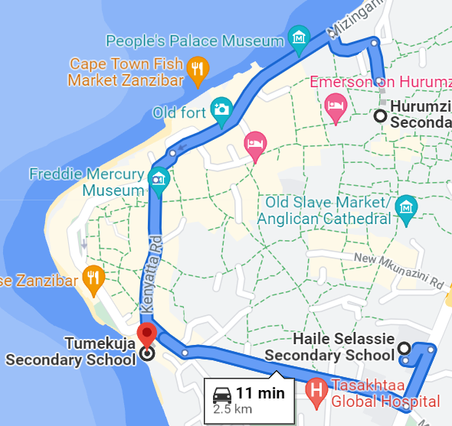

This map show the location of Tumekuja School to Haille Sellasie School which is less than 1km as well as to Harumzi School

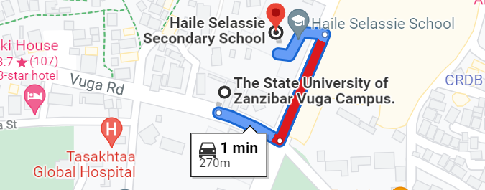

Location of State university of Zanzibar –Vuga campus

