SITE SURVEY REPORT

WORLD MOBILE SITES SURVEY_ZANZIBAR

Site name: | HAMAMNI SECONDARY SCHOOL
Site address:
Date: | 28/11/2021
Participants: | Name | Signature
SSW Engineer | Emmanuel Edward

Contents
1. GENERAL INFORMATION 3
1.1 Site Info: 3
2. SITE INFRASTRUCTURE 4
2.1 Pole Installation: 4
2.2 Solar Power System 5
2.3 Antenna system info: 5
3. SITE PHOTOS - Site Location, Pole Location and the required antenna attachments 6
3.1: Site Physical location: 6
3.2: The Pole and Solar panel location: 7
4. REQUIRED QUANTITIES OF INSTALLATION MATERIALS – Kit # 8
5. POTENTIAL CHALLENGES 9
6. REGULATORY COMPLIANCE CHECKS 9
7. RECOMMENDATIONS 10
8. SURVEYOR REVIEWER INFROMATION 10
APPENDIX 11
MAP 11

1. GENERAL INFORMATION

Site Info:

Site location and GPS Coordinates | The school is located at 435 Soko Muhogo street
Site location and GPS Coordinates | Latitude: -6.9’43’’  Long:39.11’15’’ | Longitude: 39.11’24’’ |  | Altitude: 9.4m
Site Type and Ownership | Type: Secondary School |  | Owner’s name: Government/SMZ owned
Contact person for Site details: | Name: |  | Telephone:
Is a special permit required for site access? | Yes The head of school should be notified prior to accessing the site |  | No ☐
Site access time:  (days x hours) | 7x24 | 5x8 ☐ |  | Other (state):
Ease of vehicular access: | Normal | Difficult ☐ |  | Very Difficult ☐
Ease of vehicular access: | Hard-standing ☐ | Gravel ☐ |  | To be constructed ☐
Route instructions (if required):
Describe the Site/Service Area: | The school is located at Soko Muhogo street, Stone town. It is about 180m away from Forodhani Secondary School, approximately 350m away from Kiponda Secondary School in addition to 420m away from Haile Selassie school.  It is a two storey building with a wall fence and a man-guard security 24/7. There is a Telecom site in the Campus. The neighbouring surrounding are mostly storey buildings. Moreover there are businesses, hotels for instance MaruMaru Hotel approximately 100m away in addition to banks such as DTB, People’s bank of Zanzibar between 100-150m away.  Note: These distance are based on the roads
Potential Beneficiaries | - Tourists and Hotels  - The residents nearby  - Occupants of the school  - Business people and Banks
Comments: | The site is accessible on all days with prior notice to the school with the exception of special occasions such as the National examinations

2. SITE INFRASTRUCTURE

2.1 Pole Installation:

Required Infrastructure: | POLE INSTALLATION
Pole Location | Ground based along the wall fence facing the exit gate
Pole Location | Latitude: : -6.9’43’’ | Longitude: 39.11’24’’ | Altitude: 9.4m
Pole type (recommend required height) | Counter weight ☐ | Wall mounted ☐ | Other Ground based  h= 4m
Describe if foundations is needed/rooftop/ground based | Foundation is required
Describe Roof/Mounting surface conditions
Comments:

2.2 Solar Power System

Existing / Required Infrastructure: | SOLAR POWER SYSTEM INSTALLATION
Solar power system Panel Location | Panel location: On the roof of the School hall roof
Solar Panel coordinates | Latitude: -6.9’43’’ | Longitude: 39.11’24’’ | Altitude: 9.4 m
Solar panel mounting | Position: Rooftop | Type: Metallic mounting required.
Battery and Controller location | Mounted on the wall | The wall along the School hall as shown in the photos attached at the end of the document
Comments:

2.3 Antenna system info:

Antenna/Access Point:
Antenna model / height:
Coverage | AP to provide coverage to the school and hotels and other business nearby, mostly located within 100m to 400m
Antenna Mounting  (Type and height of the pole | 6 meters ground based pole
Availability/Location of backhaul fiber and connectivity options | Fiber connectivity is recommended.
Comments | AP that supports:  - Dual bands i.e. 2.4GHz and 5GHz.  - MU-MIMO technology and at least 802.11ac for 5GHZ and 802.11n for 2.4GHz is recommended.

3. SITE PHOTOS - Site Location, Pole Location and the required antenna attachments

3.1: Site Physical location:

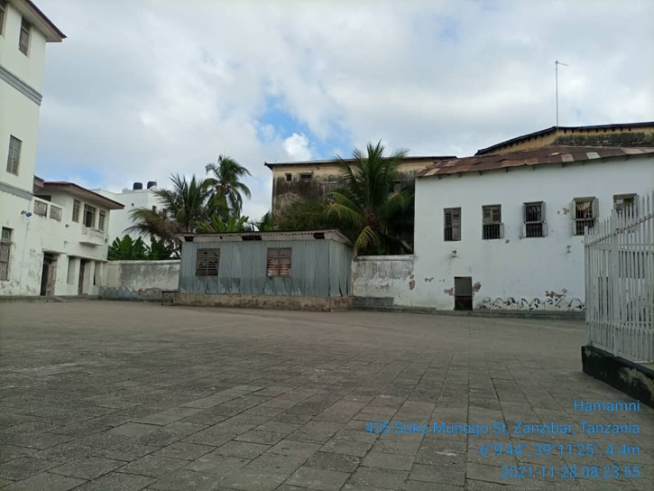  Hamamni Secondary School | 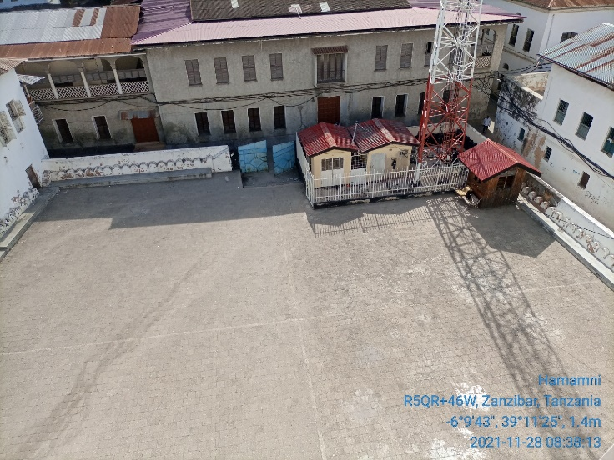  School overview

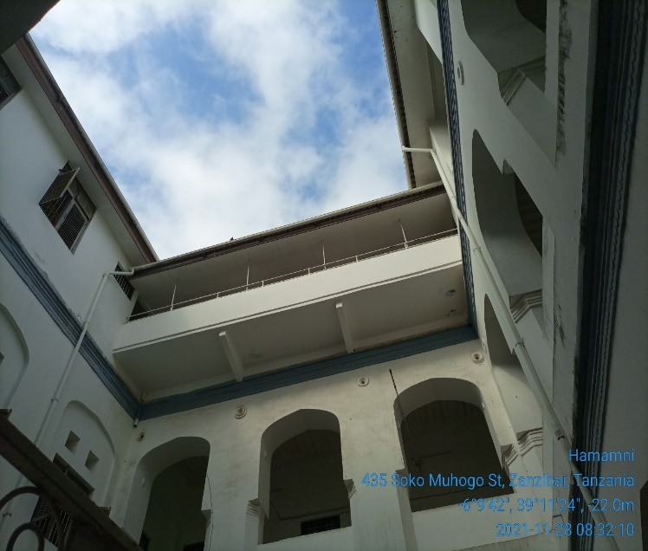 | 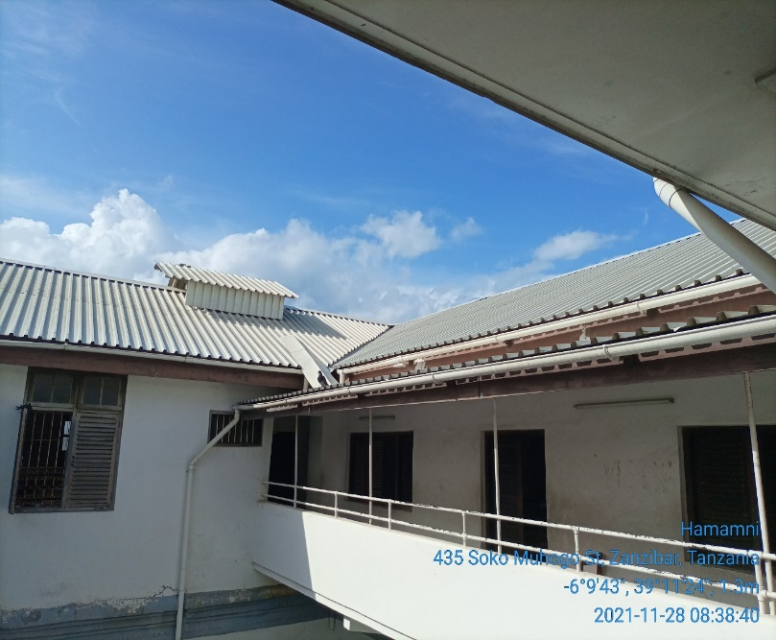

3.2: The Pole and Solar panel location:

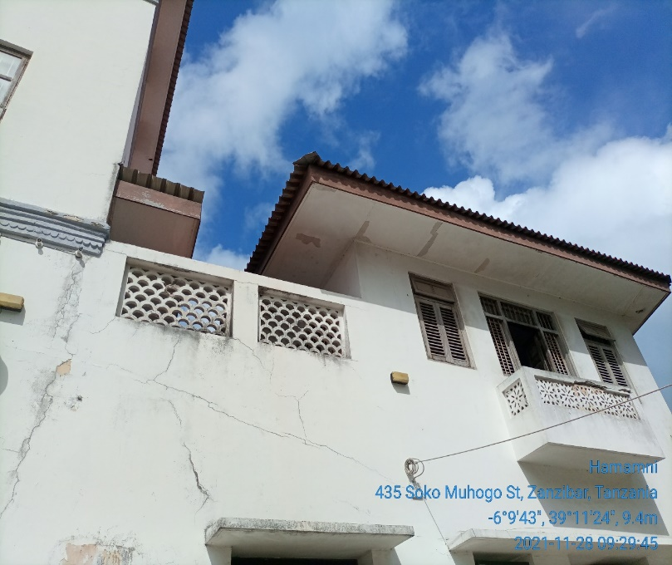  Fig 3.2a: Solar panel on the roof, Battery and controller box, fixed on the wall.  Battery and controller box  Solar Panel proposed position 1 | 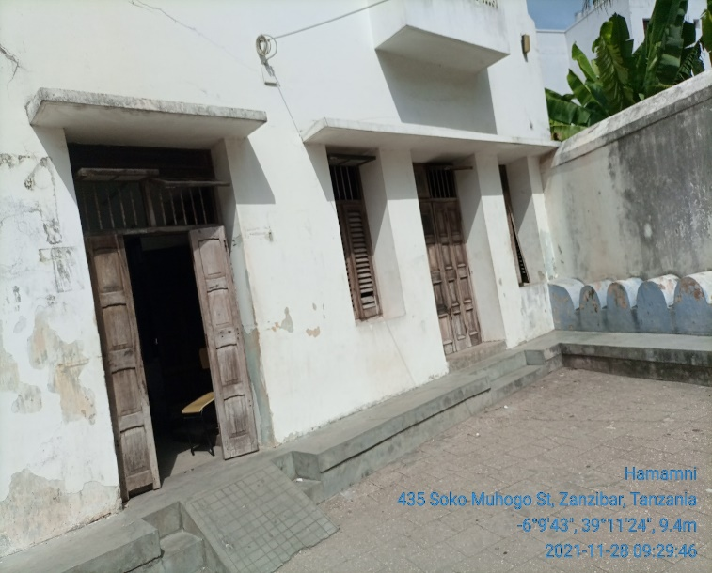  Fig 3.2b: Proposed pole location facing the exit gate

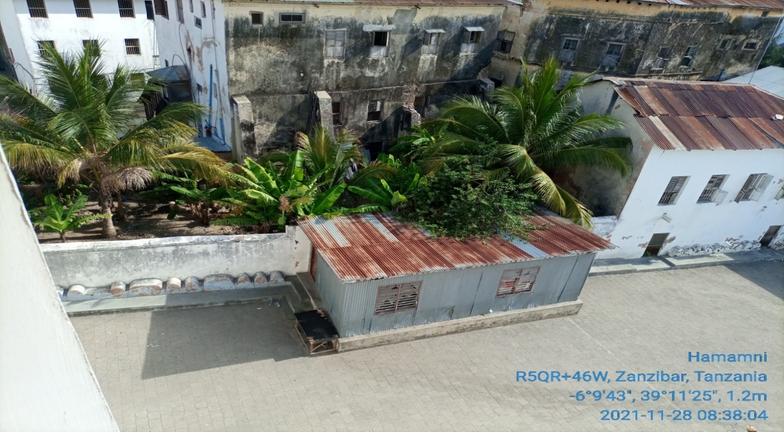
Proposed location 2. For solar panel
Proposed ground based pole location

4. REQUIRED QUANTITIES OF INSTALLATION MATERIALS – Kit #

S/N | Material/Equipment | Specifications | Unit | Quantity
- 1 | Pole | Ground based-6m | PC | 1
- 3 | Cables | CAT 6 Outdoor | Meters
 | AP and PoE |  | PC | 1
- 6 | Connector | RJ45 | PC | 2
- 7 | Socket outlet |  | PC | 1
- 8 | Plug |  |  | 1
- 9 | DC cable red | 16 sqmm | Meters | 12
- 10 | DC cable blue | 16 sqmm | Meters | 12
- 11 | PVC conduit pipe | 1 inch | PCS | 6
- 12 | PVC elbow | PVC, 1inch | PCS | 6
- 13 | Cable tie |  | pkt | 4
- 14 | U Clamp | 1inch | PCS | 15
- 17 | Iron bar | 8mm | PCS | 1
- 18 | Earth cable | 16sqmm | Meters | 30
- 19 | Earth rod | 2ft | PCS | 2
- 20 | Raw bolts | 4mm | PCS | 8
- 21 | Extension cable | Tronics | pcs | 1
- 22 | Flexible cable | 2.5sqmm,3core | Meters | 10
- 23 | Flexible conduit | 1inch | Meters | 6
- 24 | Insulation tapes | red and black | Pcs | 2
- 26 | Cable rugs | 16 sqmm | PCS | 8

5. POTENTIAL CHALLENGES

Challenges | Description
- Any restrictions on time we can work?  - Any access issues?  - Detail any challenges caused by existing site architecture?  - Will the installation annoy or adversely affect neighbors / be vulnerable to theft or damage?  - Are there any additional permissions to work on site required?  - Describe any security challenges  - Any other challenges? | Company IDs will be required for access,  A ladder is required to reach the rooftop  No,  The site is safe, has wall fence, and has 24hrs manned security protection.  Reaching the roof top a ladder is required,

6. REGULATORY COMPLIANCE CHECKS

PERMIT REQUIRED
TCRA
Municipal Authority
Land lord
Engineer checks e.g. Structural
Integrity test

Any other certification/Permit
Comment | Pole foundation construction and other civil works, will require authorization  Note: World Mobile is responsible for acquisition of all permits

7. RECOMMENDATIONS

Check the appropriate box below
- Approve site for system installation ☐
- Do not approve site for system installation (If not approved specify reasons for rejections) ☐
Comments

8. SURVEYOR REVIEWER INFROMATION

Reviewed:
Name:
Organization
Signature Date:
Approved:
Name:
Organization
Signature Date:

APPENDIX

MAP

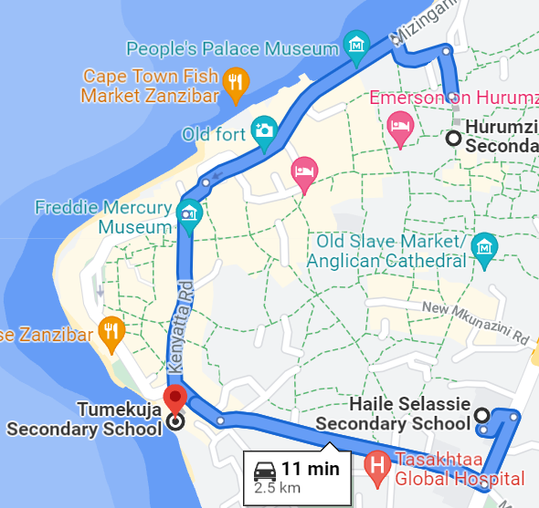

This map show the distance by road from Hamamni Sec. School, Forodhani Sec. School, Kiponda Sec. School and Haile Selassie

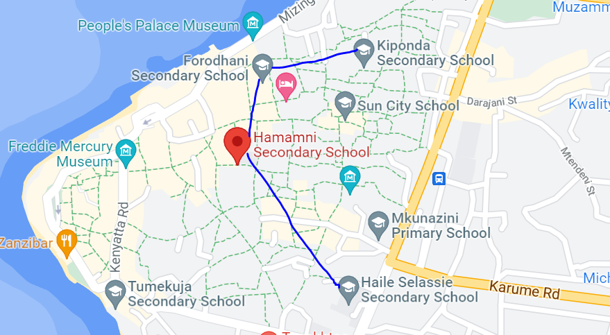

This could be used in planning mesh topology

