SITE SURVEY REPORT

WORLD MOBILE SITES SURVEY_ZANZIBAR

Site name: | HURUMZI SECONDARY SCHOOL
Site address:
Date: | 27/11/2021
Participants: | Name | Signature
SSW Engineer | Emmanuel Edward

Contents
SITE SURVEY REPORT 1
WORLD MOBILE SITES SURVEY_ZANZIBAR 1
1. GENERAL INFORMATION 3
1.1 Site Info: 3
2. SITE INFRASTRUCTURE 4
2.1 Pole Installation: 4
2.2 Solar Power System 4
2.3 Antenna system info: 5
3. SITE PHOTOS - Sketch of the Site Location, Pole Location and the required antenna attachments 5
3.1: Site Physical location: 5
3.2: The Pole and Solar panel location: 6
4. REQUIRED QUANTITIES OF INSTALLATION MATERIALS – Kit # 7
5. POTENTIAL CHALLENGES 8
6. REGULATORY COMPLIANCE CHECKS 8
7.. RECOMMENDATIONS 9
8. SURVEYOR REVIEWER INFROMATION 9
APPENDIX 10
MAP 10

1. GENERAL INFORMATION

Site Info:

Site location and GPS Coordinates | Site is located at Jamatini Road
Site location and GPS Coordinates | Latitude: -6.9’38’’  Long:39.11’15’’ | Longitude: 39.11’30’’ |  | Altitude: 12.0m
Site Type and Ownership | Type: Secondary School |  | Owner’s name: Government/SMZ owned
Contact person for Site details: | Name: |  | Telephone:
Is a special permit required for site access? | Yes  The head of school should be notified prior to accessing the site |  | No ☐
Site access time: | 7x24  | 5x8 ☐ |  | Other (state):
Ease of vehicular access: | Normal  | Difficult ☐ |  | Very Difficult ☐
Ease of vehicular access: | Hard-standing ☐ | Gravel ☐ |  | To be constructed ☐
Route instructions (if required):
Describe the Site/Service Area: | The site is a public secondary school located along the Jamatini Road in the Forodhani area. The site is about 200m from Zanzibar ferry terminal near the main port. There are hotels and restaurants such as Spice palace hotel, Golden tulip boutique about 300m. In addition there are other local business nearby  Note: These distance are by road
Potential Beneficiaries | - Tourists  - Passer-byes  - Occupants of the school  - Business people
Comments: | The site is accessible on all days with prior notice to the school with the exception of special occasions such as the National examinations

2. SITE INFRASTRUCTURE

2.1 Pole Installation:

Required Infrastructure: | POLE INSTALLATION
Pole Location | Proposed at the Rooftop
Pole Location | Latitude: -6.9’38’’ | Longitude: 39.11’30’’ | Altitude: 21.6m
Pole type (recommend required height) | Counter weight | Wall mounted  h= 3m | Other
Describe if foundations is needed/rooftop/ground based | No foundation required, a wall mounted pole will be required
Describe Roof/Mounting surface conditions
Comments: | Given the topology of the school and surroundings, the streets are very crowded. Narrow street path and mostly the surrounding building are storey building as well. Hence the wall mounted pole will be suitable in this site as shown in the photos.

2.2 Solar Power System

Existing / Required Infrastructure: | SOLAR POWER SYSTEM INSTALLATION
Solar power system Panel Location | Panel location: Rooftop | The solar panels will be located along the pole location
Solar Panel coordinates | Latitude: -6.9’38’’ | Longitude: 39.11’30’’ | Altitude: 19.9m
Solar panel mounting | Position: Rooftop | Type: Metallic mounting required.
Battery and Controller location | Mounted on the wall | The wall along the library room as shown in the photos attached at the end of the document
Comments:

2.3 Antenna system info:

Antenna/Access Point:
Antenna model / height:
Coverage | AP to provide coverage to the school and hotels and other business nearby, mostly located within 100m to 400m
Antenna Mounting  (Type and height of the pole | 3 meters wall mounted pole,
Availability/Location of backhaul fiber and connectivity options | Fiber connectivity is recommended.
Comments | AP that supports:  - Dual bands i.e. 2.4GHz and 5GHz.  - MU-MIMO technology and at least 802.11ac for 5GHZ and 802.11n for 2.4GHz is recommended.

3. SITE PHOTOS - Sketch of the Site Location, Pole Location and the required antenna attachments

3.1: Site Physical location:

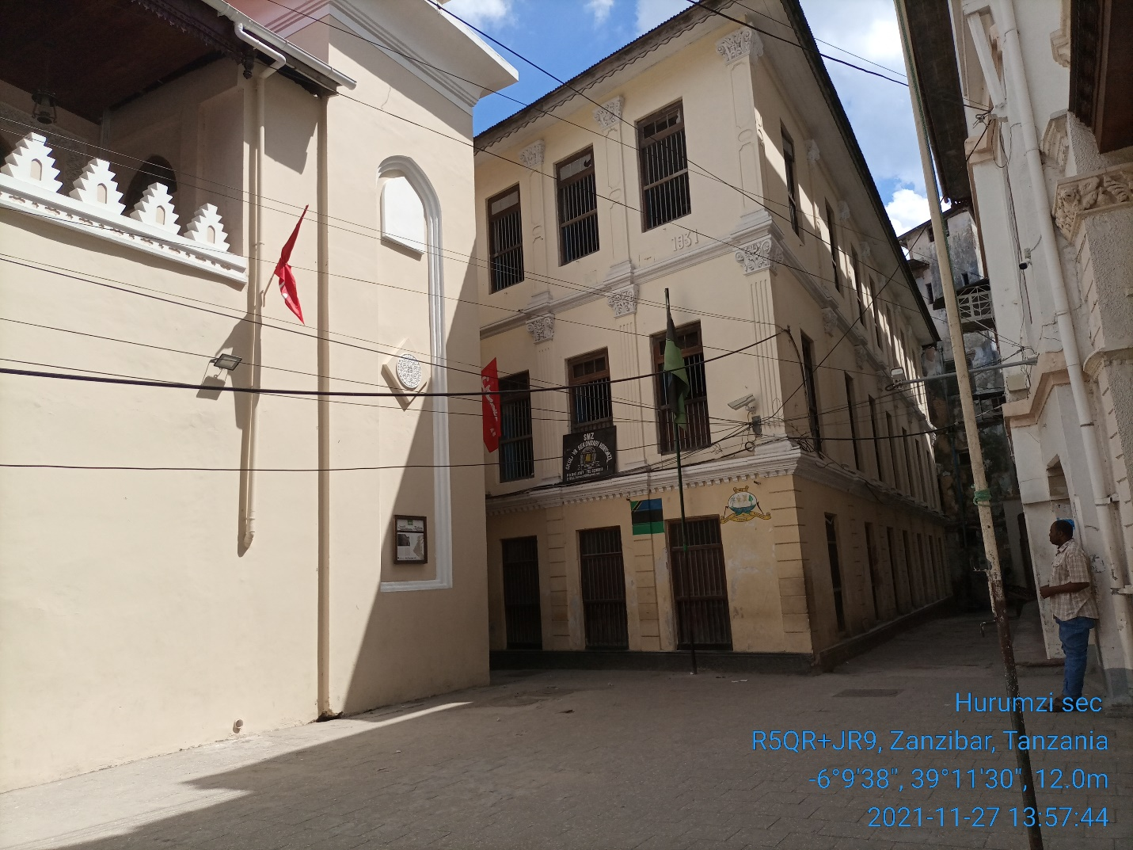  Harumzi Secondary School | 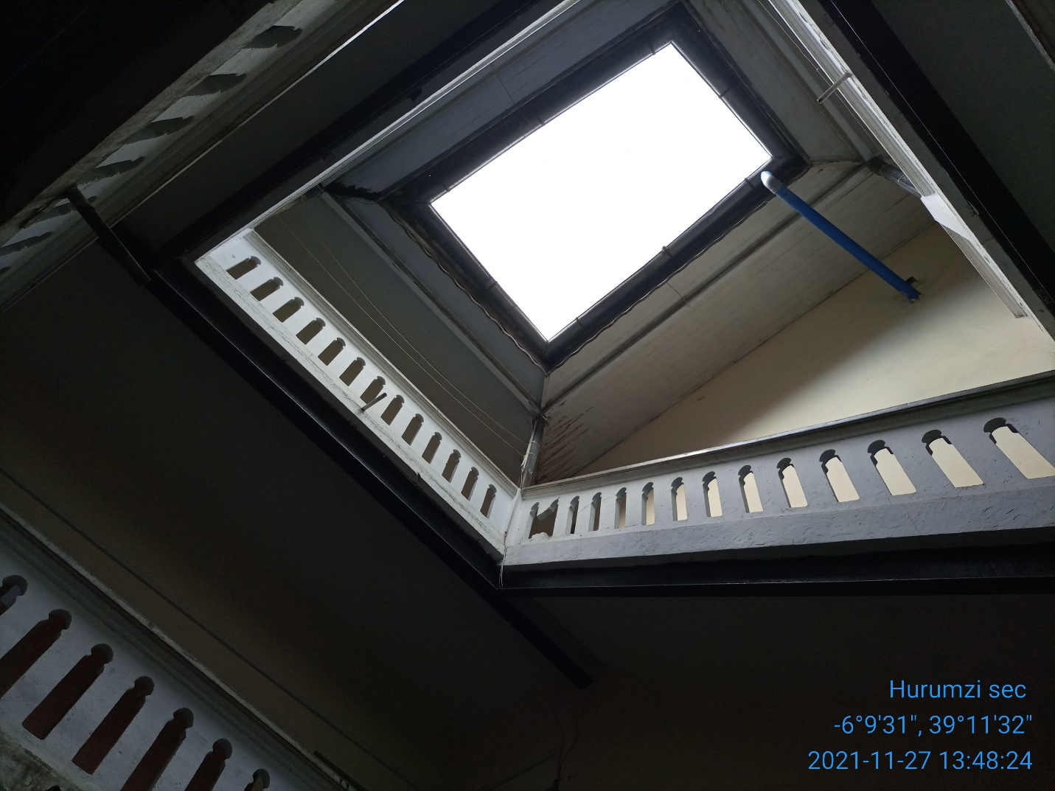  School upper view

3.2: The Pole and Solar panel location:

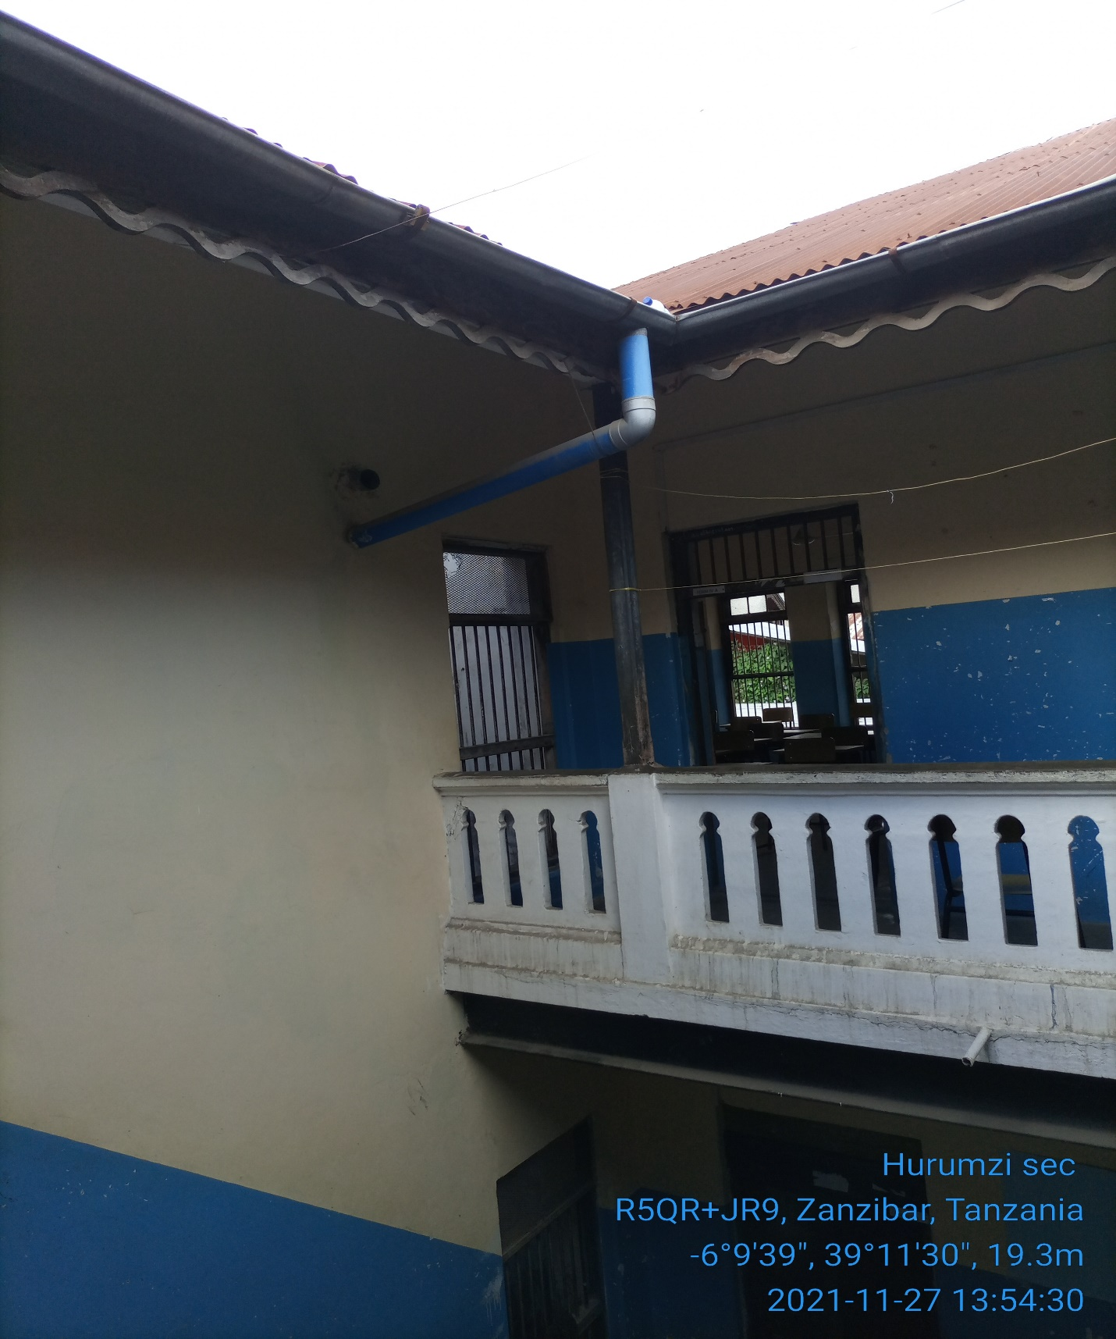  Fig 3.2a Solar panel on the roof, Battery and controller box, fixed on the wall. | 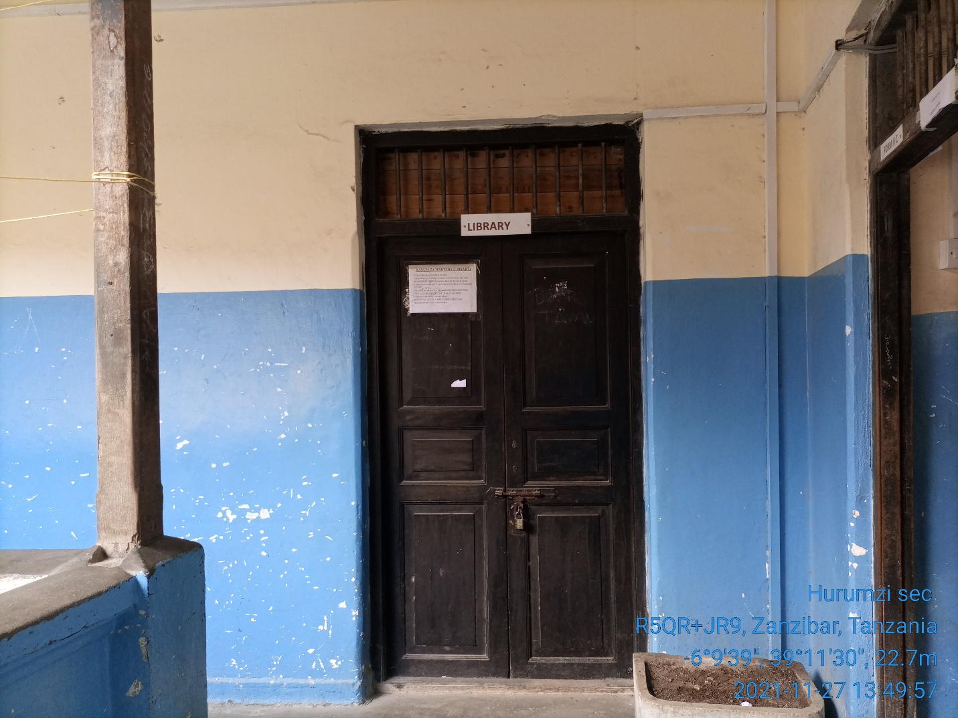  Fig 3.2b Battery, controller’s cabinet will be fixed on the wall.

Proposed pole location where the antenna will be facing upwards | 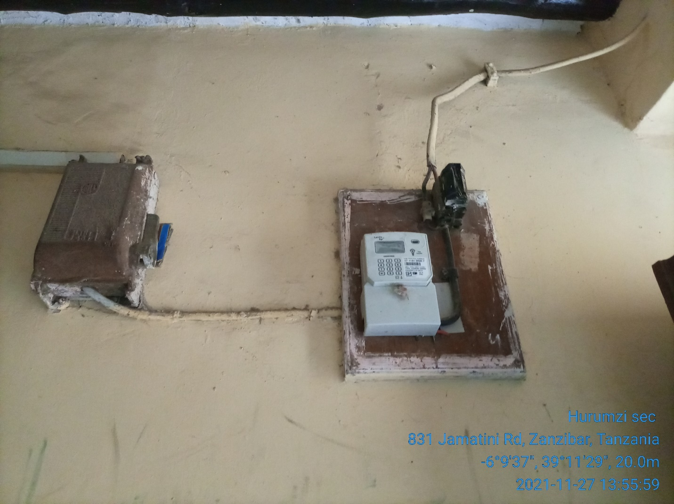  Power source

4. REQUIRED QUANTITIES OF INSTALLATION MATERIALS – Kit #

S/N | Material/Equipment | Specifications | Unit | Quantity
1 | Pole | 1 Counter weight type. | Meters | 1
2 | Mounting type (Antenna) | Counter weight support
3 | Cables | CAT 6 Outdoor | Meters
4 | POE |  | PC | 1
5 | Extension cable |  | PC | 1
6 | Connector | RJ45 | PCS | 2
7 | Socket outlet |  |  | 1
8 | Plug |  |  | 1
9 | DC cable red | 16 sqmm | Meters | 12
10 | DC cable blue | 16 sqmm | Meters | 12
11 | PVC conduit pipe | 1 inch | PCS | 15
12 | PVC elbow | PVC, 1inch | PCS | 6
13 | Cable tie |  | pkt | 4
14 | U Clamp | 1inch | PCS | 15
17 | Iron bar | 8mm | PCS | 1
18 | Earth cable | 16sqmm | Meters | 30
19 | Earth rod | 2ft | PCS | 2
20 | Raw bolts | 4mm | PCS | 8
21 | Extension cable | Tronics | pcs | 1
22 | Flexible cable | 2.5sqmm,3core | Meters | 10
23 | Flexible conduit | 1inch | Meters | 6
24 | Insulation tapes | red and black | Pcs | 2
26 | Cable rugs | 16 sqmm | PCS | 8

5. POTENTIAL CHALLENGES

Challenges | Description
- Any restrictions on time we can work?  - Any access issues?  - Detail any challenges caused by existing site architecture?  - Will the installation annoy or adversely affect neighbors / be vulnerable to theft or damage?  - Are there any additional permissions to work on site required?  - Describe any security challenges  - Any other challenges? | Company IDs will be required for access,  A ladder is required to reach the rooftop  No,  The site is safe, has wall fence, and has 24hrs manned security protection.  Reaching the roof top a ladder is required,

6. REGULATORY COMPLIANCE CHECKS

PERMIT REQUIRED
TCRA
Municipal Authority
Land lord
Engineer checks e.g. Structural
Integrity test

Any other certification/Permit
Comment | Pole foundation construction and other civil works, will require authorization  Note: World Mobile is responsible for acquisition of all permits

7. RECOMMENDATIONS

Check the appropriate box below
- Approve site for system installation 
- Do not approve site for system installation (If not approved specify reasons for rejections) ☐
Comments

8. SURVEYOR REVIEWER INFROMATION

Reviewed:
Name:
Organization
Signature Date:
Approved:
Name:
Organization
Signature Date:

APPENDIX

MAP

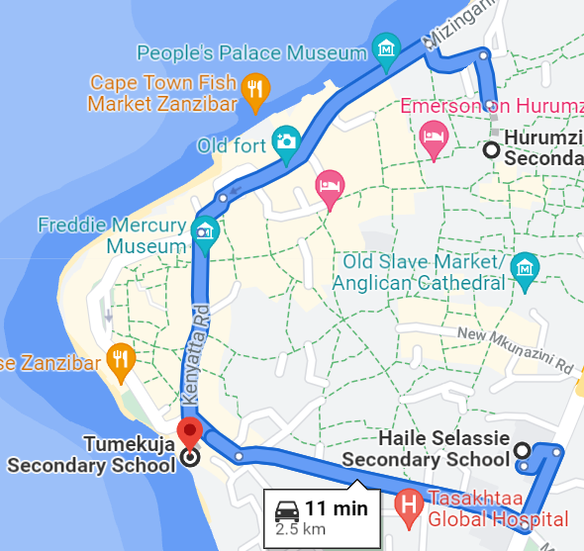

This map show the location of Tumekuja School, Haille Sellasie School and Harumzi School, These locations can be used while setting a mesh topology

