SITE SURVEY REPORT

WORLD MOBILE SITES SURVEY_ZANZIBAR

Site name: | TUMEKUJA SECONDARY SCHOOL
Site address:
Date: | 24/11/2021
Participants: | Name | Signature
SSW Engineer | Emmanuel Edward

Contents
1. GENERAL INFORMATION 3
1.1 Site Info: 3
2. SITE INFRASTRUCTURE 4
2.1 Pole Installation: 4
2.2 Pole Installation: 5
2.3 Antenna system info: 5
3. SITE PHOTOS - Sketch of the Site Location, Pole Location and the required antenna attachments 6
3.1 Site Physical location 6
3.2 The Pole and Solar panel location 6
4. Required quantities of Installation material 7
5. Potential Challenges 8
6. REGULATORY COMPLIANCE CHECKS 9
7. RECOMMENDATIONS 9
8. SURVEYOR REVIEWER INFROMATION 10
APPENDIX 11
MAP 11

1. GENERAL INFORMATION

1.1 Site Info:

Site location and GPS Coordinates | Site is located at Kaunda Road
Site location and GPS Coordinates | Latitude: -6.9’56’’  Long:39.11’15’’ | Longitude: 39.11’15’’
Site Type and Ownership | Type: Secondary School |  | Owner’s name: Government/Public owned
Contact person for Site details: | Name: |  | Telephone:
Is a special permit required for site access? | Yes  The head of school should be notified prior to accessing the site |  | No ☐
Site access time:  (day x hours) | 7x24  | 5x8 ☐ |  | Other (state):
Ease of vehicular access: | Normal | Difficult ☐ |  | Very Difficult ☐
Ease of vehicular access: | Hard-standing ☐ | Gravel ☐ |  | To be constructed ☐
Route instructions (if required):
Describe the Site/Service Area: | The school is a public school owned by the government located along the sea shore. This is a wall fenced school compound bounded by government institutes and ministry offices around. Moreover there are hotels and lodges such as Kisiwa house about 100m among other business such as banking nearby.  The school is a two storey building with a classroom buildings. School hall as well as a computer lab/room
Potential Beneficiaries | - Tourists  - Passer-byes  - Occupants of the school  - Government institutions/Ministry offices
Comments: | The site is accessible on all days with prior notice to the school with the exception of special occasions such as the National examinations

2. SITE INFRASTRUCTURE

2.1 Pole Installation:

Required Infrastructure: | POLE INSTALLATION
Pole Location  Rooftop  Ground based pole location | Two location were identified Rooftop and ground based as shown in the photos
Pole Location  Rooftop  Ground based pole location | Latitude: -6° 9’ 54’’ | Longitude: 39°11’ 15’’ | Altitude: 21.6m
Pole Location  Rooftop  Ground based pole location | Latitude: -6° 9’ 54’’ | Longitude: 39°11’ 15’’ | Altitude: 18.7m
Pole type (recommend required height) | Counter weight  h= 4m | Wall mounted ☐ | Other☐
Describe if foundations is needed/rooftop/ground based | Foundation may be required for a ground based pole
Describe Roof/Mounting surface conditions
Comments: | The buildings are old incase of renovation/reconstruction an alternative ground based position is proposed.

2.2 Pole Installation:

Required Infrastructure: | SOLAR POWER SYSTEM INSTALLATION
Solar power system Panel Location | Panel location: Rooftop | The solar panels will be located along the pole location
Solar Panel coordinates | Latitude: -6° 9’ 54’’ | Longitude: 39°11’ 15’’ | Altitude: 21.1m
Solar panel mounting | Position: Rooftop | Type: Metallic mounting required.
Battery and Controller location | Computer room
Comments:

2.3 Antenna system info:

:
Antenna/Access Point:
Antenna model / height:
Coverage | AP to provide coverage to the school and nearby government offices , hotels and other business nearby
Antenna Mounting  (Type and height of the pole | 4meters pole,  Supported by counter weight.
Availability/Location of backhaul fiber and connectivity options | Fiber connectivity is recommended
Comments | AP that supports:  - Dual bands i.e. 2.4GHz and 5GHz.  - MU-MIMO technology and at least 802.11ac for 5GHZ and 802.11n for 2.4GHz is recommended.

3. SITE PHOTOS - Sketch of the Site Location, Pole Location and the required antenna attachments

3.1 Site Physical location

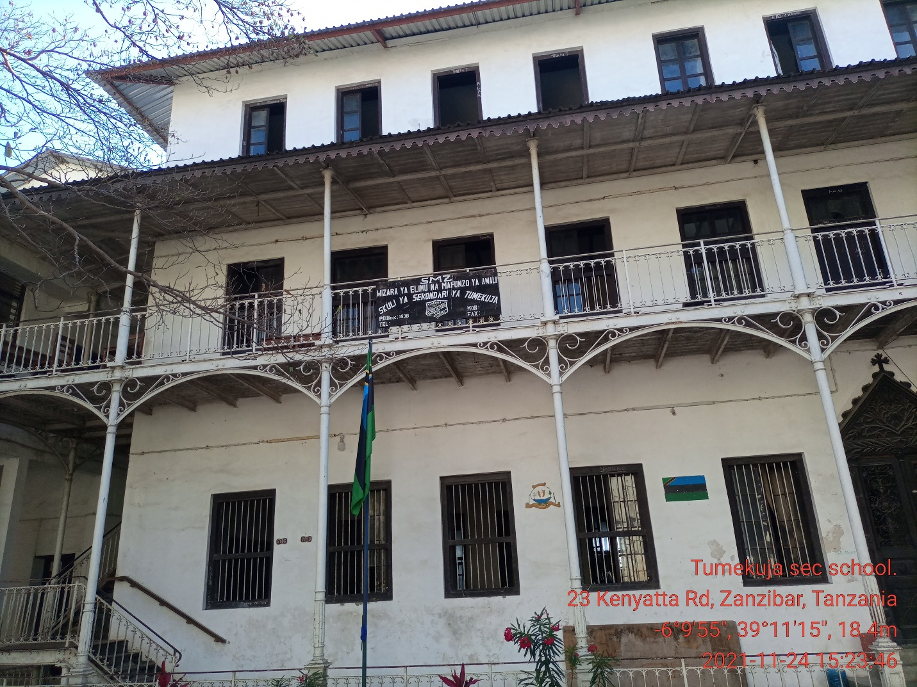

3.2 The Pole and Solar panel location

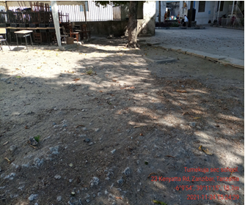  Alternative location for Pole (Ground based | 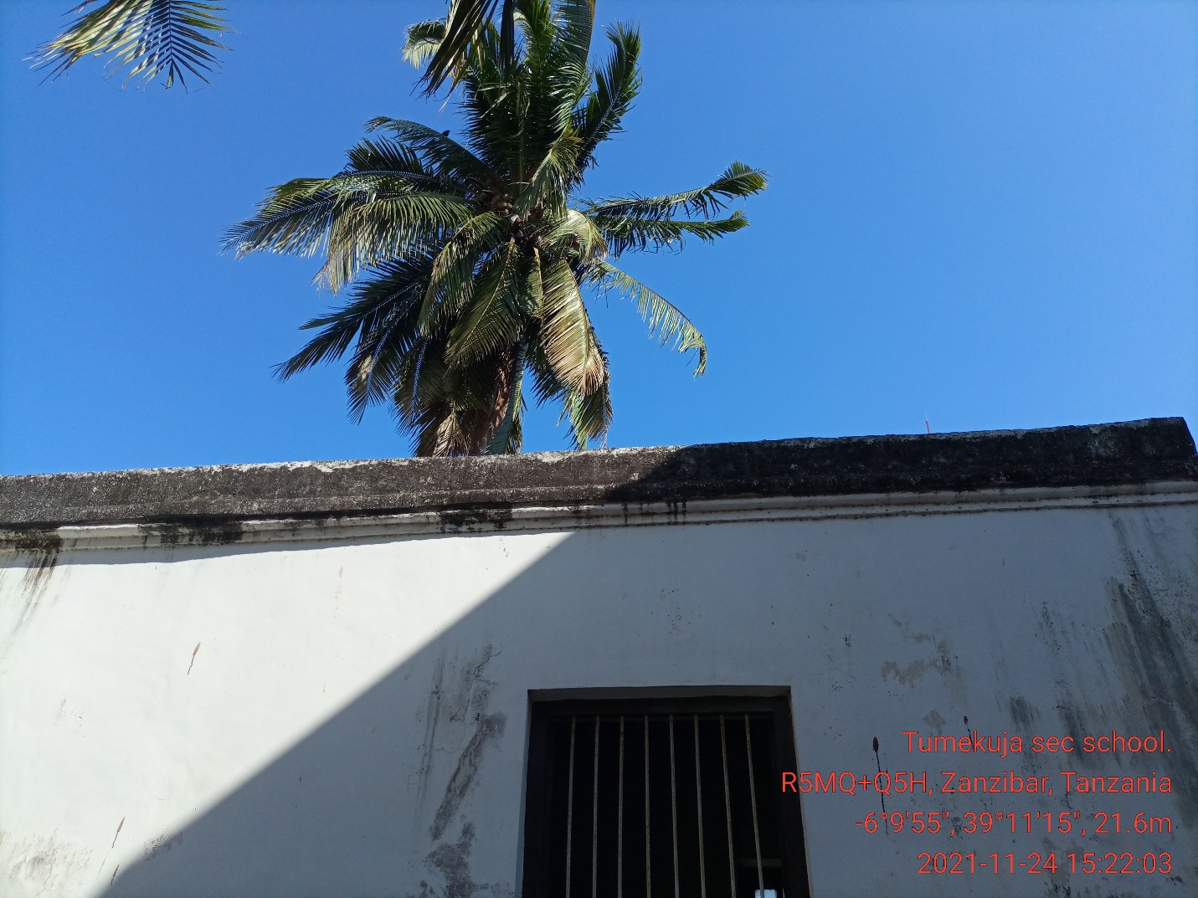  The arrow shows the rooftop where Pole and solar panels will be allocated
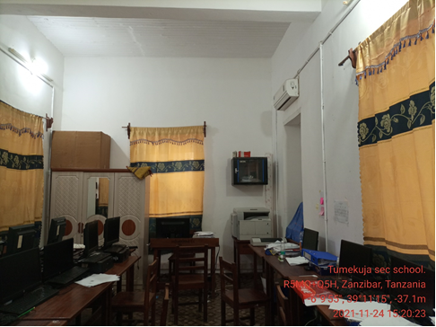
Server room which is the Battery and controller proposed room

4. REQUIRED QUANTITIES OF INSTALLATION MATERIAL

S/N | Material/Equipment | Specifications | Unit | Quantity
1 | Pole | 1 Counter weight type. | Meters | 1
2 | Mounting type (Antenna) | Counter weight support
3 | Cables | CAT 6 Outdoor | Meters
4 | POE |  | PC | 1
5 | Extension cable |  | PC | 1
6 | Connector | RJ45 | PCS | 2
7 | Socket outlet |  |  | 1
8 | Plug |  |  | 1
9 | DC cable red | 16 sqmm | Meters | 12
10 | DC cable blue | 16 sqmm | Meters | 12
11 | PVC conduit pipe | 1 inch | PCS | 15
12 | PVC elbow | PVC, 1inch | PCS | 6
13 | Cable tie |  | pkt | 4
14 | U Clamp | 1inch | PCS | 15
17 | Iron bar | 8mm | PCS | 1
18 | Earth cable | 16sqmm | Meters | 30
19 | Earth rod | 2ft | PCS | 2
20 | Raw bolts | 4mm | PCS | 8
21 | Extension cable | Tronics | pcs | 1
22 | Flexible cable | 2.5sqmm,3core | Meters | 10
23 | Flexible conduit | 1inch | Meters | 6
24 | Insulation tapes | red and black | Pcs | 2
26 | Cable rugs | 16 sqmm | PCS | 8

5. Potential Challenges

Challenges | Description
- Any restrictions on time we can work?  - Any access issues?  - Detail any challenges caused by existing site architecture?  - Will the installation annoy or adversely affect neighbors / be vulnerable to theft or damage?  - Are there any additional permissions to work on site required?  - Describe any security challenges  - Any other challenges? | Company IDs will be required for access,  nil  No,  The site is safe, has wall fence, and has 24hrs manned security protection.  Nil.

6. REGULATORY COMPLIANCE CHECKS

PERMIT REQUIRED | STATUS (Obtained/Not Obtained/In progress/ In progress)
TCRA
Municipal Authority
Land lord
Engineer checks e.g. Structural
Integrity test

Any other certification/Permit
Comment | Pole foundation construction and other civil works, will require authorization  Note: World Mobile is responsible for acquisition of all permits  Since there are government offices nearby all compliances should be considered

7. RECOMMENDATIONS

 | Check the appropriate box below
- Approve site for system installation ☐
- Do not approve site for system installation (If not approved specify reasons for rejections) ☐
Comments | The site is one of the historical places and has the potential to provide coverage to tourists, businesses, the community nearby and the government offices
Comments | Moreover there are two schools about 1km from here which may be used in creating a mesh network. There are Hurumzi Secondary school and Haille Sellasie ~ [google map]

8. SURVEYOR REVIEWER INFROMATION

Name:
Organization
Signature Date:
Please list other committee members in reviewing this design
Name:
Organization
Signature Date:

APPENDIX

MAP

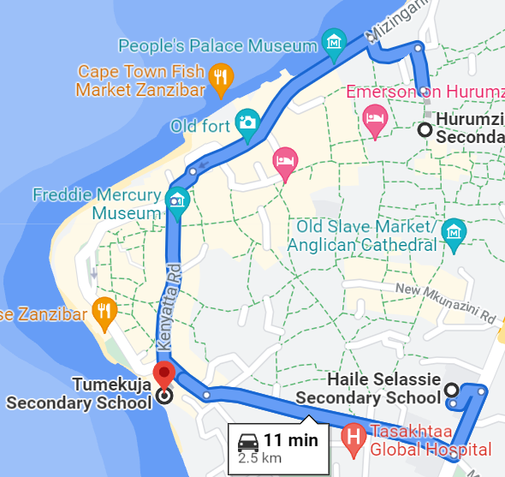

This map show the location of Tumekuja School to Haille Sellasie School which is less than 1km as well as to Harumzi School

