Title: EAGER: SitS: Collaborative: Terahertz Sensors for In-Situ Soil Characterization and Imaging
1. Introduction
Presently, there is a need in agriculture to produce greater and greater yields to feed a growing population. Meanwhile, resource intensive agriculture puts a strain on limited supplies of water and energy. This has motivated the field of precision agriculture, which aims to precisely apply inputs to farming systems where they are needed most. For instance, measurements of plant health can show where and when irrigation or fertilizer needs to be applied, in a targeted fashion. A key driver of plant health is the soil condition, including water content and nutritional status (for instance, nitrogen, organic matter, phosphorus, etc). This presents a sensing challenge: how to get measurements of these variables when the soil profile is not easily accessible? Naturally, a farmer can take soil cores and have them tested for water content and nutrients. This is cumbersome, time consuming, and has poor spatial and temporal resolution. Ideally one would like a real-time, continuous, and spatially mapped monitoring method.
For soil water content, a few methods have been employed, including neutron probes, matric potential, and electromagnetic (EM) sensors [1, 2]. Neutron probes operate by measuring the thermalized neutrons scattered from a radioactive source, lowered to different depths along an access tube. It's considered the gold standard for accuracy, but makes use of radioactive materials and requires manual measurements in the field. Matric potential sensors use porous discs which absorb soil water, changing their electrical properties, which can be readily measured. These sensors are prone to clogging and must be buried in the soil along a profile, which means digging a pit, installing, and back-filling, disturbing the soil profile and therefore corrupting measurements. EM sensors, including time-domain reflectometry and capacitance, operating up to the gigahertz range, can readily measure soil water, but suffer similar installation difficulties and are only useful for measuring water and electrical conductivity, a proxy for salts content.
Nutrient status is similarly difficult to measure. Due to resonances associated with O-H, N-H, and C-H bonds in the infrared range (the frequency range of 300 GHz to 430 THz), near-infrared spectroscopy (NIRS) can measure water content and a number of nutrients [3]. NIRS observes the reflectance or transmittance of a material at different IR wavelength. In a field setting, it could be positioned over the soil surface and measure the reflectance, or in a lab setting, it could measure the transmittance of soil samples diluted in water. NIRS is particularly useful in soils at wavelengths of 1400 nm (214 THz), 1700 nm (176 THz), 1900 nm (158 THz), and 2200 nm (136 THz) to measure total C, total N, moisture, and cation exchange capacity. To a lesser degree, it may also measure several ion species [4]. While short-wave IR (100-214 THz) is useful, it does not rule out using additional wavelengths. However, this method is limited to measurements at the surface, which are affected by surface roughness [5, 6], or diluted soil solutions in the lab.
The objective of this proposal is to design a sensor to overcome these challenges. Our sensor design would be easy to install, and bring NIRS monitoring underground, at various depths. We propose using surface plasmon resonance (SPR) sensors, combined with NIRS analysis, to measure the status of water and nutrients of the soil profile using THz electromagnetics. The proposed research will be performed by a comprehensive research team consisting of Yong-Kyu Yoon (micro-/nano fabrication), Changzhi Li (analog circuit design), and Joaquin Casanova (device design and system test).
The intellectual merits are the novelty of the technique and application, and the utility of subsurface measurements of soil nutrients and water. This is a high-risk project, given that this technique has never been applied in soil - conventional SPR primarily is used for uniform liquids and gases, not the mixed media of soil. Moreover, the off-the-shelf components may not be able to meet necessary specifications. Finally, in a two-year span it may be very difficult to accomplish the stated goals. However, such a combined profiling nutrient and moisture soil sensor simply does not exist at present and would be a boon to precision agriculture. For these reasons, it is suitable for EAGER.
2. Preliminary Work
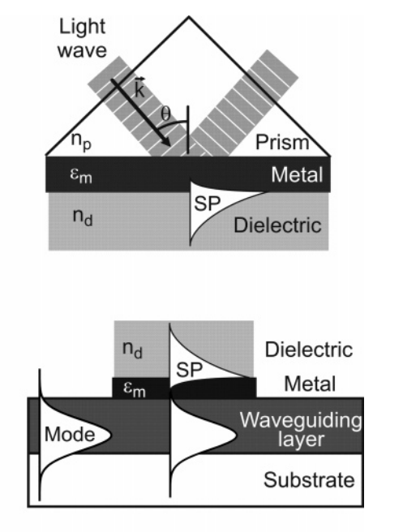
Figure 1: ATR (top) and waveguide (bottom) SPR sensor geometries [8].
Surface plasmon resonance is an EM phenomenon where a wave of charges forms in the thin metal layer between two dielectric media. A source wave is propagated in one medium (a prism or optical waveguide); this couples to the metal layer where, if conditions are right, a surface wave forms; this surface wave forms evanescent field that penetrates the other medium (to be sensed) [7]. Most SPR is done in the visible and near infrared range, and typical metals are Au and Ag. These are chosen because in visible and NIR, they have negative indices of refraction, a necessity for SPR. At a particular set of dielectric properties and wavelength, maximum absorbance by the medium to be sensed is achieved. This sensing technique has been used primarily in bio- or chemo-sensing applications in fluids, as it can measure subtle changes in dielectric associated with species binding to special functionalized coatings [8]. For instance, the presence of a protein may be detected by coating the metal layer with a ligand that binds to this protein. As the protein attaches to the surface, the dielectric properties change, which is detected by the SPR sensor.
SPR sensors come in a few different geometries, the primary two being attenuated total reflection (ATR) and waveguide [8]. ATR consists of (Figure 1) a prism with a thin metal layer on one face. Light is shined through one of the other faces, and some couples to the metal layer and some is reflected through the other face of the prism at a changed wavelength. The degree to which the incident light is coupled to a surface plasmon, and thus the evanescent field’s penetration in the medium, is a function of the incident angle of the light, its wavelength, and the dielectric of the medium. A waveguide SPR sensor operates by coating one side of a rectangular optical waveguide with a metal layer and light is propagated parallel to this interface [9]. In either form of SPR sensor, one can measure the ratio of transmitted to incident power (the transmission coefficient) at a particular, fixed wavelength (power interrogation), or the change in the wavelength of the reflected light (wavelength interrogation). For a small, field sensor, power interrogation at discrete wavelengths is simpler and more realizable than measuring wavelength shift, which would require a full spectrometer.
3. Proposed Work
Our sensor will combine SPR sensors with NIRS, allowing underground spectroscopy. This has been tried to a limited extent by some researchers [10,11], who made use of an ATR configuration and a full Fourier transform IR (FTIR) spectrometer. Our approach would be novel in that we will examine discrete wavelengths and sense soil underground, overcoming the complexity of typical SPR and the surface limitations of NIRS. Moreover, the proposed design will be modular and simple to install.
3.1. Sensor Design
The proposed sensor will consist of tubular segments following the design of the waveguide-on-access-tube (WOAT) TDR described in [12] (Figure 2). Each segment will have a number of independent waveguide-coupled SPR sensors running longitudinally and arranged around the circumference. A discrete set of photodiodes operating at specific IR wavelength will transmit light through the waveguides, and photodetectors at the other end will measure received power. Amplification and digitization follows, and the measured signals will be transmitted along a communication bus common to all segments. A stack of such modules (Figure 3) would be installed by pressing the tube into the soil while augering soil out through the central core. Once installed, this design could measure soil properties with depth and with angle. Naturally, there are still design variables to be analyzed, such as optimal wavelengths, sensor geometry, and coating materials, as well as ensuring the structure has mechanical strength to be installed.
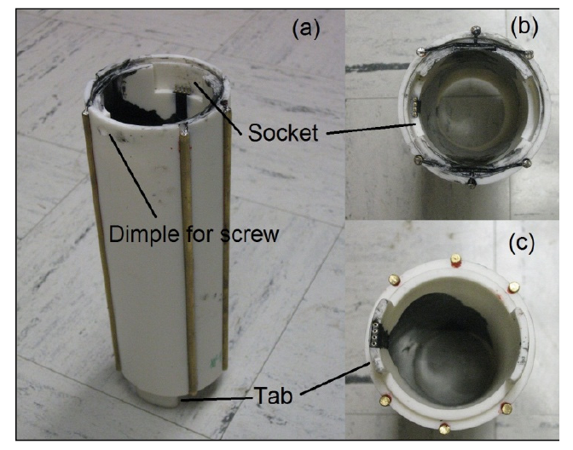
Figure 2: WOAT sensor from [12].
Ultimately, the stack would provide a set of transmission coefficients at specific wavelengths at each depth. These can be curve-fit to predict soil properties.
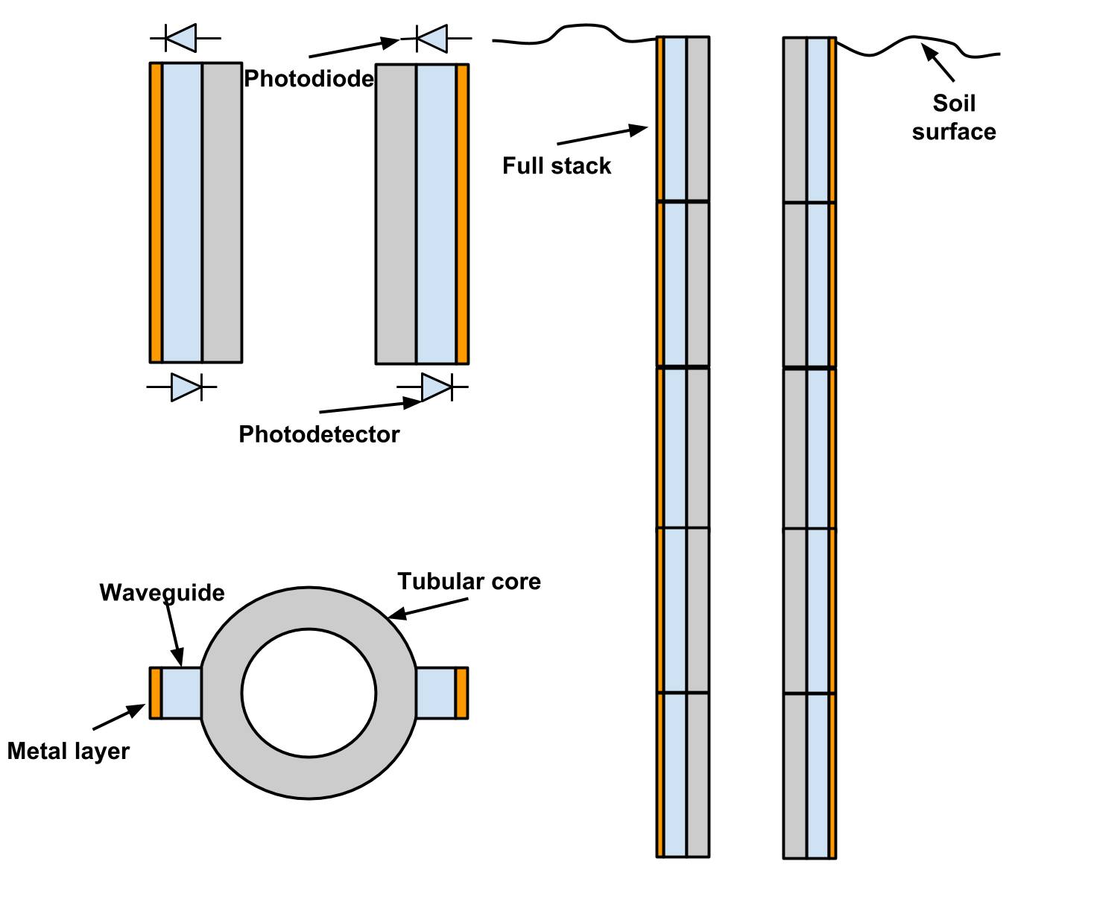
Figure 3: Proposed sensor concept drawing.
The design process requires a few steps which may be iterative: wavelength selection; simulation and geometry and material selection; mechanical design; and lab prototype tests. The initial step is simply choosing a set of wavelengths, or a range of wavelengths, that are sensitive to the soil properties of interest. These can be chosen based on a review of the soil NIRS literature [3-5]. Then, these wavelengths will govern the coating type and properties, selection of off-the-shelf photodiodes and detectors, and the sensor geometry. Whether or not SPR is supported is determined by the plasma frequency of the metal layer; the metal dielectric constant at the frequencies of interest; the thickness of the metal layer, relative to the penetration depth at the frequency of interest; the soil properties at the wavelength; and the dielectric and thickness of the optical waveguide. Some initial choices for sensor material and geometry may be made by hand EM analysis [7], and then this can be refined in a simulation tool such as COMSOL. A challenge here may be in estimating soil refractive index at the frequencies for simulations. This is an uncertain area as soil particle sizes are on the order of a wavelength in NIR, so careful EM analysis is necessary to determine even if SPR could be supported. The soil roughness along the sensing surface may prevent use of SPR at all. Coating types are limited to a discrete set of materials, including Au, Ag, InSb [9-11], and In203 [13]. The thickness is roughly determined by the penetration depth, and the waveguide structure is primarily determined by its waveguiding properties at our chosen frequencies of interest. In addition, once the SPR sensor structure is determined, the tubular module structure must be designed to withstand the compressive forces of installation without fracturing or buckling failures, and maintain sensor functionality even with surface damage from installation, a major design challenge. Initial prototypes can be fabricated (3.2) and tested (3.4) with circuits from (3.3) or off-the-shelf spectrometers. The design will be revised according to these test results.
3.2. Microfabrication process
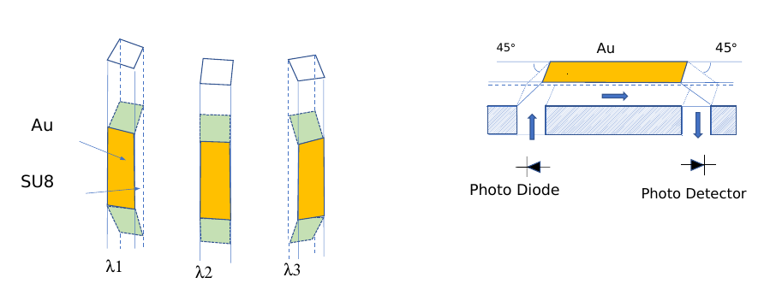
Figure 4: Gold electrode SPR sensor array and integrated waveguide: (a) Different wavelengths incident to each SPR sensors and (b) SPR electrode integrated micromachined waveguide.

One sensor configuration is shown in Figure 4. A series of SPR sensors consisting of a 5 ~ 10 nm thick gold layer and an SU8 (photopatternable epoxy, SU8 2025, Microchem Inc.) optical waveguide are located around the core cavity (Figure 4a). Each SPR sensor will be illuminated with a photo diode (THz light source) with a discrete wavelength. While the Au sensing layer is interfaced with the soil, other electronics including photo diodes, photo detectors, and other processing circuits will be located inside the core tube. SU8 optical waveguides with 45° slanted mirrors (Figure 4b) are microfabricated.
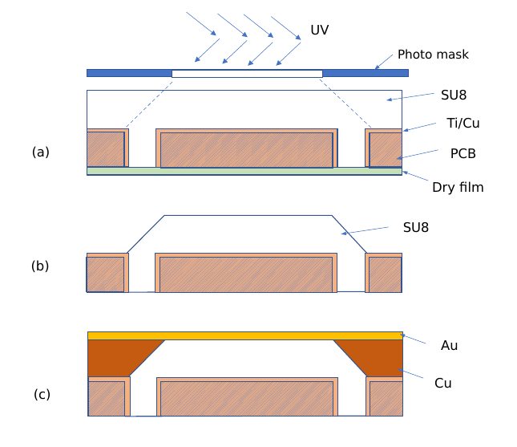Figure 5: Fabrication process.

Figure 5 shows a fabrication process. A printing circuit board (PCB) is drilled to form via holes, which will serve as the optical waveguide ports. One side is sputter deposited with a seed layer using Titanium/Copper (30 nm/300 nm). The other side is taped with dry film. SU8 (100 mm) is spin coated. In order to form a 45° slanted mirror, multidirectional UV lithography [14] will be applied (a). After post exposure bake, SU8 is developed (b). Using the pre-deposited seed layer, Cu electrodeposition is performed to the thickness of the SU8 waveguide. A top Au (5 ~ 10 nm) layer is sputter deposited (c). Optionally, a polyethyleneglycol (PEG) layer, which is dissolvable in water, could be coated to protect the Au layer during the insertion of the sensors into the ground.
3.3. Circuit Design
Electronically, the SPR sensor requires a photodiode on the input of the waveguide and a photodetector on the other end. The rest of the circuit consists of photodiode amplification and digitization.
The design of electronic circuit is nontrivial because of the difficult tradeoff among conflicting considerations such as detector sensitivity and circuit noise. In order to maximize the detector sensitivity, large area and high reverse bias are desirable for the PIN photodiode to achieve a large depletion region. Unfortunately, both of these conditions increase noise in the system. Moreover, large-area detectors tend to have higher parasitic capacitance, which presents a design challenge for the detector circuit because of the largely increased noise gain and reduced settling speed of the amplifier circuit. Increasing the reverse bias voltage will reduce junction parasitic capacitance and boost the generated current level. Unfortunately, a higher bias voltage also leads to a higher leakage current, which in turn generates more noises.
To solve the above challenges, several techniques will be investigated. First, to increase the sensitivity and minimize random geographical error when probing soil, the desired large effective detector area will be realized by several pseudo-parallelized channels at each wavelength, with each driven individually by a dedicated pre-amplifier stage. One positive thing is that the cost of the required circuits is very low, as many high-quality off-the-shelf amplifiers come with multiple amplifiers in a single package. This will be one of the key procedures to resolve the tradeoff between detector sensitivity (i.e. the need for large detector area) and circuit noise (i.e. the limit on detector area). To this end, optimal detector channels and the combination of various photodiodes will be investigated.
Since the receiver is composed of multiple detector channels whose signals are processed by different amplifiers, it is important to properly combine the outputs from all the channels. To realize this, sophisticated shaping circuit will be implemented so that the outputs from different channels have consistent waveform. Optimization of the frequency and noise performance of the pre-amplifiers and shaping amplifiers will be pursued to meet the demand for large combined detecting area. Following the pre-amplifier and pulse shaping amplifier stage, a high dynamic range analog adder will be designed to add the output from all the amplifier channels together. After the analog adder combines the input from all the detector channels, the signal will be sent to the analog-to-digital converter (ADC) of a microcontroller (e.g. TI MSP430F2619 with 365 μA active current at 1 MHz 2.2 V) for digitization and further signal analysis that results in useful readings for soil professionals.
3.4. Test Plan
The design, fabrication, and testing of our sensor will go according to the following plan: electromagnetic analysis, simulation and design; initial, single SPR prototype and lab testing; and full, tubular module design and testing. In the first stage, we will design the sensor structure following electromagnetic analysis. Here we determine the relevant frequencies; the choice of coating; and the geometry. At this stage we will have to carefully analyze the unique random mixture of soil properties - it’s made of silicon dioxide, air, and water, randomly distributed in space. Initial SPR tests can be conducted using an spectrometer and an ATR SPR sensor to determine SPR effectiveness in soil. Following, an initial prototype of a single SPR will be fabricated and tested in the lab, using samples of known soil properties. From this, multivariate regression can establish the sensitivities of the sensor, and we can make adjustments to the design. Finally, the cylindrical module will be designed and tested in a field setting, or a mock field setting in the lab (ie, buried under soil), to establish functionality and sensitivity to soil properties, which will be measured separately by other methods. As this project is limited to a two-year duration, it will not be possible to get to the design and test of the final sensor module, let alone conduct a full agricultural field experiment and test the use of the sensor in a precision agriculture application, though this may be possible in the future.
4. Broader Impacts
4.1. Education
Course development:
PIs plan to develop coursework modules for micro-/nano fabrication (UF, EEE5354L Semiconductor Device Fabrication Lab), electromagnetics (EEL4483, Electromagnetic Fields and Applications 2) and high-sensitivity detector circuits design (TTU, ECE4341/5341 Design and Analysis of Analog Integrated Circuits) for graduate and undergraduate level. Each module will consist of the design, fabrication, and characterization of the micromachined magnetic gradiometer. Students will be given access for design tools such as COMSOL package (COMSOL Inc.) and Cadence Virtuoso.
Undergraduate mentoring and research:
The PIs mentor multiple ECE undergraduate students per semester. They have been actively involved in recruiting and training undergraduates at the University of Florida (UF) and from other collaborating domestic and international institutions. Yoon has been serving a mentor for the UF University Minority Mentoring Program (UMMP) and University Scholar Program (USP). Besides closely working with TTU undergraduate students, Dr. Li will leverage the TTU College of Engineering exchange program to recruit visiting undergraduate students. To help lower the barrier of entry of undergraduate students into research, the PIs will stay involved in various organizations such as UF/TTU IEEE, Gator Amateur Radio Club, and UF/TTU Women in ECE (WECE).
Graduate mentoring and research in the sharing infrastructure:
Yoon supervises average 5 graduate students per year for their graduate research in microfabrication and microwave components. Yoon has an access to shared labs of microfabrication, packaging, machining, and nanofabrication lab in addition to the cleanroom at the Nanoscale Research Facilities at UF. In fall 2018, TTU has met the enrollment criteria to be recognized as a Hispanic-Serving Institution (HSI) by the U.S. Department of Education. Li has leveraged this opportunity to recruit Hispanic graduate student Mr. Rodriguez to work on the circuit design and testing of this project.
4.2. Outreach
We leverage UF’s Center for Precollegiate Education and Training (CPET) to coordinate various outreach activities for the articulation and transfer of science and technology. Specifically, two venues will be explored: the Student Science Training Program (SSTP) and Special Explorations for Teachers and Students (SETS). SSTP is a college-level summer residential research program for high school students with research and daily lecture/seminar components. The SETS program is for teachers to bring their students on campus for a custom designed science experience. A 3-4 hour hands-on exploration and/or demonstration project will be developed pertaining to the proposed work. As a faculty mentor of the TTU Clark Scholar program, Dr. Li regularly mentors undergraduate Clark Scholars from other states. For example, he has mentored three high school Clark Scholars from California and Arizona. He plans to supervise two visiting high school students in the proposed project.
4.3. Societal and Technical Impacts
A sensor of this type would permit better measurement of soil water and nutrient status, in real time. This would facilitate precision agriculture, the targeted application of crop inputs to maximize yield while minimizing resource consumption. Such resource-saving is necessary to feed a growing population with finite resources. Further, understanding soil carbon and nitrogen is paramount for understanding the C and N cycles, particularly with their impacts on global warming. Subsurface NIRS may also be able to monitor other pollutants. While this project is still exploratory, a fully commercialized sensor would be a great benefit to farmers and environmental scientists, and the research will involve a new generation of engineers interested in this area.
5. NSF Results of Prior Support
ECCS-1232413, 2/1/08-1/31/14, $399,999, is entitled “CAREER: RF devices and components using micro-/nano machined metamaterial” (Yoon, UF).
Intellectual Merits: Using advanced micro-/nano fabrication processes, highly power efficient, compact metamaterial structures and their RF applications including interconnects, filters, and antennas, were studied. The research outcome includes low-loss metamaterials. It has seeded the microwave low-loss metaconductor concept consisting of multiple Cu/Ni or Cu/Co layers, resulting in multiple follow-up projects including NSF I/UCRC Multifunctional Integrated System Technology (MIST) (IIP-14310744, PI-Nishida), and Corning Inc. projects.
Broader Impacts: The developed low loss metamaterial technology has broad impacts on compact, power efficient, passive components. The research work is well integrated with education including course development (EEE71035 Micro-/nanomachined metamaterials; 2013, 2015), graduate/undergraduate supervision and mentoring, minority support, and community service (Advisor of UF Korean Student Association and President of Korean-American Scientists and Engineers Association Gainesville Florida Chapter) and mentoring international students from Brazil, Germany, France, and Korea.
Publications and Products: Three PhD students, 3 MS students, 3 University Scholar Program. Ten journal papers and nineteen conference proceedings have been presented on the topic. One IEEE MTT graduate fellowship, three IEEE APs Doctoral Research Awards, IEEE APs best paper awards (3 honorable mentions) are produced through this support.
ECCS-1354939, 05/01/2013~04/30/2019, $413,793, “CAREER: Smart Radar Sensor for Pervasive Motion-Adaptive Health Applications” (Li, TTU).
Intellectual Merit: Developed novel portable radar sensors for non-contact bio-imaging and detection of human physiological signals, gestures (e.g. limb motion pattern), and position. Modeled the electromagnetic wave interaction with human body, and carried out human subject experiments to verify the effectiveness of the model and advantages of the proposed radar sensing technologies. 1-D imaging of human cardiac motion using a microwave Doppler sensor was experimentally demonstrated. The project also developed several 24-GHz portable sensors on flexible substrate for localization and human imaging. In addition, a hybrid radar-camera sensing system has been demonstrated to intelligently compensate for random body movement during measurement.
Broader Impacts: Provided research experience to three high school students from California and Arizona and three undergraduate students from Puerto Rico, France, and Chile. The undergraduate student from Puerto Rico was successfully recruited as a PhD student in Dr. Li’s group. Outcomes of this project are aimed at improving human life quality.
Publications and Products: 13 journal publications. Developed the iMotion radar device, which is used by nine universities and three industrial research labs. Two PhD students, three MS students, three high school Clark Scholars. Two IEEE MTT-S graduate fellowship.

