BAA number HR001117S0025
Lead Organization University of Florida
Type of organization Other Educational
Proposerâ€™s internal reference number
Other team members :
Changzhi Li Texas Tech University
YK Yoon University of Florida
Jenshan Lin University of Florida
Proposal title Biomimetic microfabricated magnetic gradiometer
Administrative PoC :

Technical PoC :
Casanova, Joaquin
1064 Center Dr, 565 NEB, Gainesville, FL 32611
352-246-9649, jcasa@ufl.edu
Total funds requested
Submitted XX/YY/2017

Official transmittal letter
The transmittal letter should identify the BAA number, the proposal by name, and the organizationâ€™s proposal reference number (if any), and should be signed by an individual who is authorized to submit proposals to the Government.

1 Statement of Work (SOW)
The project’s aim is to develop a minaturized high-sensitivity, low-noise magnetic gradiometer. Our approach is to mimic the mechanism found in magnetosomes, the specialized cells four from bacteria to higher vertebrates such as fish and birds (see 2). This is comprised of four main tasks: modeling and simulation, microfabrication process design, circuit design, and device manufacture and testing. Each Phase (I,II,III) will include these four tasks.

1.1 Phase I
AMBIIENT Phase 1 will demonstrate sensor functionality and performance in a laboratory setting meeting the performance metrics as indicated in Table 1.

1.1.1 Modeling and simulation
• The objective in this phase is to simulate the MEMS device, taking into account geometry, material properties, and multiphysics interactions, in order to determine the range of acceptable design options. In addition, scaling laws will be derived, such that a scale model of the sensor could be fabricated from COTS components.
• Our approach here is to initially specify geometry and physical properties by hand calculation, the investigae more deeply in a finite-element multiphysics solver.
• This task will be accomplished at UF by Joaquin Casanova.
• Completion of this task is specified by successful simulation of the MEMS device that meets the physical requirements specified in the BAA.
• Deliverables include successful simulation results and design parameters.
• No government equipment is required.
• To reduce risk of later failure due to non-manufacturability, this task will be accomplished within fabrication constraints specified by the MEMS team at UF. This ensures the design is physically realizable. In parallel, other sensing modalities could be explored in the case that the MEMS cantilever is not practical.
• This task will be accomplished at UF.

1.1.2 Microfabrication
• The objective in this phase is to develop a microfabrication strategy (materials, deposition, patterning) that can meet the requirements found from simulation.
• Our approach here is to find a range of dimensional constraints and material types that could be physically realizable.
• This task will be accomplished at UF by Dr. YK Yoon.
• Completion of this task is specified by successful specification of a microfabrication plan for the sensor described by the simulation results.
• Deliverables include successful microfabrication plan.
• No government equipment is required.
• To reduce risk of later failure due to non-manufacturability, this task will be accomplished with paralel investigating of alternative MEMS sensing modalities.
• This task will be accomplished at UF.

1.1.3 Circuit design
• The objective in this phase is to develop a circuit which amplifies and digitizes the the voltage produced by the MEMS elements.
• Our approach here is to ...
• This task will be accomplished at TTU by Dr. Changzi Li.
• Completion of this task is specified by successful design of a circuit capable of amplifying and digitizing MEMS output voltage with input-referred voltage noise low enough to meet the overall sensitivity requirement.
• Deliverables include successful design and prototype of the circuit, usable with the scale model, using COTS components.
• No government equipment is required.
• To reduce risk of later failure due to excessive noise, this task will investigate only specifically low-noise designs.
• This task will be accomplished at TTU.

1.1.4 Manufacture and testing
• The objective in this phase is to construct a scale model of the MEMS design using COTS components, according to the scaling law developed in 1.1.1.
• Our approach here is to mimic the MEMS structure with COTS materials (ie, commercially available piezo elements and magnetic sheets)
• This task will be accomplished at UF by Dr. Joaquin Casanova.
• Completion of this task is specified by successful construction and testing of a scale model, which satisfies Table 1 after application of scaling laws.
• Deliverables include successful scale model prototype of the sensor.
• No government equipment is required.
• To reduce risk of failure, prototyping will begin early in Phase 1.
• This task will be accomplished at UF.

1.2 Phase II
AMBIIENT Phase 2 will develop and demonstrate an integrated sensor head meeting the performance and SWaP metrics of Table 1, and including all vacuum, photonic, and thermal control components.

1.2.1 Modeling and simulation

1.2.2 Microfabrication

1.2.3 Circuit design

1.2.4 Manufacture and testing

1.3 Phase III
AMBIIENT Phase 3 will demonstrate a fully integrated gradiometer comprising all control electronics, power conditioning, and packaging, meeting all performance metrics of Table 1

1.3.1 Modeling and simulation

1.3.2 Microfabrication

1.3.3 Circuit design

1.3.4 Manufacture and testing

2 Innovative Claims
Our approach is to design a sensor based on a magnetoreceptive mechanism used in nature - magnetite crystals torqued by external magnetic fields open ion channels in the cell wall. To mimic this, we propose a microfabricated MEMS sensor, with a layer of magnetic material on top of piezo electric cantilevers. When forced with an exernal field, torque induced on the magnet create stress in the piezo, and thus a voltage is produced. There are three advantages to this approach. First, microfabrication allows for a small size. Second, by orienting individual sensing elements in anti-series order, the output is natively a gradiometer. Third, by selecting the resonant frequency of the cantilever carefully, we can create a gradiometer which outputs a spectrogram directly. Though fluxgates can be microfabricated and function as gradiometers, they suffer a size/sensitivity tradeoff. Microfabricated atmonic magnetometers are sensitive but don’t function natively as gradiometers. Other micro-scale magnetometers, namely Lorentz-type, which operate on a similar mechanism, are not yet sensitive enough and haven’t been used as frequency-domain gradiometers, as in the proposed design.

3 Detailed Technical Approach
Magnetometers serve an important role in investigating biologically generated electromagnetic fields, such as those created by neuronal currents, or geological magnetic fields. Typically, magnetometers are unable to achieve high sensitivity in an ambient, unshielded environment - getting to femtotesla level sensitivity requires magnetic shield and cryogenic sensors, such as SQUID [13]. The novel spin relaxation free magnetometer has been minaturized and achieves less than 10 fT/, but still requires shielding and lacks directional sensitivity [18]. Fluxgates have achieved pT level resolution at small size, but this is insufficient for biomagnetic field measurement [16, 17, 23]

[Sorry. Ignored \begin{subfigure} ... \end{subfigure}]
[Sorry. Ignored \begin{subfigure} ... \end{subfigure}]
Figure 1: Fundamental-mode orthogonal fluxgate gradiometer [17].17
Lorenz-type magnetometers (which translate magnetic fields into mechanical actuation of a magnet or current carrying wire) have been built in MEMS substrates, but are as yet insufficiently sensitive and require shielding [11, 12, 20, 22]

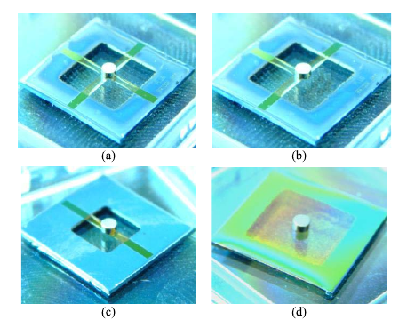
Figure 2: Lorenz-type magnetometer [20].20

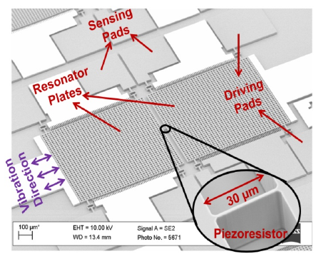
Figure 3: Lorenz-type magnetometer [11].11
In nature, many organisms have a sense of magnetoreception used for navigation, from magnetotactic bacteria to birds. Two mechanisms have been proposed: a spin-selective (and thus field-sensitive) chemical reaction rate, or magnetite crystals which are actuated by external fields and activate ion channels in the cell membrane [5, 9, 10]. Measurements of these magnetosomes show a magnetic dipole moment of up to 100fA/m [7, 8].

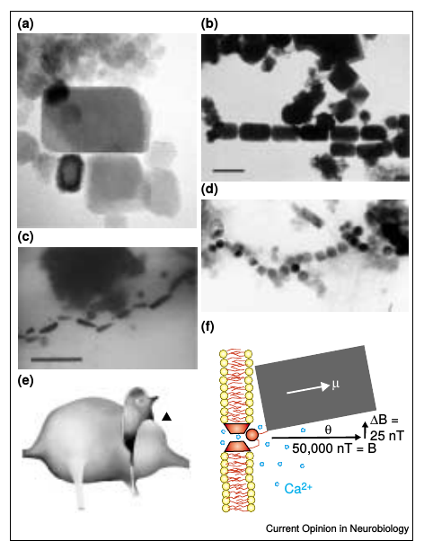
Figure 4: Magnetosomal mechanism [10].10
Our approach is to mimic the approach found in magnetosomes, with some key modifications so that is frequency-selective and functions inherently as a gradiometer and thus does not require shielding. The closest biomimetic sensor is a flow sensor which uses ferromagnetic cilia to detect microfluidic flow rates [1].

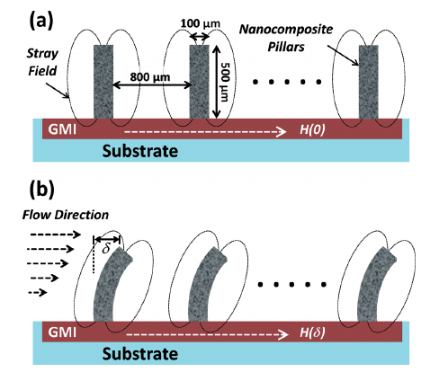
Figure 5: Magnetic cilia flow sensor [1].1
To acomplish this, we propose layering single-domain magnetic crystals on top of piezoelectric cantilevers. The moment M induced on the magnetic layer with moment ⃗μ and field ⃗B is:
M=⃗μ×⃗B
Interpreted as a point load at the cantilever tip, this moment causes a stress distribution on a cantilever of length L, thickness t, second moment I, piezoelectric constant , and modulus E, at point x, of

and n in series generates a voltage

Two features are possible from the cantilever design: frequency selection and gradiometery. As in [19], a cantilever has a resonant frequency, which can be modifying through geometrical parameters. Peak response will be achieved at this frequency. By selection many cantilevers of different dimensions, each corresponding to a separate output, the magnetometer output is a spectrometer. Many cantilevers at the same resonance in series generate a largeer voltage; in anti-series, the difference is taken, thus functioning as a gradiometer with very high spatial resolution.
Even though biological magnetoreception is limited to nT sensitivity, our design will allow us to surpass this. First, by careful selection of materials (such as Co-Pt or rare-earth magnets) [2, 4] we can have much higher magnetic dipole moment, and thus higher moment. Second, by careful selection of geometery, we can employ parametric resonance [24]. Finally, using two banks of cantilevers in series in anti-series, we both boost the voltage and create a high resolution gradiometer.
The noise floor of magnetic materials is governed by Barkhausen noise - the random flipping of magnetic domains [3]; this noise is characterized as a flux noise level. The flux noise can be converted into a magnetic moment noise, and thus moment noise. Piezo noise floor is largely a function of piezo losses [14]. Additionally, there is the input-referred noise of any amplifier. With conservative estimates for all of these, and two anti-series banks of 30 cantilevers each with dimensions 400x40x3 μm, the sensitivity level is less than 10 fT/cm/sqrtHz.
An alternative design, should magnetic/piezo integration prove infeasible, is to measure the tilt of magnetic cilia by some other means. One way would be to affix micromirrors to the magnetic cilia and measure the change in reflected angle of a laser beam [6]. Instead of a laser, millimeter-wave radar could detect changes in tilt angle, similar to the techniques used in vital-signs radar [15].

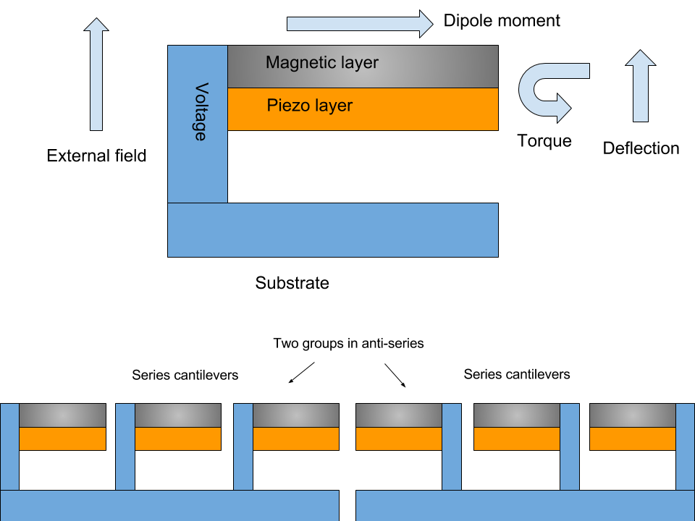
Figure 6: Diagram of proposed design.
MEMS fabrication processes are capable of constructing the above-described sensor. This consists of two main fabrication tasks: piezo cantilever construction, and magnetic material integration. The process described in [19] can be used for our task, with an additional step to apply the magnetic layer. PZT has a high voltage coefficient and is highly suitable for the piezo elements [21] and can be deposited with pulsed laser deposition or solution-based deposition and patterned with chemical etching or ion etching. Rare-earth magnetic materials, such as alloys of Sm-Co, offer high magnetic energy product at room temperature and can be integrated into MEMS using sputtering or pulsed laser deposition [2]. However, patterning of these materials is slow, using wet etching or ion-beam milling.
Circuit description?
To test, in Phase I, it may be more feasible to test a scale model which can be built from COTS components. An appropriate scaling law and set of nondimensional parameters can be used to appropriately choose materials and dimensions for the scale model.

Metric | Phase 1 | Phase 2 | Phase 3
Power consumption | 150 mW | 50 mW | 100 mW
Sensor Volume | 3x3x10 cm | 1x1x7 cm | 1x1x7 cm
Control Electronics Volume | N/A | N/A | < 20cm
Ambient Magnetic Field | ± 100 μT | ± 100 μT | ± 100 μT
Ambient Operating Temperature | N/A | 0 C to 50 C | 0 C to 50 C
Gradient Full-scale Range | 1 nT/cm | 1 nT/cm | 1 nT/cm
Gradient Sensitivity | 10 fT/cm/ | 3 fT/cm/ | 1 fT/cm/
Gradient Accuracy | 100 fT/cm | 30 fT/cm | 10 fT/cm
Total Field Range | 100 μT | 100 μT | 100 μT
Total Field Sensitivity | 100 pT/ | 30 pT/ | 10 pT/
Total Field Accuracy | 1 nT | 500 pT | 100 pT
Data Rate | 100/s | 200/s | 500/s
3 dB Bandwidth | 200 Hz | 400 Hz | 1000 Hz

Table 1: Design objectives, by phase.

Phase | Milestone | Date
1 | Cantilever simulation and design
1 | Fabrication plan
1 | Circuit design
1 | Scale model design and testing
2 | Cantilever simulation and design
2 | Fabrication plan
2 | Circuit design
2 | MEMS fabrication and testing
3 | Cantilever simulation and design
3 | Fabrication plan
3 | Circuit design
3 | MEMS fabrication and testing

Table 2: Milestones schedule

4 Risk Analysis and Mitigation Plan

[Sorry. Ignored \begin{tabularx} ... \end{tabularx}]
Table 3: Risk matrix
Identify the major technical and programmatic risks in the program. Include a risk matrix. For each risk, assign a probability of occurrence on a scale of 1-10, where 10 indicates a high likelihood that the risk will impact program success, as well as an assessment of impact, also on a scale of 1-10, where 10 indicates that this risk would maximally limit the program from delivering prototypes on schedule or meeting performance objectives. For each item with total risk (likelihood Ã— impact) exceeding 40, include a plan for mitigating the risk and assessing risk reduction. Where necessary, parallel risk reduction tasks may be proposed, e.g. concurrent development of redundant techniques or components. The proposal must differentiate the primary technical path from risk reduction tasks, which should be uniquely identified in the SOW and separately costed as optional tasks in Volume II.

5 Schedule and Milestones
Include a high-level Gantt chart outlining major technical tasks and measureable milestones by phase. At a minimum, the schedule should include each SOW task of Volume 1, Section II.A. Where risk reduction tasks are proposed, the schedule should include a milestone for assessment and removal of redundant tasks.

6 Test Plan
Describe how compliance with the proposed metrics and milestones will be demonstrated in each phase of the program. The test plan should be structured so that compliant performance can be verified prior to delivery of hardware for government test and evaluation.

6.1 Phase 1

6.2 Phase 2

6.3 Phase 3

7 Results and Technology Transfer
Description of the results, products, transferable technology, and expected technology transfer. This should also address mitigation of life-cycle and sustainment risks associated with transitioning intellectual property for U.S. military applications, if applicable. See also Section IV.B.10, â€œIntellectual Property.â€

8 Ongoing Research
Comparison with other ongoing research indicating advantages and disadvantages of the proposed effort.

9 Proposer Accomplishments
Discussion of proposerâ€™s previous accomplishments and work in closely related research areas. In this section, also include any ongoing research projects or pending proposal activity that technically overlaps with the proposed effort, including funding source, administrative point of contact, and the program management plan for combining and de-conflicting the efforts.

10 Facilities
Description of the facilities that will be used for the proposed effort.

11 Teaming
Description of the formal teaming agreements that are required to execute this program. Describe the programmatic relationship between investigators and the rationale for choosing this teaming strategy. Present a coherent organization chart and integrated management strategy for the program team. For each person, indicate: (1) name, (2) affiliation, (3) abbreviated listing of all technical area tasks they will work on with roles, responsibilities, and percent time indicated, (4) discussion of the proposersâ€™ previous accomplishments, relevant expertise and/or unique capabilities.
References Cited
[1] Ahmed Alfadhel, Bodong Li, Amir Zaher, Omar Yassine, and Jürgen Kosel. A magnetic nanocomposite for biomimetic flow sensing. Lab on a Chip, 14(22):4362–4369, 2014.
[2] David P Arnold and Naigang Wang. Permanent magnets for mems. Journal of microelectromechanical systems, 18(6):1255–1266, 2009.
[3] Mattia Butta and Ichiro Sasada. Sources of noise in a magnetometer based on orthogonal fluxgate operated in fundamental mode. IEEE Transactions on Magnetics, 48(4):1508–1511, 2012.
[4] John MD Coey. Magnetism and magnetic materials. Cambridge University Press, 2010.
[5] Charlotte A Dodson, PJ Hore, and Mark I Wallace. A radical sense of direction: signalling and mechanism in cryptochrome magnetoreception. Trends in biochemical sciences, 38(9):435–446, 2013.
[6] Can Duan, Quentin Tanguy, Antonio Pozzi, and Huikai Xie. Optical coherence tomography endoscopic probe based on a tilted mems mirror. Biomedical Optics Express, 7(9):3345–3354, 2016.
[7] Stephan HK Eder, Hervé Cadiou, Airina Muhamad, Peter A McNaughton, Joseph L Kirschvink, and Michael Winklhofer. Magnetic characterization of isolated candidate vertebrate magnetoreceptor cells. Proceedings of the National Academy of Sciences of the United States of America, pages 12022–12027, 2012.
[8] Marianne Hanzlik, Michael Winklhofer, and Nikolai Petersen. Pulsed-field-remanence measurements on individual magnetotactic bacteria. Journal of Magnetism and Magnetic Materials, 248(2):258–267, 2002.
[9] Sönke Johnsen and Kenneth J Lohmann. The physics and neurobiology of magnetoreception. Nature Reviews Neuroscience, 6(9):703–712, 2005.
[10] Joseph L Kirschvink, Michael M Walker, and Carol E Diebel. Magnetite-based magnetoreception. Current opinion in neurobiology, 11(4):462–467, 2001.
[11] Varun Kumar, Mohammad Mahdavi, Xiaobo Guo, Emad Mehdizadeh, and Siavash Pourkamali. Ultra sensitive lorentz force mems magnetometer with pico-tesla limit of detection. In Micro Electro Mechanical Systems (MEMS), 2015 28th IEEE International Conference on, pages 204–207. IEEE, 2015.
[12] Jukka Kyynäräinen, Jaakko Saarilahti, Hannu Kattelus, Anu Kärkkäinen, Tor Meinander, Aarne Oja, Panu Pekko, Heikki Seppä, Mika Suhonen, Heikki Kuisma, et al. A 3d micromechanical compass. Sensors and Actuators A: Physical, 142(2):561–568, 2008.
[13] James Lenz and S Edelstein. Magnetic sensors and their applications. IEEE Sensors journal, 6(3):631–649, 2006.
[14] Felix A Levinzon. Fundamental noise limit of piezoelectric accelerometer. IEEE Sensors Journal, 4(1):108–111, 2004.
[15] Changzhi Li, Victor M Lubecke, Olga Boric-Lubecke, and Jenshan Lin. A review on recent advances in doppler radar sensors for noncontact healthcare monitoring. IEEE Transactions on microwave theory and techniques, 61(5):2046–2060, 2013.
[16] I Sasada. Orthogonal fluxgate mechanism operated with dc biased excitation. Journal of Applied Physics, 91(10):7789–7791, 2002.
[17] Ichiro Sasada and Shoumu Harada. Fundamental mode orthogonal fluxgate gradiometer. IEEE Transactions on Magnetics, 50(11):1–4, 2014.
[18] Vishal K Shah and Ronald T Wakai. A compact, high performance atomic magnetometer for biomedical applications. Physics in medicine and biology, 58(22):8153, 2013.
[19] Dongna Shen, Jung-Hyun Park, Jyoti Ajitsaria, Song-Yul Choe, Howard C Wikle III, and Dong-Joo Kim. The design, fabrication and evaluation of a mems pzt cantilever with an integrated si proof mass for vibration energy harvesting. Journal of Micromechanics and Microengineering, 18(5):055017, 2008.
[20] Kushagra Sinha and Massood Tabib-Azar. 27 pt silicon nitride mems magnetometer for brain imaging. IEEE Sensors Journal, 16(17):6551–6558, 2016.
[21] S Tadigadapa and K Mateti. Piezoelectric mems sensors: state-of-the-art and perspectives. Measurement Science and technology, 20(9):092001, 2009.
[22] Matthew J Thompson and David A Horsley. Parametrically amplified mems magnetometer. In Solid-State Sensors, Actuators and Microsystems Conference, 2009. TRANSDUCERS 2009. International, pages 1194–1197. IEEE, 2009.
[23] Tsuyoshi Uchiyama, Norihiko Hamada, and Changmei Cai. Highly sensitive cmos magnetoimpedance sensor using miniature multi-core head based on amorphous wire. IEEE Transactions on Magnetics, 50(11):1–4, 2014.
[24] Cornelis A Van Eysden and John E Sader. Resonant frequencies of a rectangular cantilever beam immersed in a fluid. Journal of applied physics, 100(11):114916, 2006.
BAA number HR001117S0025
Lead Organization University of Florida
Type of organization Other Educational
Proposerâ€™s internal reference number
Other team members :
Changzhi Li Texas Tech University
YK Yoon University of Florida
Jenshan Lin University of Florida
Proposal title Biomimetic microfabricated magnetic gradiometer
Administrative PoC :

Technical PoC :
Casanova, Joaquin
1064 Center Dr, 565 NEB, Gainesville, FL 32611
352-246-9649, jcasa@ufl.edu
Total funds requested
Submitted XX/YY/2017
Award instrument requested Cost-Plus-Fixed Fee (CPFF), Cost-contractâ€”no fee, cost sharing contractâ€”no fee,or other type of procurement contract (specify) or Other Transaction
Place(s) and period(s) of performance
Total proposed cost separated by basic award and option(s), if any, by calendar year and by government fiscal year
Defense Contract Management Agency (DCMA) administration office (if known) Name, address, and telephone number
Defense Contract Audit Agency (DCAA) audit office (if known) Name, address, and telephone number
Date proposal was prepared
DUNS
TIN
CAGE
Subcontractor Information
Proposal validity period (120 days is recommended)
Any Forward Pricing Rate Agreement other such approved rate information, or such documentation that may assist in expediting negotiations (if available). Attachment 1, the Cost Volume Proposer Checklist, must be included with the coversheet of the Cost Proposal.

Detailed Cost Information (Prime and Subcontractors)
The proposerâ€™s (to include FFRDCs and Government Labs) cost volume shall provide cost and pricing information, or other than cost or pricing information if the total price is under the referenced threshold (See Note 1), in sufficient detail to substantiate the program price proposed (e.g., realism and reasonableness). In doing so, the proposer shall provide, for both the prime and each subcontractor, a â€œSummary Cost Breakdownâ€ by phase and performer fiscal year, and a â€œDetailed Cost Breakdownâ€ by phase, technical task/sub-task, and month. The breakdown/s shall include, at a minimum, the following major cost item along with associated backup documentation: Total program cost broken down by major cost items:

12 Direct Labor
A breakout clearly identifying the individual labor categories with associated labor hours and direct labor rates, as well as a detailed Basis-of-Estimate (BOE) narrative description of the methods used to estimate labor costs

13 Indirect Costs
Including Fringe Benefits, Overhead, General and Administrative Expense, Cost of Money, Fee, etc. (must show base amount and rate)

14 Travel
Provide the purpose of the trip, number of trips, number of days per trip, departure and arrival destinations, number of people, etc. See Section IV.B.13 for travel funding restrictions

15 Other Direct Costs
Itemized with costs; back-up documentation is to be submitted to support proposed costs

16 Material/Equipment
(i) For IT and equipment purchases, include a letter stating why the proposer cannot provide the requested resources from its own funding. (ii) A priced Bill of Material (BOM) clearly identifying, for each item proposed, the quantity, unit price, the source of the unit price (i.e., vendor quote, engineering estimate, etc.), the type of property (i.e., material, equipment, special test equipment, information technology, etc.), and a cross-reference to the Statement of Work (SOW) task/s that require the item/s. At time of proposal submission, any item with a unit price that exceeds $1,000 must be supported with basis-of-estimate (BOE) documentation such as a copy of catalog price lists, vendor quotes or a detailed written engineering estimate (additional documentation may be required during negotiations, if selected). (iii) If seeking a procurement contract and items of Contractor Acquired Property are proposed, exclusive of material, the proposer shall clearly demonstrate that the inclusion of such items as Government Property is in keeping with the requirements of FAR Part 45.102. In accordance with FAR 35.014, â€œGovernment property and title,â€ it is the Governmentâ€™s intent that title to all equipment purchased with funds available for research under any resulting contract will vest in the acquiring nonprofit institution (e.g., Nonprofit Institutions of Higher Education and Nonprofit Organizations whose primary purpose is the conduct of scientific research) upon acquisition without further obligation to the Government. Any such equipment shall be used for the conduct of basic and applied scientific research. The above transfer of title to all equipment purchased with funds available for research under any resulting contract is not allowable when the acquiring entity is a for-profit organization; however, such organizations can, in accordance with FAR 52.245-1(j), be given priority to acquire such property at its full acquisition cost.

17 Consultants
If consultants are to be used, proposer must provide a copy of the consultantâ€™s proposed SOW as well as a signed consultant agreement or other document which verifies the proposed loaded daily / hourly rate and any other proposed consultant costs (e.g. travel);

18 Subcontracts
Itemization of all subcontracts. Additionally, the prime contractor is responsible for compiling and providing, as part of its proposal submission to the Government, subcontractor proposals prepared at the same level of detail as that required by the prime. Subcontractor proposals include Interdivisional Work Transfer Agreements (ITWA) or similar arrangements. If seeking a procurement contract, the prime contractor shall provide a cost reasonableness analysis of all proposed subcontractor costs/prices. Such analysis shall indicate the extent to which the prime contractor has negotiated subcontract costs/prices and whether any such subcontracts are to be placed on a sole-source basis. All proprietary subcontractor proposal documentation (fully disclosed subcontract proposal), prepared at the same level of detail as that required of the prime, which cannot be uploaded to the DARPA BAA website (https://baa.darpa.mil, BAAT) as part of the proposerâ€™s submission, shall be made immediately available to the Government, upon request, under separate cover (i.e., mail, electronic/email, etc.), either by the proposer or by the subcontractor organization. This does not relieve the proposer from the requirement to include, as part of their submission (via BAAT), subcontract proposals that do not include proprietary pricing information (rates, factors, etc.). A Rough Order of Magnitude (ROM), or similar budgetary estimate, is not considered a fully qualified subcontract cost proposal submission. Inclusion of a ROM, or similar budgetary estimate, may result in the full proposal being deemed non-compliant or evaluation ratings may be lowered;

19 Cost-Sharing
The amount of any industry cost-sharing (the source and nature of any proposed cost-sharing should be discussed in the narrative portion of the cost volume); AND

20 Fundamental Research
Written justification required per Section II.B, â€œFundamental Research,â€ pertaining to prime and/or subcontracted effort being considered Contracted Fundamental Research.

