Multi-Sensor Robot Swarm for Human Rescue and Vital Signs Monitoring

1. Abstract

Locating victims after a natural or man-made disaster is a dangerous and difficult task. Many environments after an earthquake, storm, or terrorist attack may contain unstable debris, toxic gases, or confined spaces created by collapsed structures. Not only does it place additional human lives at risk, humans may not be able to find buried or obscured victims using our limited senses. Robots have been used in search and rescue operations for two decades, but still suffer from key limitations. Recent advancements in swarm robotics, vital signs radar, computer vision, and thermal imagery can provide a potential improvement to the state of the art in rescue robotics. The goal of this research is to develop a small robotic distributed sensor platform by integrating four sensor modalities: audio, radar, color vision, and thermal imagery, into a group of small robots. Figure 1 shows a concept diagram. The different sensor modalities on different robots will work together to accomplish the task of mapping an unknown interior space and locating and monitoring the vital signs of obscured humans, relaying this information to a remote human operator.

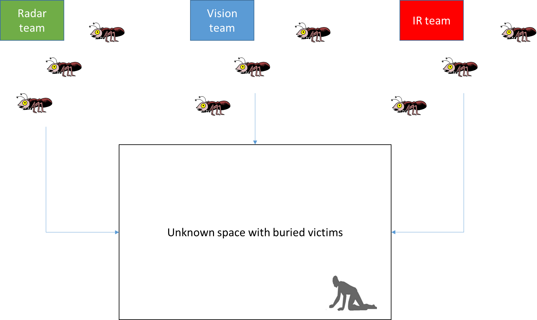

Figure Concept diagram for a swarm of human search robots

2. Need/Goals

Natural disasters or terrorist attacks present a great hazard to humans dealing with the aftermath. One solution to limiting the human risk is through the use of robots. Two excellent examples of this are after the 2011 Japan earthquake and after the 9/11 2001 terrorist attacks [1,2]. [2] offers a detailed post-hoc analysis of the strengths and weakness of real world search and rescue robots. First, robots are typically human-transported and human-operated, and most observed problems resulted from human errors due to cognitive fatigue in a highly stressed and sleep-deprived state. Second, due to necessary human operators, robots were inefficiently used, as they could not operate autonomously. Finally, they had too few sensors to be useful, at most containing a visible and infrared camera, both of which simply relayed images rather than exploiting any on-board computer vision. Additionally, there is still a dearth of commercial search and rescue robots [3]. Clearly, this shows the need for a type of search and rescue robot which is at least semi-autonomous, is low-power, has multiple sensor modalities, and is relatively inexpensive. Any robot in this situation has three primary tasks: mapping an unknown interior space, locating human victims, and assessing their health status. The goal of this proposal is to design, build and test a multi-sensor, multi-robot system to accomplish these tasks. A full implementation would also consider the mechanical robustness and navigability in rough terrain, but this mechatronic design is beyond the scope of this proposed work.

3. Method

Our proposed solution is to use a swarm-based approach, with three teams of robots individually equipped with either visible imaging, thermal imaging, or vital signs radar. The distributed sensing approach separates sensor modalities in three teams to reduce the payload and power consumption on each small robot, yet the robots will work together to perform three sensor functions and accomplish the mission. Additionally, each robot would be equipped with two-way audio for communication and monitoring of victims; and wireless communication between robots and between individual robots and the operator. Each robot team would perform different tasks, and work to form a consensus on the map of the interior space location and status of victims. The actions and abilities of each team along with the current state of the art are described below and a block diagram is in Figure 2.

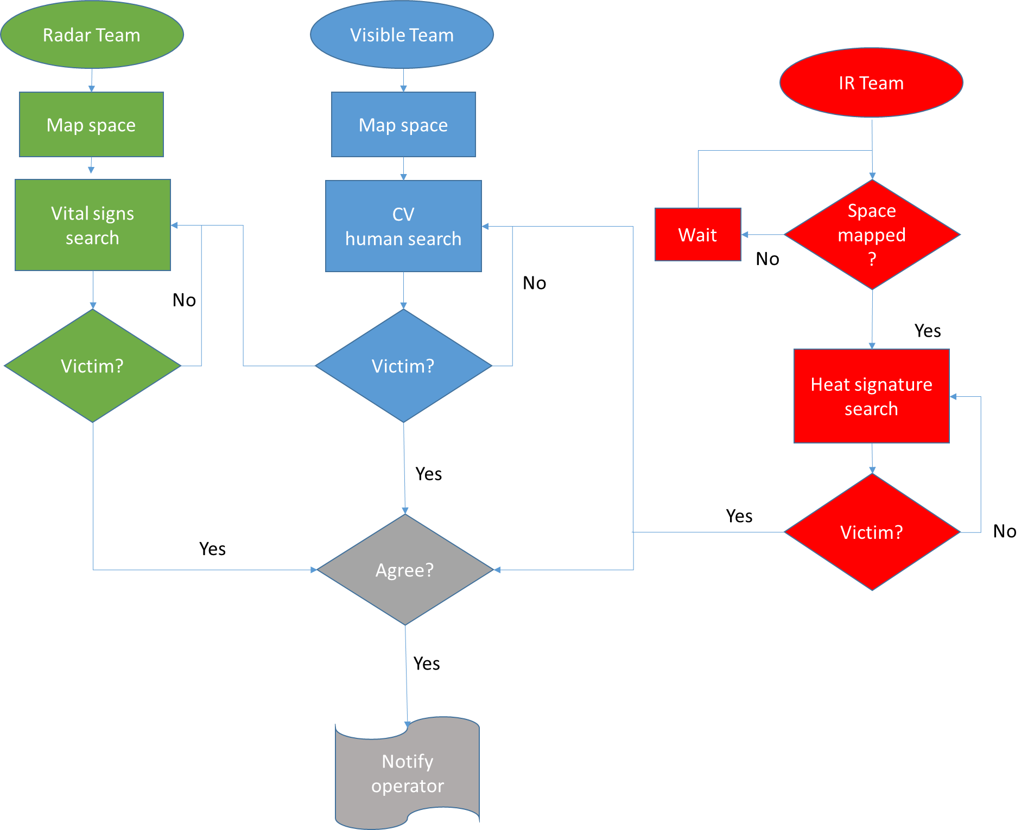

Figure 2 Example search algorithm flowchart

For this initial iteration, there are three teams of unmanned ground vehicles (UGVs) (four-wheel drive robots), although the same approach could use a combination of unmanned aerial vehicles and UGVs. Robot-robot and robot-operator communication will be accomplished by ZigBee (http://www.zigbee.org/en/index.asp). Additionally, intra-robot distances can be measured via received signal strength indication (RSSI) as in [4]. If available, RTK GPS can be used to provide absolute coordinates, though this may not always be reliable in a deeply buried space.

The tasks of the teams consist of: first, mapping the space; second, locating potential victims; finally, confirming the health status of the victims. The mapping function is initially performed by the vision team, using two broad strategies. In the well-studied field of swarm robotics, the first strategy is known as “collective exploration,” in particular, area coverage and swarm-guided navigation, similar to the behavior of ants or bees [5]. Agents act to maximally cover the space and map it out. This has been accomplished previously with pre-deployed sensor nodes [4,6]. In our case, by combining computer vision from multiple camera-equipped UGVs, we can achieve stereoscopic vision, effectively creating a three-dimensional map of the interior space. The computational load is well within the capabilities of the Jetson (www.nvidia.com/object/jetson-tk1-embedded-dev-kit.html). Additionally, radar can be used to map the space, as in [7]. This offers redundancy and the ability to see glass. Combined with RSSI, area coverage is achieved without pre-deployed nodes.

In the second step, the goal is localization of victims. There are six possible scenarios: unobscured victim, partially obscured victim, and fully obscured victim; the victim may be alive or dead. In all three scenarios with a living victim, cries for help may be detected through audio. If the victim is fully or partially visible, the now area-covered robots can use computer vision to detect them [8], perhaps using the recently developed and extremely powerful technique of convolutional neural networks [9]. The thermal imaging team uses the interior map established by the vision team to locate victims by body heat, a well-established technique in search and rescue robotics [10].

At this step, the teams act in the swarm behaviors of “aggregation” and “consensus forming” [5]. Potential victims are surrounded by UGVs from all three teams. It would be undesirable for all agents to surround one victim and cease searching, so the technique of probabilistic finite state machines (PFSM) [11] can be used to permit some robots to randomly continue the search effort. Computer vision, thermal imaging, and vital signs radar can be used simultaneously to confirm the presence and health of a victim using data fusion [12]. Most important among these is vital signs radar, a long established technique for measuring heartbeat and respiration using radar. Recent advancements allow for chip-scale radar systems, as well as cancellation of random body movements and vibration motion cancellation of the platform [13, 14]. Using the information from the vision and thermal teams, the radar agents can optimally position themselves for measurements. These measurements can be relayed to a remote human operator.

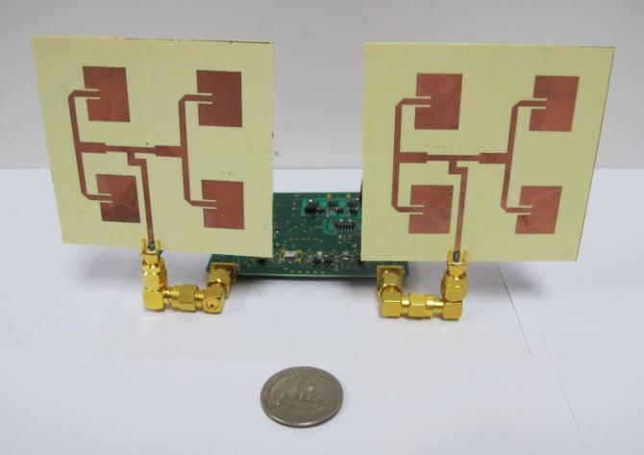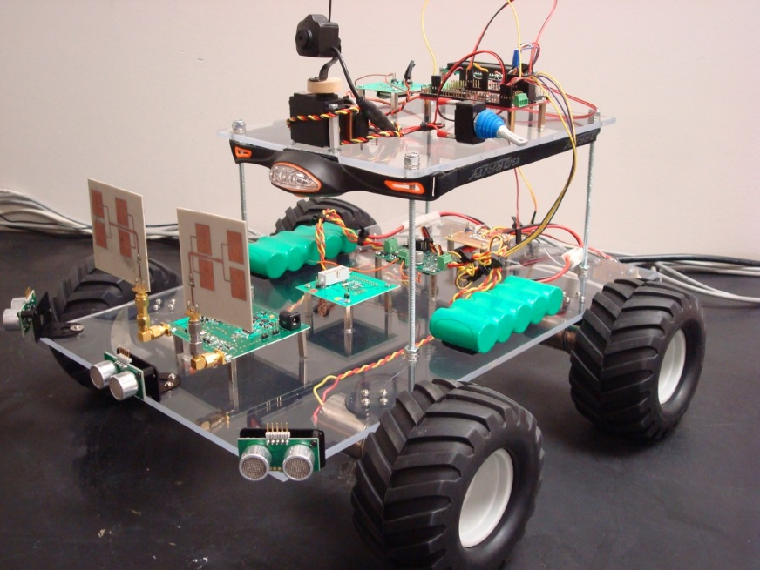

Figure Prototype vital signs systems developed at UF

The development and testing process consists of modular chassis design, computer vision system programming, thermal infrared programming, vital signs radar implementation, swarm programming, and testing. A single off-the-shelf four-wheel drive chassis with servo control and a pan-tilt platform would serve as a common platform for all three teams. A powerful single-board computer, such as the Jetson, may be used as the computational platform for all three. Communications may be realized by ZigBee or Bluetooth LE. Inexpensive digital cameras without IR filters allow vision in dark environments and thermal imaging systems exist, and our labs have extensive experience in the design and construction of vital signs radar systems (see Figure 3). As an initial test, the technique may be tested in a lab environment using increasingly difficult circumstances, in terms of level of obscured human targets.

4. Differentiation

While we use techniques that individually have been explored previously, no system has incorporated these techniques simultaneously. Cooperative UAV and UGV search teams have been demonstrated in [14,15], but lack the advanced sensor implementation we propose. Swarm behaviors have been demonstrated in robots [5], but rely on previously deployed sensor nodes. Vital signs radar, thermal imaging, and computer vision for human detection and navigation have all been developed [16,10,8], but not on mobile teams of small robots in a search-and-rescue capacity, working in teams as proposed. Commercial search robots are bulky, power-intensive, and remotely operated (from Inuktun, and iRobot, for example [2]). In short, this proposal is for a novel implementation of existing technologies, exploiting recent advances in all fields. It is anticipated that new algorithms of search-and-rescue swarm robots will be developed from this research.

5. Personnel/resources

The Radio Frequency Circuits and Systems Research Lab, led by Prof. Jenshan Lin and Prof. Joaquin Casanova, is equipped with RF/Microwave/mixed-signal test instruments and accessories. The lab is also equipped with computers with popular EDA tools (Agilent ADS, ANSYS Ansoft, Cadence) for designing RF wireless circuits, antennas, and systems.

The lab has an extensive array of test equipment, including the following major research instrumentations:

* Millimeter-Wave Vector Network Analyzer: 110GHz.
* Millimeter-Wave Spectrum Analyzer: 50GHz, extended to 325GHz with external mixers.
* RF Signal Generator: 250kHz-40GHz, +15dBm output power.
* RF Spectrum Analyzer: 9kHz-26.5GHz.
* Digital Sampling Oscilloscope: DC-26.5GHz.
* Phase Noise Analyzer: DC-26.5GHz, expandable to millimeter-wave and higher with external mixer.
* Cascade Semi-automatic RF Probe Station: capable of on-wafer testing of RF devices.

In addition, the following three research service centers in College of Engineering provide state-of-the-art fabrication facilities and analytical instruments. They can be used on hourly fee basis:

Nanoscale Research Facility (NRF) [https://nrf.aux.eng.ufl.edu](https://nrf.aux.eng.ufl.edu/)

Major Analytical Instrumentation Center (MAIC) [https://maic.aux.eng.ufl.edu](https://maic.aux.eng.ufl.edu/)

Particle Analysis Instrumentation Center (PAIC) [http://maic.aux.eng.ufl.edu](http://maic.aux.eng.ufl.edu/)

Dr. Changzhi Li’s research group at Texas Tech University is located in a fully ESD-protected Microwave and Analog Circuits Laboratory. The following major equipment is available for use in this project:

* HP Agilent 8722ES Network Analyzer (40 GHz)
* HP 83630A Synthesized Sweeper (26.5 GHz)
* ZABER KT-NA08A50 Linear Actuator
* Rohde & Schwarz FSU26 Spectrum Analyzer (26 GHz)
* Rohde & Schwarz SMR20 Microwave Signal Generator (20 GHz, with B25 built-in upconverter for 40 MHz to 6 GHz digitally modulated IF signals option)
* Rohde & Schwarz AMIQ I/Q Modulation Generator
* Rohde & Schwarz CMU200 Universal Radio Communication Tester
* Agilent Technologies MSO9254A Mixed Signal Oscilloscope
* APS Dynamics Long-Stroke Shaker
* National Instruments PXI with PXIe-8133 Controller, PXIe-5663 Vector Signal Analyzer, PXIe-5673 Vector Signal Generator, PXIe-5630 Vector Network Analyzer
* National Instruments PXIe-8135 Controller, PXIe-5645R Vector Signal Transceiver, PXI-4130 Power SMU

The following major software will be used in the proposed project:

* AWR Microwave Office
* Cadence Virtuoso IC Design Tool
* Calibre DRC and LVS Tools
* Advanced Design System
* MATLAB
* LabVIEW

Texas Tech University and Dr. Li’s research group have licenses to access all of these software tools. The research group is part of the Electrical and Computer Engineering Department at the Texas Tech University. The infrastructure and equipment of the department (electronic shop, secretarial and accounting support) will be available for this project. Faculty and graduate students working on this project will be provided adequate office space. Dr. Li is a lead user of National Instruments, and receives continuous equipment donation and technical support from National Instruments and AWR.

6. Bibliography

[1] Guizzo, Erico. "Japan earthquake: Robots help search for survivors." IEEE Spectrum 3 (2011).

[2] Casper, Jennifer, and Robin R. Murphy. "Human-robot interactions during the robot-assisted urban search and rescue response at the World Trade Center." IEEE Transactions on Systems, Man, and Cybernetics, Part B (Cybernetics) 33.3 (2003): 367-385.

[3] Magnuson, Stew. "Search-and-Rescue Robots Needed, But Market Has Yet to Develop." National Defense Magazine. N.p., Oct. 2011. Web. 8 Sept. 2016.

[4] Ko, Albert, and Henry YK Lau. "Robot assisted emergency search and rescue system with a wireless sensor network." International Journal of Advanced Science and Technology 3 (2009): 69-78.

[5] Brambilla, Manuele, et al. “Swarm robotics: a review from the swarm engineering

perspective.” Swarm Intelligence 7 (2013): 1-41.

[6] Kantor, George, et al. "Distributed search and rescue with robot and sensor teams." Field and Service Robotics. Springer Berlin Heidelberg, 2003.

[7] Wang, Guochao, et al. "A hybrid FMCW-interferometry radar for indoor precise positioning and versatile life activity monitoring." IEEE Transactions on Microwave Theory and Techniques 62.11 (2014): 2812-2822.

[8] Moeslund, Thomas B., and Erik Granum. "A survey of computer vision-based human motion capture." Computer vision and image understanding 81.3 (2001): 231-268.

[9] Krizhevsky, Alex, Ilya Sutskever, and Geoffrey E. Hinton. "Imagenet classification with deep convolutional neural networks." Advances in neural information processing systems. 2012.

[10] Rudol, Piotr, and Patrick Doherty. "Human body detection and geolocalization for UAV search and rescue missions using color and thermal imagery." Aerospace Conference, 2008 IEEE. IEEE, 2008.

[11] Garnier, S., et al. “Aggregation behaviour as a source of collective decision in a group of cockroach-like robots.” In Lecture notes in artificial intelligence: Vol. 3630. Advances in artificial life (2005): 169–178. Berlin: Springer.

[11] Xiao, Lin, Stephen Boyd, and Sanjay Lall. "A scheme for robust distributed sensor fusion based on average consensus." IPSN 2005. Fourth International Symposium on Information Processing in Sensor Networks, 2005.. IEEE, 2005.

[12] Li, Changzhi, et al. "A review on recent advances in Doppler radar sensors for noncontact healthcare monitoring." IEEE Transactions on microwave theory and techniques 61.5 (2013): 2046-2060.

[13] Nakata, Robert, et al. "RF techniques for motion compensation of an Unmanned Aerial Vehicle for remote radar life sensing." 2016 IEEE MTT-S International Microwave Symposium (IMS). IEEE, 2016.

[14] Jennings, James S., Greg Whelan, and William F. Evans. "Cooperative search and rescue with a team of mobile robots." Advanced Robotics, 1997. ICAR'97. Proceedings., 8th International Conference on. IEEE, 1997.

[15] Bernard, Markus, et al. "Autonomous transportation and deployment with aerial robots for search and rescue missions." Journal of Field Robotics 28.6 (2011): 914-931.

[16] Gu, Changzhan, et al. "Instrument-based noncontact Doppler radar vital sign detection system using heterodyne digital quadrature demodulation architecture." IEEE Transactions on Instrumentation and Measurement 59.6 (2010): 1580-1588.