CTA 1

Joaquin Fox
Colorado State University Global
CSC475: Platform based development
Russell Frith
May 22, 2022

Screenshots

Step 1, figure 1: Build
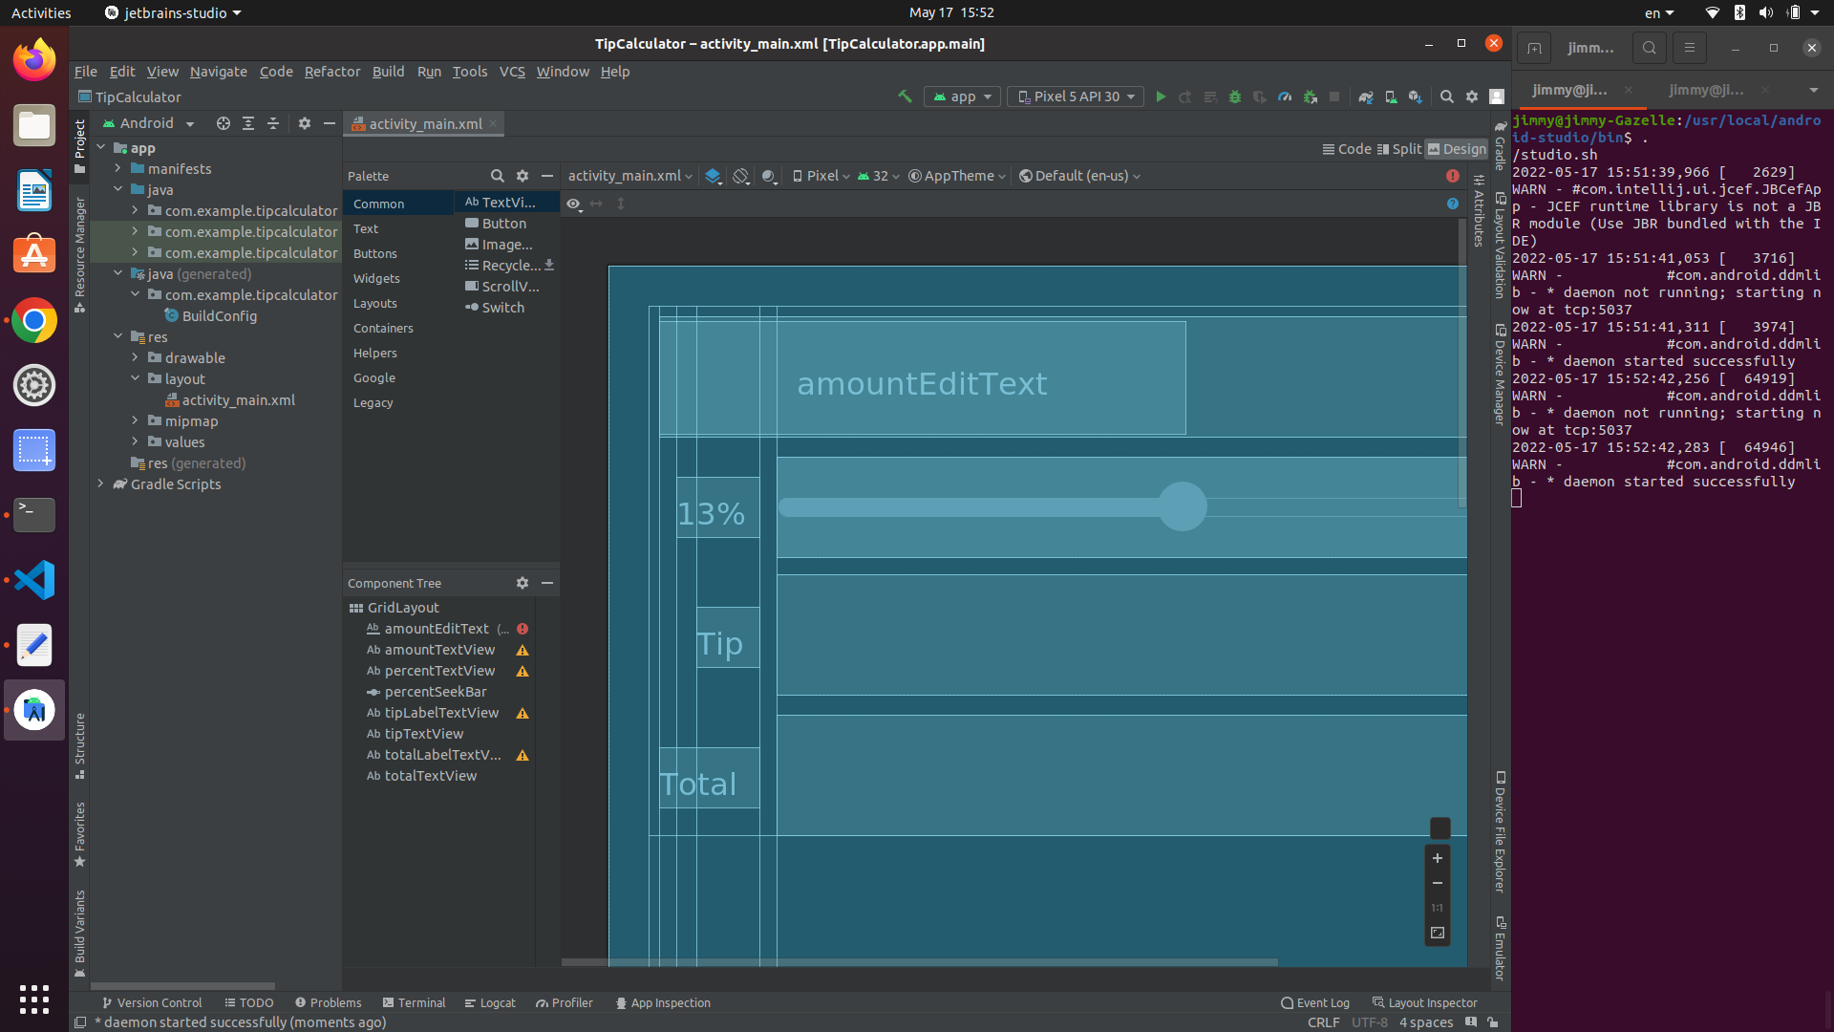

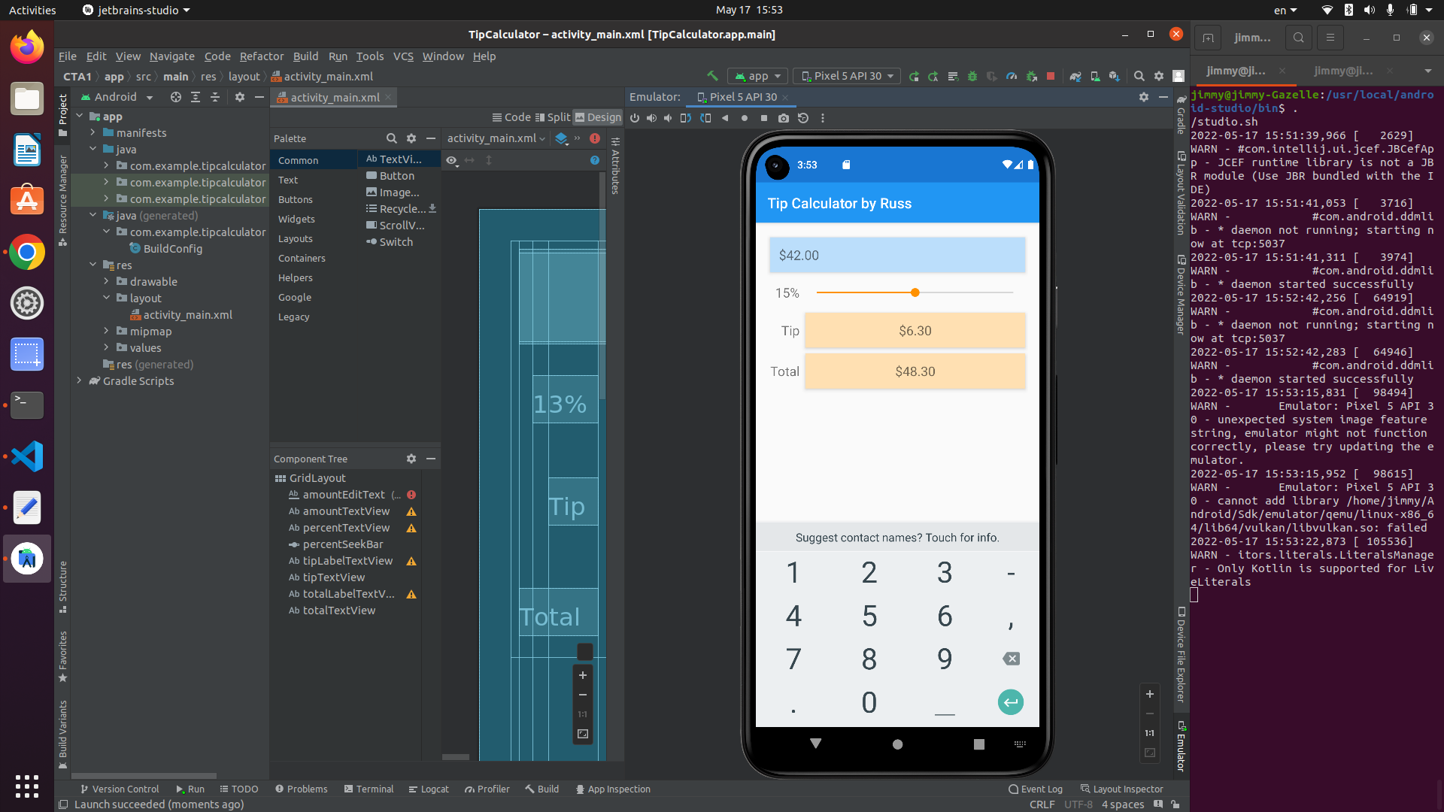
Step 2, figure 2: Emulator

