CTA 2

Joaquin Fox
Colorado State University Global
CSC475: Platform based development
Russell Frith
May 27, 2022

Screenshots
Figure 1: Build
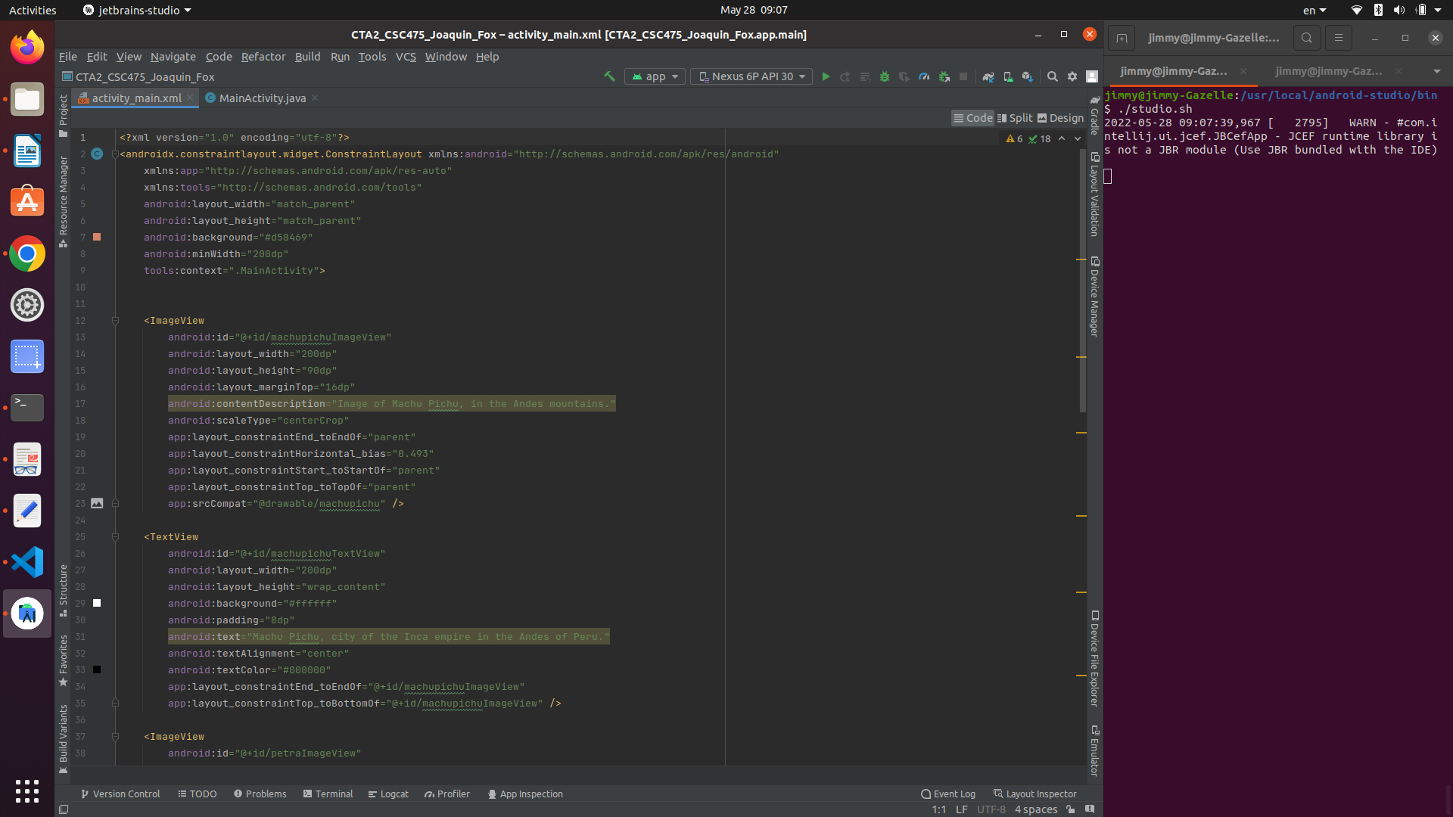
Figure 2: Run, code view
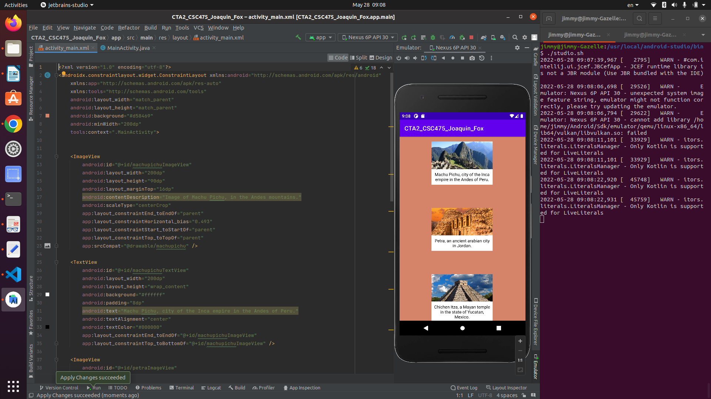
Figure 3: Run, design view
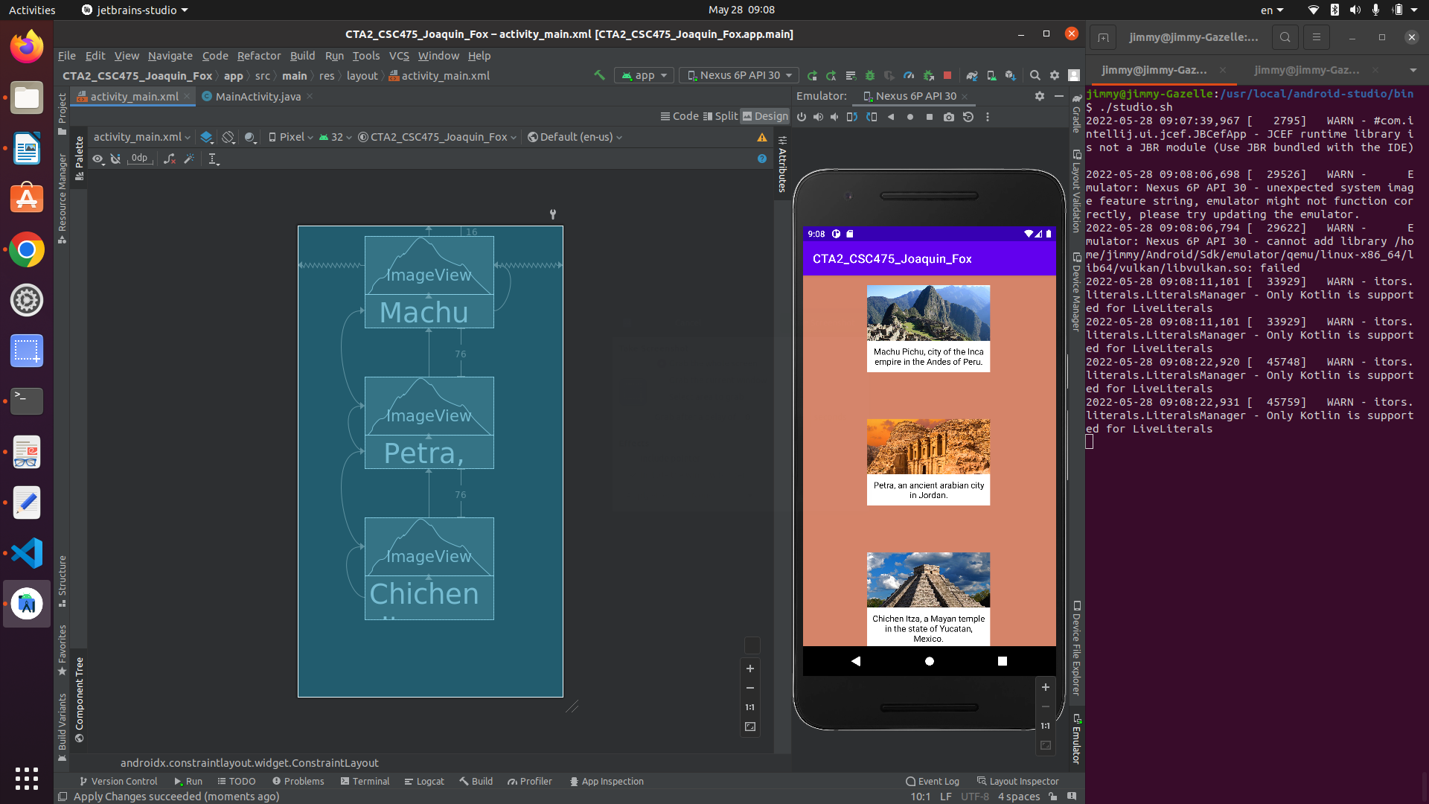

Discussion
CTA2_CSC475_Joaquin_Fox displays three landscape images with text elements. It uses a ConstraintLayout to position and display all visible components. The developments steps are outlined as follows:
- Open a new AndroidStudio project from the command line with ./studio.sh, and choose NewProject with a single, empty activity.
- Add three images to res/drawable.
- In code view, create three ImageView, and three TextView widgets.
- For the purpose of constraining view elements relative to each other, I give each element an id. Later, when working in design view, these id's will allow AndroidStudio to auto generate constraints. The id's are written in the form
android:id="@+id/machupichuImageView"
The "@" symbol tells the IDE to search in the resource file.
The "+" tells the IDE to add a new id, if an existing one is not found.
- In design view, I use the LayoutEditor to finalize the layout as follows:
  - First bind each TextView to it's corresponding ImageView. This makes the two views a single view group.
  - I chose the Machu Pichu view group to be the first element displayed. This element gets constrained to the top and sides of the view window. The side constraints have the effect of centering the view group.
  - The remaining view groups (for Chichen Itza and Petra) are then daisy chained onto the first one. This ensures that the second and third view groups will align to the first.
  - The top view group is given a top margin of 10dp and other elements are spaced vertically at 72dp.
  - A background color is written into the ConstraintLayout opening tag.
  - Content descriptions are added to each image for accessibility.
  - TextView elements are given padding of 8dp, and a good color contrast on a white background, for readability.

