CTA 3

Joaquin Fox
Colorado State University Global
CSC475: Platform based development
Russell Frith
June 5, 2022

Mortgage Calculator

Overview
The MortgageCalculator UI presents the user with three input fields for a home's purchase price, a down payment amount, and an interest rate. On clicking a large button the app then computes and renders a monthly payment for default loan terms of 10, 20 and 30 years. In addition a SeekBar slider widget lets a user pick a custom loan term. Doing so will invoke the onStopTrackingTouch() method of OnSeekBarChangeListener and a new payment will be calculated and rendered.

Screenshots
Figure 1: Build
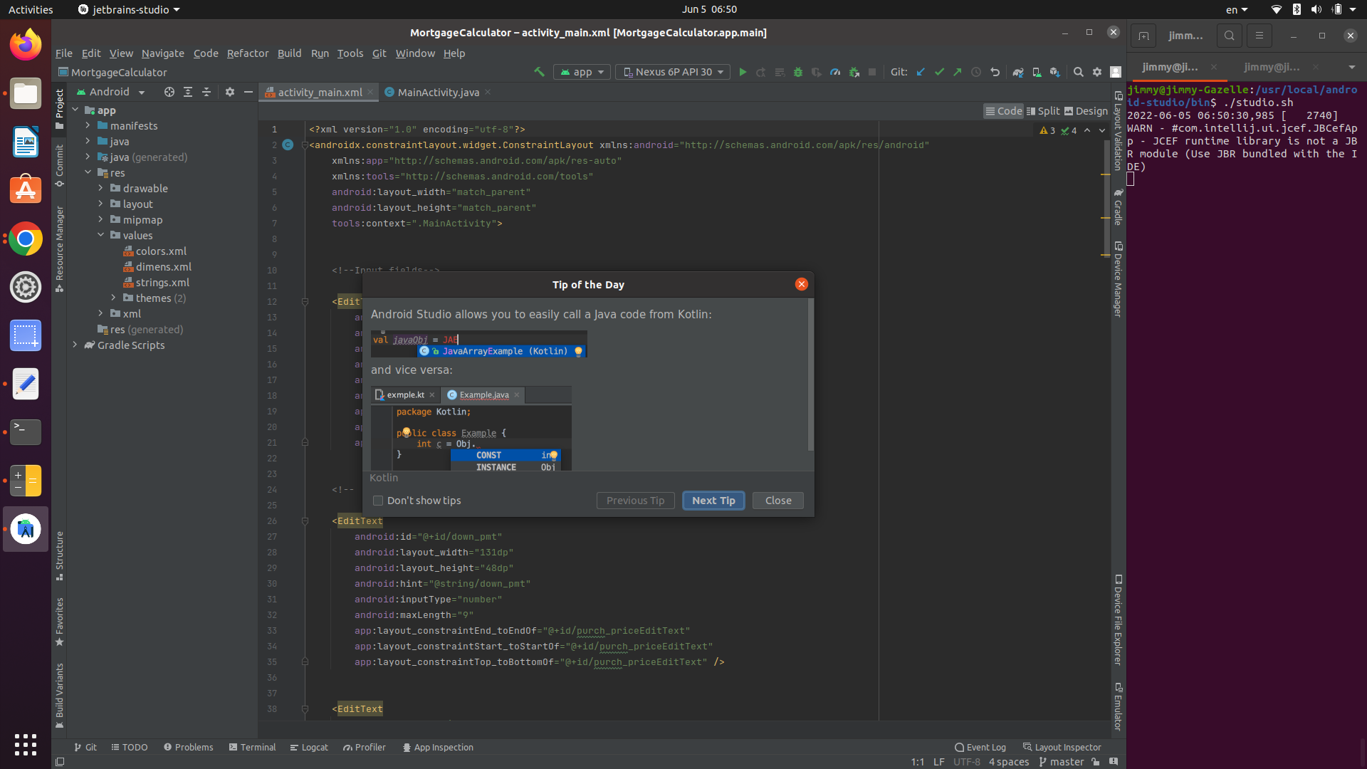

Figure 2:Run
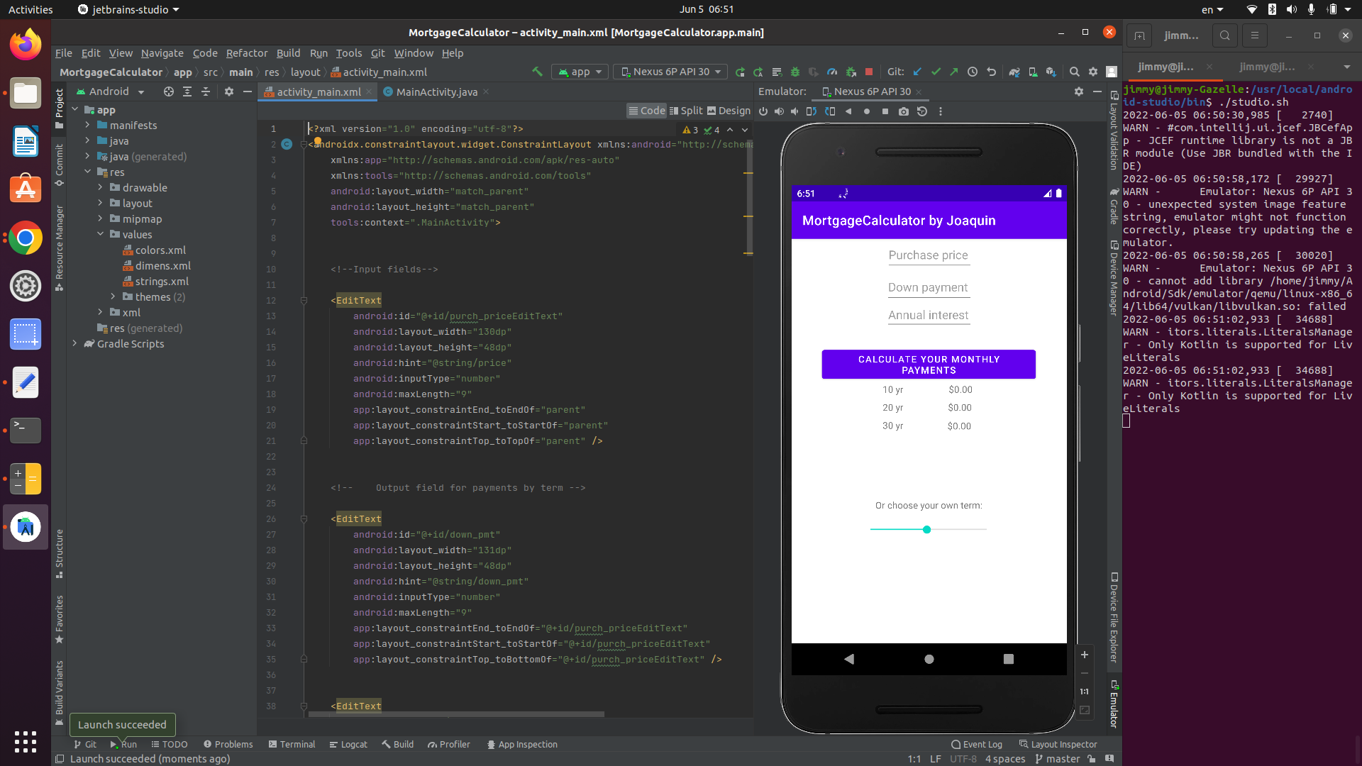

Figure 3: EditText and SeekBar event handler execution.
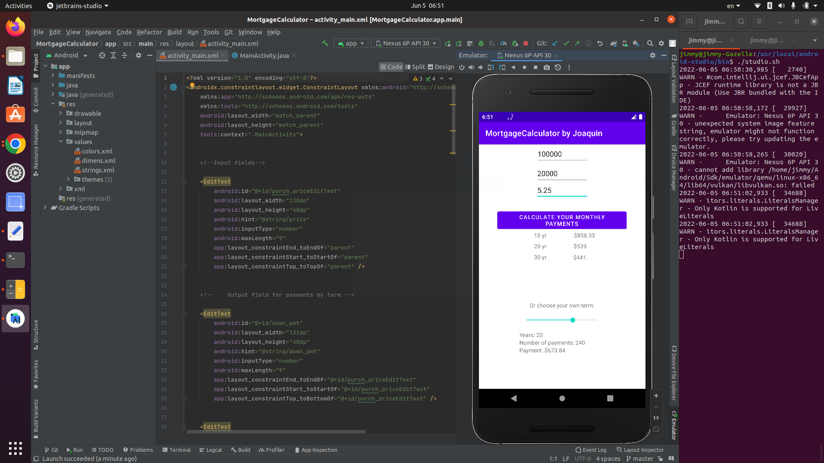

Figure 4: Data validation
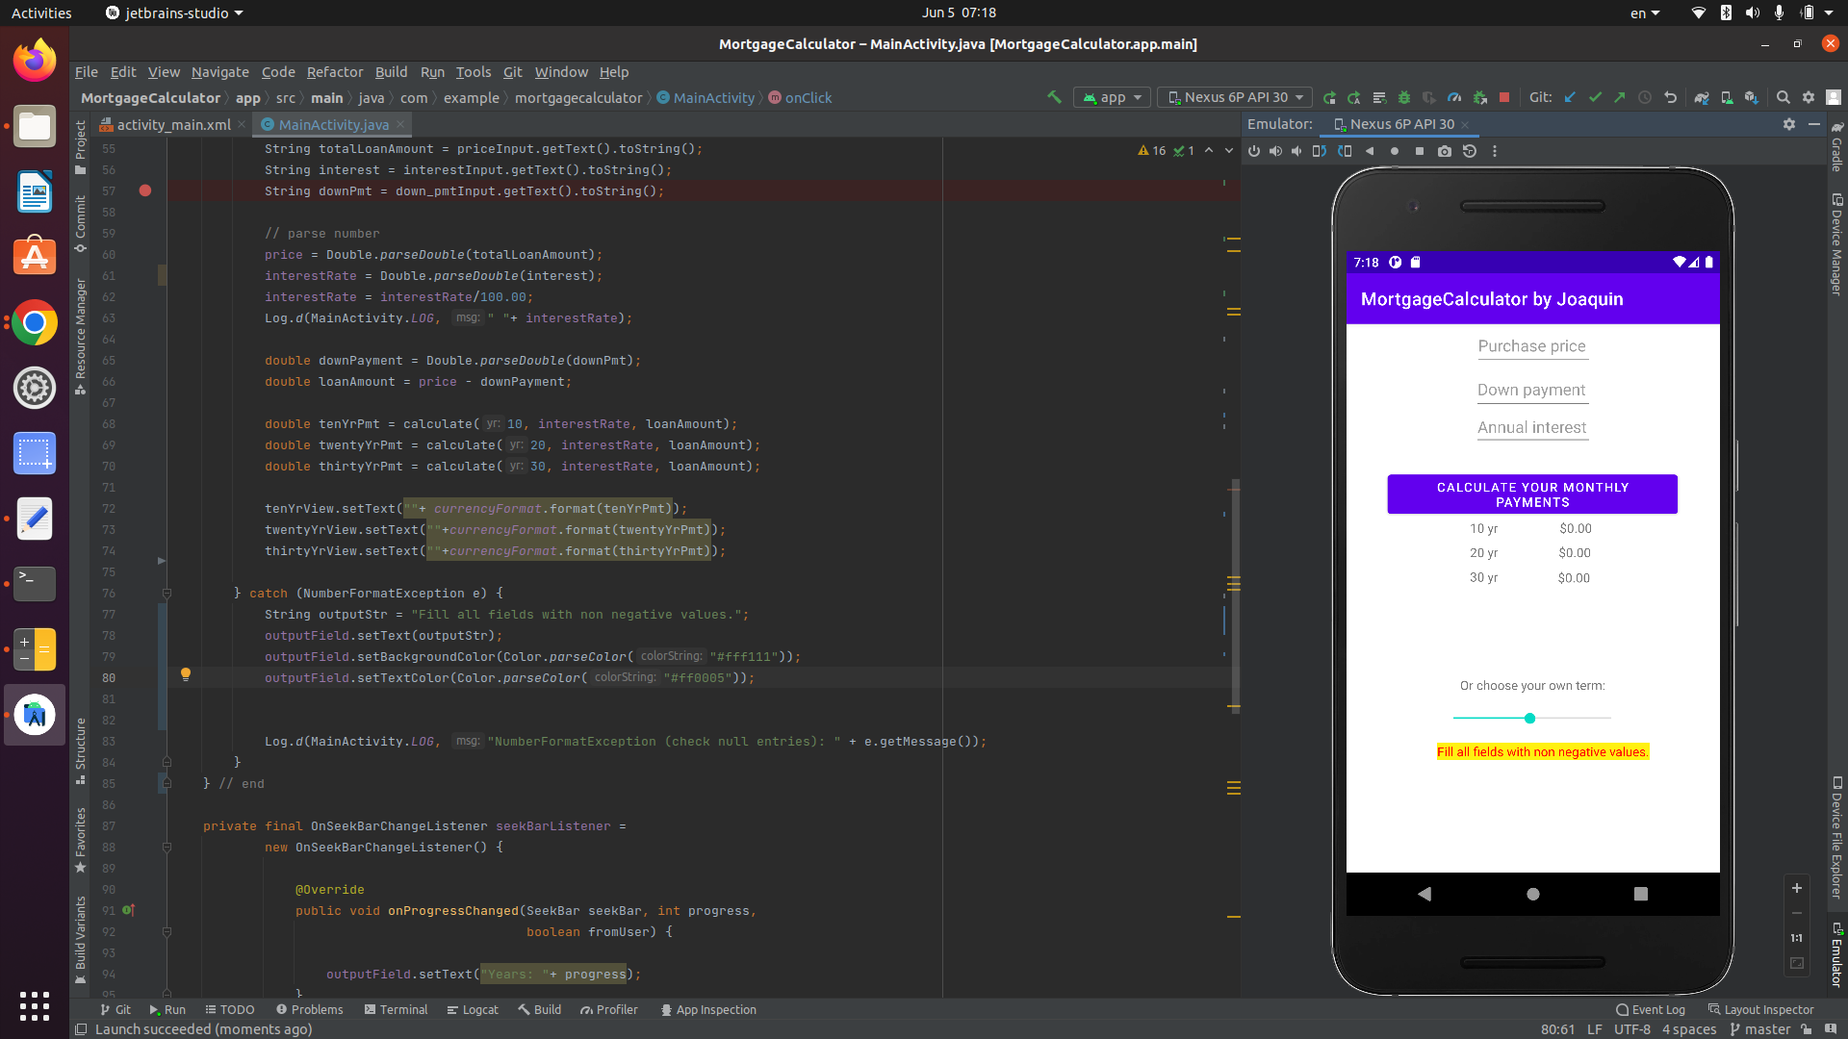
Discussion
The app uses constraintLayout to align components for user inputs, and messaging. EditText components are used to capture user inputs for dollar amounts and interest rate. Because the relevant calculation requires three inputs (price, down payment and interest rate), a button with an event listener is used to invoke calculate() when clicked.
Because a button click is used to initiate much of the program logic, I opted to implement the OnClickListener of class View, rather than a TextWatcher. An event listener is applied to the button element with
button.setOnClickListener(this);
The onClick() method can throw a NumberFormatException which, if thrown, is handled in a try - catch block. In the event an exception is thrown user message is generated and rendered with the text "Fill all fields with non negative values:
calculate() is called both by the onClick() method of the OnclickListener and also by the onStopTrackingTouch method of the OnSeekBarChangedListener.
Design flaws
As of this writing there are several design flaws I would improve or fix in an extension. I will discuss these flaws here.
When a user slides the SeekBar to a point and releases it, the onStopTrackingTouch method calls calculate() and passes it the current value of the SeekBar slider, and recycles the globally scoped attributes for interest rates and payment amounts. In the program flow, a user is likely to have populated those fields and so those values will be available. However, in the event that a user moved the SeekBar without populating the EditText fields, calculate() will return Nan.
If a user leaves an EditText field blank and click the main button, an exception is thrown and handled. In addition the catch block generates and renders a message to the UI informing the user of the error. This message is formatted to be visible, and that formatting is not cleared for the duration of the session.

