CT 1

Joaquin Fo
Colorado State University Global
CSC450: Programming III
Lawrence Meadors
March 22, 2022

Console application and bug fixes
Person.cpp contains a class Person that defines name and address fields along with accessor methods and a parametized contructor. main() uses I/O streams to initialize those fields with user inputs and then print summary information to the console.

Person
Figure 1: Person.cpp source code
#include <iostream>
#include <string.h>

using namespace std;
class Person
{
string firstName;
string lastName;
string address;
string city;
int zip;

public:
Person(string first, string last, string addr, string city, int zip) : firstName(first), lastName(last), address(addr), city(city), zip(zip){};
void setLastName(string last) { lastName = last; }
void setFirstName(string first) { firstName = first; }
void setAddress(string addr) { address = addr; }
void setCity(string city) { city = city; }
void setZip(int zip) { zip = zip; }
string getLastName()
{
return lastName;
}
string getFirstName()
{
return firstName;
}
string getAddress()
{
return address;
}
string getCity()
{
return city;
}
int getZip()
{
return zip;
}
}; // End

int main()
{
string firstName;
string lastName;
string address;
string city;
int zip = 45265;
cout << "Enter a first name: " << endl;
cin >> firstName;
cout << "Enter last name: " << endl;
cin >> lastName;
cout << "Enter address:" << endl;
cin.ignore();
getline(cin, address);
cout << "Enter city and zip : " << endl;
cin >> city >> zip;

Person bob(firstName, lastName, address, city, zip);

cout << endl
<< bob.getFirstName() << " " << bob.getLastName() << endl;
cout << bob.getAddress() << ", " << bob.getCity() << ", " << bob.getZip() << endl;
} // End

Figure 2: Screenshot, Person.cpp compiling
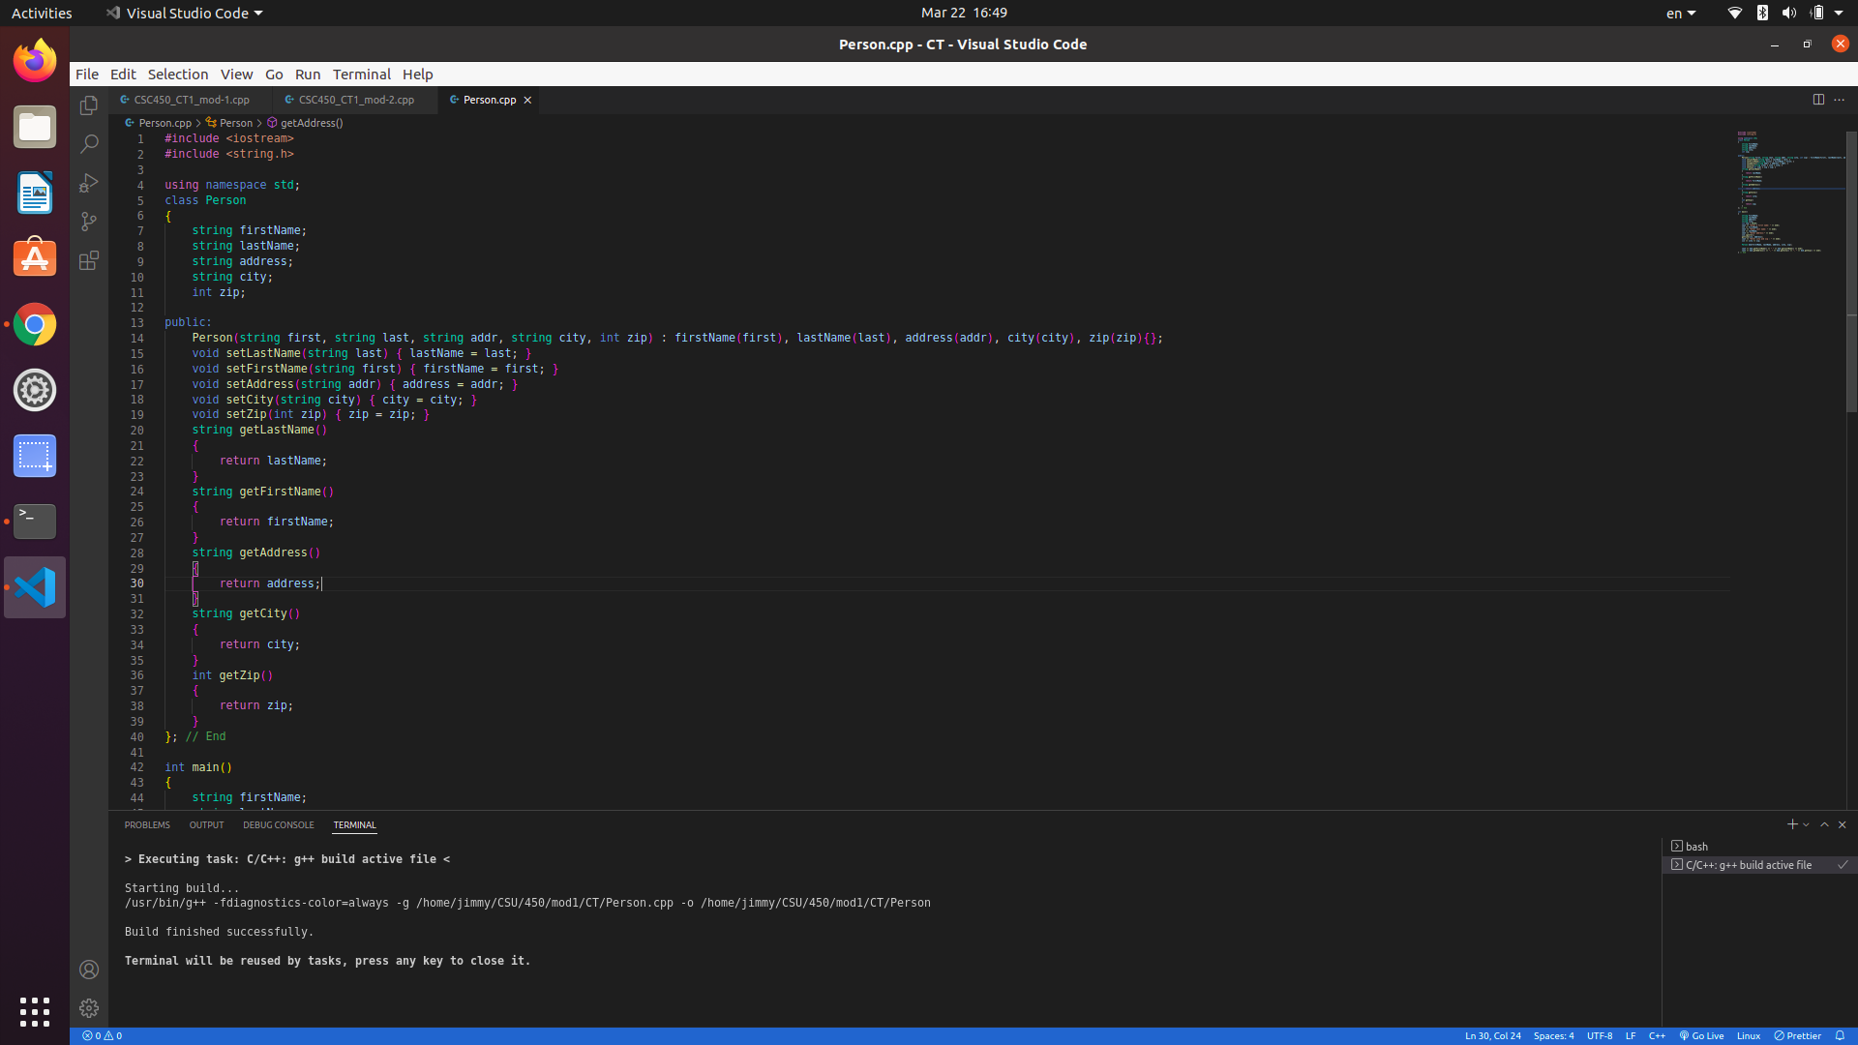

Figure 3: Person execution.
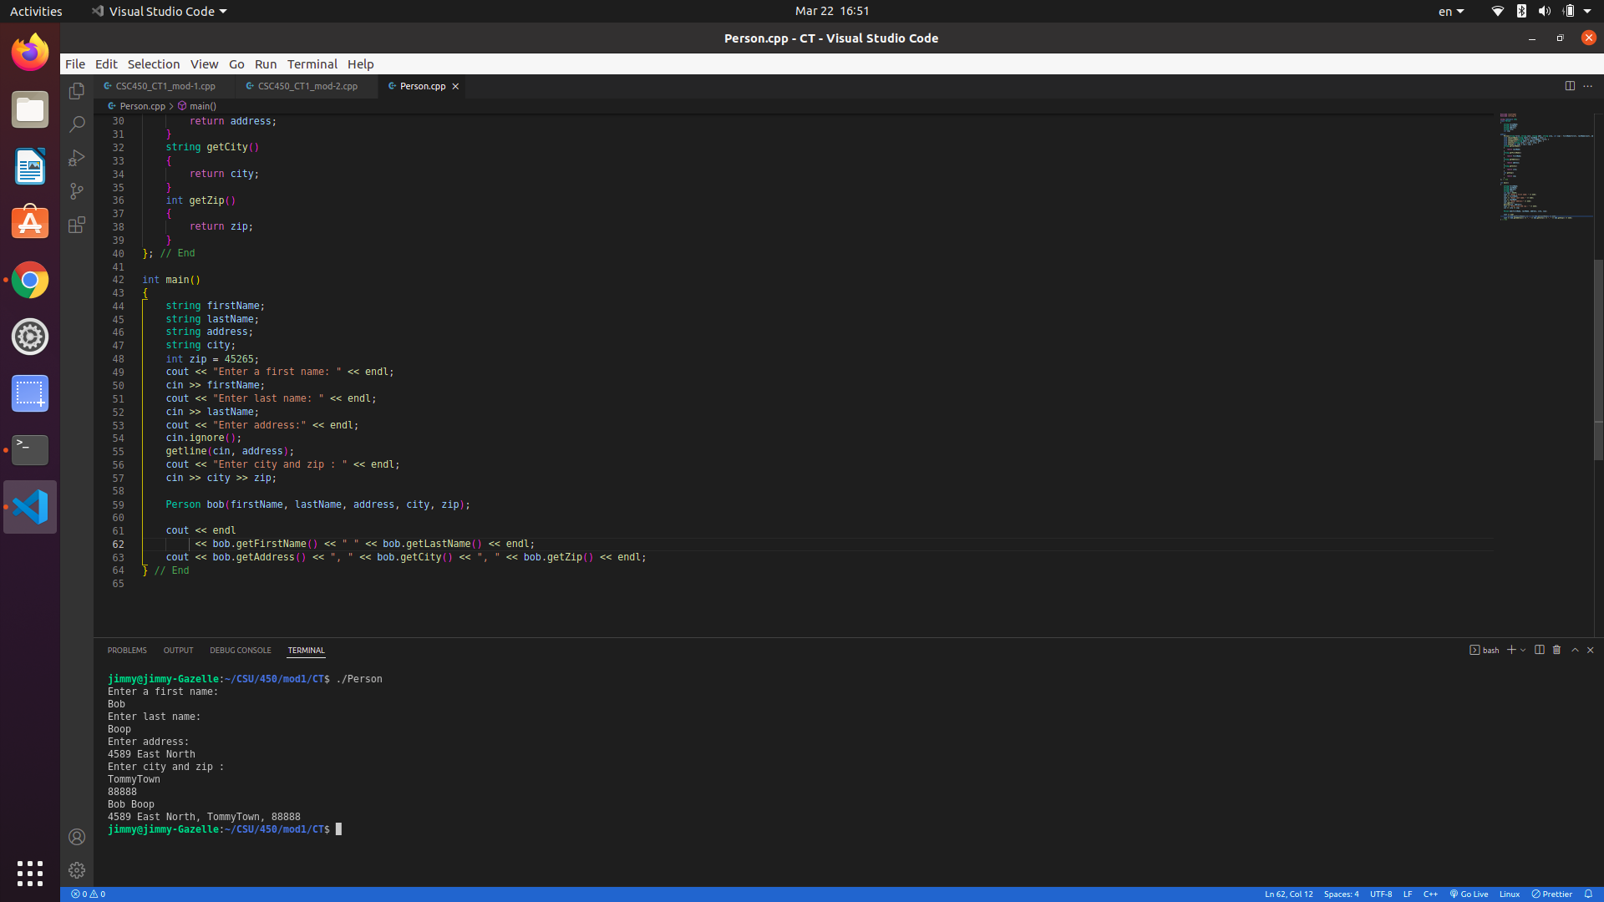

Figure 4: Console interface wtth output
Enter a first name:
Bob
Enter last name:
Boop
Enter address:
4545 West North
Enter city and zip :
Chicoogoo 77777

You entered:
Bob Boop
4545 West North, Chicoogoo, 77777
Bug fixes
Figure 5: CSC450_CT1_mod-1
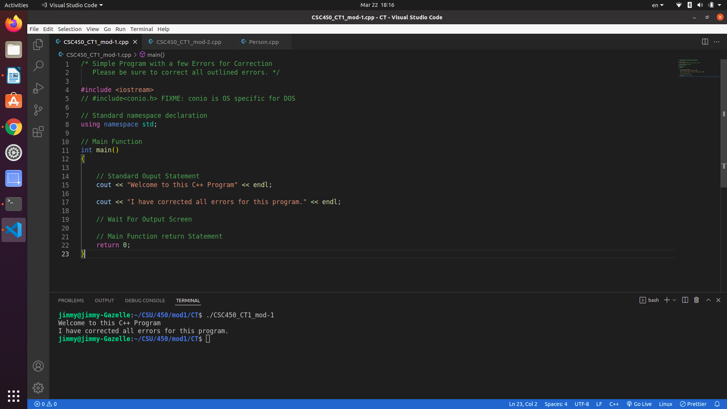

Figure 5: CSC450_CT1_mod-2
