CT 2, Option 1

Joaquin Fox
Colorado State University Global
CSC450: Programming III
Lawrence Meadors
March 29, 2022

Console application
File reverseString.cpp presents a console interface to get user string inputs and then prints these inputs in reverse.

Program analysis
In this module we have focused on the security vulnerabilities posed by strings, in C++. Those vulnerabilities are grouped by SEI into four broad categories (Ballman, Aaron. 2016). Here I discuss these categories as they relate to reverseString.cpp.

STR50 Guarantee storage.
This vulnerability is mostly addressed by using the basic_string class which, according to Ballman, addresses most of the buffer overflow, and truncation problems associated with improper handling of character arrays.

Mitigation: All strings are of class string , which implements basic_string. In this code I do not mix string types because of unintended behaviors that can arise as a result.

STR51 Do not create a string form a null pointer.
This vulnerability relates to the std::string implementation, which inherits from std::char_trait. Any string methods that implement char_trait can result in a buffer overflow and lead to associated exploits.

Mitigation: I use pointers to the user inputs and store these in string array. The pointers are generated inside of a do-while loop and because of this it would be possible for an empty user entry to be associated with the pointer. If that pointer was later de-referenced and assigned to a string variable, it would cause this scenario. I use an assert to enforce non - null entries.

Figure 1: Mitigating Null pointer vulnerabilities
do
{
string *ptr;
counter == 0 ? cout << "Enter a string: " : cout <<
"Enter another string: ";
getline(cin, input);
assert(input.length() > 0);
input = reverseStr(input); // reverse the user input
ptr = &input; // assign input location to a
pointer
stringArr[counter] = *ptr; // store the pointer in an
array
counter++;
} while (counter < 3);

STR52 Use valid references, pointers and iterators to reference elements of a basic_string
My program has real potential to violate this standard, because the method getline()
invalidates the pointer (SEI CERT, 6.3.1).
Mitigation: What I have tried to do is to update the pointer values at each call to getline() so that the invalidated pointer is never accessed, as demonstrated in SEI CERT, 6.3.2.

STR53 Range check element access
Mitigation: I match the iterations through the while loop to the length of the array.

Figure 2: Build
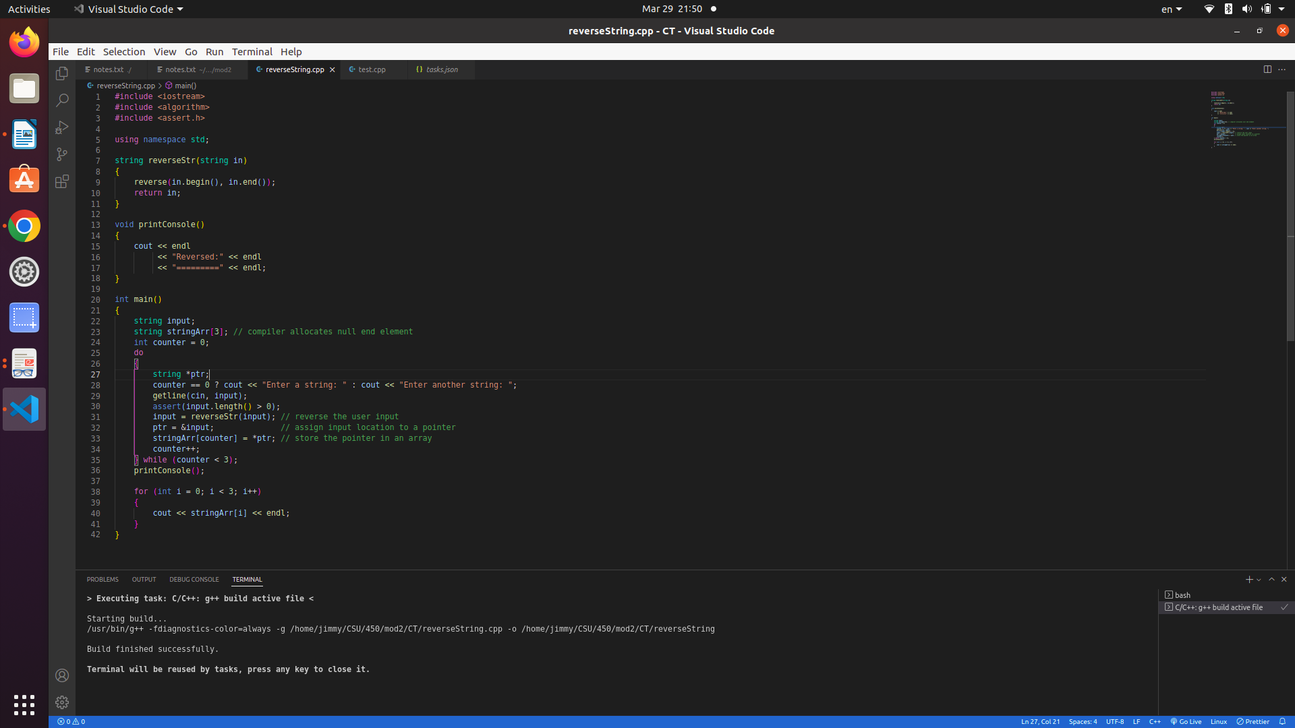

Figure 3: program execution
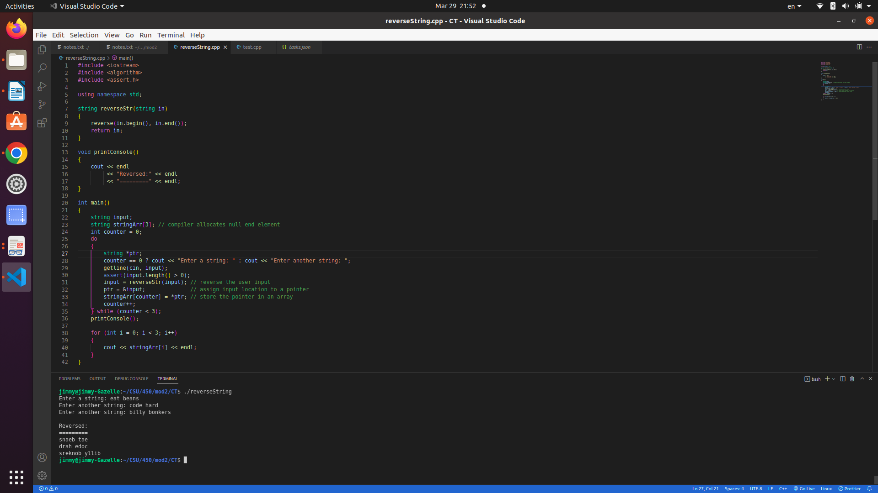

Figure 4: source code
#include <iostream>
#include <algorithm>
#include <assert.h>

using namespace std;

string reverseStr(string in)
{
reverse(in.begin(), in.end());
return in;
}

void printConsole()
{
cout << endl
<< "Reversed:" << endl
<< "=========" << endl;
}

int main()
{
string input;
string stringArr[3]; // compiler allocates null end element
int counter = 0;
do
{
string *ptr;
counter == 0 ? cout << "Enter a string: " : cout << "Enter another string: ";
getline(cin, input);
assert(input.length() > 0);
input = reverseStr(input); // reverse the user input
ptr = &input; // assign input location to a pointer
stringArr[counter] = *ptr; // store the pointer in an array
counter++;
} while (counter < 3);
printConsole();

for (int i = 0; i < 3; i++)
{
cout << stringArr[i] << endl;
}
} // End

References
Ballman, Aaron. 2016. SEI CERT C++ Coding Standard. Chapter 6.

Seacord, Robert. 2013. Secure Coding in C and C++.

