CT 3, Option 1

Joaquin Fox
Colorado State University Global
CSC450: Programming III
Lawrence Meadors
April 6, 2022

Pointers
File mod3CT.cpp presents a console interface for user inputs, obtains 3 integers, and then assigns pointers to each of these. Heap space is then allocated for each input, the heap address is printed for demonstration, and the heap is cleared.

Implementation
The following lines declare integer variables and pointers to those variables:
int num1, num2, num3;
int *pnum1 = &num1, *pnum2 = &num2, *pnum3 = &num3;

These variable locations are referenced and de-referenced to print the target outputs.

Variables are allocated stack memory by default. To allocate heap memory I use the keyword new() as follows:
pnum1 = new int(num1)

As a final step I de-allocate heap memory with delete(pnum1);

Dynamic allocation to the heap is carried out in a try - catch block, to handle exceptions of type bad_alloc. A second catch block is in place to handle any other exception types that might occur.

Program analysis

The "*" and "&" operators of the pointer type allow the use of aliases for variables and objects, reducing space time complexity and improving overall performance (Backman, 2015). These operators are especially useful for tasks such as allocating dynamic space (heap space), exception handling, instantiating large objects and passing arguments generally.

SEI CERT Coding Standard MEM describes vulnerabilities related to pointer operations. Several of these could potentially affect my program as I will discuss in this section.

MEM50, Do not access freed memory describes attempts to access locations that have been de-referenced. This might come about if I were to do the following:

delete pnum1, pnum2, pnum3;
cout << pnum1;

In practice, my compiler warns me if I try this, though it does allow me to compile and execute the program. For compliance I do not read or write to de-allocated pointers.

MEM51, Properly de-allocate dynamically allocated resources describes methods to free resources in C++, namely delete(). Failure to do so can lead to undefined behavior and exploitable vulnerabilities (SEI CERT. 7.2.19).

MEM52, Detect and handle memory allocation errors, relates directly to the new() operator. My program wraps the dynamic allocation in a try - catch block specifically to catch the bad_alloc exception that can result. This exception is a catch all for any problem that arises in trying to place data in the heap.

MEM53 describes manually allocating dynamic memory, by invoking one of the C methods. This is not recommended and I do not manually allocate memory. Instead I use the operators new()and delete() which are compliant.

MEM54 describes allocating dynamic memory that is the wrong size or type, as illustrated here:
short s;
long *lp = ::new (&s) long;

I allocate heap space for the same variable type as referenced by my pointers, and so there is consistency in the memory spaces declared. This should make my code compliant with this guideline.

Other guidelines seem less relevant, or describe methods I do not use (such as smart pointers).

Conclusion
in C++, pointer operations are important to several programming tasks, including exception handling, object instantiation, and dynamic memory management. SEI CERT Chapter 7 describes associated vulnerabilities. With these in mind, I have tried to write compliant code by following recommended practices:
- Watching for and handling exception type bad_alloc, in a try - catch expression.
- Not accessing de-allocated memory.
- Using the new() and delete() operators to properly allocate and de-allocate heap memory.

Figure 1: Build
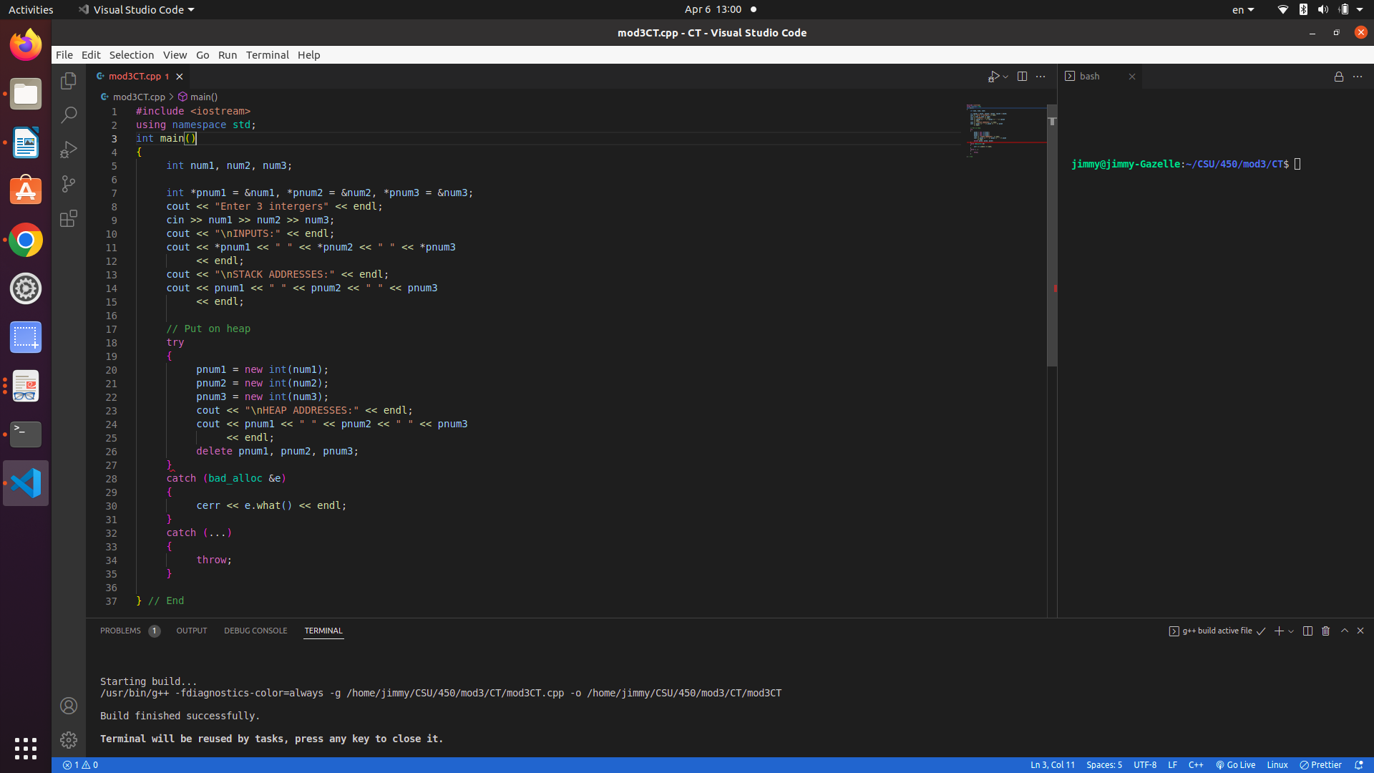

Figure 2: program execution
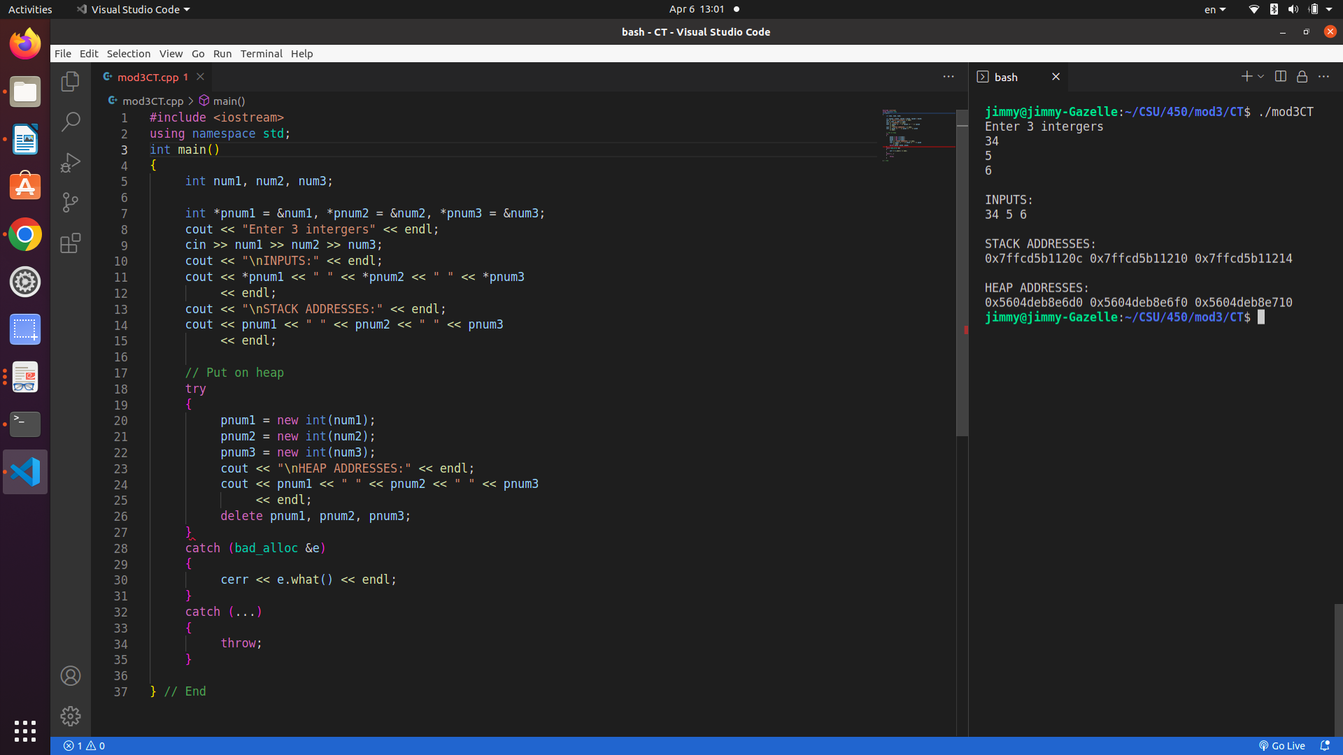

Figure 3: source code
#include <iostream>
using namespace std;
int main()
{
int num1, num2, num3;

int *pnum1 = &num1, *pnum2 = &num2, *pnum3 = &num3;

cout << *pnum1 << " " << *pnum2 << " " << *pnum3
<< endl;
cout << "\nSTACK ADDRESSES:" << endl;
cout << pnum1 << " " << pnum2 << " " << pnum3
<< endl;

// Put onto heap
try
{
pnum1 = new int(num1);
pnum2 = new int(num2);
pnum3 = new int(num3);
cout << "\nHEAP ADDRESSES:" << endl;
cout << pnum1 << " " << pnum2 << " " << pnum3
<< endl;
delete pnum1, pnum2, pnum3;
}
catch (bad_alloc &e)
{
cerr << e.what() << endl;
}
catch (...)
{
throw;
}

} // End

References
Ballman, Aaron. 2016. SEI CERT C++ Coding Standard. Chapter 7.
GeeksForGeeks (2021). Stack vs. heap memory allocation
https://www.geeksforgeeks.org/stack-vs-heap-memory-allocation/
Bäckman, Kjell . 2015. Structured Programming with C++.

