CT 4, Option 1

Joaquin Fox
Colorado State University Global
CSC450: Programming III
Lawrence Meadors
April 13, 2022

Employee Salary Calculator
File main.cpp calculates total weekly earnings for an employee given inputs for time (total weekly hours worked) and a pay rate (dollars per hour). After prompting the user for inputs, the program then calculates and prints a formatted table with the following outputs:
- Regular hours: Hours worked not in excess of 40.
- Regular earnings: (pay rate) x (regular hours).
- Overtime hours: hours worked in excess of 40.
- Overtime earnings: (overtime hours) x (pay rate) x 1.5.
- Total earnings: (regular earnings) + (overtime earnings)

Special attention is paid to security compliance in handling numeric data, heap space and pointer types.

Implementation.
Variables of type double are declared for needed values and each variable is paired to a pointer. The pointers are allocated heap space with the new() operator, and assigned memory locations with the reference operator "&".

The user is prompted to enter hours worked and a pay rate. Inputs are validated with an assertion, to ensure only positive entries for time and rate. The pointers are de-referenced with the inputted values as well as default values of 0 for overtime, and regular time. This is accomplished inside of a try - catch block. The catch block is used to handle a standard exception of type bad-alloc, which can be thrown in the event of a lack of adequate heap memory (Learn C++. 2022. 11.11 Dynamic memory allocation with new and delete).

A wage calculation block breaks the hours input down into overtime and regular hours and then computes the needed outputs.

To format the output the program makes use of several methods of class iomanip including setprecision(), setiosflags(), and setw().

Before exiting, the program deletes heap space and references all pointers to nullptr.

Security.
The potential for security vulnerabilities in this program fall into one of two categories:
- Vulnerabilities related to the allocation of heap space.
- Vulnerabilities related to operations with numeric values.
Heap space.
C++ allows us to interact directly with heap space, an ability not available to most other languages. This allows us to preserve the relatively scarce stack memory for static, global and local variables and for function parameters. When a program receives as an input a value of unknown size, and which could potentially be large, the best practice is to allocate heap space, which is relatively scarce when compared to stack space (Learn C++. 2022 ).
The allocated space has to be manually freed. Failure to do so leads to dangling pointers and memory leaks, with resulting undefined behavior an potential program crashes. This vulnerability is described in section 7 of the SEI CERT under MEM50.
A related vulnerability can arise when there is no heap space left to allocate, in which case an exception type bad_alloc will be thrown. Failure to handle the exception is a security vulnerability described in SEI CERT ERR58, Handle All Exceptions.

Mitigation: I allocate dynamic memory in a try block and handle any resulting exceptions in the catch block.

Numeric values.
Security vulnerabilities with numeric types in C++ relate to the fixed byte sizes of these types ( primitive types have fixed sizes). In C++ it is possible to blow up a numeric type with a resulting buffer overflow, and all the consequences of uncontrolled memory access. Here is an example of an integer overflow:

int max = 2147483647;
cout << max*2;
// -2

Mitigation: In using a type double the program ensures a large enough variable type, given that the inputs are weekly hours worked and a rate of pay. As a logic test I enforce that hours entered and pay rates be positive values. This is done wth assertions, as in

assert(hours > 0.00 && "Hours must be a positive number.");

After deleting the pointers, and freeing heap space, I take the additional step of referencing the pointers to nullptr.

Conclusion
C++ has characteristics that pose unique security considerations. First, the language allows for direct manipulation of both stack and heap memory. Second, the language does not automate memory management with garbage collection. Third, the language provides few guardrails during compilation to warn the programmer of vulnerabilities related to improper memory management. The compiler will however throw checked exceptions under certain circumstances, and these can be used by a programmer as a security check on certain operations. Otherwise, C++ requires that the programmer be alert to vulnerabilities. The C++ programmer uses exception handling methods, data validation checks and an understanding of type behaviors to mitigate risks.
Allocating dynamic memory poses a unique security concern in that it exposes data outside of the stack. Because heap space is abundant relative to stack space, is used in situations where a program receives inputs of an unknown size. While this conserves limited stack space, and can prevent a stack overflow, heap space however, has to be managed manually in C++, as the language does not automatically free heap space after is has been used. Failure to do so can lead to a situation where more and more heap space is consumed by subsequent program executions. This is a memory leak.

Figure 1: Build
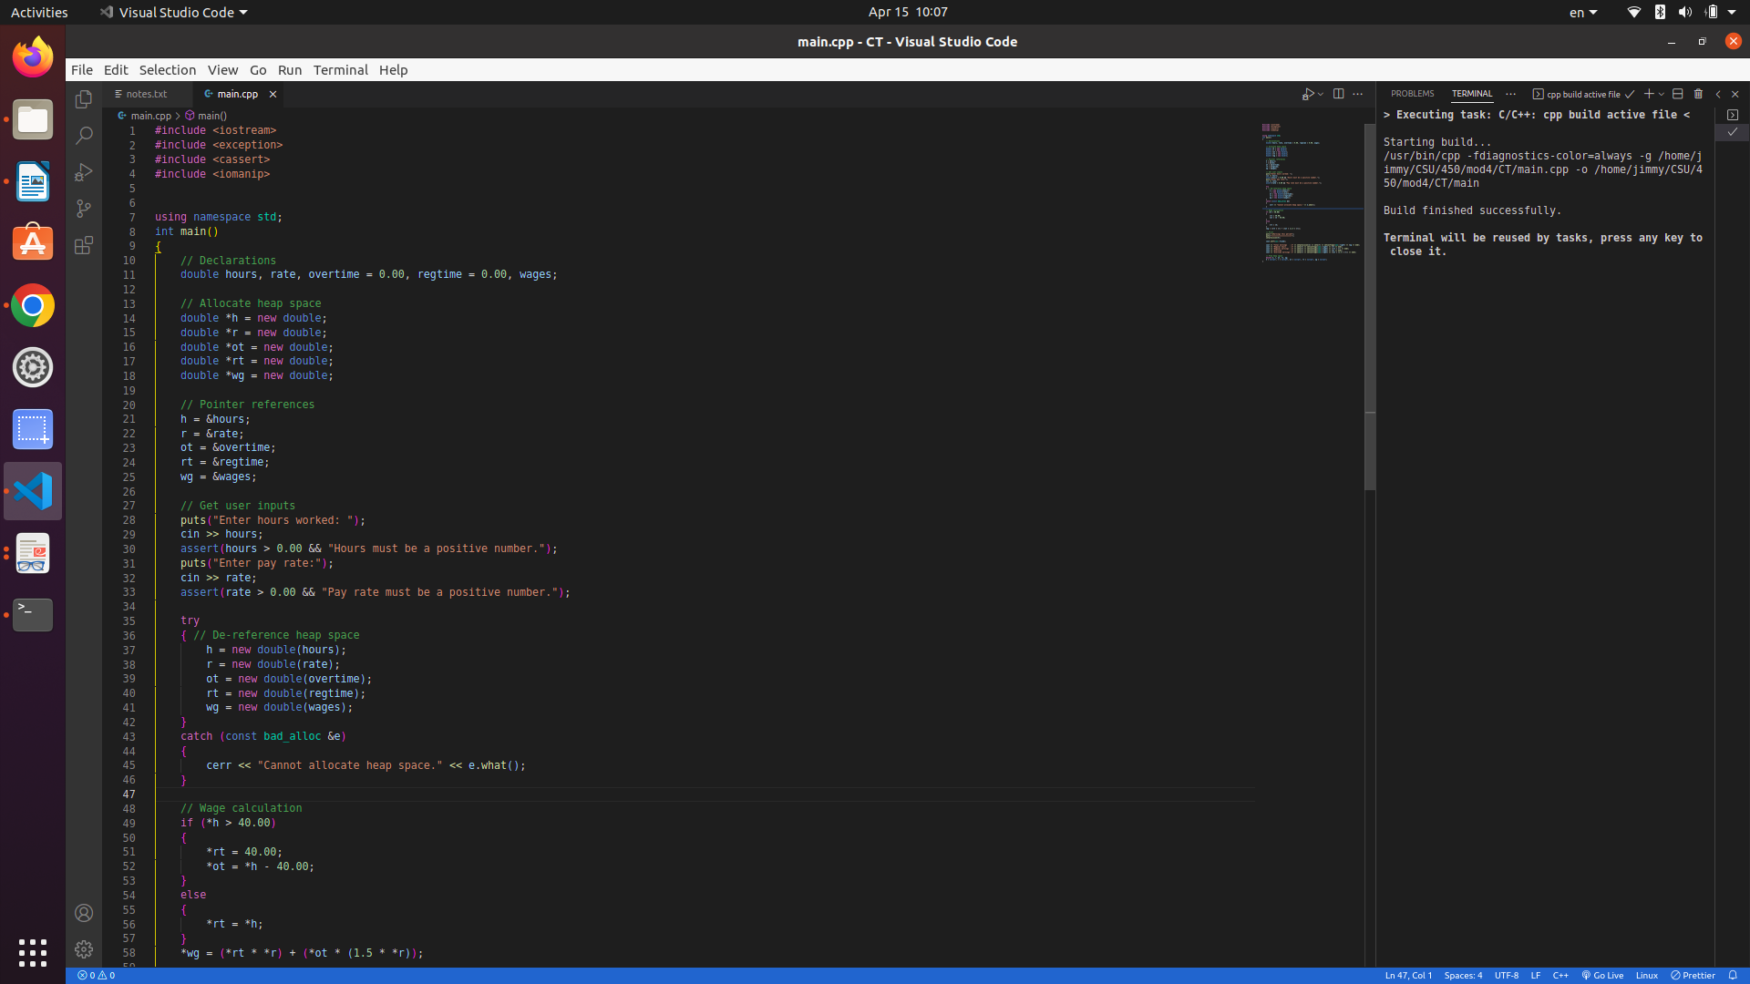
Figure 2: program execution
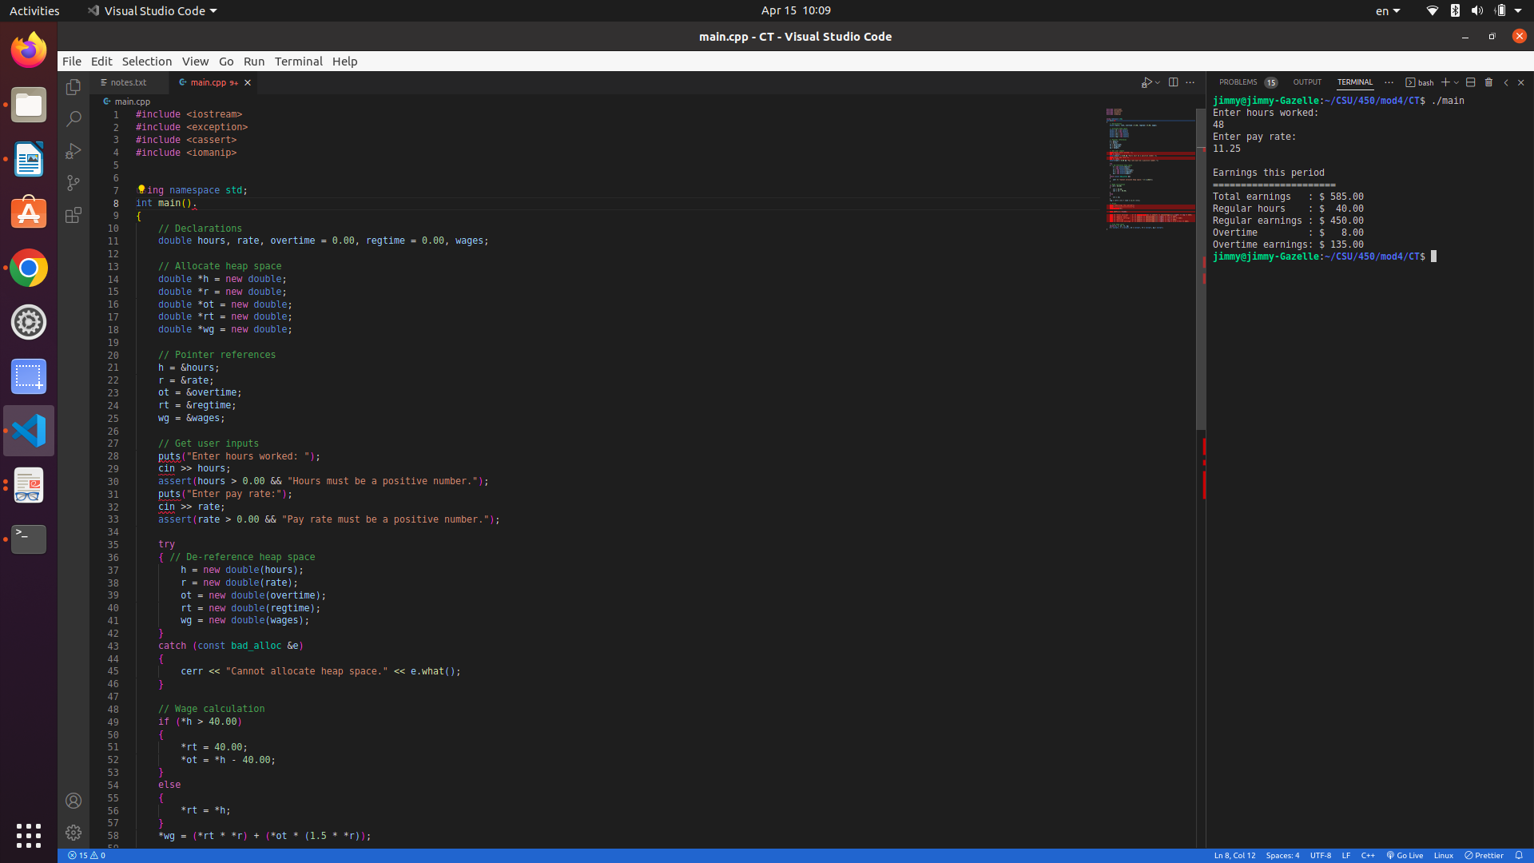
Figure 3: output detail
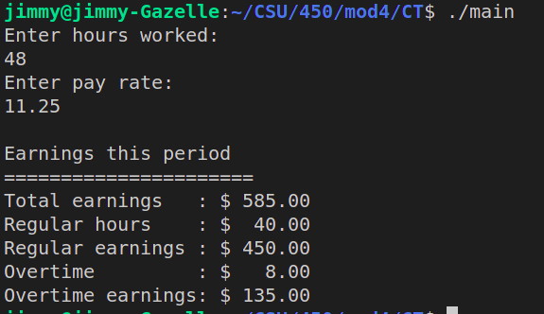

Figure 4: source code

#include <stream>
#include <exception>
#include <cassert>
#include <iomanip>

using namespace std;
int main()
{
// Declarations
double hours, rate, overtime = 0.00, regtime = 0.00, wages;

// Allocate heap space
double *h = new double;
double *r = new double;
double *ot = new double;
double *rt = new double;
double *wg = new double;

// Pointer references
h = &hours;
r = &rate;
ot = &overtime;
rt = &regtime;
wg = &wages;

// Get user inputs
puts("Enter hours worked: ");
cin >> hours;
assert(hours > 0.00 && "Hours must be a positive number.");
puts("Enter pay rate:");
cin >> rate;
assert(rate > 0.00 && "Pay rate must be a positive number.");

try
{ // De-reference heap space
h = new double(hours);
r = new double(rate);
ot = new double(overtime);
rt = new double(regtime);
wg = new double(wages);
}
catch (const bad_alloc &e)
{
cerr << "Cannot allocate heap space." << e.what();
}

// Wage calculation
if (*h > 40.00)
{
*rt = 40.00;
*ot = *h - 40.00;
}
else
{
*rt = *h;
}
*wg = (*rt * *r) + (*ot * (1.5 * *r));

// Print
puts("\nEarnings this period");
puts("======================");
setprecision(5);

cout.setf(ios::fixed);

cout << "Total earnings : $" << setprecision(2) << setw(7) << setiosflags(ios::right) << *wg << endl;
cout << "Regular hours : $" << setw(7) << setiosflags(ios::right) << *rt << endl;
cout << "Regular earnings : $" << setw(7) << setiosflags(ios::right) << (*rt * *r) << endl;
cout << "Overtime : $" << setw(7) << setiosflags(ios::right) << *ot << endl;
cout << "Overtime earnings: $" << setw(7) << setiosflags(ios::right) << (*ot * (1.5 * *r)) << endl;

// Free heap space
delete h, r, ot, rt, wg;
h = nullptr, r = nullptr, ot = nullptr, rt = nullptr, wg = nullptr;
} // End

References
Ballman, Aaron. 2016. SEI CERT C++ Coding Standard. Chapter 2, 7 and 9.
Learn C++. (2022). 11.11 Dynamic memory allocation with new and delete.
https://www.learncpp.com/cpp-tutorial/dynamic-memory-allocation-with-new-and- delete/

