CT 6, Option 1

Joaquin Fox
Colorado State University Global
CSC450: Programming III
Lawrence Meadors
April 29, 2022

Secure code with Java
In this paper I discuss security issues related to the Java programming language. I examine an I/O read method which does not comply with established best practices, and discuss ways of mitigating vulnerabilities.

Introduction
The Java programming language implements a number of security features including
      - automated memory management with periodic garbage collection,
      - compiler type checking and strict rules for variable type casting (conversions),
      - programmer defined access modifiers to regulate data exchange between objects and classes,
      - exception classes that are meant to alert the programmer to unsafe methods.
These built in properties taken together account for Java's reputation as a robust and secure language. The language however does have vulnerabilities which can be exploited. Most arise in the context of enterprise systems, of a certain scale and complexity.
The Java spec provides built in methods for mitigating vulnerabilities (such as a Security Manager and Provider classes). In addition, third party solutions have emerged that are specific to enterprise scale projects.
In this paper I will highlight common vulnerabilities related to read - write operations and demonstrate solutions. I will begin with a description of how Java handles reading and writing to files generally.

Java read - write operations
Java input and output (IO) operations are achieved through the use of streams, which are packaged sequences of data. Streams can be sent and received between Java objects. Streams can be either of characters (used for processing text files) or byte code (used for everything else). The available methods for handling streams vary somewhat between the two data types. Table 1 summarizes these differences.

Table 1: Java stream types.
Byte stream | Character stream
The basic data unit is a generic byte (of 8 bits) | Data units are Unicode characters of 2 bytes
Used for binary (non text) data, such as .jpg or .png | Used for file types ending in .txt.
Methods descend from classes InputStream and OutputStream | Method descend from Reader and Writer
Derived from javaconceptoftheday.com Byte Stream Vs. Character Stream in Java

In addition to the two stream types there are two alternative classes for handling IO operations, the java.io and the java.nio classes, refered to here as IO and NIO, respectively. NIO works on a different technology than the java.io library. Instead of using streams, NIO accomplishes data transfer using a buffered space that is transmitted via a thread, that is itself capable of asynchronous, multi threading. NIO can read asynchronously from multiple file types and can offer efficiencies in applications with complex and large volume data exchange. (Jenkov, Jacob. 2020)

I will discuss the security implications for each of these approaches next.

Vulnerabilities
Vulnerabilities in Java revolve around issues of data security, the injection of malicious code, the misuse of language features and aspects of the built in security features Java offers. (Long, Fred, et all. 2018)

Figure 1 illustrates a method readData() that reads a character stream from a file.

Figure 1: a non-compliant method
void readData() throws IOException {
BufferedReader br = new BufferedReader(new InputStreamReader(new FileInputStream(file)));
String data = br.readLine();
} // End
Adapted from Java Coding Guideline, Chapter 1, p.4

The method readData() is cited as an example of non compliant code in Java Coding Guidelines ( Long, Fred, et al. 2014), under the section "Limit the lifetime of sensitive data". Because the method stores the results of the read in a string variable, and because the life of that variable will continue until the process is terminated, longer than it is needed, the code is non compliant with the first recommendation.
Although not mentioned by the authors, I would add that the code also fails to meet guideline 2, by storing unencrypted data and guideline 5 because it does not prevent arbitrary file uploads. In addition the method in figure 1 seems to confuse methods intended for binary streams, such as FileInputStream and methods intended for character streams such as BufferedReader. Combining these classes in a single method results in compilation errors being thrown in my IDE.

Reviewing the solution.
The authors of Java Coding Guidelines show a compliant code block that improves on the read operation in figure 1. That solution is reprinted below, for the following discussion.

Figure 2: a compliant version
void readData() {
ByteBuffer buffer = ByteBuffer.allocateDirect(16 * 1024);
try (FileChannel rdr = (new
FileInputStream("file")).getChannel()) {
while (rdr.read(buffer) > 0) {
buffer.clear();
}
} catch (Throwable e) {
}
}
Reproduced from Java Coding Guidlines

The solution in figure 2 has the following features
- It used the java.nio library, and in particular the allocateDirect() method
- It process the data as binary data instead of characters.
- It wraps the read function in a try catch block.

NIO Vs. IO
The choice of NIO over IO strikes me as odd, because in my research there is no indication that one method is safer over the other. A search of the CSU Global library with the terms "NIO" and "security" returned zero results and likewise there does not seem to be a topic being discussed online. Why the authors chose to present NIO and the allocateDirect() as a security improvement is unclear. The benefits of NIO seem to be confined to its ability to process data concurrently. (Jenkov, Jacob. 2020)

Binary Vs. Characters
Likewise the author's choice to process data as binary bytes, and not text is unclear. Again in my research there is no indication that one method improves security over another. The choice has more to do the nature of the data being read. Text files are read as characters and other file types as binary (GeeksForGeeks. 2021).
The key feature in figure 2 is that the buffer itself is manually cleared. The same data destruction could just as easily been obtained by destroying the string variable shown in figure 1, as I demonstrate next.

Other solutions.
In figure 3 below, method01() replicates the read operation of figure 1. While it doesn't really matter whether we use a binary stream or a character stream from a security standpoint, it does matter that we are being consistent within the method. In figure 3 I pair the FileReader which forms the actual stream for character elements and BufferedReader, which allocates memory buffered to the upper boundary set in the mark() method, set here to 100 characters (Jenkov, Jacob. 2020).

Figure 3: Reading a character stream
static void method01() throws IOException {
FileReader fr = new FileReader("file.txt");
BufferedReader br = new BufferedReader(fr);
br.mark(100);
if (br.ready()) {
System.out.println(br.readLine());
br.reset();
}
br.close();
}
The read data is never stored, since there is no specific need to and the close() method immediately closes the stream which has the effect of returning all the resources associated with that stream(GeeksForGeeks [GFG]. 2020).

A different approach is shown in figure 4. In this case I suppose there is a need to retain the results of the read operation before exiting the process. Here I store the results in a string, do something with the string, and then immediately set the string to null. This approach keeps the sensitive data as briefly as possible. Setting the string variable to null destroys the data and marks the allocated memory for garbage collection (GFG. 2020).As a further precaution the access modifier of the method is set to private, which adds another layer of control over the process.

Figure 4:
private static void method02() throws IOException {
FileReader fr = new FileReader("file.txt");
BufferedReader br = new BufferedReader(fr);
String output = "";
br.mark(100);
if (br.ready()) {
output += br.readLine();
// Do something with the string here
System.out.println(output);
br.reset();
}
br.close();
output = null;
}
The method in figure 4 limits the lifetime of the data, but it still exposes the data within the method. A further improvement (not demonstrated) would be to encrypt the data for the time it is held in scope.

Conclusion
Secure practices can be grouped into four categories, along with general recommendations as follows.
Category | Best practices include
Handling sensitive data. | Limit data lifespan, return all system resources, escape output, encrypt data held
Preventing code injections | validate input, normalize input, sanitize input, add a Security Manager.
Language vulnerabilities | use caution with clone(), and Object.equals()
Built in methods | Apply SecurityManager layer when interacting with API's, handle all exceptions.
This table aggregates and summarizes the guidelines in Java Coding Guidlines

In this paper I demonstrate some methods of handling data read from a file. Other methods not shown, but which could also improve the methods above (and which are more difficult to implement) include encrypting any data held, and sanitizing and/or escaping the data that is read, to prevent malicious code injection.

Figure 1: Build and execution
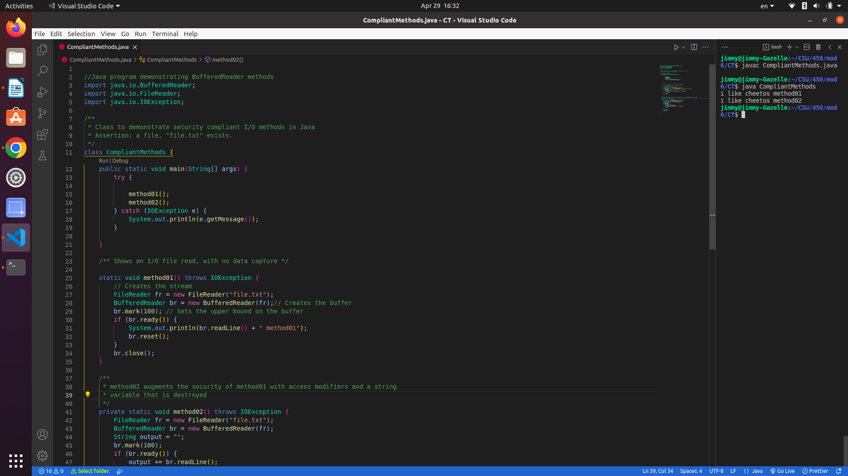

Figure 2: Source code
//Java program demonstrating BufferedReader methods
import java.io.BufferedReader;
import java.io.FileReader;
import java.io.IOException;

/**
* Class to demonstrate security compliant I/O methods in Java
* Assertion: a file, "file.txt" exists.
*/
class CompliantMethods {
public static void main(String[] args) {
try {

method01();
method02();
} catch (IOException e) {
System.out.println(e.getMessage());
}

} // End main

/** Shows an I/O file read, with no data capture */

static void method01() throws IOException {
// Creates the stream
FileReader fr = new FileReader("file.txt");
BufferedReader br = new BufferedReader(fr);// Creates the buffer
br.mark(100); // Sets the upper bound on the buffer
if (br.ready()) {
System.out.println(br.readLine() + " method01");
br.reset();
}
br.close();
} // End method01

/**
* method02 augments the security of method01 with access modifiers and a string
* variable that is destroyed
*/
private static void method02() throws IOException {
FileReader fr = new FileReader("file.txt");
BufferedReader br = new BufferedReader(fr);
String output = "";
br.mark(100);
if (br.ready()) {
output += br.readLine();
System.out.println(output + " method02");
br.reset();

}
br.close();
output = null;
}
} // End

References
Long, Fred, et. all. 2014. Java Coding Guidlines. Chapter 1.

Jenkov, Jacob. 2020. Java NIO Tutorial
https://jenkov.com/tutorials/java-nio/index.html

GeeksForGeeks. (Mar, 2021). java.nio ByteBuffer class in Java
https://www.geeksforgeeks.org/java-nio-bytebuffer-class-in-java/?ref=gcse

GeeksForGeeks. (Mar, 2021). java.io.BufferedReader class in Java
https://www.geeksforgeeks.org/java-io-bufferedreader-class-java/

Wikipedia. (accessed April 29, 2022). Non-blocking I/O(Java)
https://en.wikipedia.org/wiki/Non-blocking_I/O_(Java)

Java Concept Of The Day. ( April, 2022). Byte Stream Vs. Character Stream In Java.
https://javaconceptoftheday.com/byte-stream-vs-character-stream-in-java/

