Urban Tree Canopy and Heat Vulnerability in Chicago
Joaquin Rivera
Earth 211

During the past decades, urban heat islands have disproportionately affected communities with low incomes and communities of color. This is a pattern that has been shaped by years of low investment and discriminatory policies. Tree canopy has been widely recognized as one of the most cost-effective mitigation strategies. This is because trees reduce surface temperature through shading and evapotranspiration. Moreover, they improve air quality and they provide other public health benefits. Nevertheless, the distribution of trees in urban areas is far from equitable. While the wealthier areas usually have a higher canopy coverage.

This project has the main objective of investigating the correlation and relationship between urban tree canopy coverage and exposure to heat across Chicago areas. The project examines whether lower-canopy areas are associated with higher land surface temperature and thus greater social vulnerability. Chicago is a very interesting place, as it is one of the largest cities in the United States, and it has seen a decline in its tree canopy since 2010. Chicago shows many inequalities in environmental quality and socioeconomic conditions.

The project will stick to the following research question: How does urban tree canopy coverage vary across Chicago neighborhoods, and are lower-canopy areas associated with higher land surface temperatures and greater social vulnerability?

To answer this question, research will be based on the American Forests Tree Equity Score dataset for Illinois which was made in 2020 and provides data on tree canopy percentage on a block group level, heat exposure, and demographic variables that have been derived from the U.S Census Bureau’s American Community Survey 5-year estimates. The dataset has 2,163 block groups that divide the city of Chicago.

The Tree Equity Score dataset contains the following key variables:

temp_diff (Response) – Difference between block group heat and urban area average (Celsius)
treecanopy (Predictor 1) – Percentage of block group covered by tree canopy
pctpoc (Predictor 2) – Percentage of residents identifying as people of color
pctpov (Predictor 3) – Percentage of residents below the poverty line
unemplrate (Predictor 4) – Unemployment rate within the block group
tes (Supplementary) – Tree Equity Score – composite equity index
holc_grade (Supplementary) – Historical redlining grade from mapping inequality

All processing and analysis of data were done with the program R using the tidyverse, tidycensus, sf, and tmap packages. The first step was filtering the Illinois Tree Equity Score CSV to Chicago Block groups and then joining it to Census block group spatial boundaries. Furthermore, a multiple ordinary least squares, OLS, regression model was estimated in order to assess the predictors of heat exposure throughout the Chicago block groups. The model was estimated at the block group level.

Supplementary analyses included a Pearson correlation matrix of all key variables, scatter plots of tree canopy against heat exposure, and a boxplot made to compare tree canopy coverage across redlining grades to revise the legacy of discriminatory housing policy based on present-day tree distribution.

Chicago is divided into 2,163 block groups, and they all show variation in both tree canopy coverage and heat exposure. The range of tree canopy goes from zero to over 50%; the mean is at approximately 16%. The deviation of heat from the urban average ranges from -14 degrees to 8 degrees Celsius, thus demonstrating that there is a significant difference in surface temperatures in the city.

The multiple linear regression model explained 31.1% of the variance in heat exposure. All four predictor variables where below the statistical significance level. All the regression results can be seen in the table below.
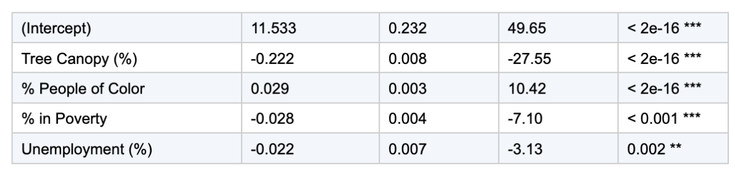
Tree canopy is considered to be the strongest predictor of heat reduction, as a one percentage point increase in tree canopy leads to a 0.222 degree Celsius decrease in surface temperature, while holding all other variables constant. Furthermore, the percentage of people of color leads to higher heat exposure, meaning that block groups in Chicago that have a higher proportion of people of color have higher surface temperatures, even after accounting for poverty and unemployment.

The results in this project show clearly how tree canopy is negatively related to heat exposure, meaning that a lower tree canopy percentage will lead to higher surface-level temperatures and more heat exposure, thus leading to more social vulnerability in Chicago. This negative relationship shown in the project is ecologically meaningful at the neighborhood scale.

The relationship between the percentage of people of color and heat exposure is a particularly important finding given that the relationship is positive and independent of poverty and unemployment. This result suggests that race, regardless of socioeconomic status, is an independent factor leading to higher surface temperatures in Chicago. The analysis done shows that neighborhoods that have been historically targeted by discriminatory housing policies have a lower canopy and thus have higher surface temperatures.

Nevertheless, there are many limitations that should be taken into consideration. The analysis is done in a way that does not establish causality. The block group is an administrative unit that may not reflect the residents’ experienced neighborhoods. Furthermore, the tree equity score heat variable is in relation to the deviation from the urban average rather than the total temperature. Further work should include longitudinal data on canopy change, spatial autocorrelation diagnostics, and qualitative community perspectives on tree access and maintenance.

This project finds strong evidence that urban tree canopy coverage is a significant predictor of heat exposure across Chicago block groups, and that lower-canopy areas are disproportionately home to communities of color and lower-income residents. Every one percentage point increase in tree canopy is associated with a 0.222°C reduction in relative heat exposure. The persistence of these patterns across historical redlining grades suggests that addressing urban heat inequity requires confronting the structural legacies that produced it. Targeted tree planting programs in underserved South and West Side neighborhoods represent both an environmental intervention and a step toward spatial justice.

American Forests. (2023). Tree Equity Score Illinois dataset. https://www.treeequityscore.org/methodology

Locke, D. H., Hall, B., Grove, J. M., Pickett, S. T. A., Ogden, L. A., Aoki, C., Boone, C. G., & O'Neil-Dunne, J. P. M. (2021). Residential housing segregation and urban tree canopy in 37 US cities. npj Urban Sustainability, 1(15). https://doi.org/10.1038/s42949-021-00022-0

Nelson, R. K., Winling, L., Marciano, R., & Connolly, N. (n.d.). Mapping inequality: Redlining in New Deal America. American Panorama. https://dsl.richmond.edu/panorama/redlining

U.S. Census Bureau. (2020). American Community Survey 5-year estimates, block group level, Cook County, Illinois. https://www.census.gov/programs-surveys/acs

