**Introduction**

A gridded product of daily soil moisture at 250-meter spatial resolution was created by integrating in situ soil moisture from the Kansas Mesonet and a simple soil water storage model as part of my research. The model represented temporal soil moisture dynamics using the following equation:

Where  represent the soil water storage in the rootzone at day t, is a recursive parameter representing the fraction of remaining water storage after the daily storage loss due to the different processes of the water dynamics in soil. *SLL* is the lowest limit the soil can reach after it is completely dry, and *SUL* is the maximum amount of water the soil can store, , represent the previous state of soil water storage, finally represent the precipitation events. In the current model is implemented as a function of vapor pressure deficit (VPD).

**Significance of the study**As shown in Figure 1, there is a correlation between VPD and , however the proposed equation is no accounting for all the possible values that are not being represented by the linear regression. Using a Bayesian approach for this problem can lead to more accurate and reliable predictions or inferences, by incorporating prior knowledge, and will allow to quantify the uncertainty.

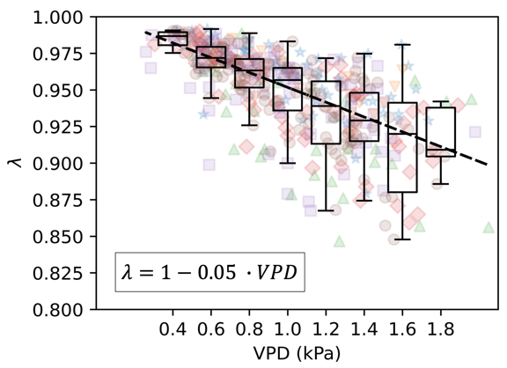

Figure 1. λ as a function of VPD.

**Methodology**

Using the Bayesian framework this project aims to quantify the uncertainty during the inference of the soil water storage dry-down in each location by adjusting a Bayesian linear regression model which will provide a more accurate and reliable prediction of soil moisture dynamics by accounting for all possible values that are not represented by the linear regression equation currently used.

**Data Dissemination**

The findings of this research will be published as part of my research in a poster at the 2023 ASA-CSA-SSSA annual meeting and a scientific article in the Vadoze Zone Journal. Moreover, the outcomes of this research will be used to develop a Mesoscale Soil Moisture Monitoring tool as one of the Rainfed Agriculture Innovation Network project objectives.