# **Deploying Apache Web Server using Ansible on AWS EC2**

**Objective**: The objective of this exercise was to utilize Ansible to automate the deployment and undeployment of a web server across multiple virtual machines on Amazon Web Services (AWS).

**1. AWS EC2 Setup**

We initialized three virtual machines on AWS EC2, situated within the US West (Northern California) region. Their respective IP addresses were:

* Control Machine (VM1)
* Web Server 1 (VM2)
* Web Server 2 (VM3)

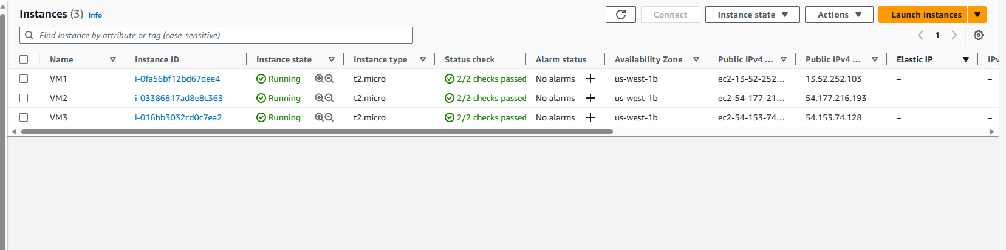

**2. Ansible Installation**

On VM1, which served as our control node, we proceeded to install Ansible. This control node was vital in managing and automating tasks across VM2 and VM3.

Include screenshots of the successful Ansible installation.

**3. SSH Key Configuration**

To ensure seamless communication between VM1 and the other VMs (VM2 and VM3), SSH keys were set up. This allowed VM1 to interact with VM2 and VM3 without constantly prompting for passwords.

**4. Web Server Deployment**

Using Ansible, we crafted a playbook named deploy_webserver.yml which performed the following tasks:

* Update the package manager's cache.
* Install the Apache2 web server software.
* Configure Apache to listen on port 8080.
* Display a distinct "Hello World from SJSU-X" message on both VM2 and VM3.

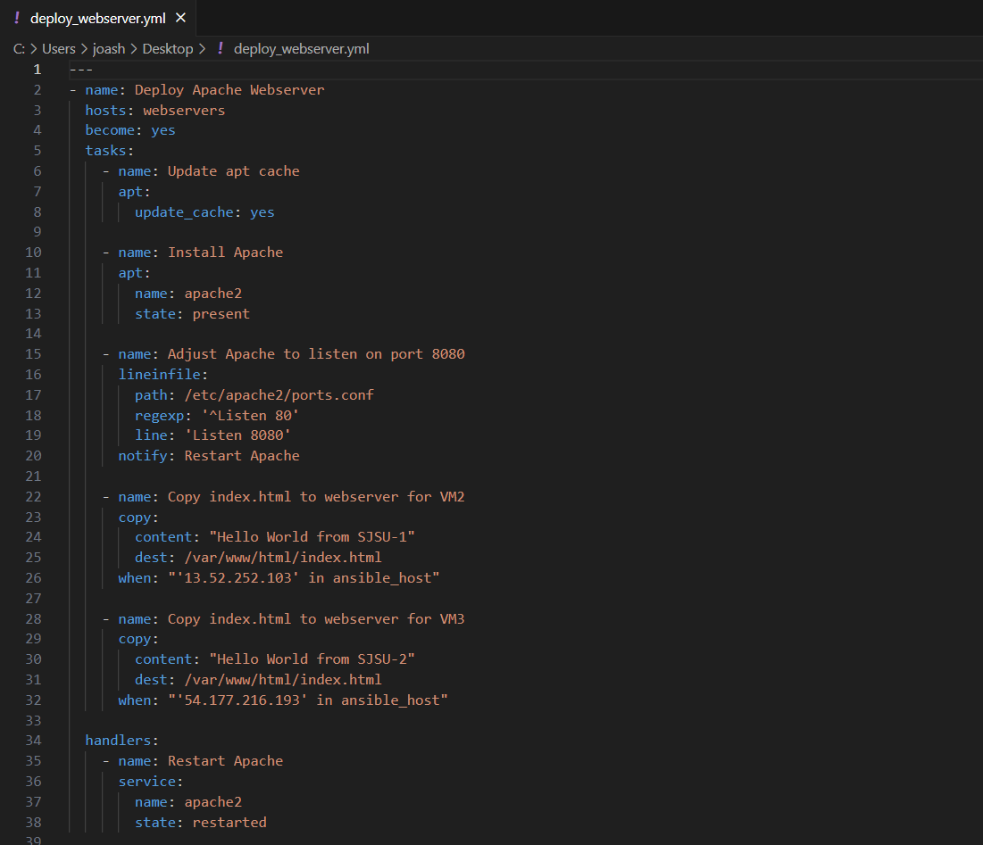

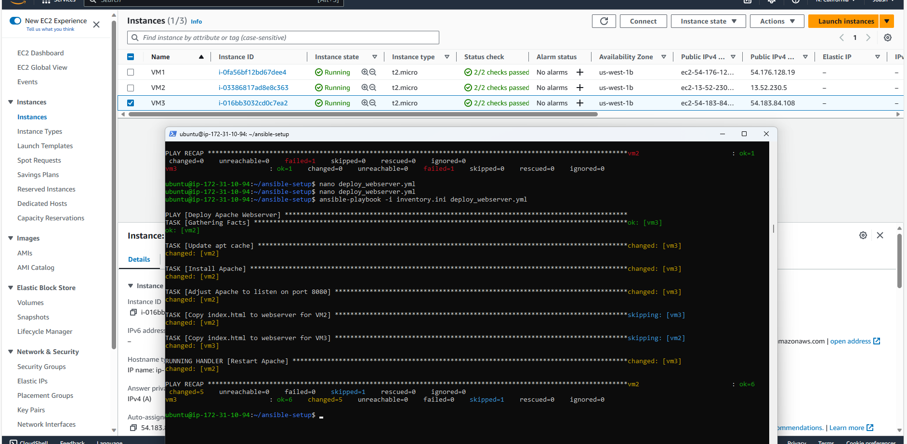

**5. Web Server Verification**

Following the deployment, we verified the proper functioning of the web server. By accessing the IP addresses of VM2 and VM3 via a web browser, we confirmed the display of the messages "Hello World from SJSU-1" and "Hello World from SJSU-2" respectively.

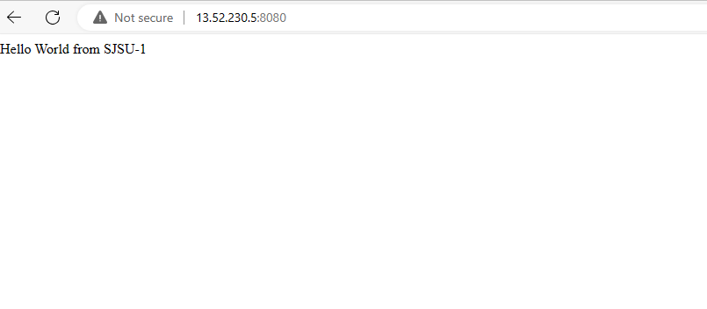



**6. Web Server Undeployment**

To demonstrate the undeployment process, another Ansible playbook named undeploy_webserver.yml was created. This playbook was responsible for:

* Stopping the Apache2 service.
* Uninstalling the Apache2 package.
* Removing any associated files or configurations.

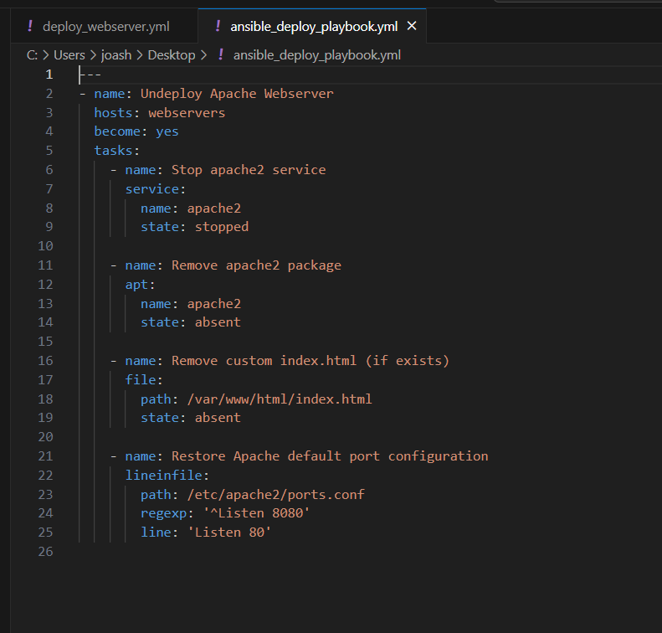

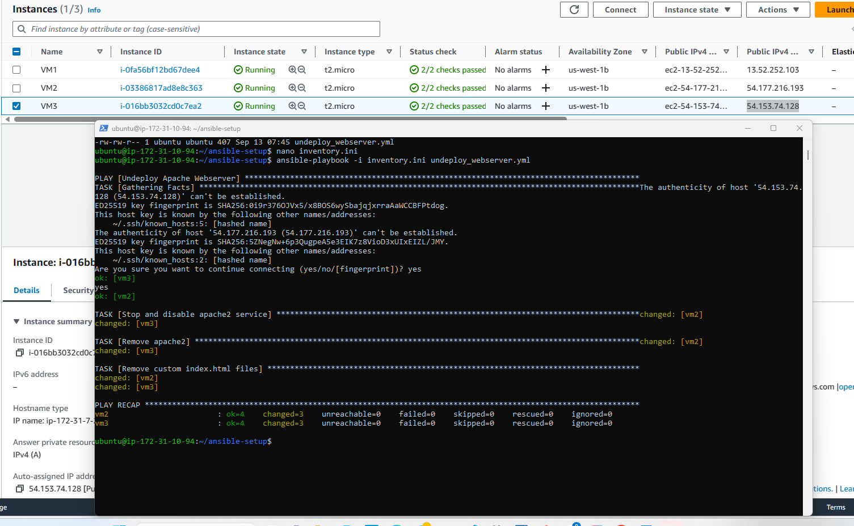

**7. Conclusion**

Utilizing Ansible for automation significantly streamlined the process of deploying and undeploying web servers across multiple AWS EC2 instances. This exercise demonstrated the efficiency and effectiveness of infrastructure as code, offering a reproducible and scalable approach to managing cloud resources.