PROTOTYPE DEFECT REPORT – NTB PLATFORM
English translation of “Rapport des anomalies du prototype – Plateforme BNT”
All original screenshots are reproduced from the source report. Text within screenshots remains in its original interface language.

1. User Interface and Usability

1.1. Logo Overlap with the Home and Report Buttons
When the platform menu is displayed in French, the logo text overlaps with the “Home” button.
Original screenshot: logo and navigation-button overlap

1.2. Responsive Design Issue on the Administrative Platform (Web Responsive Test)
Finding: The administrative platform interface does not adapt properly to smaller screens.
When users access the platform from a tablet or mobile phone, the main navigation menu does not display correctly or is inaccessible.
This issue makes navigation difficult, or even impossible, on tablets and mobile devices and prevents a consistent user experience across different screen sizes.
The responsive design of the administrative platform should be reviewed so that the interface automatically adjusts to different screen resolutions.
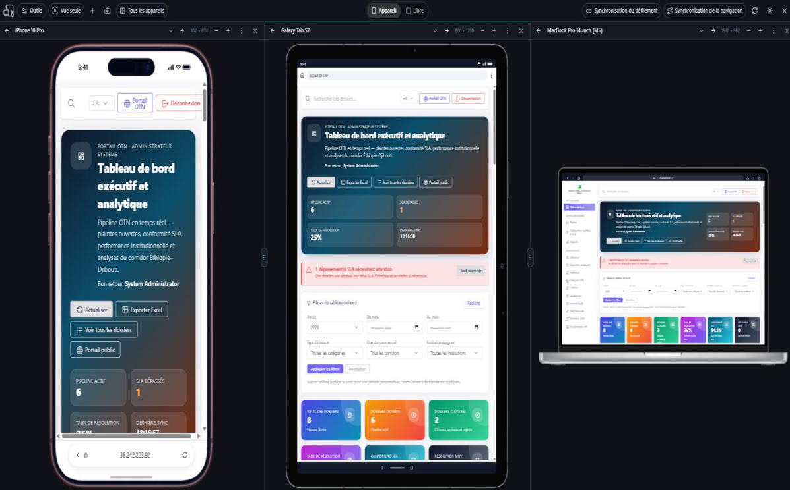
Original screenshot: mobile, tablet and desktop responsive-design test

2. Login Form

2.1. Missing Password Reset Functionality
The user login form currently has no link or button allowing a user to reset a forgotten password.
Impact: A user who forgets their password has no self-service mechanism for regaining access to their account.
The user must currently contact a platform administrator, who then has to use the user management interface to reset the password.
Recommendation
Add a “Forgot password?” link to the login page.
This link should allow users to initiate a secure password reset process themselves.
The recommended process is:
- The user clicks “Forgot password?”.
- The user enters their email address or username.
- The system verifies the account.
- A secure, temporary password reset link is sent to the email address associated with the account.
- The user sets a new password.
- The reset link expires after a limited period and can only be used once.
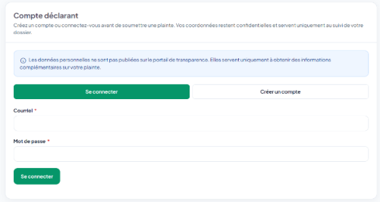
Public portal: original login-screen screenshot
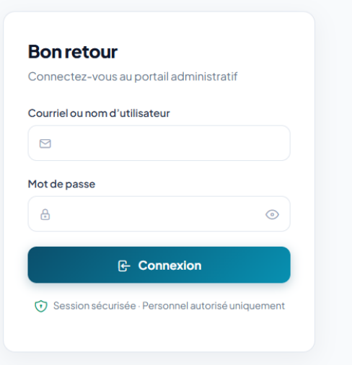
Administrative portal: original login-screen screenshot

3. Multi-Factor Authentication (MFA)

3.1. “Reset MFA” Button
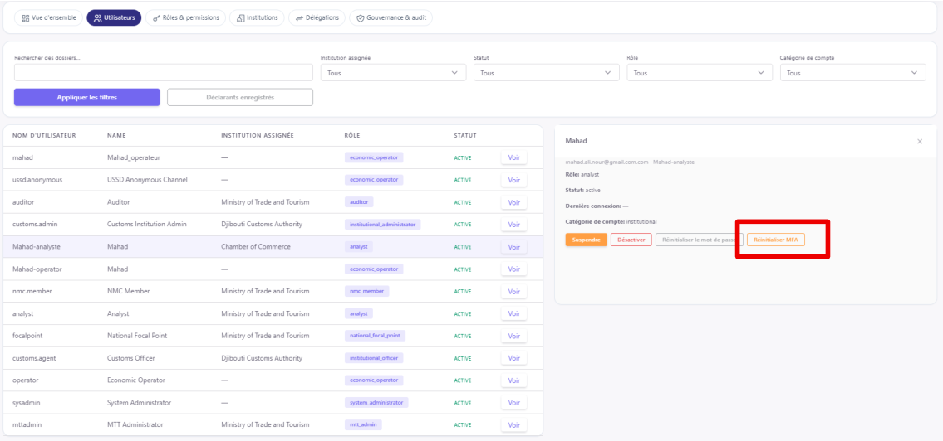
Original screenshot: “Reset MFA” control in the user administration interface
Finding: The button currently labelled “Reset MFA” does not trigger any functional action.

3.2. MFA Security Setting
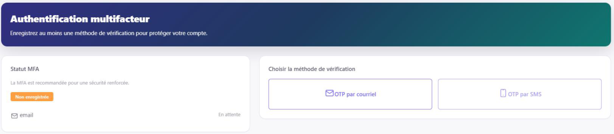
Original screenshot: MFA security configuration and verification method
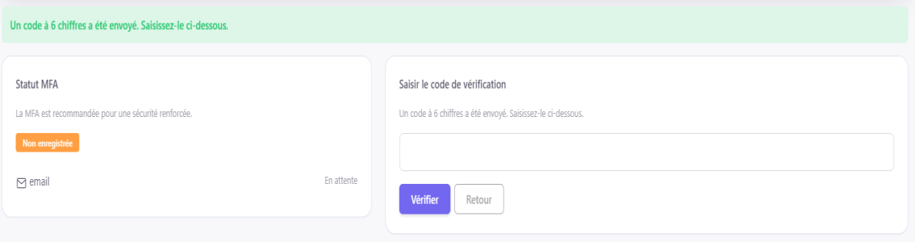
Original screenshot: MFA email verification code entry
Finding: A security setting for configuring multi-factor authentication (MFA) is present on the platform.
When MFA is configured using the email OTP option, the platform displays a message stating that a six-digit verification code has been sent to the user.
However, after checking, no code is actually received in the user’s email inbox.
Impact: This defect prevents users from correctly completing the activation or verification of MFA using an OTP.
It also creates an inconsistency between the behaviour indicated by the interface and the actual operation of the code-delivery service.
The following issues must be corrected:
- The “Reset MFA” button does not trigger any action.
- The six-digit OTP stated to have been sent is not received by the user.
- The operation of the email-sending service must be verified.
- The OTP generation, sending and validation process must be tested end to end.
- An MFA reset procedure must be provided for users who lose access to their second authentication factor.

4. Dialog Boxes and User Experience

4.1. Use of Native Browser Dialog Boxes
Finding: During certain administrative operations, particularly when generating or entering text, the system displays a native browser dialog box when the “Suspend” and “Deactivate” buttons are clicked.
In the screenshot, the message also displays the server’s IP address, for example:
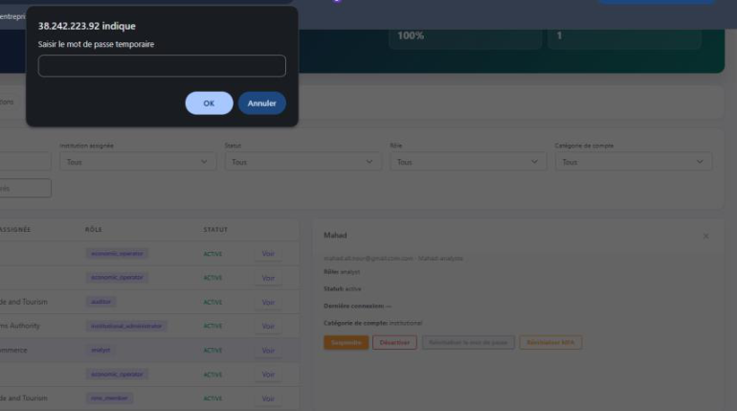
Original screenshot: native browser prompt displaying the server address
This behaviour gives the impression of an unfinished application and is inappropriate for an institutional platform intended for production use.
I recommend replacing the window.confirm() and window.prompt() dialogs with modal dialogs integrated directly into the platform interface.

5. Submission of NTB Complaints / Cases

5.1. Unable to Submit a Complaint
Finding: It is currently not possible to submit an NTB complaint/case through:
- The public portal;
- The administrative portal.
This defect blocks a core platform function: recording and submitting a non-tariff barrier.
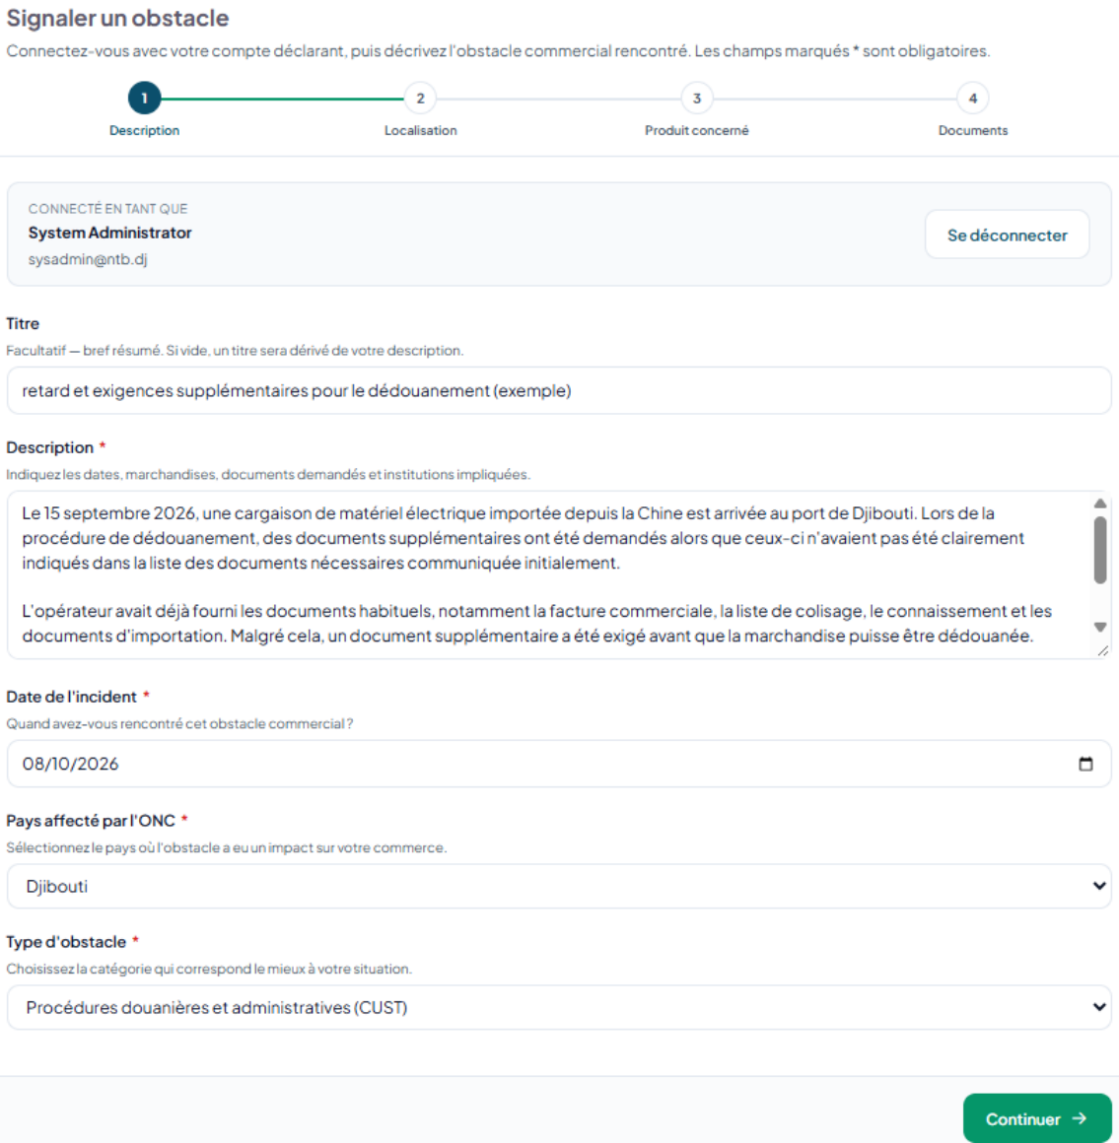
Original screenshot: complaint submission – description stage
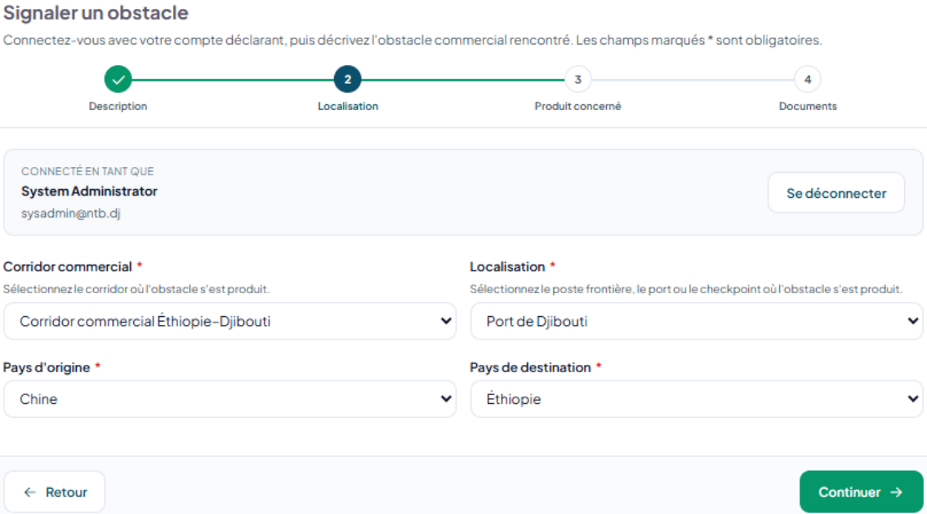
Original screenshot: complaint submission – location stage
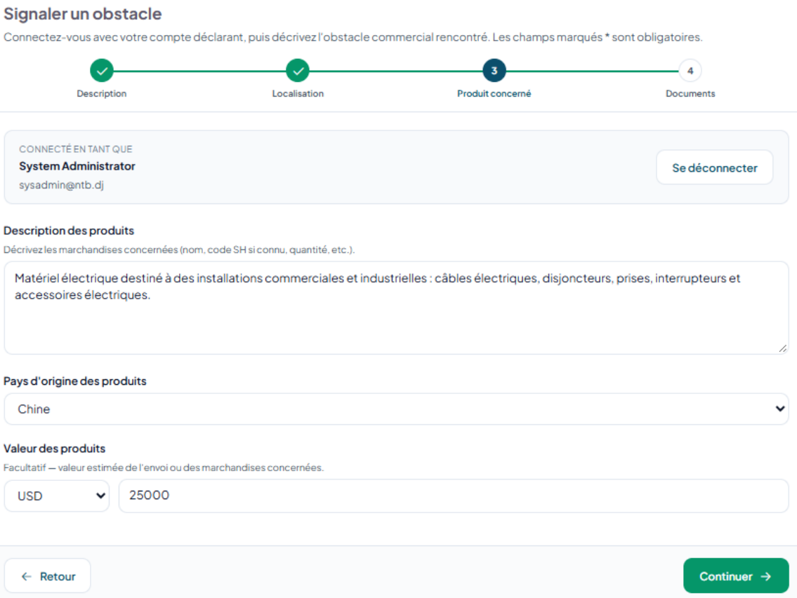
Original screenshot: complaint submission – affected products stage
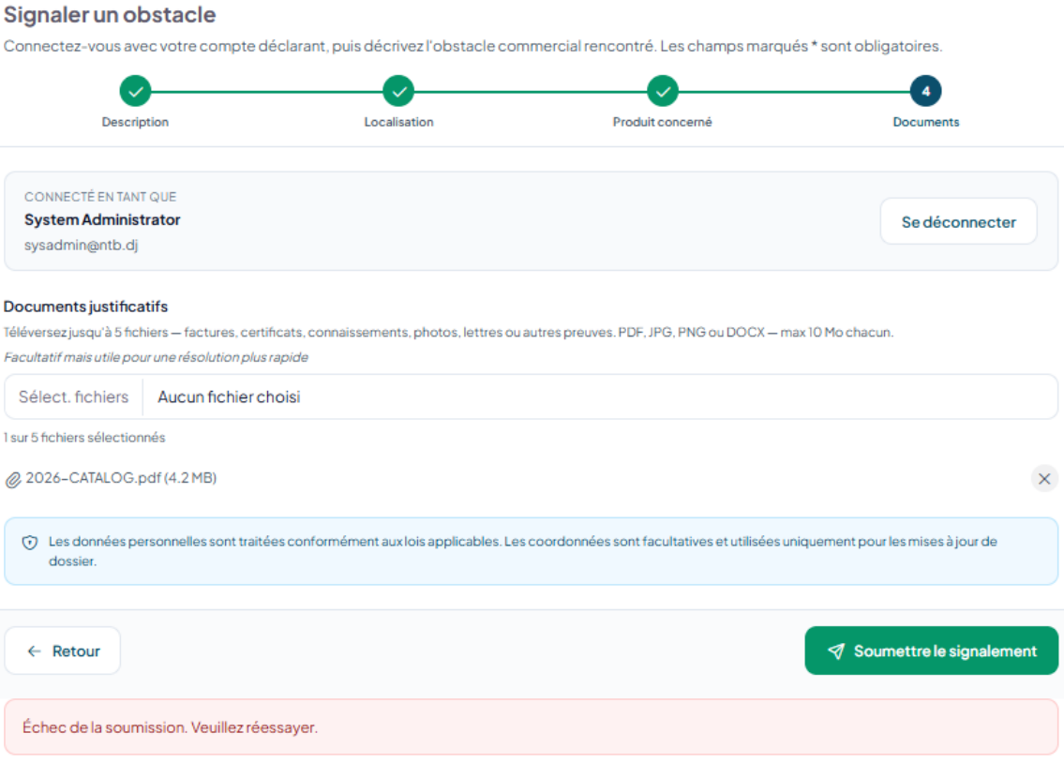
Original screenshot: complaint submission – documents stage and error message
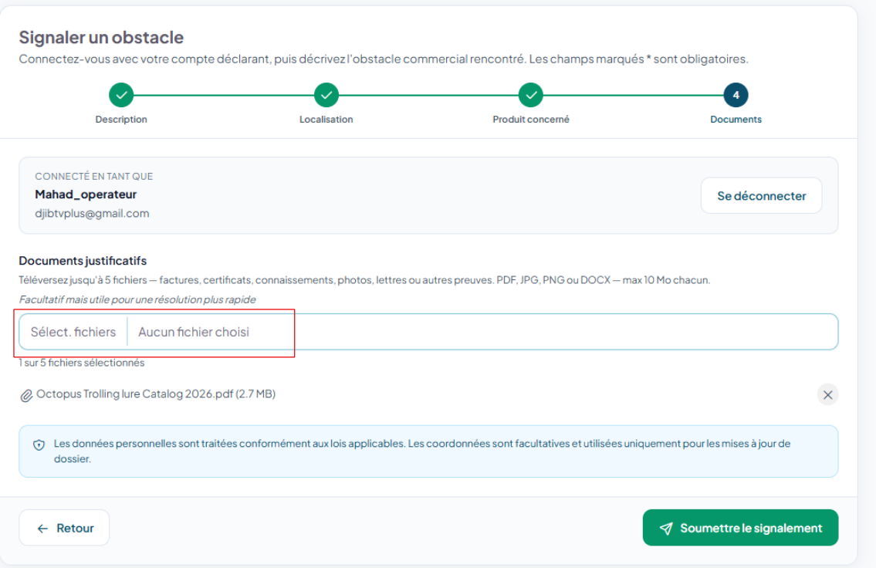
Original screenshot: complaint submission – additional user example
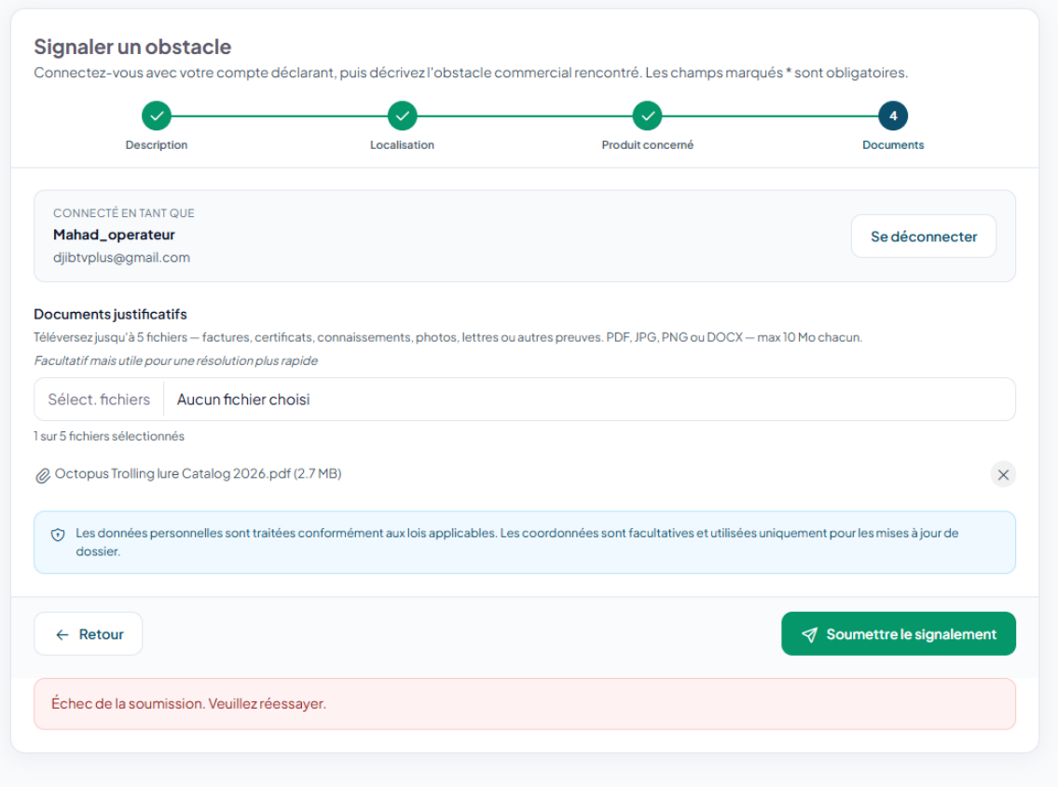
Original screenshot: complaint submission error following attempted submission

6. Institutional Model and Governance
An institution is an administrative or official organisation to which an NTB case may be assigned for processing, monitoring or supervision.
The following distinctions should be made:
- Institution: the body responsible for processing a case;
- User: a person who has an account;
- Role: the user’s permission level.
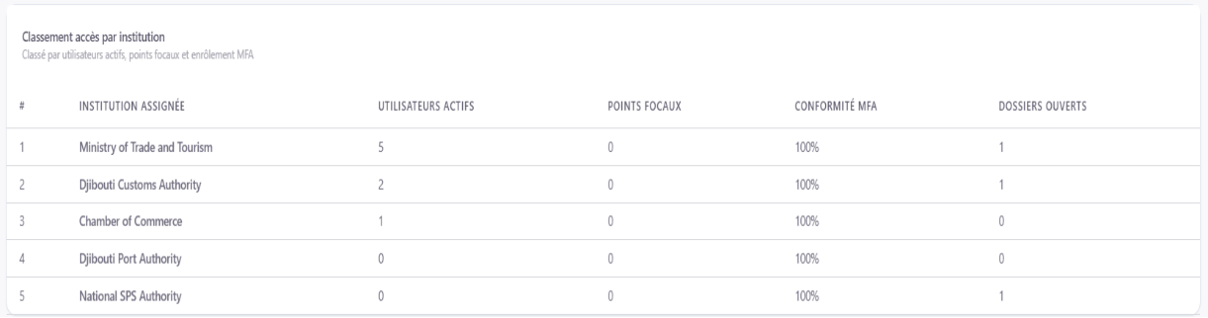
Original screenshot: case assignments by institution

6.1. Important Missing Institutions
Analysis of the platform shows that certain institutions identified in the SDS are not yet represented, or are not clearly represented, in the system.
National Monitoring Committee (CNS)
The SDS assigns it a central role: “Coordination, arbitration and supervision”.
The CNS should therefore be represented within the platform’s institutional/governance model and have access rights corresponding to its responsibilities.
Ministry of Transport
The SDS assigns it, in particular, responsibility for: “Coordination of corridor-related issues”.
It should therefore be included among the institutions that can participate in processing NTB cases relating to transport and corridors.
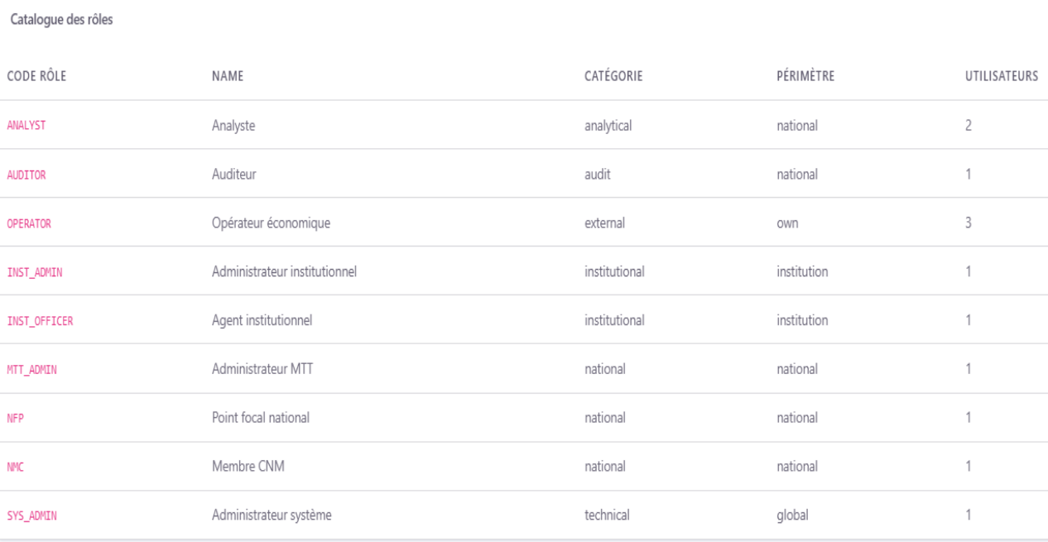
Original screenshot: role catalogue

6. Roles and Permissions
The section on roles is broadly consistent with the SDS. A technical error occurs when using the role-assignment function:
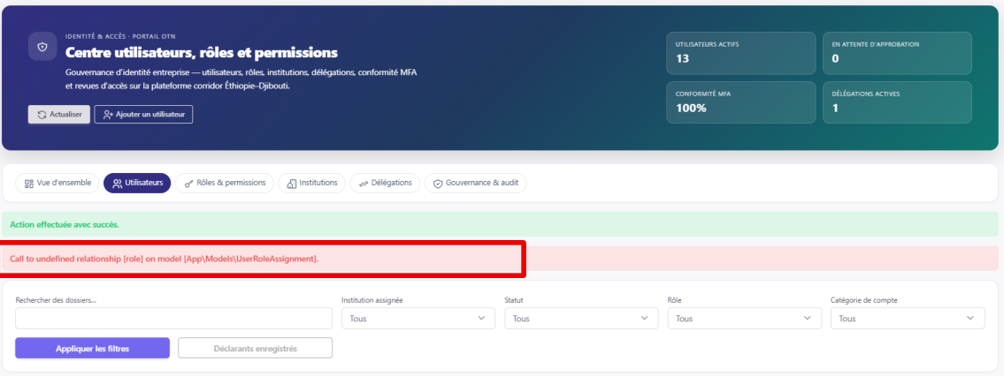
Original screenshot: error displayed when applying role assignment
Call to undefined relationship [role] on model [App\Models\UserRoleAssignment].
Impact: This error probably indicates a problem with the relationship between the UserRoleAssignment model and the corresponding role model.
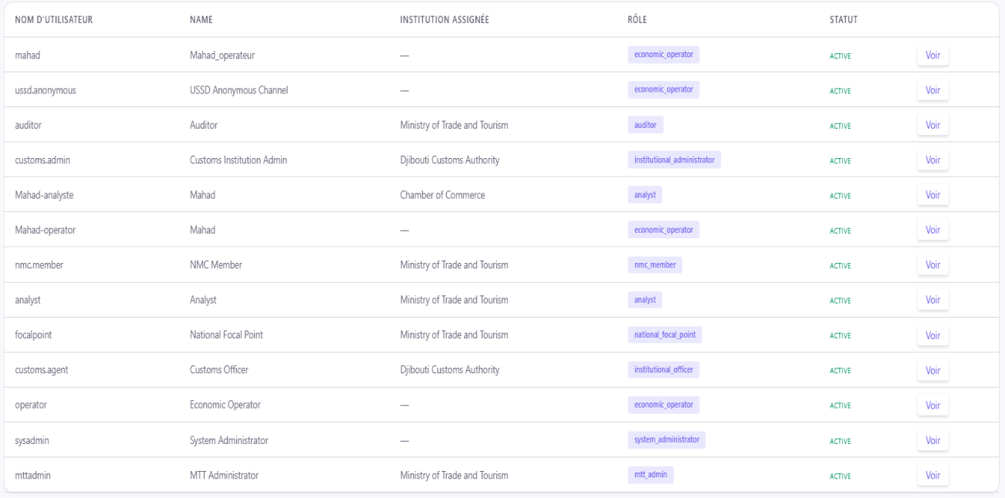
Original screenshot: user list, assigned institutions, roles and status

