# 2.1 – System modeling

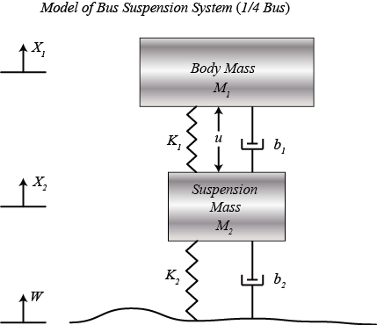

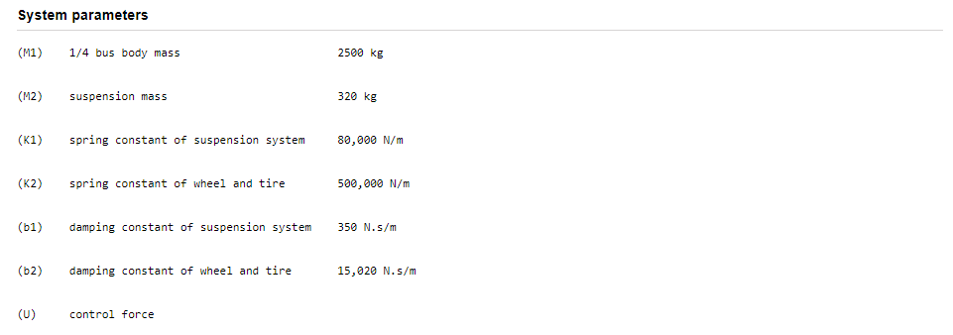

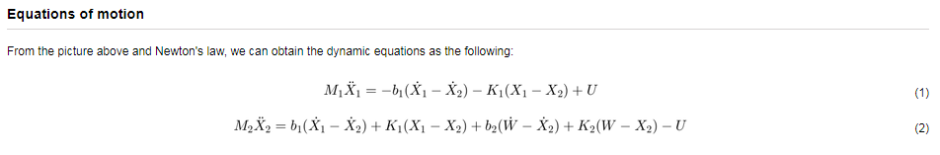

Explain

* Outputs of interest (deflection, acceleration of suspended mass, tire force).
* Laplace transform and TF between input and output.

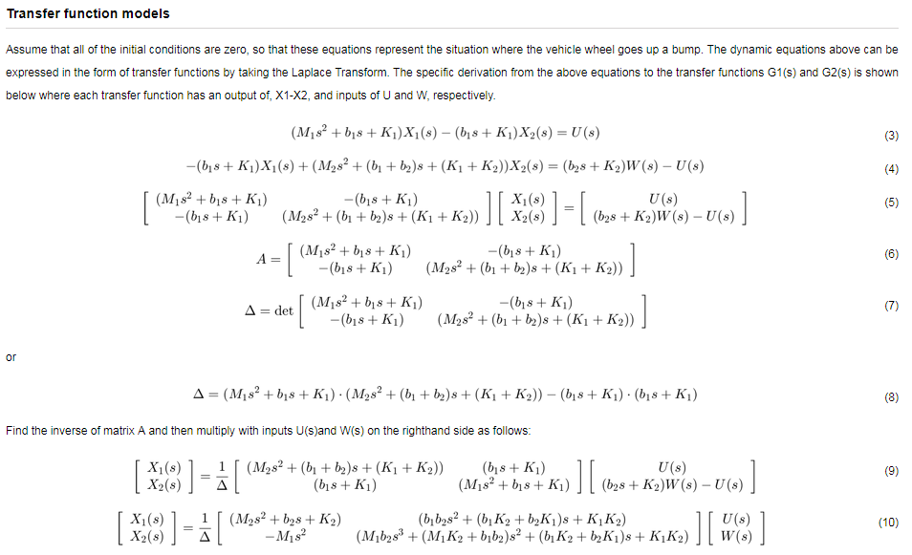

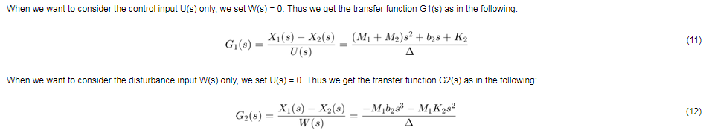

# 2.2 – System analysis

## Step response

Design requirements:

* Deflection overshoot < 5%
* Settling time < 5s

For example, when the bus runs onto a 10-cm step, the bus body will oscillate within a range of +/- 5 mm and will stop oscillating within 5 seconds.

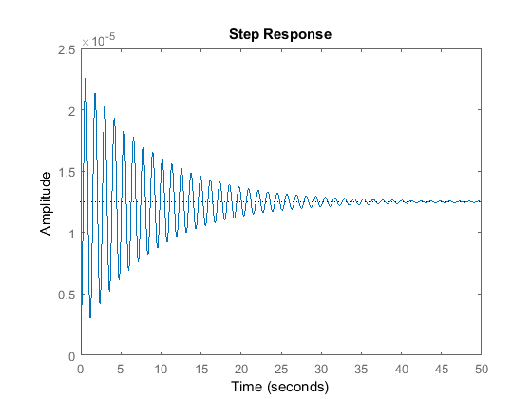

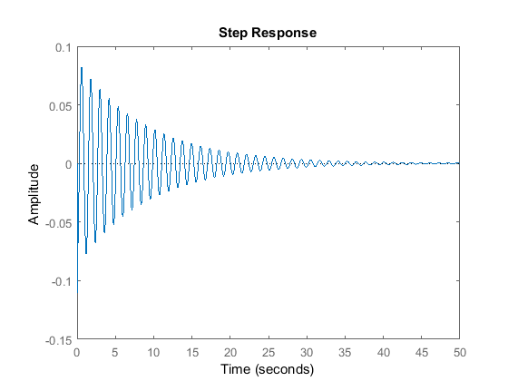

Requirements not satisfied: large overshoot (8cm), long settling time (50s).

Solution: implement a controller

## Frequency analysis

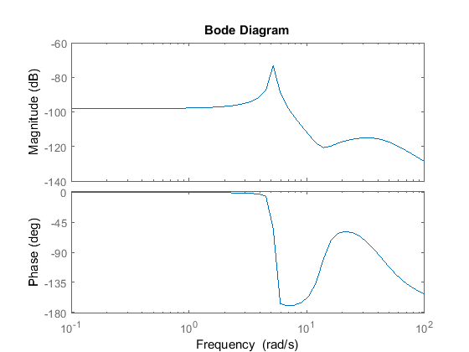

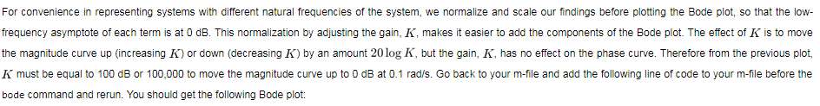

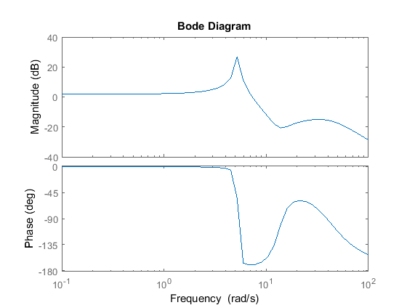

# 2.3 – PID controller design

Represent the system like (check if position of C is wrong!!!!)

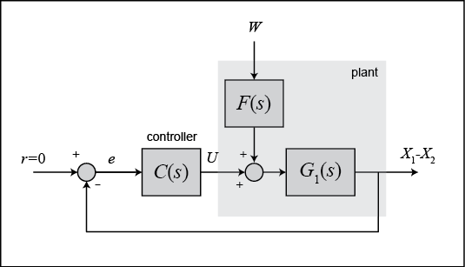

F(s)G1(s) = G2(s)

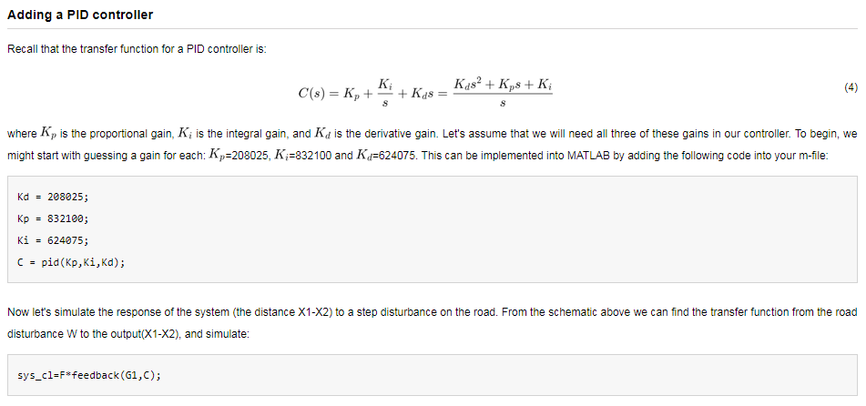

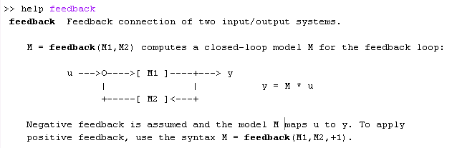

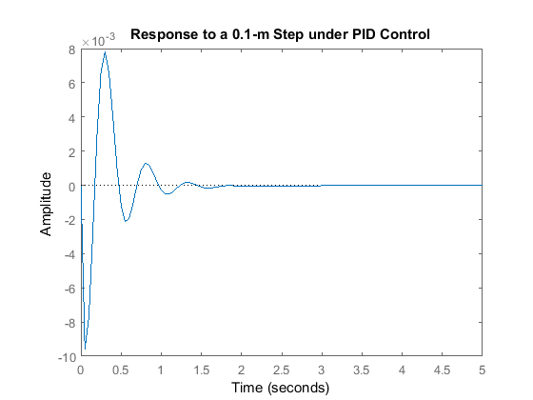

Settling time OK, but overshoot too high.

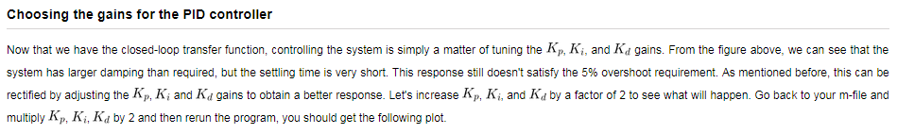

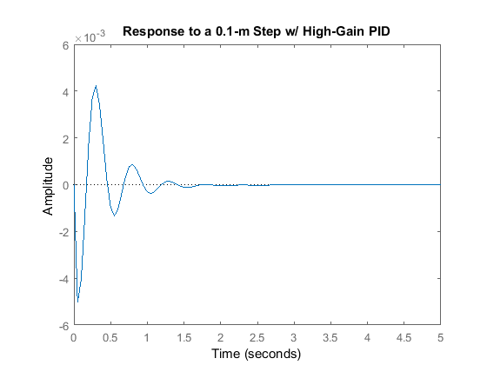

This satisfies the requirements!

# 2.4 – Simulink modeling

