NetMap
Screenshot Evidence
Assessment 9 · Real scan workflow · 22 October 2026

01 · Scan selection
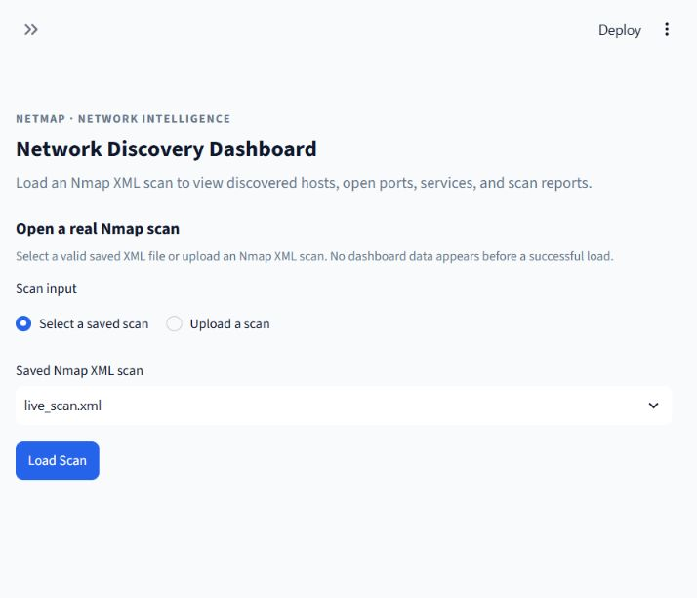
The app opens on the real-scan selection screen with no dashboard metrics or sample records.

02 · Real scan overview
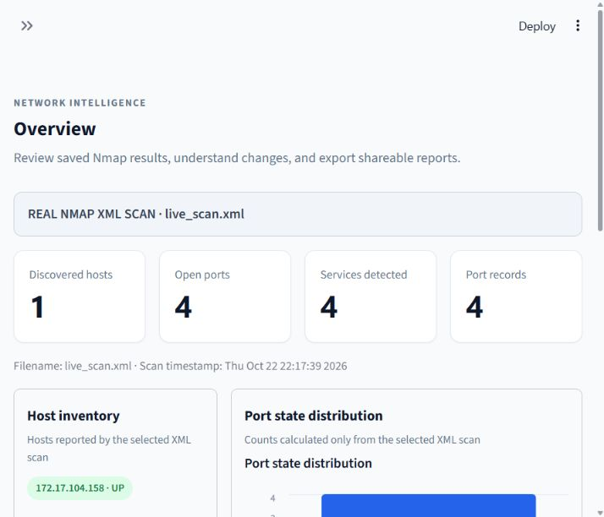
REAL NMAP XML SCAN · live_scan.xml. The scan reports 1 discovered host, 4 open ports, 4 services, and 4 port records. The visible scan timestamp is Thu Oct 22 22:17:39 2026.

03 · Host Discovery
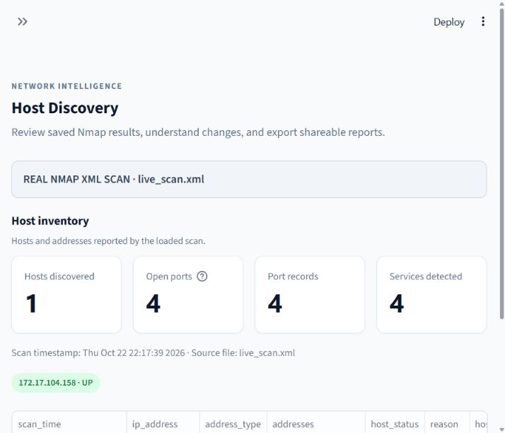
Host inventory from the selected XML: 172.17.104.158 is up; the page shows 1 host and 4 open ports.

04 · Ports & Services
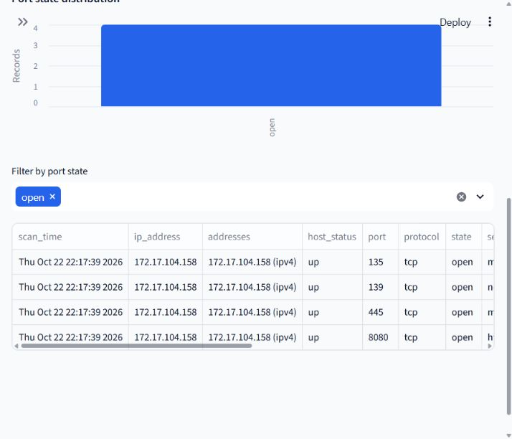
The XML-derived table shows open TCP ports 135, 139, 445, and 8080 for 172.17.104.158.

05 · Comparison
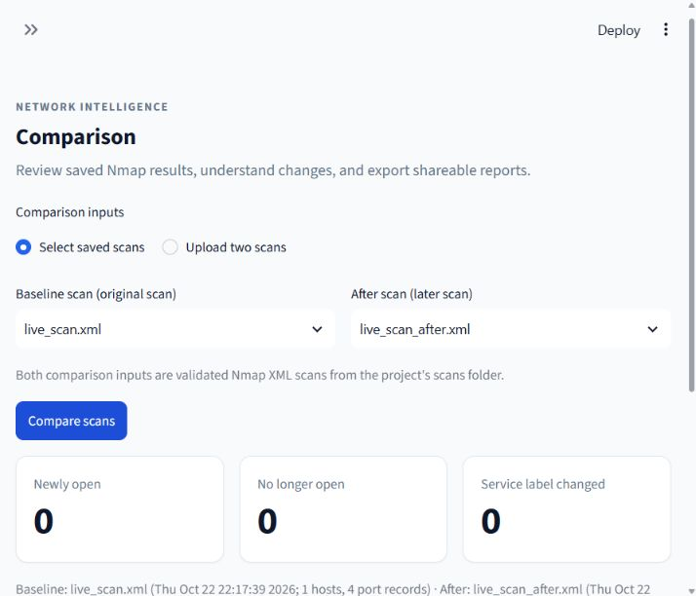
Baseline live_scan.xml compared with live_scan_after.xml. The app reports 0 newly open, 0 no-longer-open, and 0 changed service labels, with no differences detected.

06 · Reports & Exports
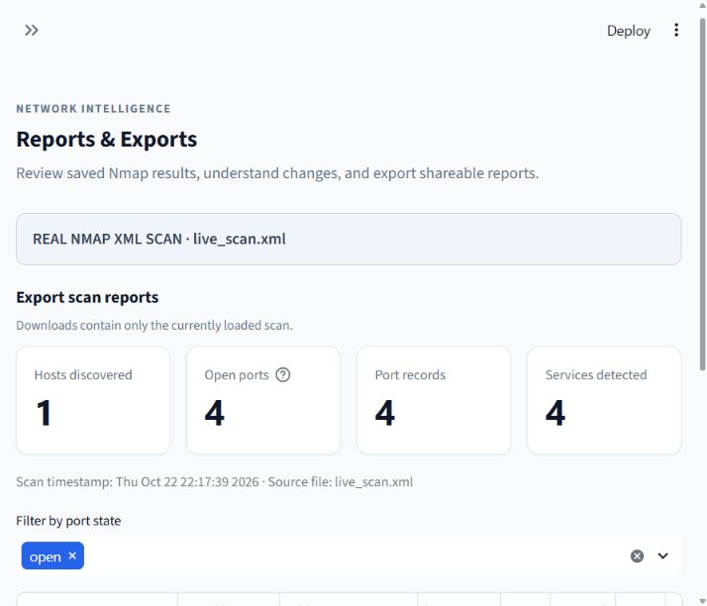
The report page is explicitly sourced from live_scan.xml and reports 1 host, 4 open ports, 4 port records, and 4 services.

07 · Export controls
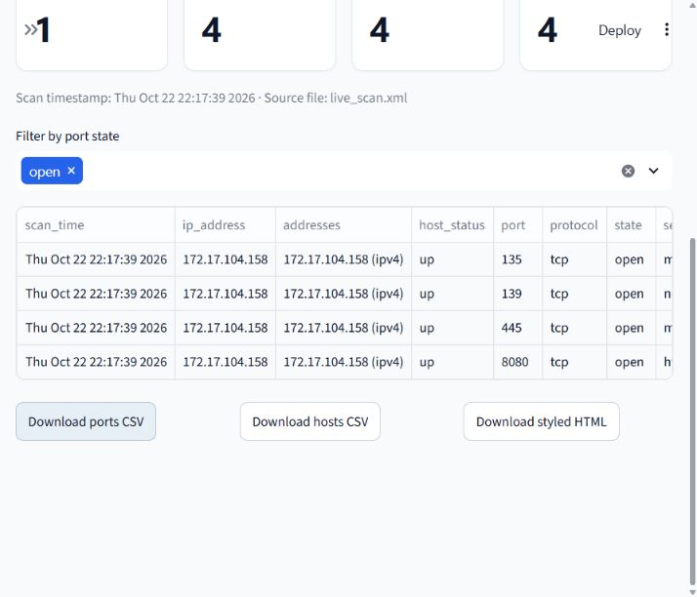
The page presents ports CSV, hosts CSV, and styled HTML exports alongside the four real-scan port records. The in-app browser did not expose the downloaded files for visual inspection in this run.

08 · Nmap command and saved output in Command Prompt
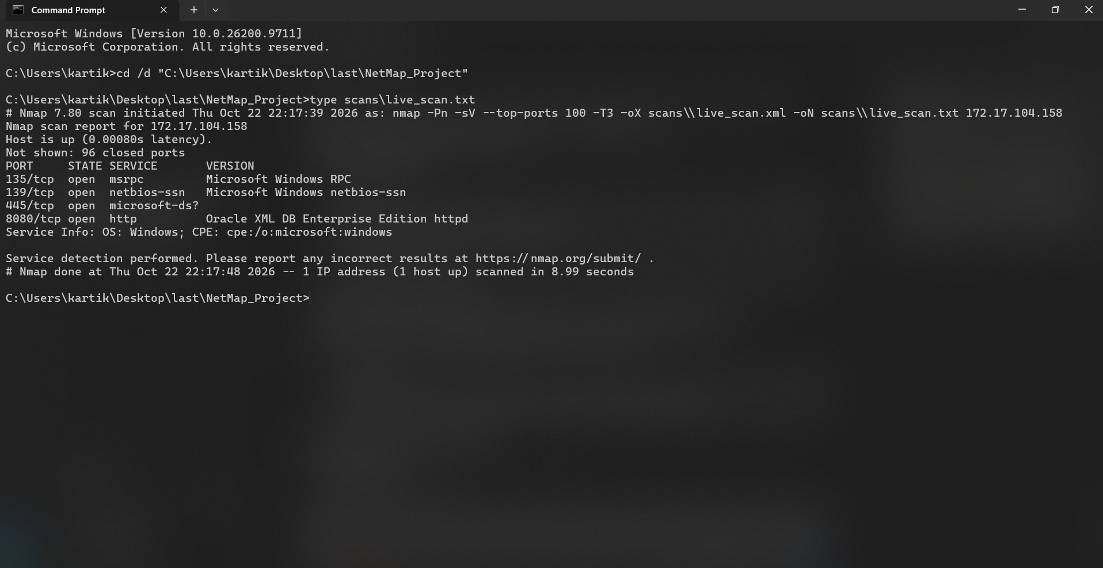
This Command Prompt shows the saved scans\live_scan.txt, including the recorded Nmap command and its result: one host up with four open ports. It displays the saved log via `type`; this screenshot does not show a new scan being run.

09 · Wireshark capture inspection
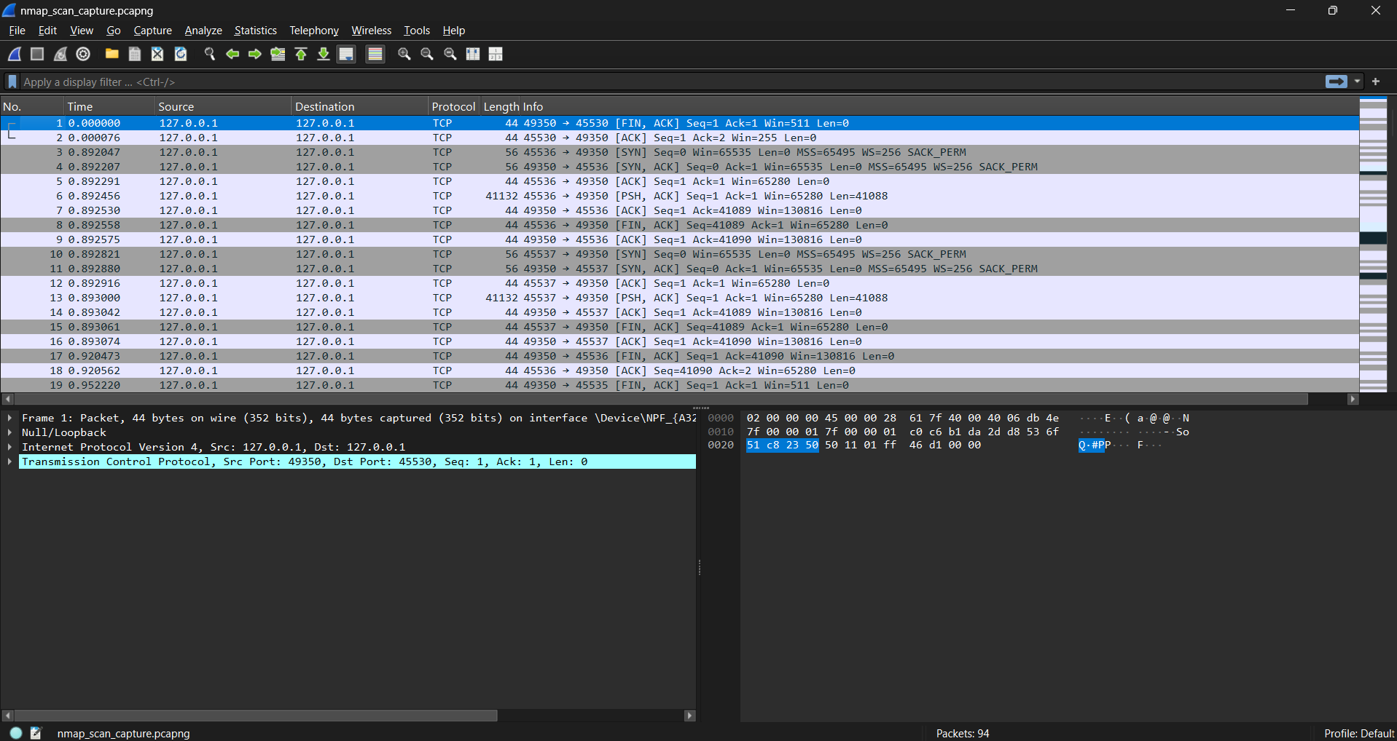
Wireshark displays nmap_scan_capture.pcapng with 94 packets. The visible packet endpoints are 127.0.0.1; this capture does not corroborate the Nmap scan of 172.17.104.158.

