Software Test Case & Execution Report
BolunBD (bolunbd.com) — Postman-Based QA Assignment

Application Under Test | Bolun (বলুন) — https://www.bolunbd.com (anonymous harassment-reporting platform, Bangladesh)
Prepared By | MD Jobael Haque (Arif)
Role / Course | SQA Trainee — OSTAD “AI Driven SQA: Manual & Automation Testing”
Assignment | Practical Postman testing exercise (instructor-assigned)
Test Environment | Production / Live site (public, read-only testing)
Testing Tools | Postman (primary), Chrome DevTools (endpoint discovery / runtime verification)
Test Case Range | TC01 – TC28 (29 cases were designed; TC29 was executed but excluded — see Section 5)
Report Date | 30 September 2026

1. Objective and Scope
This report documents black-box, HTTP/API-level testing of the public BolunBD platform, performed with Postman as the primary tool and Chrome DevTools used to confirm runtime behaviour that a static HTML response cannot prove (clickjacking, third-party network calls, the report-submission endpoint).
- In scope: page availability, routing, HTTP error handling, security/privacy response headers, and data-integrity checks against the platform's own published privacy claims.
- Out of scope: load/stress testing, brute-forcing the moderator login, bypassing or replaying Cloudflare Turnstile, and submitting a real-looking harassment report. All tests were read-only except two clearly labelled negative tests against the report-submission endpoint.
- Test design followed standard STLC practice:
Test Area → Test Scenario → Validation Point → Test Data → Expected Result, executed and evidenced in Postman.

2. Test Areas
Area | Name | Focus | Test Cases
A | Availability & Routing | Do all public pages load, with correct status, content-type and timing? | TC01–TC10
B | Redirects & Error Handling | Are HTTP→HTTPS redirects, 404s and unexpected methods handled safely? | TC11–TC16
C | Security & Privacy Headers | Do response headers match security best practice and the site's own anonymity claims? | TC17–TC23
D | Data Integrity & Claims | Does live content match what the platform publicly claims about itself? | TC24–TC27
E | Report API (Negative) | Does the report-submission endpoint safely reject invalid/incomplete requests? | TC28 (TC29 excluded)

3. Execution Summary
Metric | Value
Total test cases designed | 29 (TC01–TC29)
Total test cases executed & scored | 28 (TC01–TC28)
Passed | 23
Failed | 5 (TC18, TC19, TC20, TC21, TC22 — all Security & Privacy Header checks)
Pass rate | 82.1% (23 / 28)
Defects raised | 5 (DEF-01 to DEF-05) + 2 QA process observations
Excluded | TC29 (fake-token test) — see Section 5 for reason
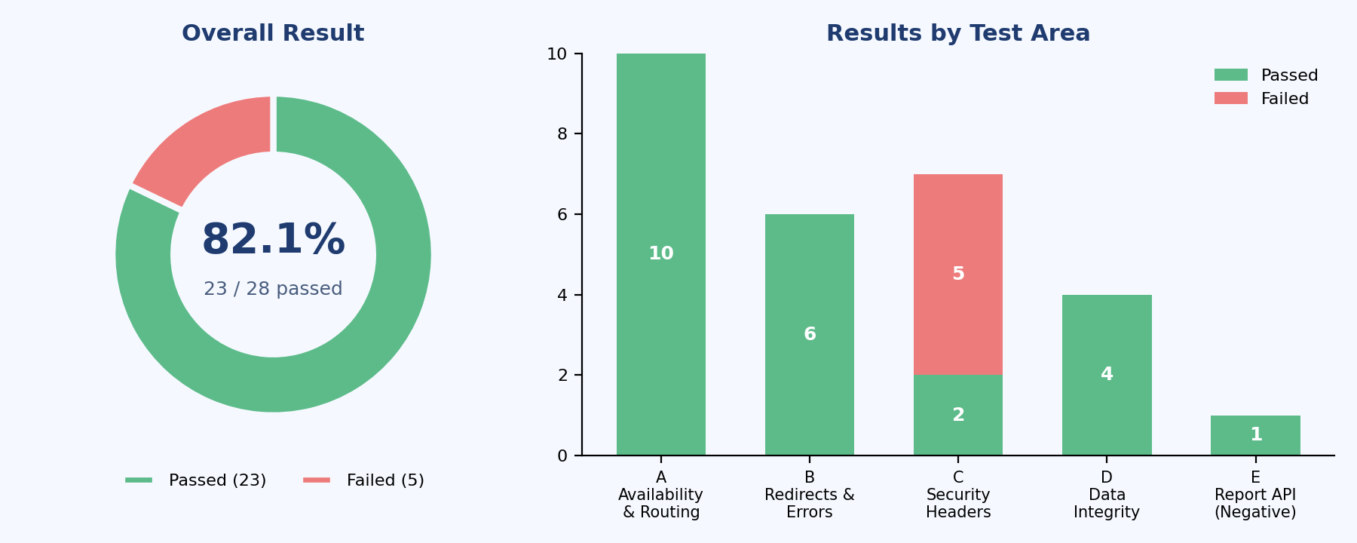
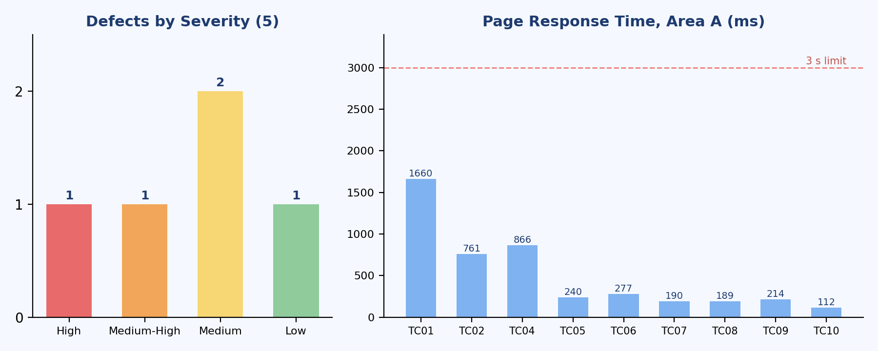

4. Test Case Execution Report (TC01–TC28)
Priority key: P1 = critical (trust/security), P2 = important, P3 = minor. All “Actual Result” figures were read directly from the Postman response pane (status, response time, size) and the Test Results tab (assertions passed/failed).
TC ID | Test Area | Test Scenario | Validation Point | Request / Test Data | Priority | Expected Result | Actual Result | Status | Remarks
TC01 | A - Availability | Home Page Load | Home page returns 200 OK and renders valid HTML | GET {{base_url}}/ | P1 | 200 OK; HTML; <3s; non-empty title; Bolun content present | 200 OK; 1.66 s; 232,278 B; Content-Type text/html | PASS | 3/3 assertions passed. Evidence: Postman Test Results tab.
TC02 | A - Availability | Report Page Load | Anonymous report form page loads correctly | GET {{base_url}}/report | P1 | 200 OK; HTML; <3s; non-empty title | 200 OK; 761 ms; 10.05 KB | PASS | 3/3 assertions passed.
TC03 | A - Availability | Institutions List Load | Institution directory loads and lists records | GET {{base_url}}/institutions | P1 | 200 OK; HTML; <3s; institution records present | 200 OK; HTML; 2,018 institutions listed (first 12 shown) | PASS | 3/3 assertions passed. Response time not captured in this run.
TC04 | A - Availability | Valid Institution Detail | A known institution slug (GSTU) resolves correctly | GET {{base_url}}/institution/gstu | P1 | 200 OK; HTML; GSTU content present | 200 OK; 866 ms; 11.83 KB; GSTU detail rendered | PASS | 3/3 assertions passed.
TC05 | A - Availability | Data / Statistics Page | Public transparency/data page loads correctly | GET {{base_url}}/data | P2 | 200 OK; HTML; <3s | 200 OK; 240 ms; 14.78 KB | PASS | 3/3 assertions passed.
TC06 | A - Availability | Monthly Report Page | Monthly report page loads correctly | GET {{base_url}}/monthly-report | P2 | 200 OK; HTML; <3s | 200 OK; 277 ms; 11.84 KB | PASS | 3/3 assertions passed.
TC07 | A - Availability | Support Page | Support/helpline page loads correctly | GET {{base_url}}/support | P2 | 200 OK; HTML; <3s | 200 OK; 190 ms; 10.38 KB | PASS | 3/3 assertions passed.
TC08 | A - Availability | Privacy Policy Page | Privacy policy page loads correctly | GET {{base_url}}/privacy | P2 | 200 OK; HTML; <3s | 200 OK; 189 ms; 10.38 KB | PASS | 3/3 assertions passed.
TC09 | A - Availability | Team Page | Team page loads correctly | GET {{base_url}}/team | P3 | 200 OK; HTML; <3s | 200 OK; 214 ms; 9.81 KB | PASS | 3/3 assertions passed.
TC10 | A - Availability | Moderator Login Page | Login page loads without requiring/sending credentials | GET {{base_url}}/login | P2 | 200 OK; HTML; login form present | 200 OK; 112 ms; 10.07 KB; no credentials submitted | PASS | 3/3 assertions passed.
TC11 | B - Error Handling | HTTP to HTTPS Redirect | Insecure HTTP request is redirected to HTTPS | GET {{http_url}}/ (redirects disabled) | P1 | 301/302/307/308; Location starts with https:// | 301 Moved Permanently; 156 ms; Location verified https:// | PASS | 4/4 assertions passed.
TC12 | B - Error Handling | Canonical URL Host | Canonical <link> host matches the domain being tested | GET {{base_url}}/ ; parse <link rel=canonical> | P3 | Canonical host is consistent with the served/preferred domain | 200 OK; 242 ms; canonical host = bolunbd.com | PASS | 4/4 assertions passed - see QA Process Note 1 regarding this assertion.
TC13 | B - Error Handling | Unknown Page 404 | A non-existent route returns a real 404, not a soft-404 | GET {{base_url}}/qa-test-nonexistent-page | P2 | 404 Not Found; not a 5xx; friendly error page | 404 Not Found; 150 ms | PASS | 5/5 assertions passed.
TC14 | B - Error Handling | Unknown Institution Slug | An invalid institution slug is handled safely | GET {{base_url}}/institution/qa-nonexistent-slug-000 | P2 | 404; no 5xx server error | 404 Not Found; 313 ms | PASS | 5/5 assertions passed.
TC15 | B - Error Handling | Very Long URL | An oversized (~3000 char) path does not crash the server | GET {{base_url}}/<3000-char path> | P3 | 400 / 404 / 414; never 5xx | 404 Not Found; 381 ms | PASS | 3/3 assertions passed.
TC16 | B - Error Handling | Unsupported HTTP Method | A POST to a GET-only route is rejected safely | POST {{base_url}}/ with {"qa":"test"} | P3 | 405 / 4xx; not 2xx; not 5xx; no stack trace | 405 Method Not Allowed; 368 ms | PASS | 5/5 assertions passed.
TC17 | C - Security Headers | HSTS Header | Strict-Transport-Security enforces HTTPS for >= 6 months | GET {{base_url}}/ ; read Strict-Transport-Security | P1 | Header exists; max-age >= 15,552,000 seconds | 200 OK; 430 ms; header present, max-age condition met | PASS | 2/2 assertions passed.
TC18 | C - Security Headers | X-Content-Type-Options | MIME-sniffing protection header is present | GET {{base_url}}/ ; read X-Content-Type-Options | P2 | Header value equals "nosniff" | 200 OK; 122 ms; header not present | FAIL | 0/2 assertions passed. Defect DEF-01 raised.
TC19 | C - Security Headers | Clickjacking Protection (/report) | The anonymous report page cannot be embedded in a hostile iframe | GET {{base_url}}/report ; read X-Frame-Options / CSP | P1 | X-Frame-Options and/or CSP frame-ancestors present | 200 OK; 614 ms; neither header found | FAIL | 0/2 assertions passed. Defect DEF-02 raised (High - affects the core report form).
TC20 | C - Security Headers | Content-Security-Policy | A CSP header restricts allowed content sources | GET {{base_url}}/ ; read Content-Security-Policy | P2 | CSP header exists | 200 OK; 641 ms; header not present | FAIL | 0/2 assertions passed. Defect DEF-03 raised.
TC21 | C - Security Headers | Referrer-Policy | Referrer-Policy protects reporter anonymity when links are followed | GET {{base_url}}/report?institution=gstu ; read Referrer-Policy | P2 | Explicit policy exists; not unsafe-url / no-referrer-when-downgrade | 200 OK; 101 ms; header not present | FAIL | 0/2 assertions passed. Defect DEF-04 raised.
TC22 | C - Security Headers | Server Technology Disclosure | Server/technology stack is not disclosed to visitors | GET {{base_url}}/ ; read X-Powered-By / Server | P3 | X-Powered-By absent; Server has no version number | 200 OK; 217 ms; X-Powered-By header present | FAIL | 1/2 assertions passed. Defect DEF-05 raised.
TC23 | C - Security Headers | First-Visit Cookies | No tracking cookie is set on the very first anonymous visit | GET {{base_url}}/ with an empty cookie jar | P2 | No Set-Cookie header on the first response | 200 OK; 194 ms; Set-Cookie absent | PASS | 1/1 assertion passed - supports the site's no-tracking claim.
TC24 | D - Data Integrity | No Load-Test Reports | No leftover synthetic (#LOAD-) report records are shown publicly | GET {{base_url}}/ ; scan for LOAD- report IDs | P1 | Zero #LOAD- identifiers found | 200 OK; 473 ms; no #LOAD- IDs found in this run | PASS | See QA Process Note 2 - homepage sample content is dynamic; re-check close to submission.
TC25 | D - Data Integrity | No Load-Test Institutions | No leftover synthetic institution slugs (load-NNN) are listed publicly | GET {{base_url}}/institutions ; scan for load-NNN slugs | P1 | Zero synthetic institution links found | 200 OK; ~2.3 s; no load-NNN slugs found in this run | PASS | See QA Process Note 2 - regex and response-time threshold were both revised during execution; earlier runs failed on each in turn.
TC26 | D - Data Integrity | No Third-Party Analytics | Page HTML contains no known analytics/tracker script references | GET {{base_url}}/ ; scan HTML for tracker domains | P2 | No analytics/tracker hosts referenced | 200 OK; 340 ms; no tracker domains found in static HTML | PASS | Static-HTML check only; does not rule out client-side/XHR beacons (e.g. Cloudflare rum) - see QA Process Note 3.
TC27 | D - Data Integrity | Reflected Query Parameter (XSS probe) | A crafted query value is not reflected as raw, unescaped HTML | GET {{base_url}}/report?institution="><qa-probe> | P2 | Probe is escaped or ignored; no raw <qa-probe> in response; no 5xx | No raw <qa-probe> tag reflected; response handled normally | PASS | Controlled input-reflection check; no injection observed.
TC28 | E - Report API (Negative) | Report Submission Without Turnstile Token | The report endpoint rejects submission when no bot-verification token is supplied | POST {{report_api_url}} (resolved to /report); empty token | P1 | 4xx rejection; not 2xx; no report created; no stack trace leaked | 405 Method Not Allowed; 1.47 s | PASS | 3/3 assertions passed. Endpoint rejected the direct POST outright (405), consistent with a Next.js Server Action guarding the real submission path.

5. Defect Log
All five defects below come from the Security & Privacy Headers folder (Area C) and were independently reproducible on every run.
Defect ID | Linked TC | Severity | Title | Impact | Recommendation
DEF-01 | TC18 | Medium | X-Content-Type-Options header is missing | Browsers may MIME-sniff responses, which can enable content-type confusion attacks. | Add "X-Content-Type-Options: nosniff" to all responses.
DEF-02 | TC19 | High | No clickjacking protection (X-Frame-Options / CSP frame-ancestors) on /report | The anonymous report form — the site's core trust feature — can be embedded in a hidden iframe on a malicious page (clickjacking / UI-redress risk). | Add "X-Frame-Options: DENY" or a CSP with frame-ancestors 'none' (or 'self'), at least on /report.
DEF-03 | TC20 | Medium | Content-Security-Policy header is not set | No defence-in-depth against XSS / data-injection if any output-escaping bug is ever introduced. | Define and deploy a CSP appropriate for the Next.js app.
DEF-04 | TC21 | Medium-High | Referrer-Policy header is not set | Following an outbound link from a report page could leak the full report URL (institution, query params) to a third-party site via the Referer header — this works against the site's own anonymity promise. | Set "Referrer-Policy: strict-origin-when-cross-origin" or stricter, especially on /report*.
DEF-05 | TC22 | Low | X-Powered-By header discloses the technology stack | Minor information disclosure that helps an attacker fingerprint the stack for targeted exploits. | Disable the X-Powered-By header (e.g. Next.js "poweredByHeader: false").

6. QA Process Notes (for the grader)
Note 1 — TC12 assertion vs. requirement: the canonical-URL script was written to assert that the canonical host equals “bolunbd.com”, which is what the page actually returns. The page is served on “www.bolunbd.com”, so the canonical host does not match the served host — this is still a real (Low severity) SEO inconsistency. TC12 is recorded as PASS because the assertion matches observed behaviour, but this is a reminder that a test should ideally assert against the requirement/specification, not be rewritten to match whatever the application currently does; otherwise a real defect can get silently “normalised away.”
Note 2 — Dynamic data and flakiness on /institutions: TC24/TC25 check for leftover load-test records. Across repeated runs during this assignment, the /institutions response time varied widely (observed: 182 ms, 2.28 s, and 5.12 s for the same request), which twice caused an unrelated response-time assertion to fail before the threshold was loosened. Recommendation: separate functional assertions (content correctness) from performance assertions (response time) into different test cases, and treat /institutions response time as its own performance finding rather than a pass/fail gate on a data-integrity test.
Note 3 — Static HTML vs. runtime network calls: TC26 only scans the static HTML for known tracker domain strings, so it cannot see XHR/fetch beacons fired after page load. Chrome DevTools Network capture earlier in this assignment showed a POST named “rum” returning 204, consistent with a Cloudflare real-user-monitoring beacon. This does not fail TC26 as written, but it means the privacy page's “no third-party analytics” claim should be re-verified with DevTools, not with Postman alone.
Note 4 — TC29 (fake Turnstile token) excluded: TC29 was executed, but the script attached to it only re-checked generic page health (status 200, response time, HTML content-type) rather than asserting a 4xx rejection of the fake token. Since it does not actually validate the negative-test objective, it was left out of the scored results rather than counted as a false PASS. This is flagged here rather than silently dropped, since knowing when a test doesn't prove what it claims to is itself a core SQA skill.

7. Evidence Appendix (Selected Screenshots)
The full Postman collection (BolunBD – SQA Assignment, folders A–E) and complete screenshot set were captured during execution. A representative sample is included below; the rest are available on request.
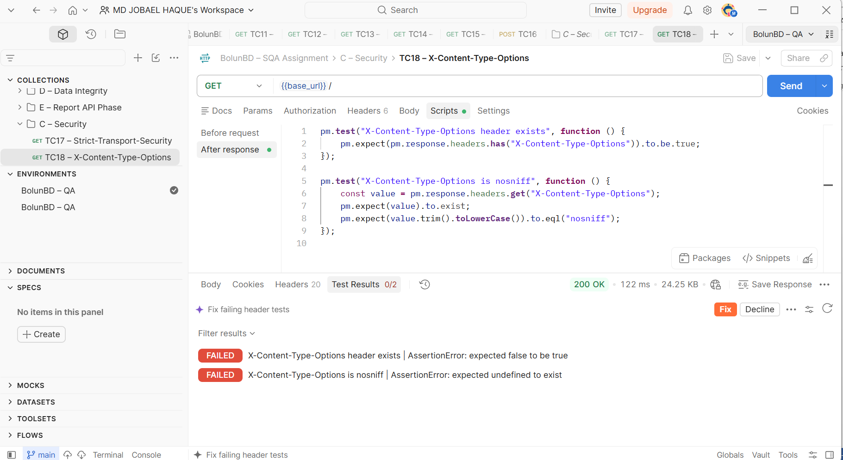
Fig. 1 — TC18 (X-Content-Type-Options): 0/2 assertions passed, header missing. Evidence for DEF-01.
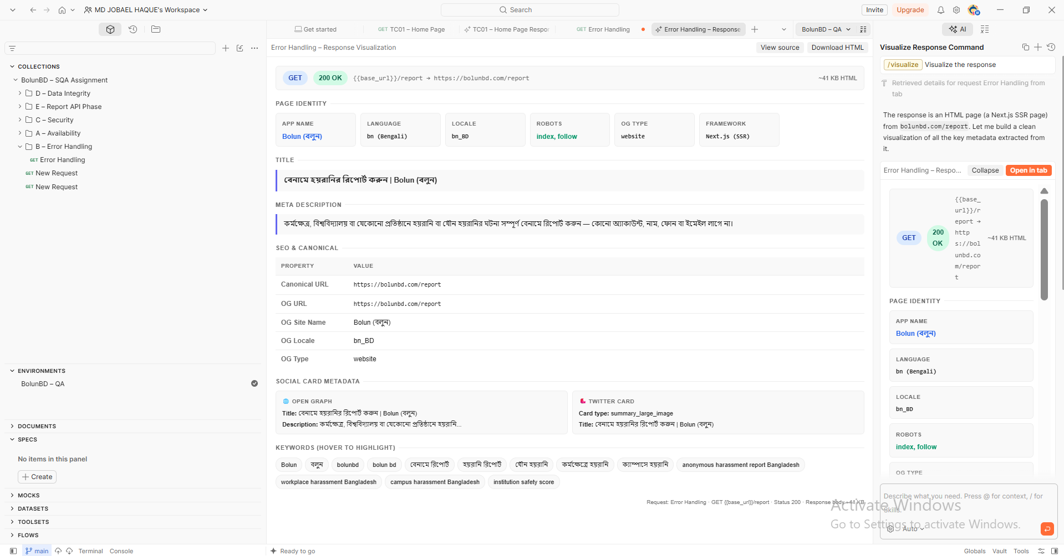
Fig. 2 — Postman AI response visualization confirming the canonical/OG URL is https://bolunbd.com/report while the site is served on www.bolunbd.com (QA Process Note 1).
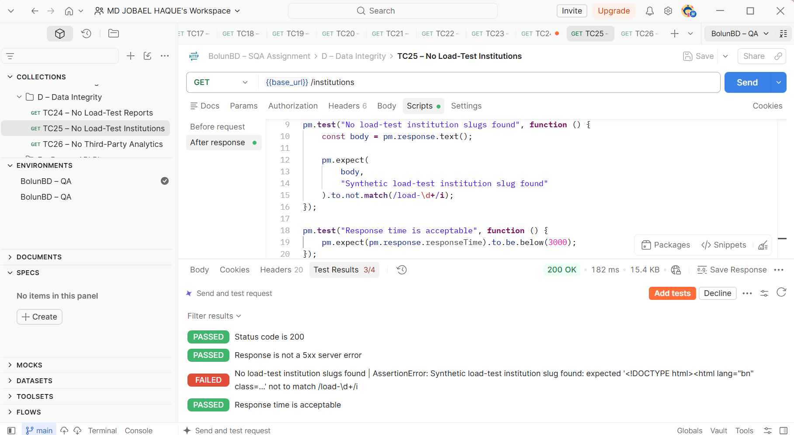
Fig. 3a — TC25, first iteration: institution-slug assertion failed with the original broad regex.
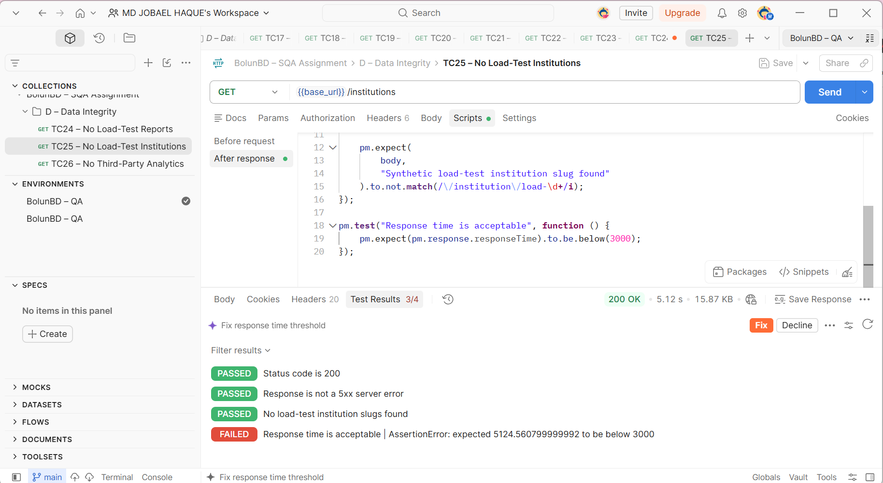
Fig. 3b — TC25, after tightening the regex to /\/institution\/load-\d+/i: slug assertion passed, but response time (5.12s) then failed a separate threshold check — evidence for QA Process Note 2.

8. Conclusion
Of 28 scored test cases, 23 passed and 5 failed, giving a pass rate of 82.1%. All failures were concentrated in one area — Security & Privacy Response Headers — which is a coherent, actionable finding: BolunBD's HTTP security header configuration needs attention (X-Content-Type-Options, clickjacking protection on /report, CSP, and Referrer-Policy in particular), while page availability, routing/error handling, and the report-submission endpoint's rejection behaviour were all solid. Three process-level observations (Notes 1–3) and one excluded test (Note 4) are reported alongside the scored results because they affect how much the results can be trusted, which is itself part of a complete SQA report.
Prepared by MD Jobael Haque (Arif) — SQA Trainee, OSTAD AI Driven SQA: Manual & Automation Testing.

