# Model Comparison Report

Generated at: E:\Thesis\Thesis\thesis_program\results\report.docx

Summary of model predictions on test_images (4 good + 4 bad).

## Accuracy Summary

|  |  |  |
| --- | --- | --- |
| Model | Correct / Total | Accuracy (%) |
| DenseNet121 | 7 / 8 | 87.50 |
| EfficientNetB0 | 7 / 8 | 87.50 |
| MobileNetV2 | 8 / 8 | 100.00 |
| ResNet50 | 8 / 8 | 100.00 |

## Composite Visualization

Below is the combined visualization (one row per model, 8 images each).

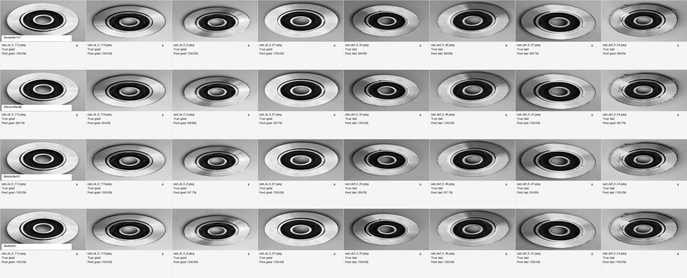

## Detailed Per-Image Results

### DenseNet121

|  |  |  |  |  |
| --- | --- | --- | --- | --- |
| Image | True | Predicted | Confidence | Correct |
| cast_ok_0_112.jpeg | good | good | 100.0% | Yes |
| cast_ok_0_114.jpeg | good | good | 100.0% | Yes |
| cast_ok_0_9.jpeg | good | good | 100.0% | Yes |
| cast_ok_0_97.jpeg | good | good | 100.0% | Yes |
| cast_def_0_33.jpeg | bad | bad | 99.9% | Yes |
| cast_def_0_40.jpeg | bad | bad | 99.8% | Yes |
| cast_def_0_41.jpeg | bad | bad | 99.7% | Yes |
| cast_def_0_54.jpeg | bad | good | 98.6% | No |

### EfficientNetB0

|  |  |  |  |  |
| --- | --- | --- | --- | --- |
| Image | True | Predicted | Confidence | Correct |
| cast_ok_0_112.jpeg | good | good | 99.7% | Yes |
| cast_ok_0_114.jpeg | good | good | 94.5% | Yes |
| cast_ok_0_9.jpeg | good | good | 99.8% | Yes |
| cast_ok_0_97.jpeg | good | good | 95.7% | Yes |
| cast_def_0_33.jpeg | bad | bad | 100.0% | Yes |
| cast_def_0_40.jpeg | bad | bad | 100.0% | Yes |
| cast_def_0_41.jpeg | bad | bad | 100.0% | Yes |
| cast_def_0_54.jpeg | bad | good | 83.7% | No |

### MobileNetV2

|  |  |  |  |  |
| --- | --- | --- | --- | --- |
| Image | True | Predicted | Confidence | Correct |
| cast_ok_0_112.jpeg | good | good | 100.0% | Yes |
| cast_ok_0_114.jpeg | good | good | 100.0% | Yes |
| cast_ok_0_9.jpeg | good | good | 97.7% | Yes |
| cast_ok_0_97.jpeg | good | good | 100.0% | Yes |
| cast_def_0_33.jpeg | bad | bad | 99.0% | Yes |
| cast_def_0_40.jpeg | bad | bad | 97.1% | Yes |
| cast_def_0_41.jpeg | bad | bad | 94.9% | Yes |
| cast_def_0_54.jpeg | bad | bad | 100.0% | Yes |

### ResNet50

|  |  |  |  |  |
| --- | --- | --- | --- | --- |
| Image | True | Predicted | Confidence | Correct |
| cast_ok_0_112.jpeg | good | good | 100.0% | Yes |
| cast_ok_0_114.jpeg | good | good | 100.0% | Yes |
| cast_ok_0_9.jpeg | good | good | 100.0% | Yes |
| cast_ok_0_97.jpeg | good | good | 100.0% | Yes |
| cast_def_0_33.jpeg | bad | bad | 100.0% | Yes |
| cast_def_0_40.jpeg | bad | bad | 100.0% | Yes |
| cast_def_0_41.jpeg | bad | bad | 100.0% | Yes |
| cast_def_0_54.jpeg | bad | bad | 100.0% | Yes |