Final Project

clinic website

Jobanpreet Singh

Table of Contents

Project Proposal 2

Project Introduction and Overview 2

Project Specifications 2

Project Goal 2

Scope 2

Project Specifications 2

Target Audience 3

Project Plan 3

Project Deliverables 3

Project Tasks and Milestones 3

Resources Required 4

Project Risks and Assumptions 4

Project Report 4

Aim and Introduction 4

Analysis 4

Functional and Non-Functional 4

Non-Functional 5

Design 6

Project Testing 11

System Usability Testing 12

Testing 12

User Manual 14

System Overview 14

System Summary 14

System Configuration 14

User Access Levels 14

# Project Proposal

# Project Introduction and Overview

This project is based on a Medical center. In this ASP.net project there are two types of account one for admin and other for the user. Admin can add, edit, delete, and access details of the candidates. Admin can also edit, delete, and access details of patients. Also, new patients can sign up for the application. User can add, edit, delete, and access details of their accounts.

# Project Specifications

## Project Goal

The main goal of this project is to implement an online web application using Asp.Net. The name of this web application will be “Health Center” In this application there is admin and user. Admin can manage Patients and staff by adding, editing, deleting, and checking details. Also, admin can edit, delete, and check details for various Locations of clinic. Moreover, user can add, edit, delete, and check details for patients, staff.

## Scope

The main goal of this application is to implement a registration of new patients by online application. This project is for 4 weeks.

# Project Specifications

* Secure login and registration for the Patients.
* Secure login and admin registration for admin.
* Admin can add, edit, delete candidates
* Admin can manage the Specialist.
* Admin can edit, delete, and access details of Patients, Locations and Staff.
* Patients can book appointment with doctor after registration.

## 

## Target Audience

The main target audience for this project will the people who are intended to see a doctor regarding their health. The target is on all age group.

# Project Plan

## Project Deliverables

|  |  |
| --- | --- |
| **Deliverable** | **Description** |
| Project Planning | This document. Introduces the project and elaborates its details and requirements. |
| Project Coding | The application being made. Marking will be based on the GUI, functionality, implementation, and testing. |
| Implementation Details | This document elaborates on the projects details as well as its analysis, design, and implementation. |
| Final Documentation and Report | This includes the final documentation of the project. |

## Project Tasks and Milestones

|  |  |  |  |  |  |  |  |  |  |  |  |  |  |  |  |  |  |  |  |  |  |
| --- | --- | --- | --- | --- | --- | --- | --- | --- | --- | --- | --- | --- | --- | --- | --- | --- | --- | --- | --- | --- | --- |
| Project Stages | Major Activities | Week-1 | | | | Week-2 | | | | | Week-3 | | | | | | Week-4 | | | | |
| Planning | Technology Research |  |  |  |  | |  |  |  |  |  |  |  |  |  |  |  |  | |  |  |
| First Meeting |  |  |  |  | |  |  |  |  |  |  |  |  |  |  |  |  | |  |  |
| Project Proposal and Documentation |  |  |  |  | |  |  |  |  |  |  |  |  |  |  |  |  | |  |  |
| Phase -1 | Database Design |  |  |  |  | |  |  |  |  |  |  |  |  |  |  |  |  | |  |  |
| User Interface Design |  |  |  |  | |  |  |  |  |  |  |  |  |  |  |  |  | |  |  |
| Phase-2 | Identity framework implementation |  |  |  |  | |  |  |  |  |  |  |  |  |  |  |  |  | |  |  |
| Admin Implementation |  |  |  |  | |  |  |  |  |  |  |  |  |  |  |  |  | |  |  |
| Candidate Implementation |  |  |  |  | |  |  |  |  |  |  |  |  |  |  |  | |  |  |  |
| Testing |  |  |  |  | |  |  |  |  |  |  |  |  |  |  |  | |  |  |  |
| Final Phase | Final Documentation |  |  |  |  | |  |  |  |  |  |  |  |  |  |  |  | |  |  |  |

## Resources Required

* Microsoft office, excel
* Identity framework
* Asp.Net framework
* Windows Operating System 10 64-bit Processors
* 8 GB or more RAM.

## Project Risks and Assumptions

* Project can take more time than estimation
* It is not feasible to perform all types of testing.

# Project Report

## Aim and Introduction

The project aims to introduce a Clinic web application which will help patients to register online and book their appointment with doctor.

# Analysis

### Functional and Non-Functional

The functional requirements of this project are divided into two types. One for Admin, and one for patient as a user.

|  |  |
| --- | --- |
| **Users** | **Functional Requirements** |
| **Admin** | * Login/logout * Register new patient * Manage Doctor’s list * Manage Patients. * Delete both Doctors and Patients * View booked appointments |
| **User (Patient)** | * Login/logout * New Patient can register themselves. * Patient can add, edit, delete, and check details of the existing ones. * Patients can vote for candidates. |

### Non-Functional

|  |  |
| --- | --- |
| **Operational** | * The system should able to run on all web browsers and accessible via mobiles |
| **Security** | * Only Administrators have full access to the system.. |

# Design

**Home Page**

This is the landing page of the web app. It consists- Home, Patient, Staff, Location, Book Appointment, Specialist, login, and register options on the navigation menu. On the right side of website there is Logo of the Website.

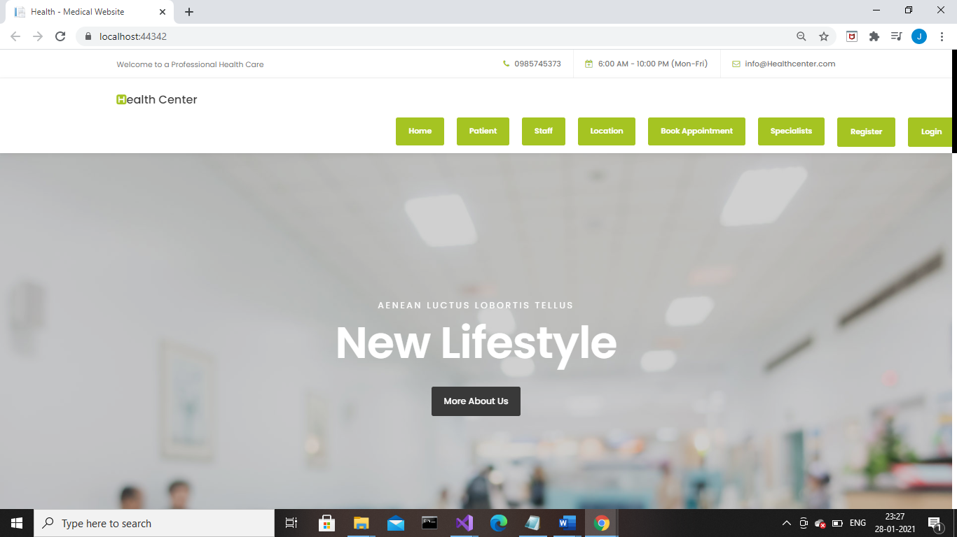

**Patient page**

This page helps Patients to register by clicking on Create new and next page will open. Patient can fill the form and register themselves.

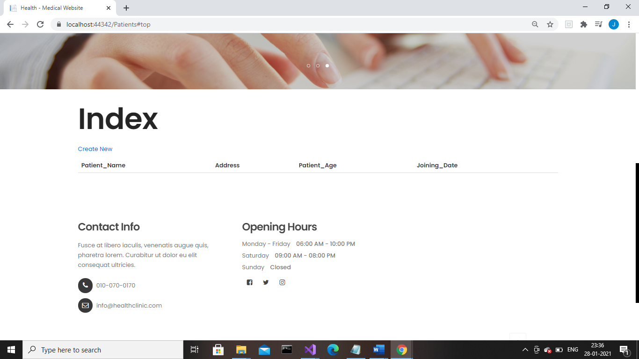

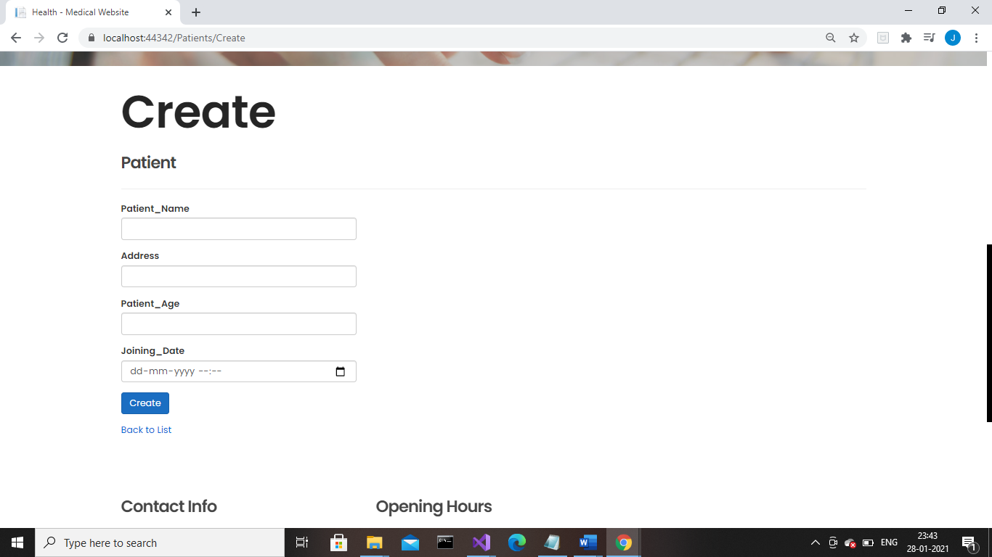

**Staff**

With the help of this page user can view the list of staff and admin can add new staff, edit and delete. 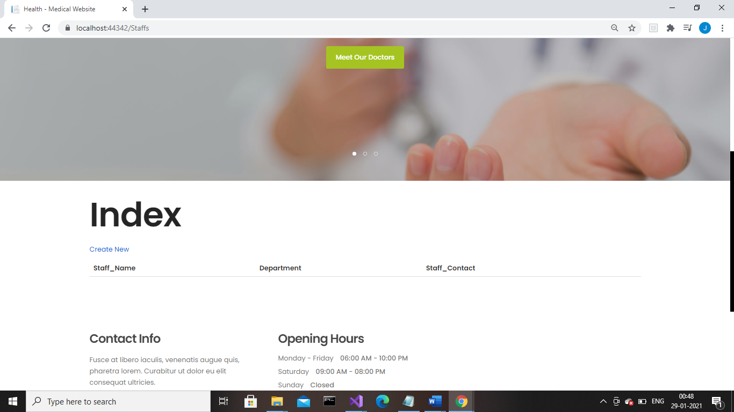

**Book Appointment**

With the help of this page patient can book their appointment by registering on web application.

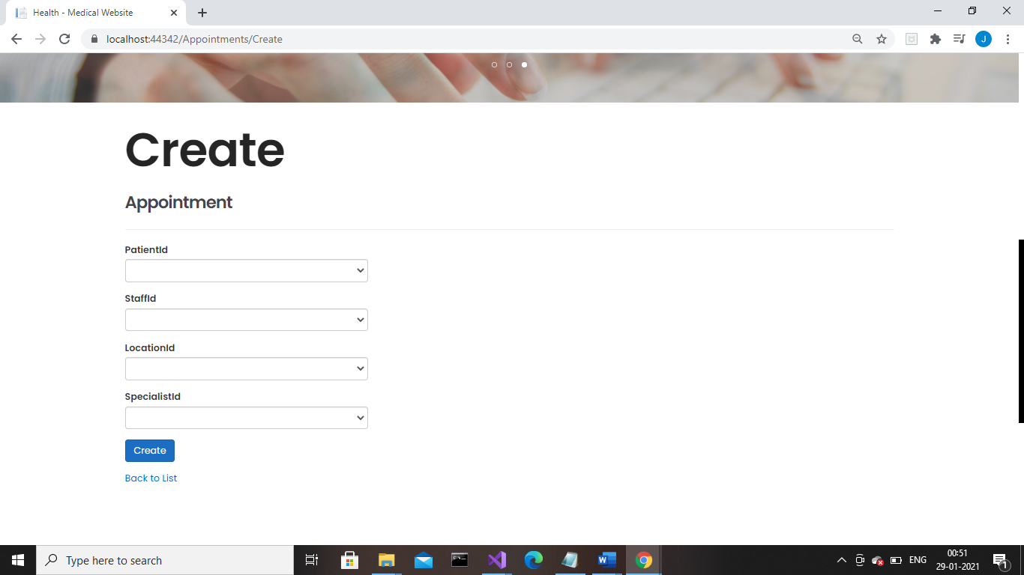

**Login Page View**

With the help of this page the registered person can login themselves by using their log in credentials.

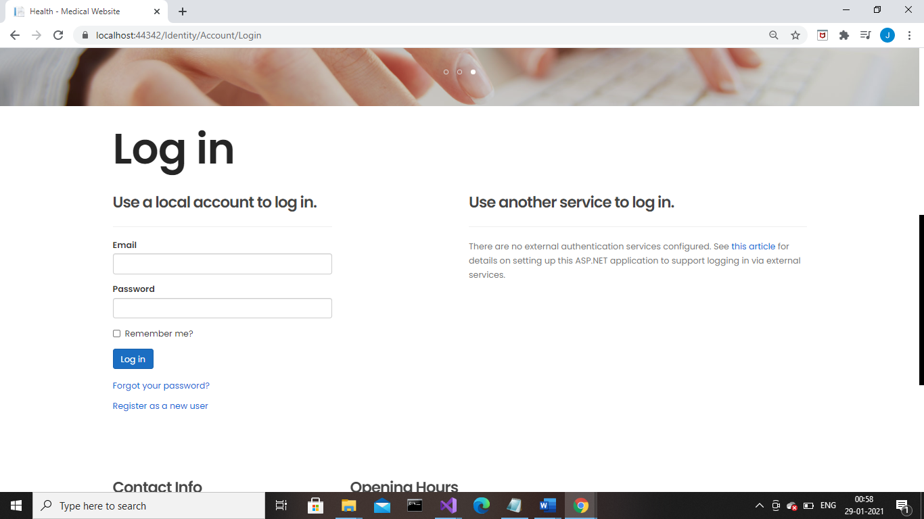

**Register page View**

This Page will help a user to register himself. So, he can Log in into the web application by using his log in credential.

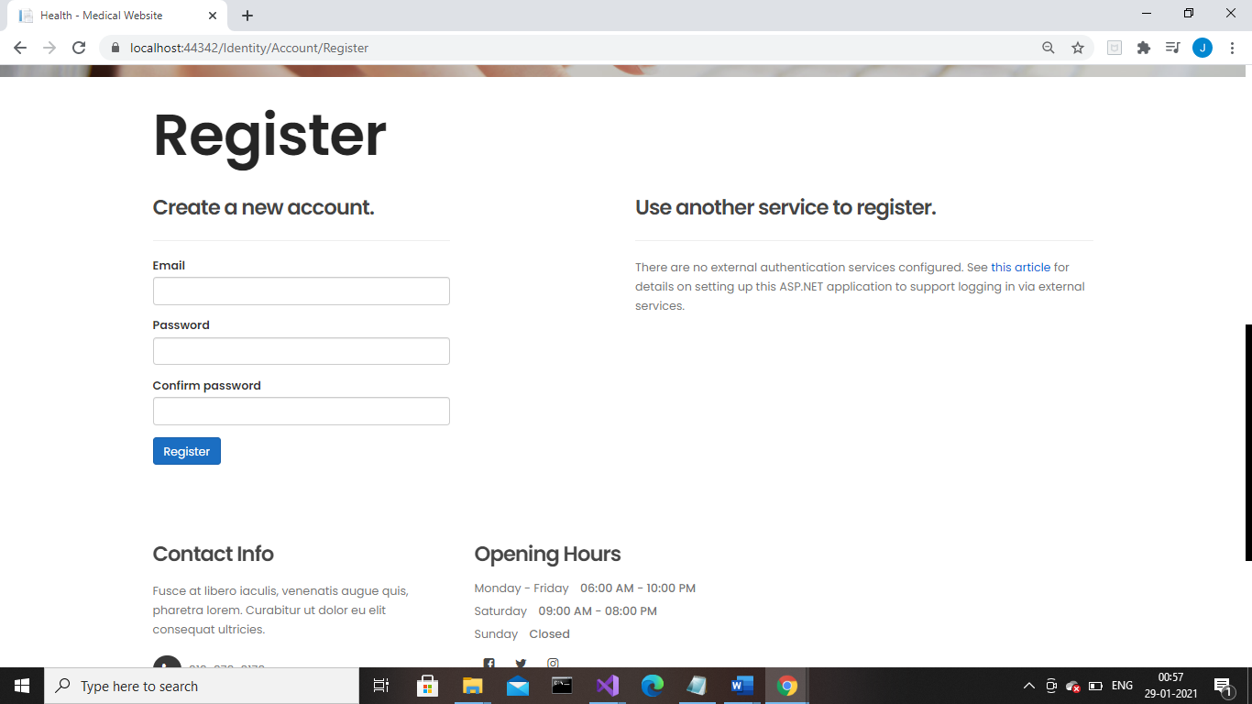

|  |  |  |  |  |  |
| --- | --- | --- | --- | --- | --- |
| **Test Case ID** | | TC1 | | | |
| **Test Case Title** | | verify the launching of web app | | | |
| **Pre-Conditions** | | Browser the web app | | | |
| **Post-Conditions** | | Website should be launched successfully | | | |
| **Step No.** | **Test Step** | **Input Data** | **Expected Result** | **Actual Result** | **Test Step Result** |
| 1 | open [project](http://www.authordeus.azurewebsites.com) in Visual studio |  | website index page should open | As Expected, | Pass |
| 2 | Close the Home page by clicking close button on browser |  | Website should close. | As Expected, | Pass |
| 3 | Manually Launched website using localhost |  | website home page should open | As Expected, | Pass |

# Project Testing

Test Case 1

**Test Case 2**

|  |  |  |  |  |  |
| --- | --- | --- | --- | --- | --- |
| **Test Case ID** | | TC2 | | | |
| **Priority** | | High | | | |
| **Test Case Title** | | Verify website Home Page interface | | | |
| **Pre-Conditions** | | Open website in a browser | | | |
| **Post-Conditions** | | The home page interface should correct and working correctly. | | | |
| **Step No.** | **Test Step** | **Input Data** | **Expected Result** | **Actual Result** | **Test Step Result** |
| 1 | Verify Home Page |  | should display all options | As Expected, | Pass |
| 2 | Verify navigation bar |  | Following options should be available in the navigation bar   * Home * vote * Candidates * Voter Sign up * Login * Register Vote Admin | As expected, | Pass |

## System Usability Testing

### Testing

**Tester 1**

|  |  |  |  |  |  |  |
| --- | --- | --- | --- | --- | --- | --- |
| **Tester –1** | | **Answer Scale** | | | | |
| **No.** | **Question** | **Strongly Disagree (1)** | **Disagree (2)** | **Normal (3)** | **Agree (4)** | **Strongly Agree (5)** |
| 1 | I think that I would like to use this system frequently |  |  |  |  |  |
| 2 | I found the system complex |  |  |  |  |  |
| 3 | I thought the system was easy to use |  |  |  |  |  |
| 4 | I found the various functions in this system were well-integrated |  |  |  |  |  |
| 5 | I thought there was too much inconsistency in this system |  |  |  |  |  |
| 6 | I would imagine that most people would learn to use this system very quickly |  |  |  |  |  |
| 7 | I felt very confident using the system |  |  |  |  |  |

**Tester-2**

|  |  |  |  |  |  |  |
| --- | --- | --- | --- | --- | --- | --- |
| **Tester –2** | | **Answer Scale** | | | | |
| **No.** | **Question** | **Strongly Disagree (1)** | **Disagree (2)** | **Normal (3)** | **Agree (4)** | **Strongly Agree (5)** |
| 1 | I think that I would like to use this system frequently |  |  |  |  |  |
| 2 | I found the system complex |  |  |  |  |  |
| 3 | I thought the system was easy to use |  |  |  |  |  |
| 4 | I found the various functions in this system were well-integrated |  |  |  |  |  |
| 5 | I thought there was too much inconsistency in this system |  |  |  |  |  |
| 6 | I would imagine that most people would learn to use this system very quickly |  |  |  |  |  |
| 7 | I felt very confident using the system |  |  |  |  |  |

# User Manual

### System Overview

Health Clinic, in this ASP.net project there are two types of account one for admin and other for the patient as a user. Admin can add, edit, delete, and access details of the Patients, staff, and can access the booked appointments. Patients can book appointment online after register themselves. The web application can be accessed via local host.

To register, just press the "Register!" button. From the Navbar.

## System Summary

### System Configuration

Health Clinic is a web application developed using Microsoft Visual Studio 2019. It will run on most modern web browsers and will not require any special system configuration. It will need internet access to operate as a web application.

### User Access Levels

Only registered users can access the features of the app like Book appointment, Register themselves as a patient. User can access the website without registration but can’t make any change without registration.