**WorkFlow of LinkedIn Post Paraphraser Project**

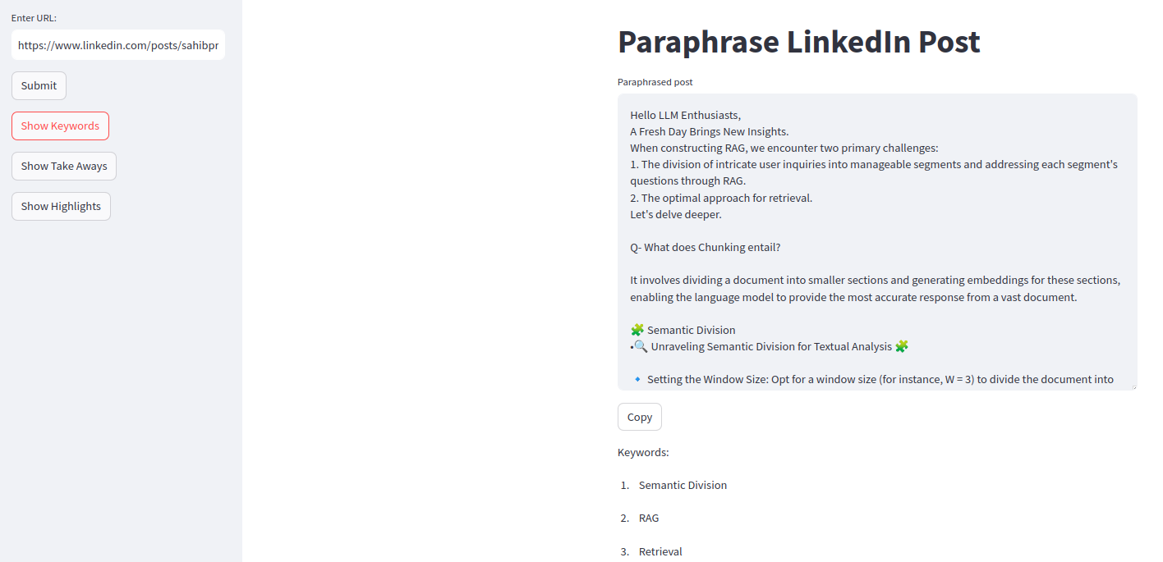

Steps:

1. User enter a LinedIn Post Url.

2. If URL is valid , it is passed to WebBaseLoader for extracting all content present on web page.

3. The extracted content is then passed to LLM for extracting only Post content.

4. The extracted post content is passed to LLM for Paraphrasing.

5. Paraphrased post is then passed to LLM for extracting Keywords , Highlights and Take aways.

Technologies used:

Python

Framework: LangChain , Streamlit (for user inteface)

API: OpenAI API (Model=gpt-4)

FlowChart:

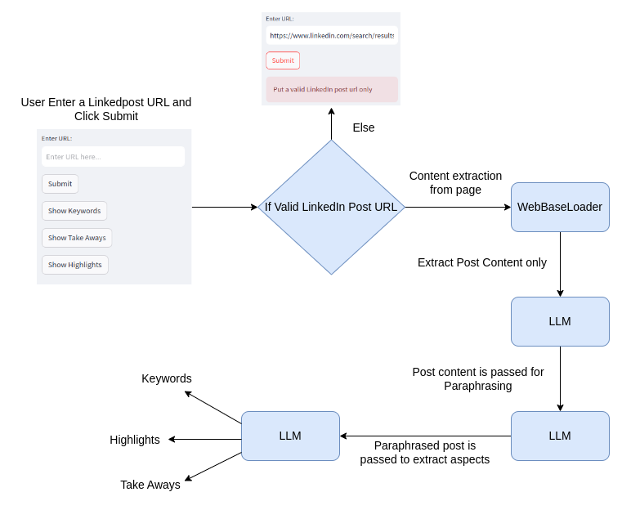

**API** is developed which takes URL as input (Json) and return Paraphrased post , Keywords , Highlights and Take aways. FastAPI is used.