BAR & HOTEL

MANAGEMENT

PROJECT

Table of Contents

1. Introduction 3

2. Background and Objectives 4

3. Milestones

4. Hardware & Software Requirement 5

5. Project Results 5

6. Screenshots 6

# Introduction

The main purpose of this document is to provide software analysis , development ,testing with the final screenshots of this project. The document should provide them with the detailed explanation of final result of this project.

This document should provide the information of project set up, milestones, matrix to complete the project.

# Background and Objectives

This project helps managers to maintain customer feedback, bills, orders, rate list of items.

This project is put to use a lot of data will be collected in the repository. This data is not only the actual text stored in the source files, but also different kind of data such as information about who did changes to a certain file and which changes .

For management this information can be valuable for determining car rented out and customer details. To collect this data and to transform it into useable information.

This project will develop an abstraction for the data and the actual website will be developed . The data can be accessed by local GUI.

# Hardware/Software Requirements

**System Specifications Minimum Hardware Requirements:-**

* 4 GB Ram
* Hard disk 500 GB
* Microsoft Compatible 101 or more Key Board Software Requirements: -

**Operating System** :

* Windows 10
* Programming language: .NET
* Web-Technology: ASP.NET 4.5
* Front-End: ASP.NET MVC
* Back-End: SQL SERVER
* Web Server: IIS

If system, which is going to be developed, is complex in nature the goals of the entire system could not be easily comprehended. Hence the need for a more rigorous system analysis phase arose.

# Milestones

|  |  |  |  |
| --- | --- | --- | --- |
| **Id** | **Description** | **Finished week** | |
| **Plan** | **Actual** |
|
| 1 | Project study | 2 | 2 |
| 2 | Requirements analysis & definition | 4 | 4 |
| 3 | Development | 8 | 8 |
| 4 | Module testing | 01 | 01 |
| 5 | Integration | 01 | 01 |
| 6 | Testing | 01 | 01 |
| 7 | Project presentation | 01 | 01 |

# 

# Project Results

|  |  |
| --- | --- |
| Requirement Description | Status |
| Login | Done |
| Wines | Done |
| Food Categories | Done |
| Food Items | Done |
| Rate List | Done |
| Table Orders | Done |
| Bill | Done |
| Feedback | Done |

# Screenshots

Login Page

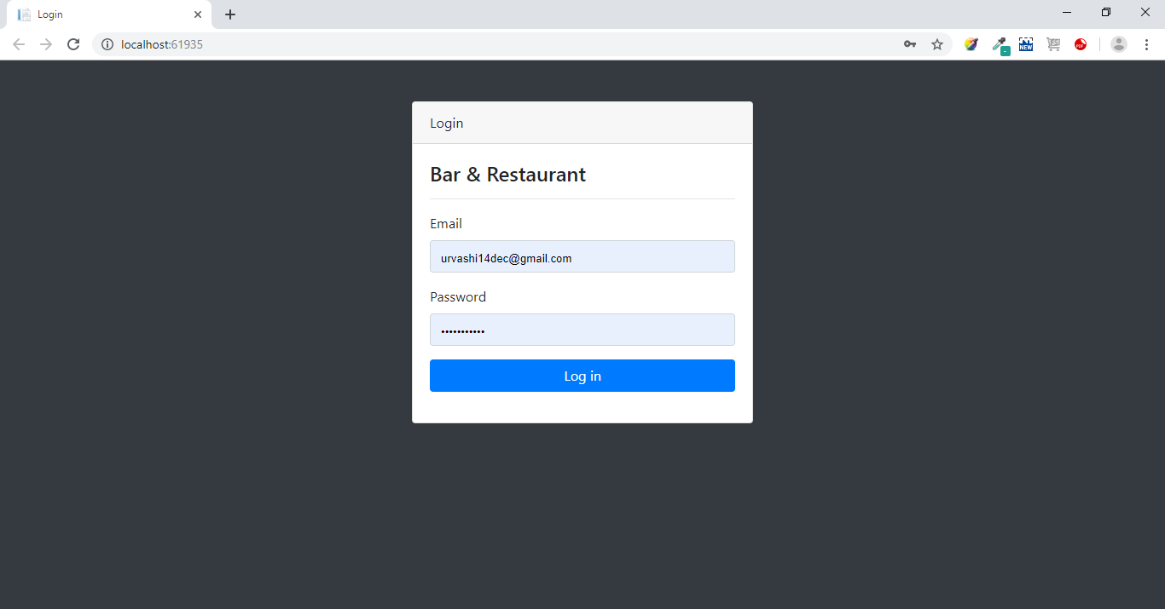

Dashboard Landing Page

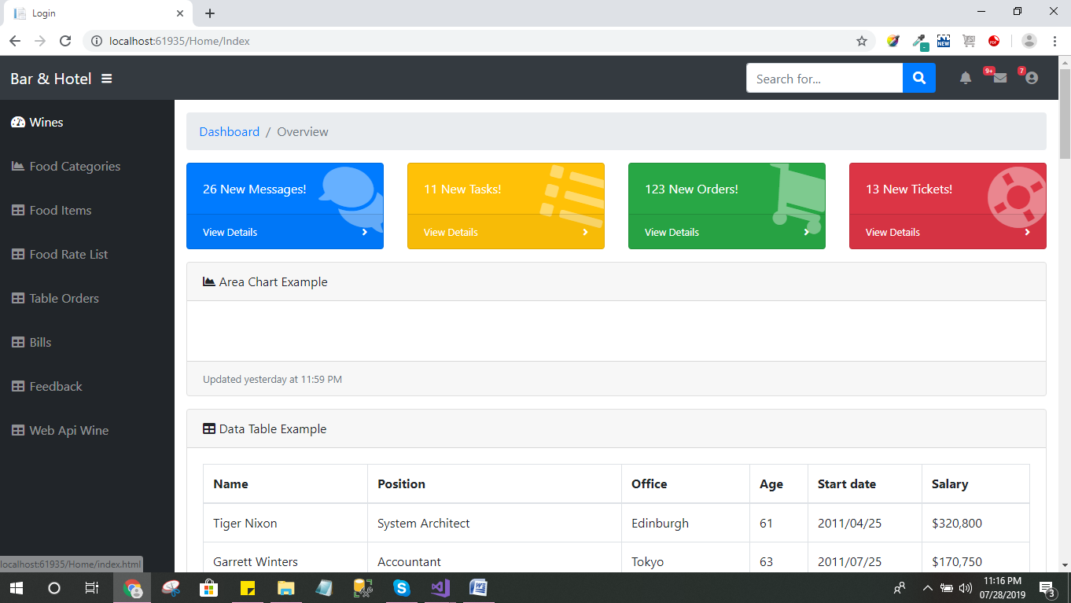

Wine List

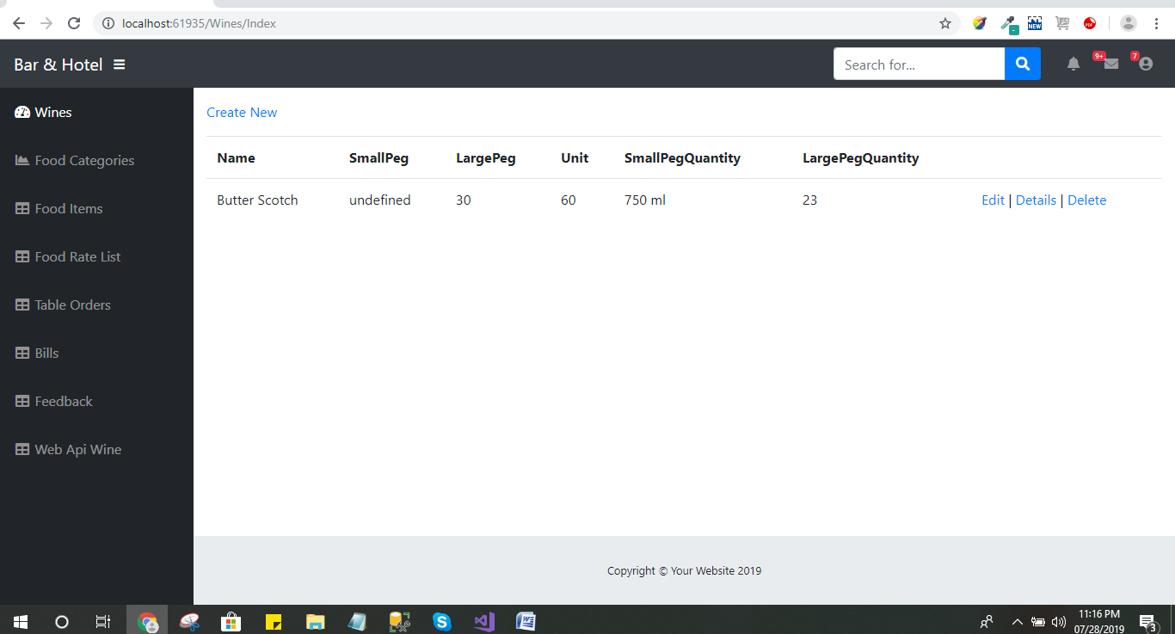

Create Wine Record

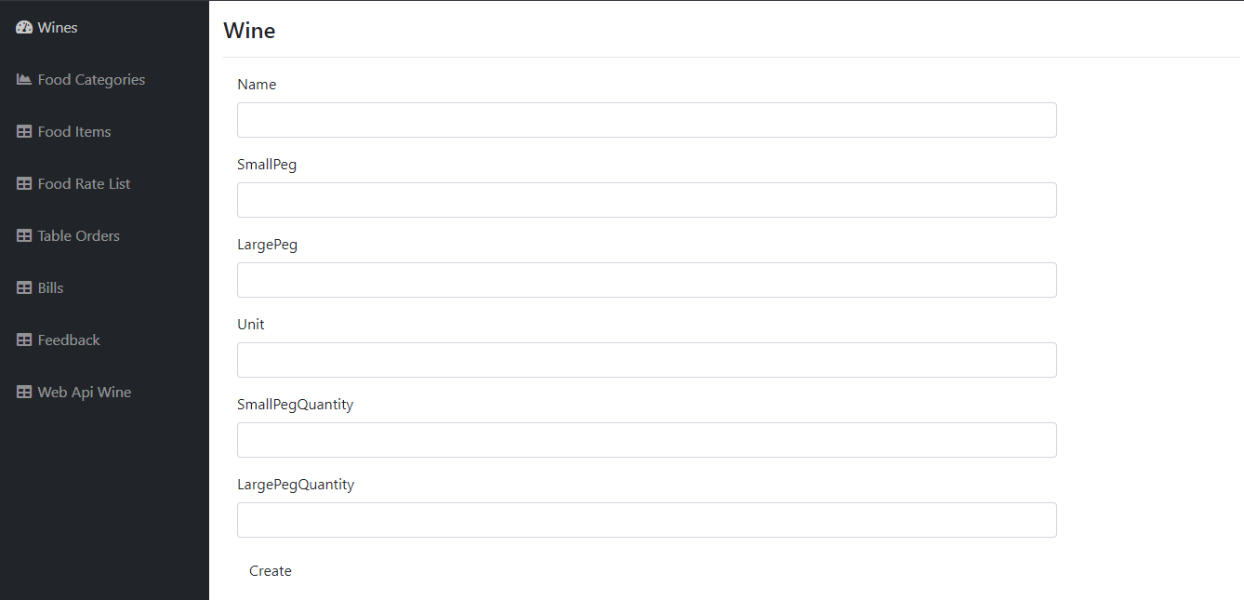

Food Category List

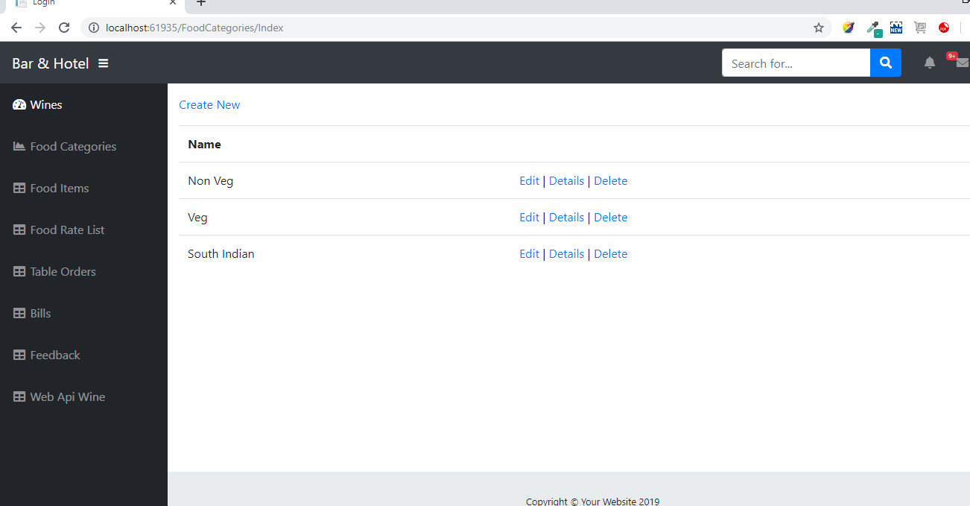

Create Food Category

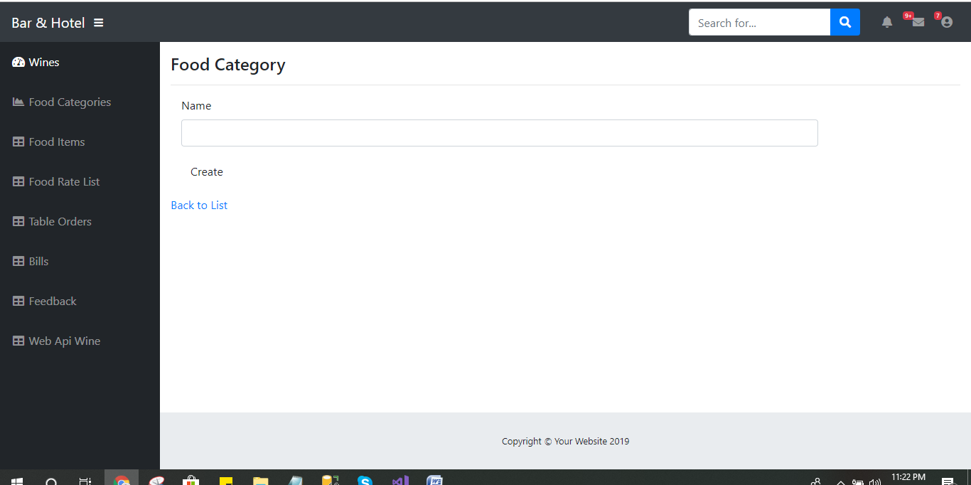

Food Item List

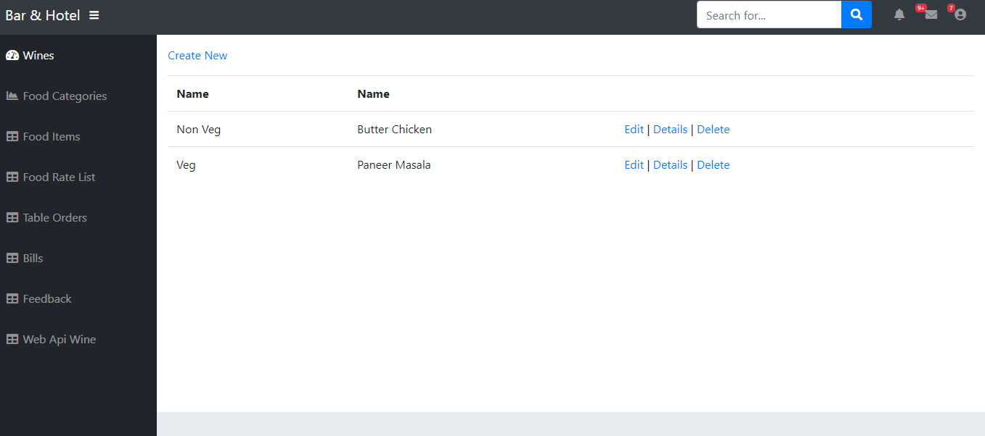

Create Food Item

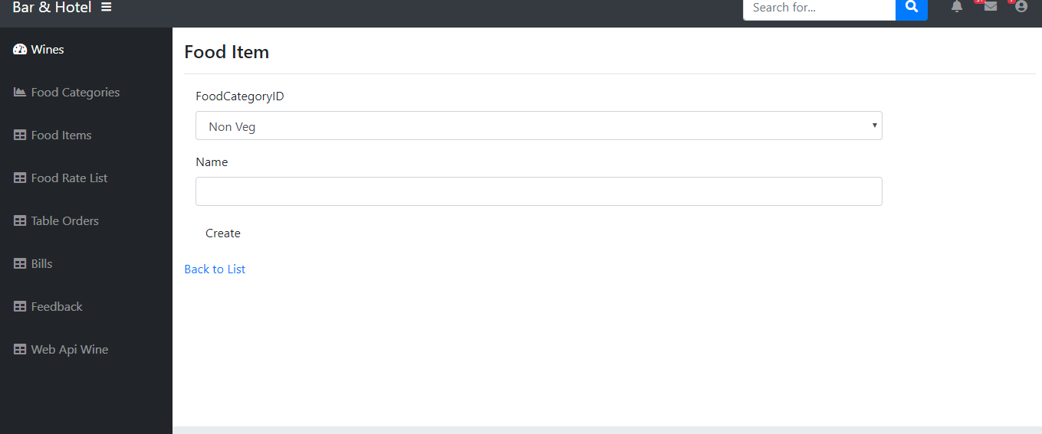

Food Rate List

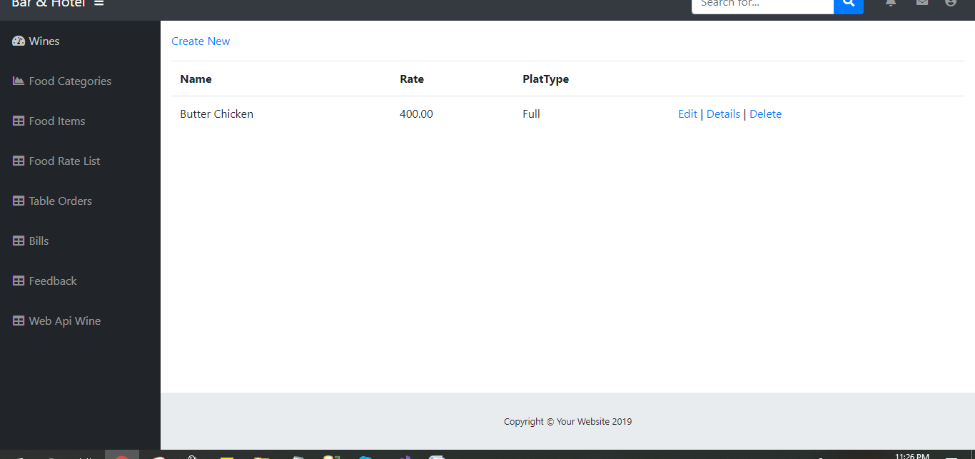

Add New Food Rate

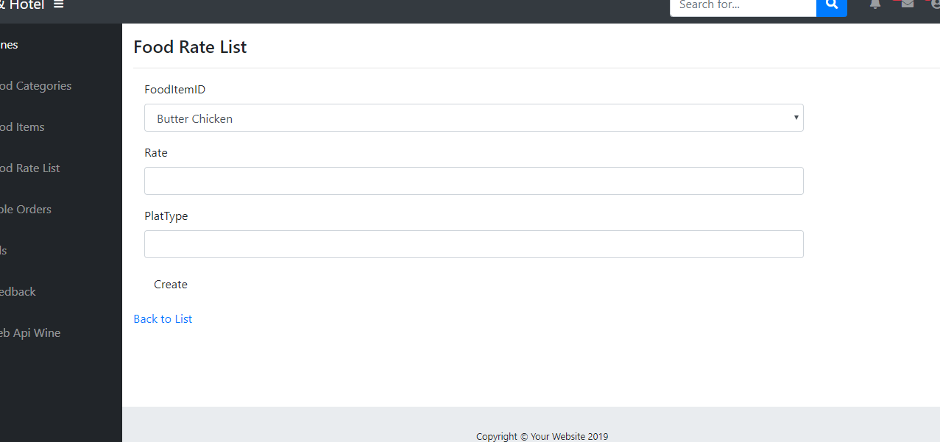

Table Order List

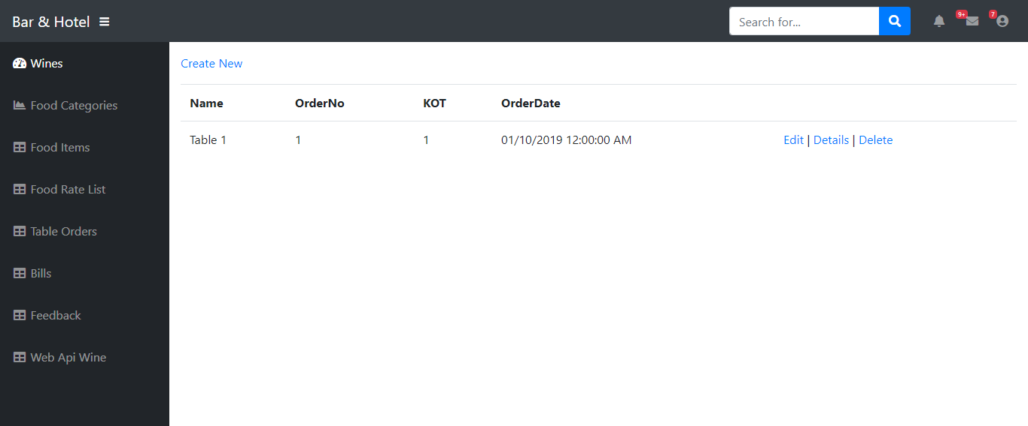

Save Table Order

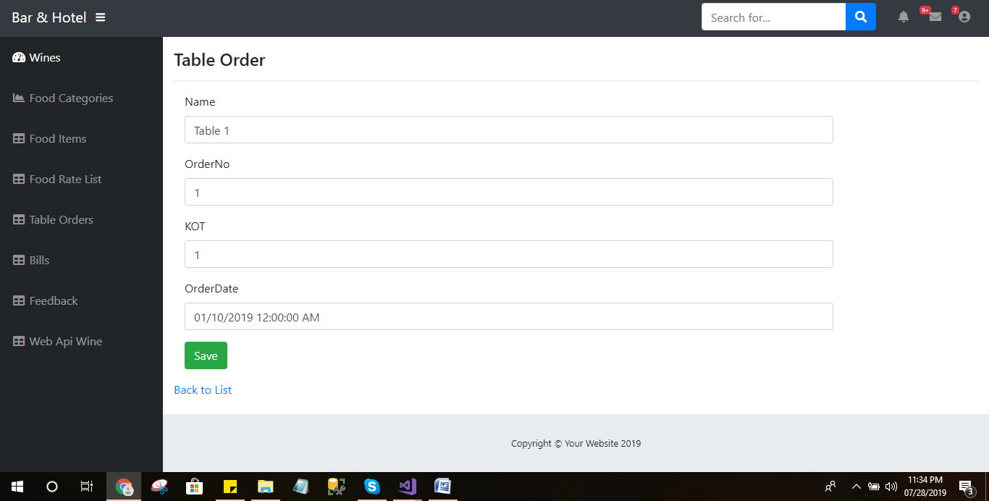

Details of Table Order

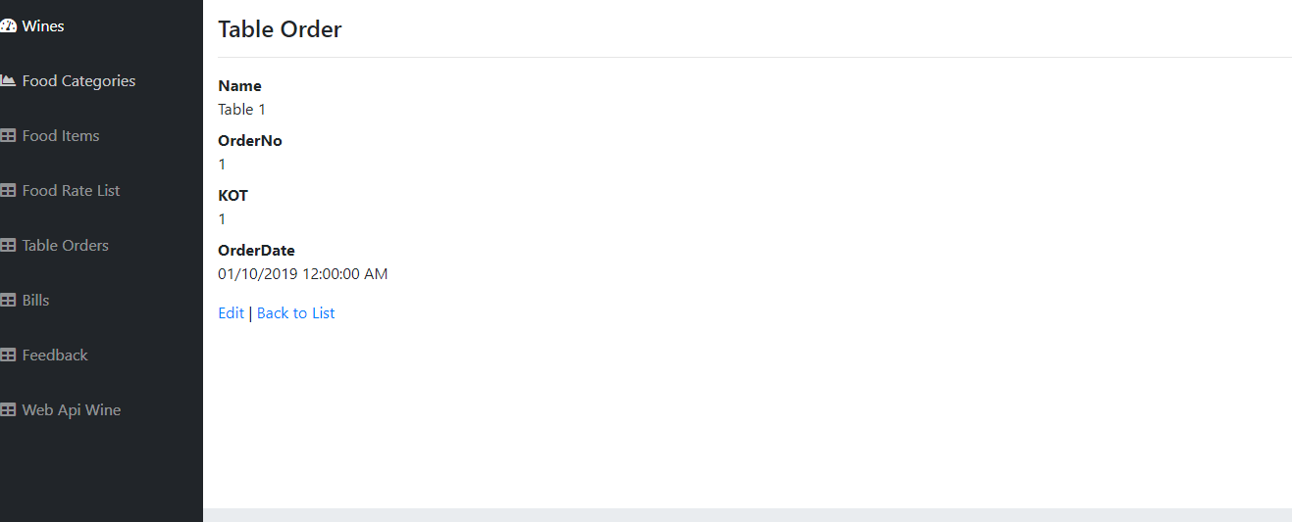

Delete Table Order

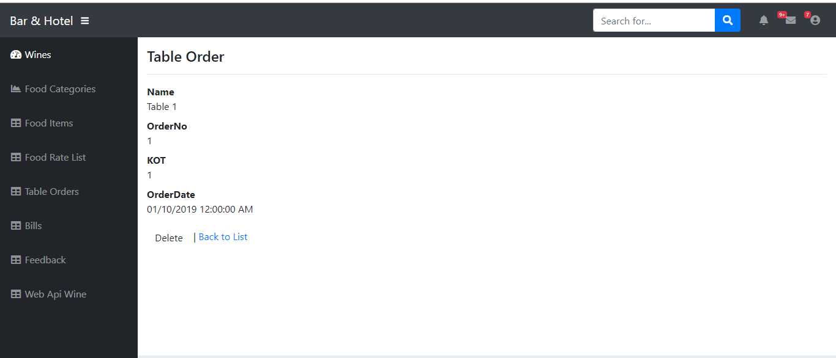

Bill List

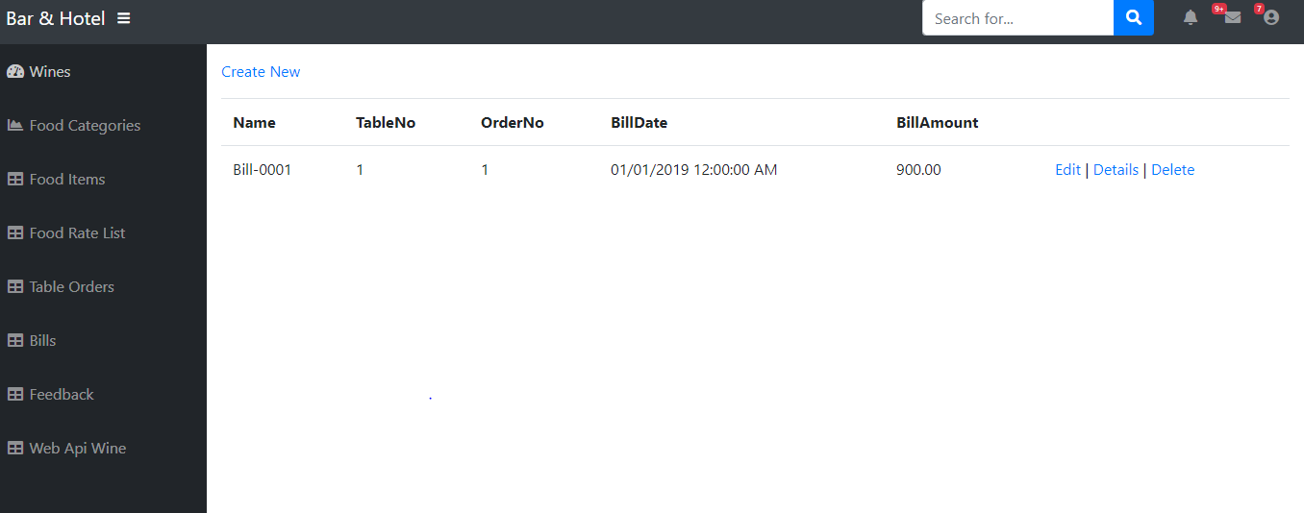

Create Bill

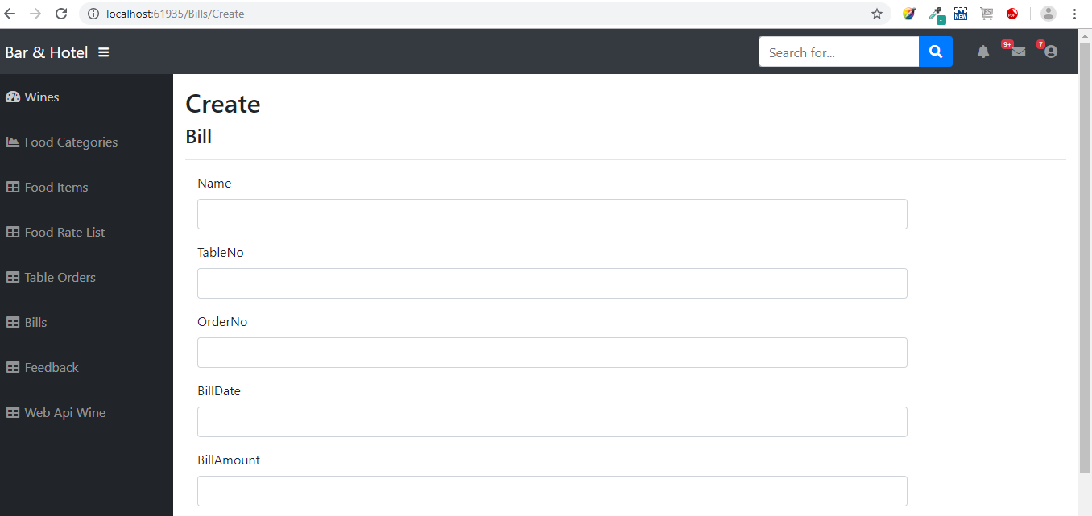

Create Bill

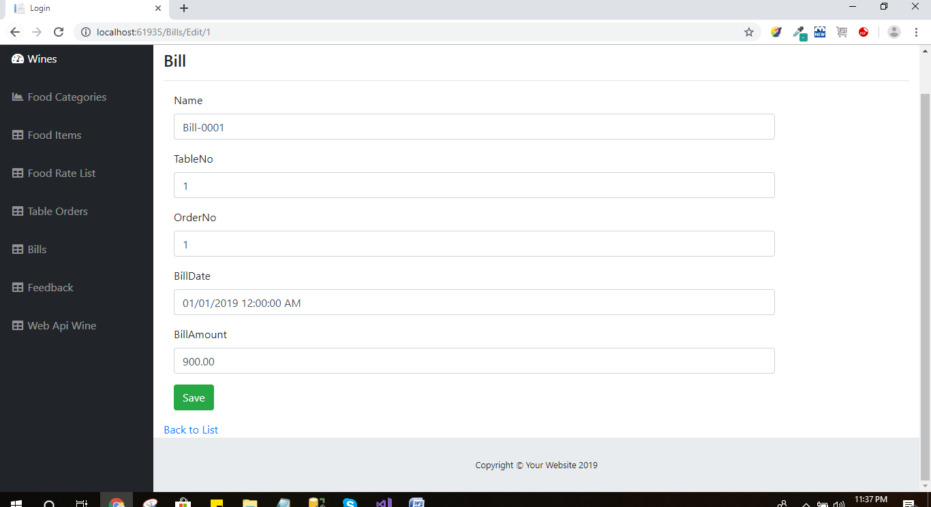

Bill Detail

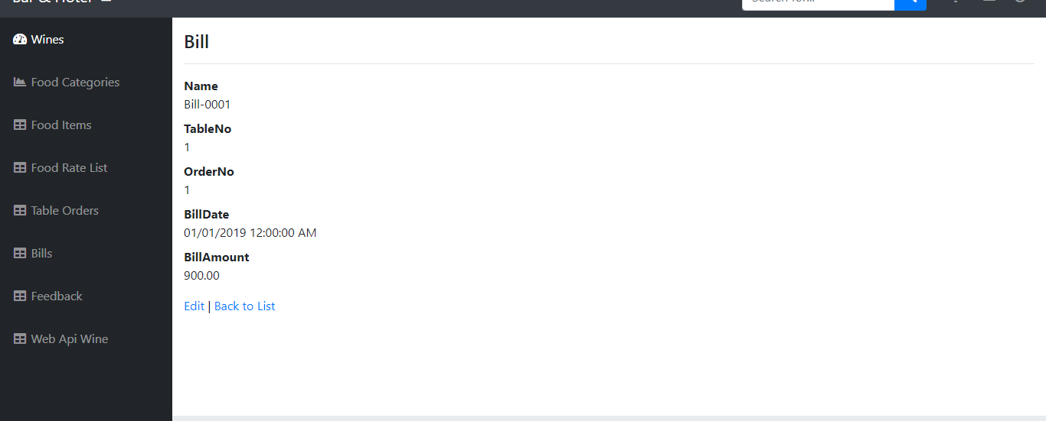

Delete Bill

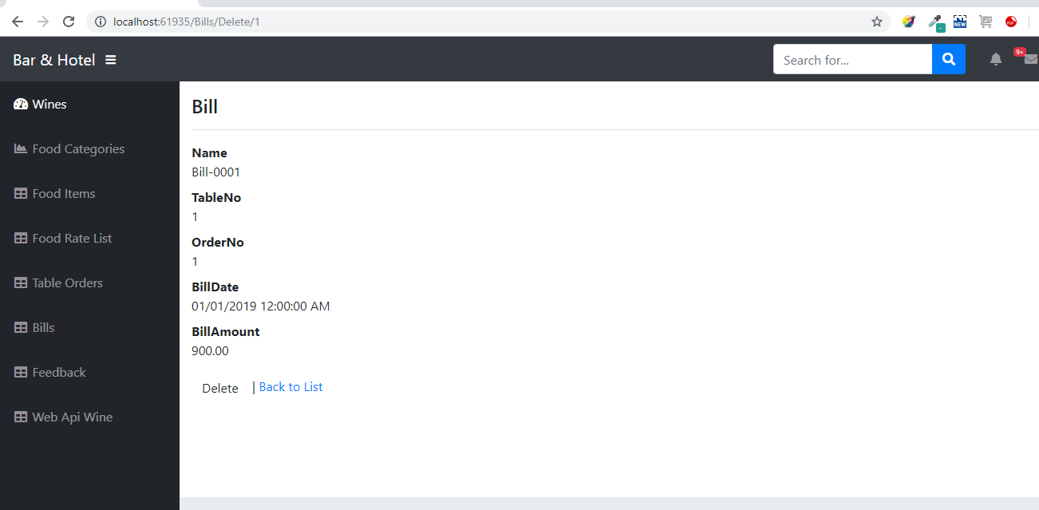

Feedback List

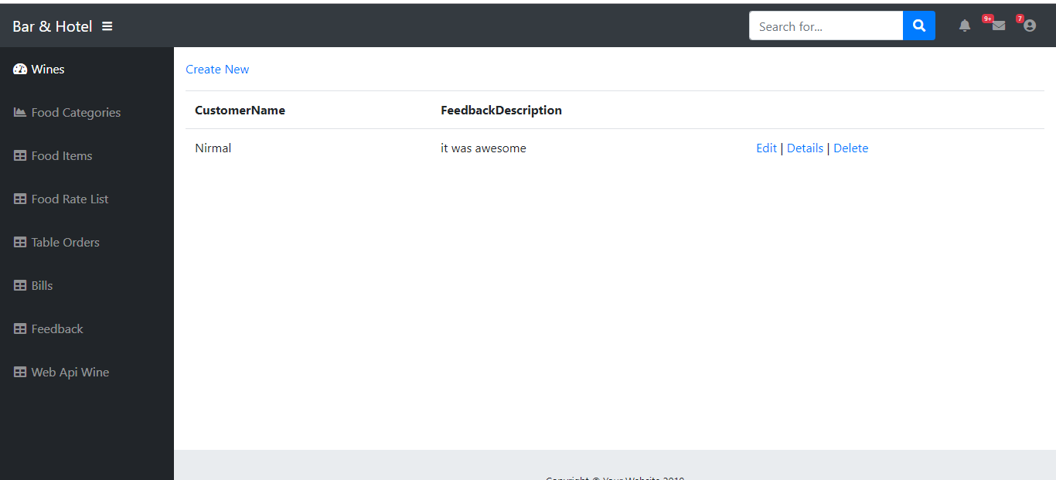

Customer Feedback Creation

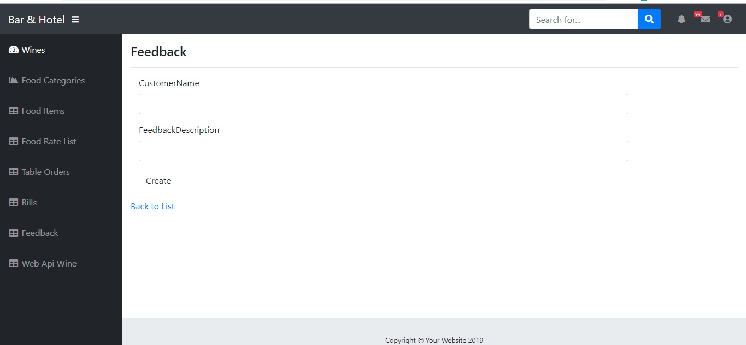

Show details of Customer Feedback

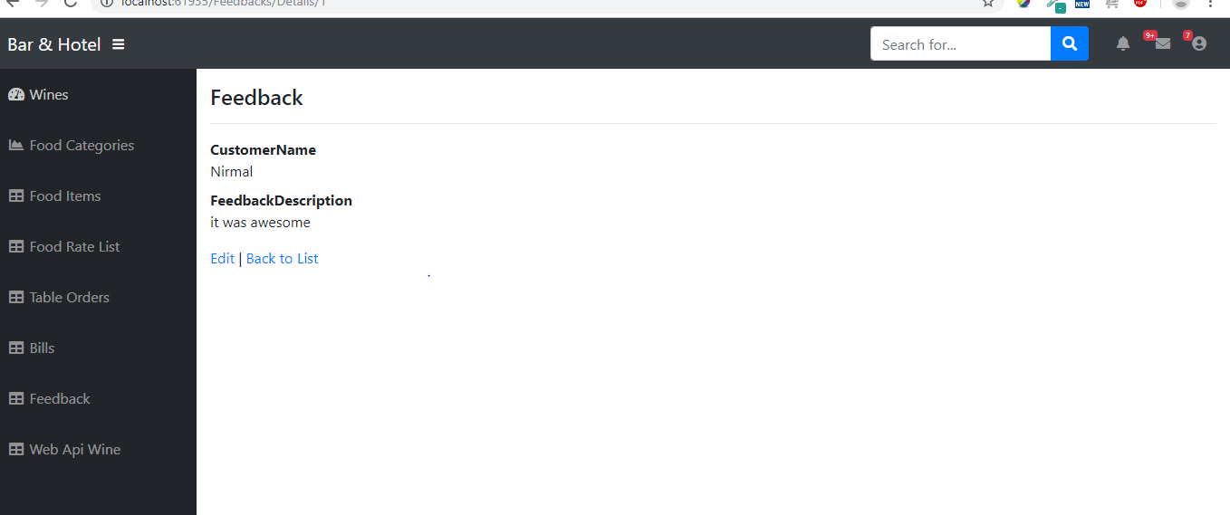

Delete Feedback

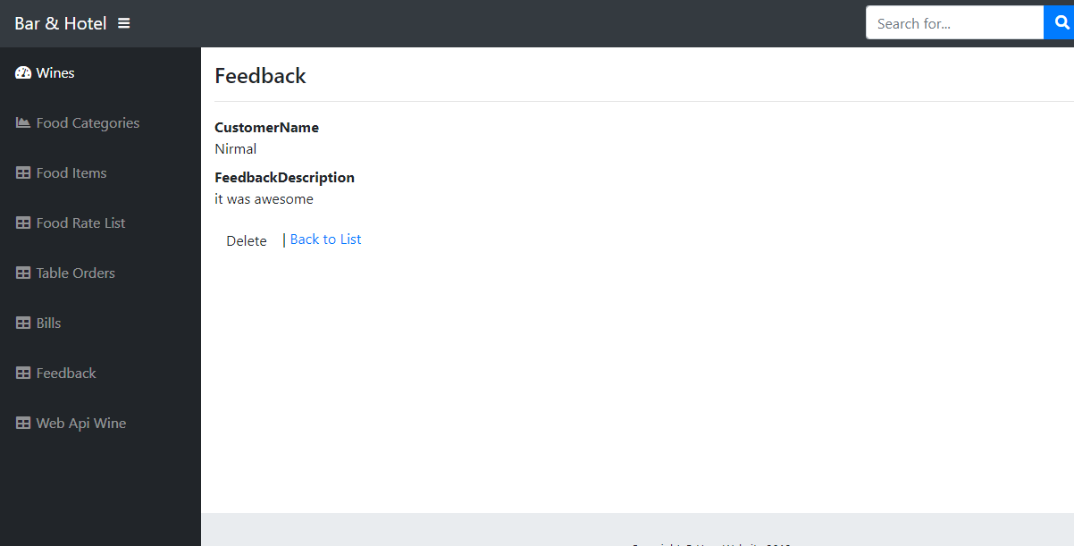

**CONTROLLERS**

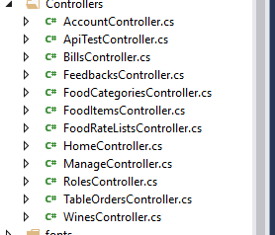

**MODELS**

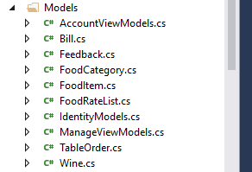

WEB API CONTROLLER

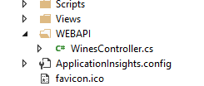

**CODING**

