Lab Task 1

- Initiate a folder name Lab Task1, under the folder there are 2 other folders named: Design (which contains design.css) and Page (contain Studentinfo.html).
- Implement the given sample, in VS code and need to submit in your Git repository.

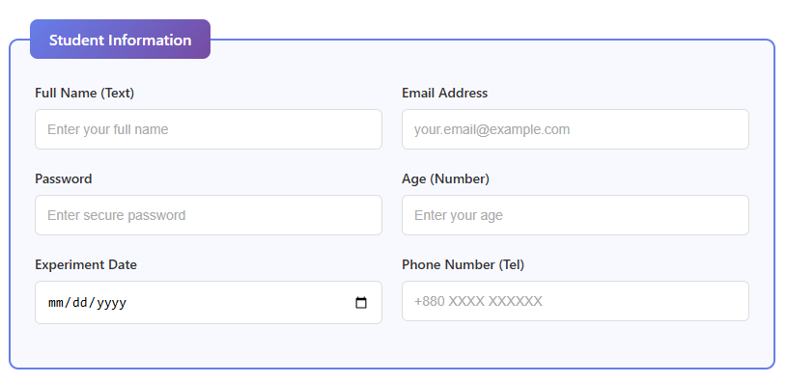
- Follow the folder name convention and instructions.

