**Know Our Curcumin Story**

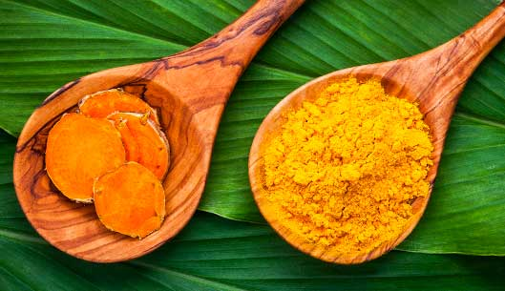

ARTICLE BY | [**Michele Olson**](https://www.terrynaturallyvitamins.com/blog/author/?author_id=3)

You may not realize it, but the curcumin you choose comes with a story. There’s a history of where it’s grown, how it’s harvested, processed, and the journey it takes to ultimately become a supplement on your shelf. You can enjoy the peace of mind that comes with understanding the story behind the products you choose. Here’s a guide on some things to look for each step of the way.  
  
**Curcumin Comes From Turmeric**  
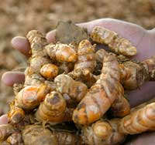

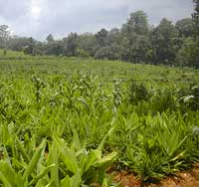Curcumin comes from the turmeric plant, which is native to India. People often think turmeric and curcumin are the same things, but it’s like saying an apple tree and an apple are the same things! While they mistakenly cite turmeric as having all the benefits, it’s the curcumin extracted from the turmeric rhizome that provides the medicinal value. More on that in a moment, but first, let’s think about the turmeric plant that is producing the curcumin. Optimally, you want a plant that is grown without pesticides or chemicals. Also, it’s your right to know that the curcumin you choose is ethically harvested, with fair pay and compensation provided to the farmers growing the plants, and the curcumin is tested for its curcuminoid content.

**A Happy Ending**  
Ready for the rest of the story? The curcumin is extracted in a facility that is powered by solar energy, extracted without the use of harmful solvents or chemicals, delivers a standardized amount of curcuminoids, and is clinically studied. It’s called BCM-95®­­/Curcugreen™. It has been the subject of over 60 published studies, including 28 human clinical trials! BCM-95/Curcugreen is the curcumin used in CuraPro® and all other products containing curcumin from Terry Naturally® CANADA.

Now you know the whole story. It’s not the end but the beginning of health support for you and your family. Don’t you love a happy ending?

**[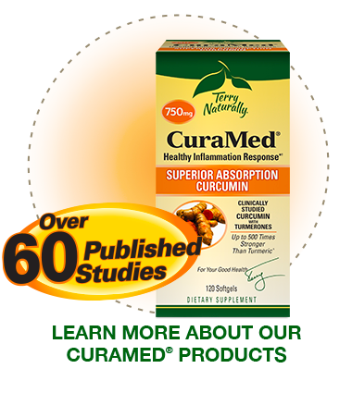](https://www.terrynaturallyvitamins.com/curamed-product-list/)**

Use box graphic for CuraPro Optimum (Canada). Change “CuraMed” to “CuraPro®” and link to CuraPro Optimum in TN.ca website