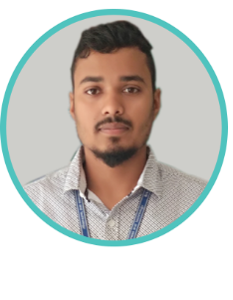

https://jobayer637.github.io/ledp_assignment/

http://wseng.herokuapp.com/home

**Jobayer Hossain**

Web Designer & Developer

A self-motivated technology expert with a focus on web development desires to work with your Organization as a Web Developer to contribute to creating an extraordinary experience for the company’s technical audience. Advanced knowledge of Object-Oriented PHP, Laravel, MySQL, JavaScript, jQuery, CSS, HTML5 and Bootstrap will be put to maximum use along with strong skills and ability in writing clean and efficient code.



CONTACT



IT SKILLS



HOBBIES



PHP

Laravel

jQuery

HTML5

Traveling



Sport



Internet



Music



EDUCATION ATTAINMENT

WORK EXPERIENCE

LANGUAGE PROFICIENCY

CSS

**BUBT University, Mirpur-2, Dhaka**

I am studying B.Sc Engg in computer science at BUBT University. Major subject is Software Engineering.

-

2017

-

Continue.

**A.P.S Degree College, Satkhira**

I have studied intermediate of science at A.P.S Degree College.

-

2014

-

2016

**Software development IV**

Online Blogging and Question System using PHP, Laravel, MySQL, jQuery AJAX, HTML5, CSS, Bootstrap. Project link-

2019

**LEDP Assignment**

2020

BENGALI

ENGLISH



Design a website using HTML5, CSS, Bootstrap, jQuery Plugins. Github live link-

ISc

BSc

Bootstrap

Mirpur-2, Rupnagar R/A, R-14, H-32/B

+88 01537441159

https://github.com/jobayer637

web.jobayer@gmail.com

https://github.com/jobayer637

JavaScript