CPT Codes

1. We need a way to tie a Physician, and Medical Facility to their CPT code list of charges. i.e. we need to be able to tie Dr. So and So to the LOC List of CPT codes and Charges, and then we need a way to tie St. Matthews to their list of CPT Codes and Charges.
2. In the Admin Panel, under the billing tab, create a pull down menu with two choices.
3. Manual Billing
4. Billing by CPT Code
5. Manual Billing. This is the system we have built, there are two changes.
6. First total the billing down for each column. This way someone will easily be able to tell what the total Physician charges are.
7. Add a new column at the end of the billing screen titled “Physician Cost”. This will be the raw cost from the CPT code and Charges for the Physician.

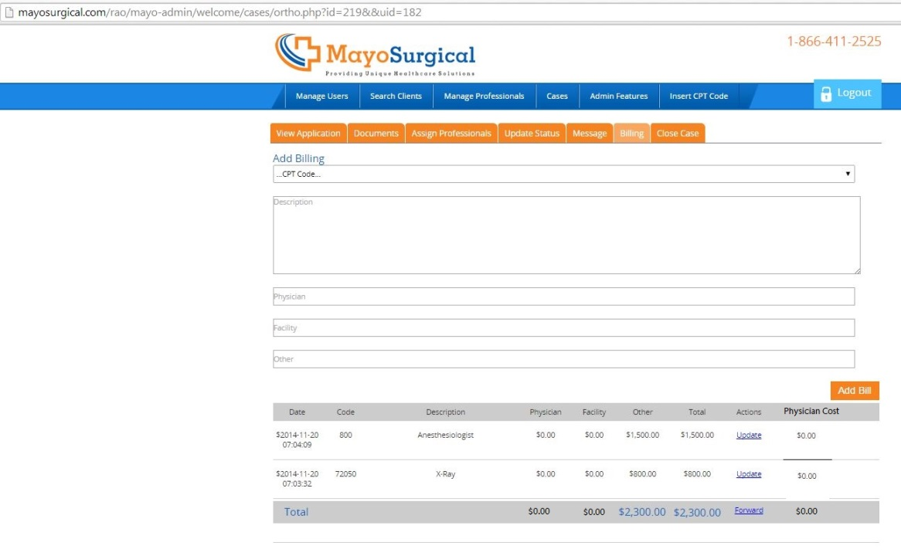

1. Billing by CPT Code (Automated)
2. I want to use the same form as the one above. The only difference is that rather than being blank in the Physician, Facility, or Other, when you click on the code in the chart it will put the information into the bill.
3. The information from the CPT codes sheet will come into the bill as follows:
4. Ortho Group = Physician
5. Phoenix and St. Matthews = Facility
6. Code 00800 – Anesthesiologist = Other
7. Cost = LOC
8. There can only be one listing per line. The means if I have type Code 23420 the following will happen. A charge of $8750 (taken from the Ortho Group) will appear in the Physician part of the bill, on a separate line a charge will appear with the same number and description on the next line with a charge in the Facilities box for $7351 (from the Phoenix) charges, and in the cost section it will show a charge for $5,258, which was taken from the LOC column.
9. When the bill goes to the Underwriter it will not have the cost information. (See Attached). Also it will need to have the Columns total.

