You are here: [**Home**](http://www.crowncityestatesales.com/) http://www.crowncityestatesales.com/media/system/images/arrow.png [**Estate Sales**](http://www.crowncityestatesales.com/los-angeles-estate-sales.html) http://www.crowncityestatesales.com/media/system/images/arrow.png Buena Park Sale - March 14 & 15

[BUENA PARK SALE - MARCH 14 & 15](http://www.crowncityestatesales.com/los-angeles-estate-sales/232-buena-park-sale-march-14-15.html)

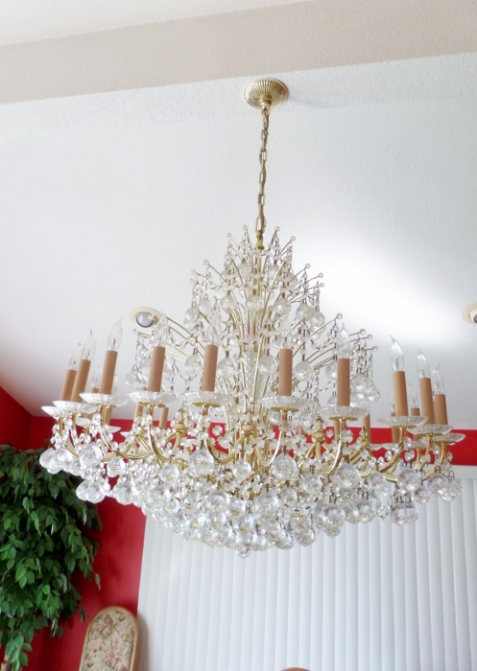<="" p="" style="border: 0px; margin: 7px;">

Nice Household sale

Featuring 2 wonderful Waterford(?) chandeliers

**Dates:**

3/14/2015 8am to 3pm (Sat)  
3/15/2015 10am to 1pm (Sun)

Really nice sale with a mix of some od and quality newer items   
Two wonderful Waterford(?) chandeliers.....  
One large Waterford(?) Chandelier, one small Waterford(?) chandelier,  
Asian items, jade, some fine jewelry, some Beleek, golf clubs,  
white damask sofa, dining room table and 12 chairs, Large brass bed, stereo equipment, LLardo (3 smaller items), large Llardo clown, Italian dish set, newer pots and pans, sterling flatware, Vintage oil paintings, new leather bound books, vintage bar ware, cement foo dogs, vintage patio, men's clothing, grandmother clock, brass carriage clock, knick knacks, linen, costume jewelry, pottery barn, newer breakfast set, vintage rattan set, large coffee tables, pine bedroom furniture, office supplies, cds, Taxidermy fish, and more

**Address: 8511 Fox Hills Ave Buena Park, CA 90621**

**Map**

* **[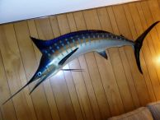](http://www.crowncityestatesales.com/images/Buena_Park/024.jpg)**
* **[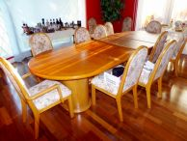](http://www.crowncityestatesales.com/images/Buena_Park/022.jpg)**
* **[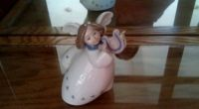](http://www.crowncityestatesales.com/images/Buena_Park/027.jpg)**
* **[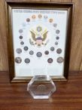](http://www.crowncityestatesales.com/images/Buena_Park/020.jpg)**
* **[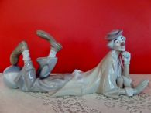](http://www.crowncityestatesales.com/images/Buena_Park/021.jpg)**
* **[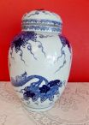](http://www.crowncityestatesales.com/images/Buena_Park/012.jpg)**
* **[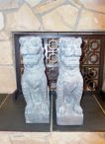](http://www.crowncityestatesales.com/images/Buena_Park/015.jpg)**
* **[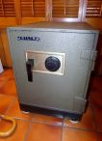](http://www.crowncityestatesales.com/images/Buena_Park/026.jpg)**
* **[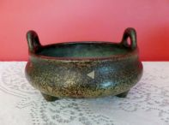](http://www.crowncityestatesales.com/images/Buena_Park/013.jpg)**
* **[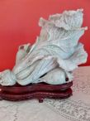](http://www.crowncityestatesales.com/images/Buena_Park/017.jpg)**
* **[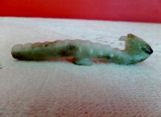](http://www.crowncityestatesales.com/images/Buena_Park/018.jpg)**
* **[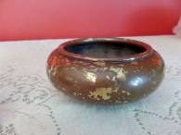](http://www.crowncityestatesales.com/images/Buena_Park/014.jpg)**
* **[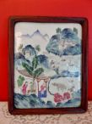](http://www.crowncityestatesales.com/images/Buena_Park/011.jpg)**
* **[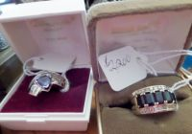](http://www.crowncityestatesales.com/images/Buena_Park/016.jpg)**
* **[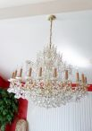](http://www.crowncityestatesales.com/images/Buena_Park/01.jpg)**
* **[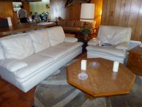](http://www.crowncityestatesales.com/images/Buena_Park/025.jpg)**
* **[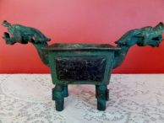](http://www.crowncityestatesales.com/images/Buena_Park/019.jpg)**
* **[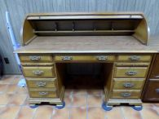](http://www.crowncityestatesales.com/images/Buena_Park/023.jpg)**

For more pics go to: [**Buena Park Sale**](http://www.estatesales.net/estate-sales/CA/Buena-Park/90621/807663)