System Design Document (SDD)

Project Name: GoCloak Prepared by: Sajib Jahan Date: March 16, 2025

Date | version | Prepared by | Checked by
20/03/2025 | 1.0.0 | Sajib Jahan | Masihur Maruf

1. Overview
Purpose: This System Design Document describes the architecture, component design, data flow, and security considerations for GoCloak—a lightweight, high-performance identity and access management (IAM) system written in Go. It aims to be a self-hosted alternative to Keycloak with modular REST APIs and an internal Admin Panel.
Scope: This document covers the following components:
- Admin Panel
- REST API Service
- Realm & User Management
- Token Service (OAuth2/OIDC)
- Role & Permission Management
- Database Design
- Security and Scalability Considerations

2. System Overview
GoCloak will have the following core components:
- REST API for managing realms, users, clients, roles, and authentication.
- Admin Panel for internal user and realm management.
- Authentication/Authorization Module using OAuth2, OpenID Connect, and JWT for token-based authentication.
- Database for persistent storage of realms, users, roles, and clients.
- Token Service for OAuth2/OIDC-based login and access control.

Key Goals
- High Performance: The system should be capable of handling a high load, with the ability to support up to 100,000 concurrent sessions per realm.
- Extensibility: A modular architecture to support future integrations like external identity providers, MFA, and audit logs.
- Ease of Deployment: A simple deployment model using Docker and Kubernetes.

3. System Architecture Diagram
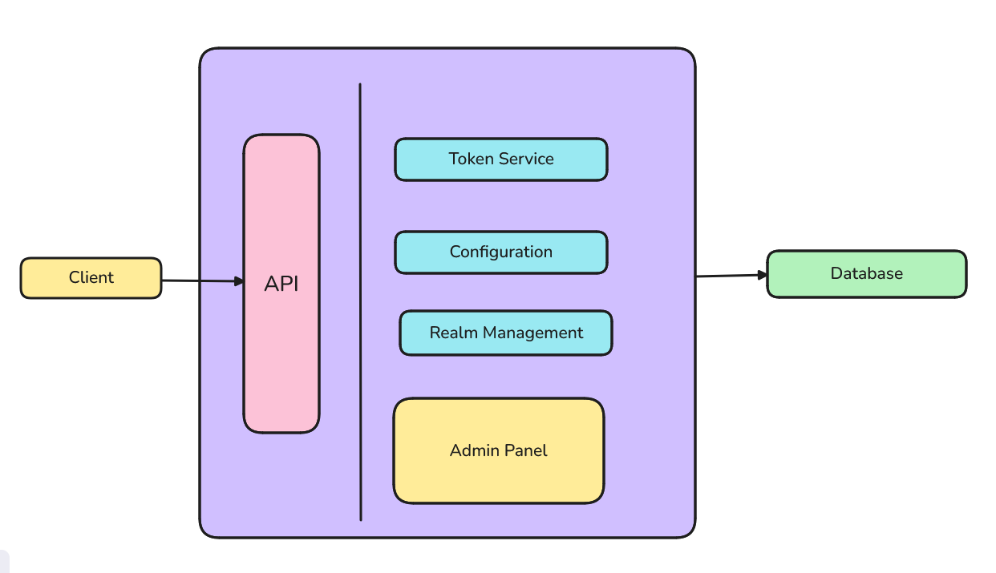
Client: Any backend machine, public frontend, mobile or device requesting IAM service
API: API endpoints that allows clients to communicate with keycloak
Admin Panel: Web based view directly built in gocloak core for managing realms & configurations
Token service: Service that facilitates token generation

4. Component Breakdown

4.1 REST API Service
- Handles external communication via REST.
- Provides endpoints for managing realms, users, roles, and clients.
- Implements OAuth2/OIDC token issuance.
- Built using Go with the Gin framework.

4.2 Admin Panel
- Internal UI for administrators.
- Uses server-side rendering or HTMX/Tailwind.
- Interacts directly with the internal API layer.
- Restricted via admin login with role-based access control.

4.3 Realm Manager
- Manages logical tenant boundaries.
- Each realm is isolated: its users, roles, clients, and settings.
- Realm configurations stored in DB.

4.4 User & Role Manager
- Handles CRUD operations for users, groups, and roles.
- Supports password reset, role assignment, and status flags.

4.5 Token Service
- Issues access tokens (JWT - RS256).
- Refresh token and introspection support.
- Validates client credentials and user login.

5. Data Flow Diagrams

5.1 User Login Flow
- User submits credentials to /realms/{realm}/login.
- Auth service validates and fetches users from DB.
- Token service issues JWT.
- Response returns access & refresh token.

5.2 Client Credential Flow
- Client sends credentials to the token endpoint.
- Service verifies client secret.
- Token is issued for the client.

More to be added

6. Database Design

6.1 Tables
- Realms: id, name, config_json
- Users: id, realm_id, username, password_hash, status
- Clients: id, realm_id, name, secret, redirect_uris
- Roles: id, realm_id, name, description
- UserRoles: user_id, role_id
- AuditLogs: action, performed_by, entity_type, timestamp
Database: PostgreSQL (SQLite for development mode)

7. API Gateway & Routing Strategy
- /realms/{realm}/... scoped endpoints
- Versioning via headers or URI
- Throttling and rate-limiting optional in API gateway
- JWT-based bearer token validation

8. Security Considerations
- HTTPS enforcement (TLS)
- Passwords hashed with bcrypt or argon2
- JWT signed with RS256
- Admin panel CSRF and XSS protection
- Input validation and sanitization
- RBAC for Admin Panel and API scopes

9. Scalability & Performance
- Stateless services for easy scaling
- Containerized deployment (Docker)
- Load-balanced token services
- Configurable DB connection pooling
- Expected to support 100K concurrent sessions per realm

10. Extensibility & Modularity
- Provider model for future integrations (social logins, LDAP)
- Plugin-based token pipeline (e.g., for audit logging)
- Configurable realms via JSON or admin UI

11. Monitoring & Logging
- Audit logs stored per realm
- Metrics endpoint for Prometheus
- Grafana dashboards for user/session analytics
- Alerting on token service failures or DB outages

12. Appendices
- API Reference - will be added
- Sequence diagrams (login, token flow) - will be added
- DB Schema diagrams - will be added

