

STUDENT DETAILS
Name: Job Roman Barasa
Admission Number:BSCCS/2024/42922
Course: Bachelor of Science in Computer Science
Unit Code: BIT 4139
Unit Name: Ethical Hacking and Counter Measures
Lecturer Name: Mr Michael Nyoro
Academic Year: 4.1

PROJECT DETAILS
Project Title: Week 6
Selected Technologies
nmap/ zenmap
Github Link: repo

Week 6: Vulnerability Assessment and Scanning 3
Demo 1: Basic Network Discovery 3

Week 6: Vulnerability Assessment and Scanning

Demo 1: Basic Network Discovery
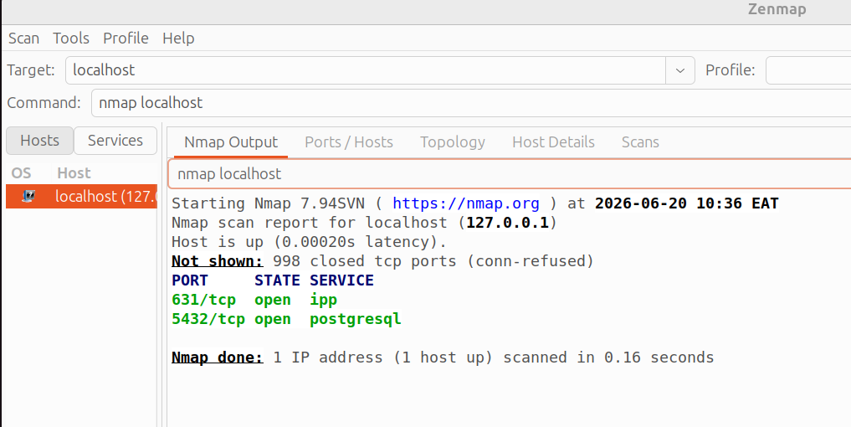Figure 1: Zenmap scan 1 showing open ports and services
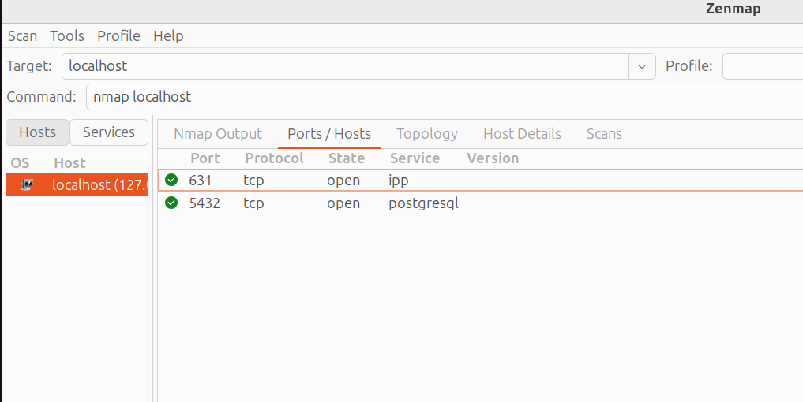Figure 2: Zenmap scan 2 showing open ports

Demo 2: Service Version Detection
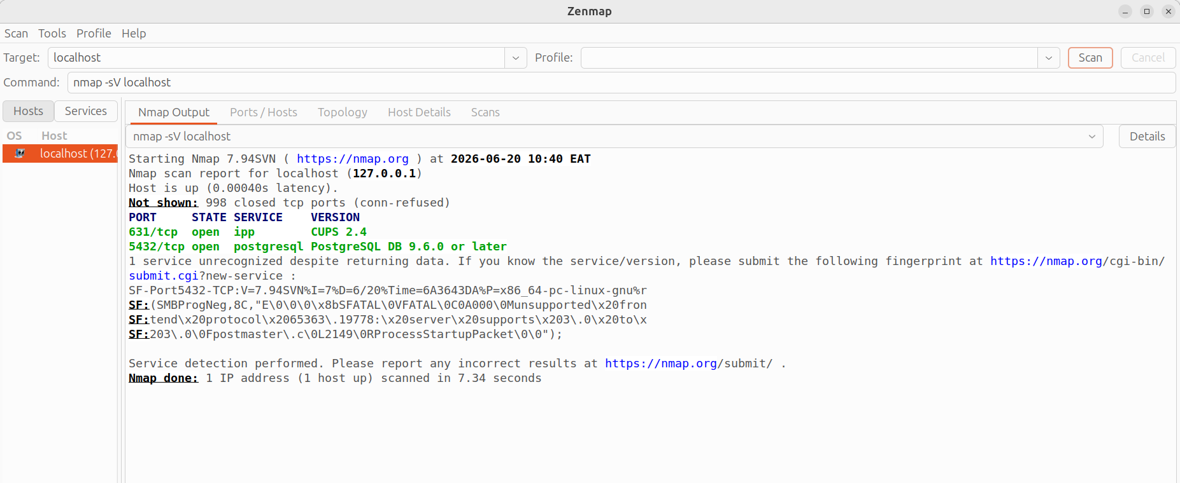Figure 3: Running services and software versions

Demo 3: Vulnerability Information Research
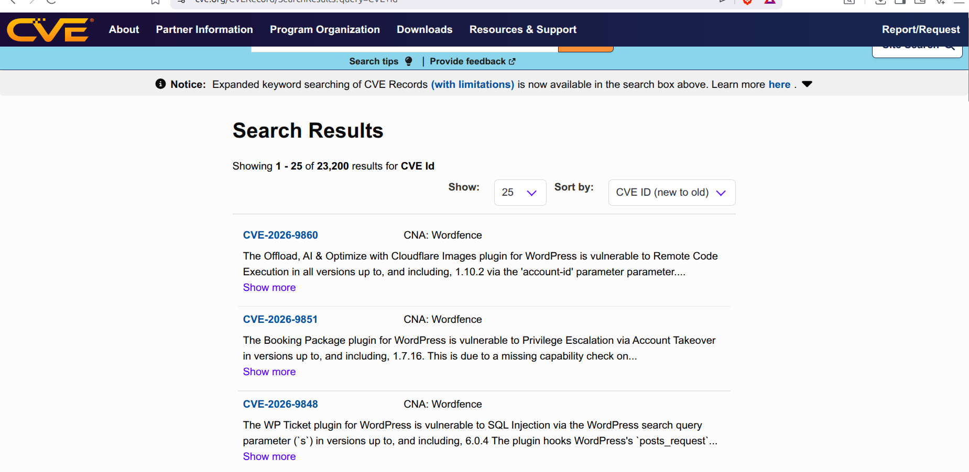Figure 4: A list of some recorded known vulnerabilities availabe on CVE

Class Activity 1: Vulnerability Identification
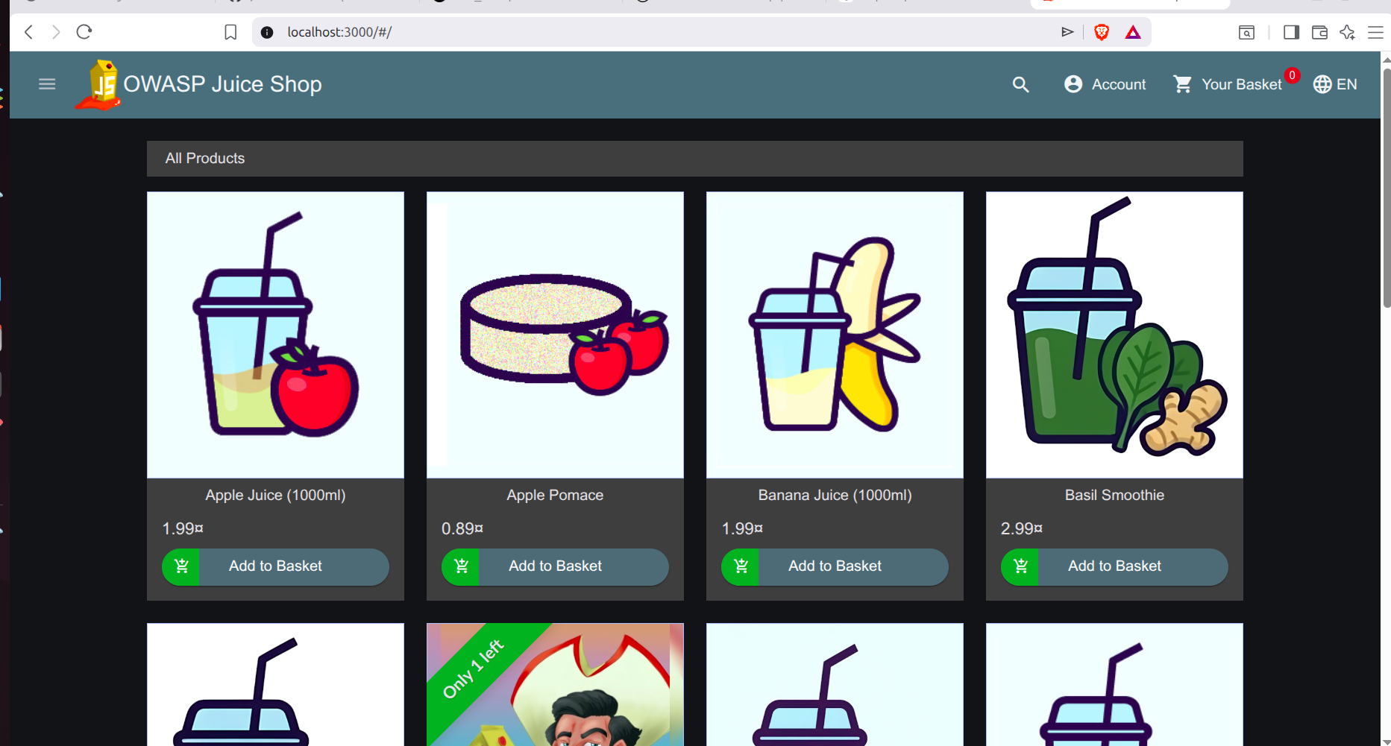Figure 5: Target website
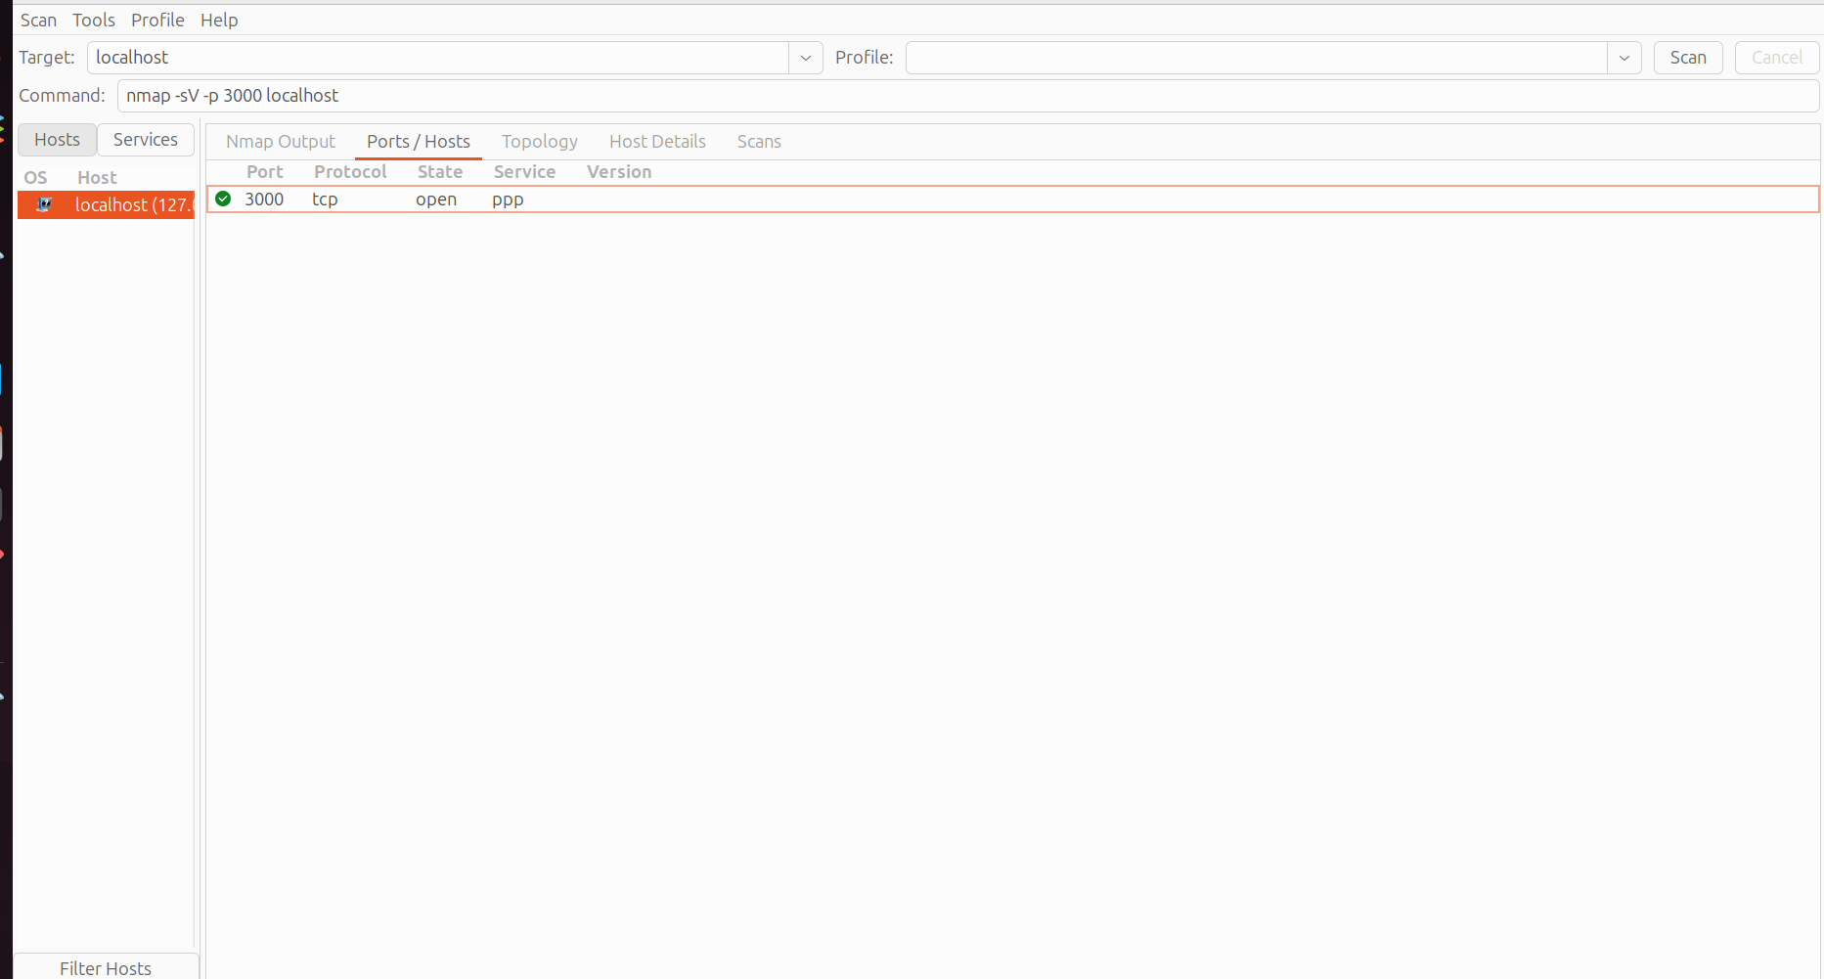

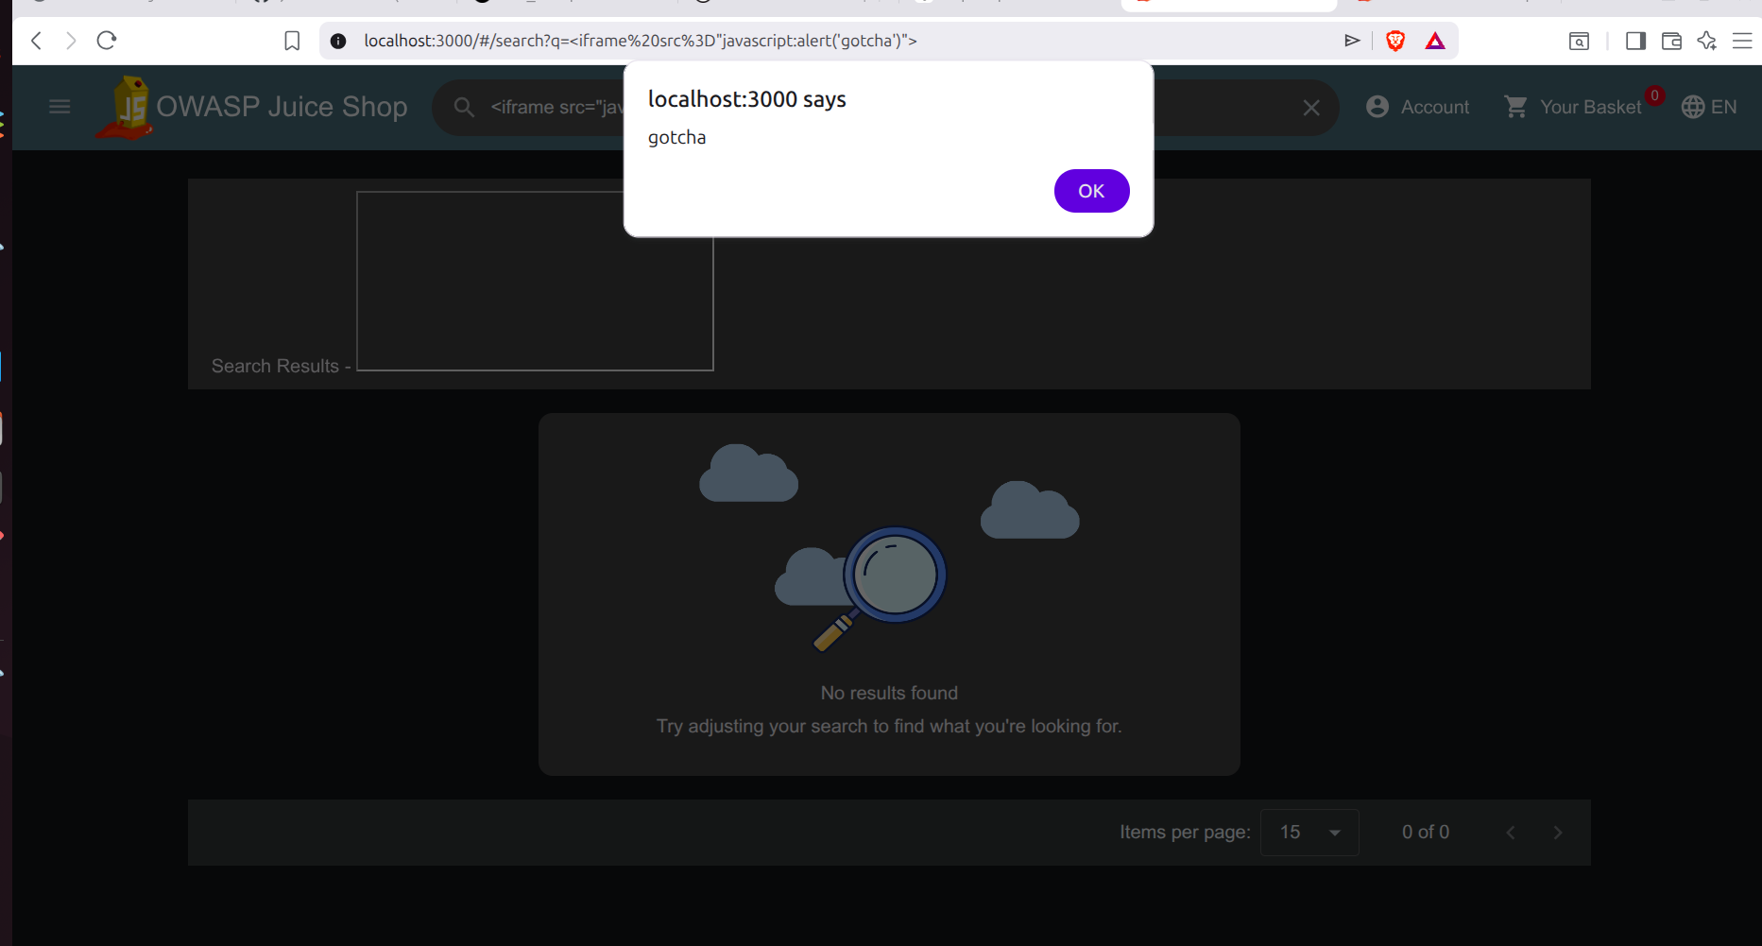Figure 6: Cross Site Scripting attempt
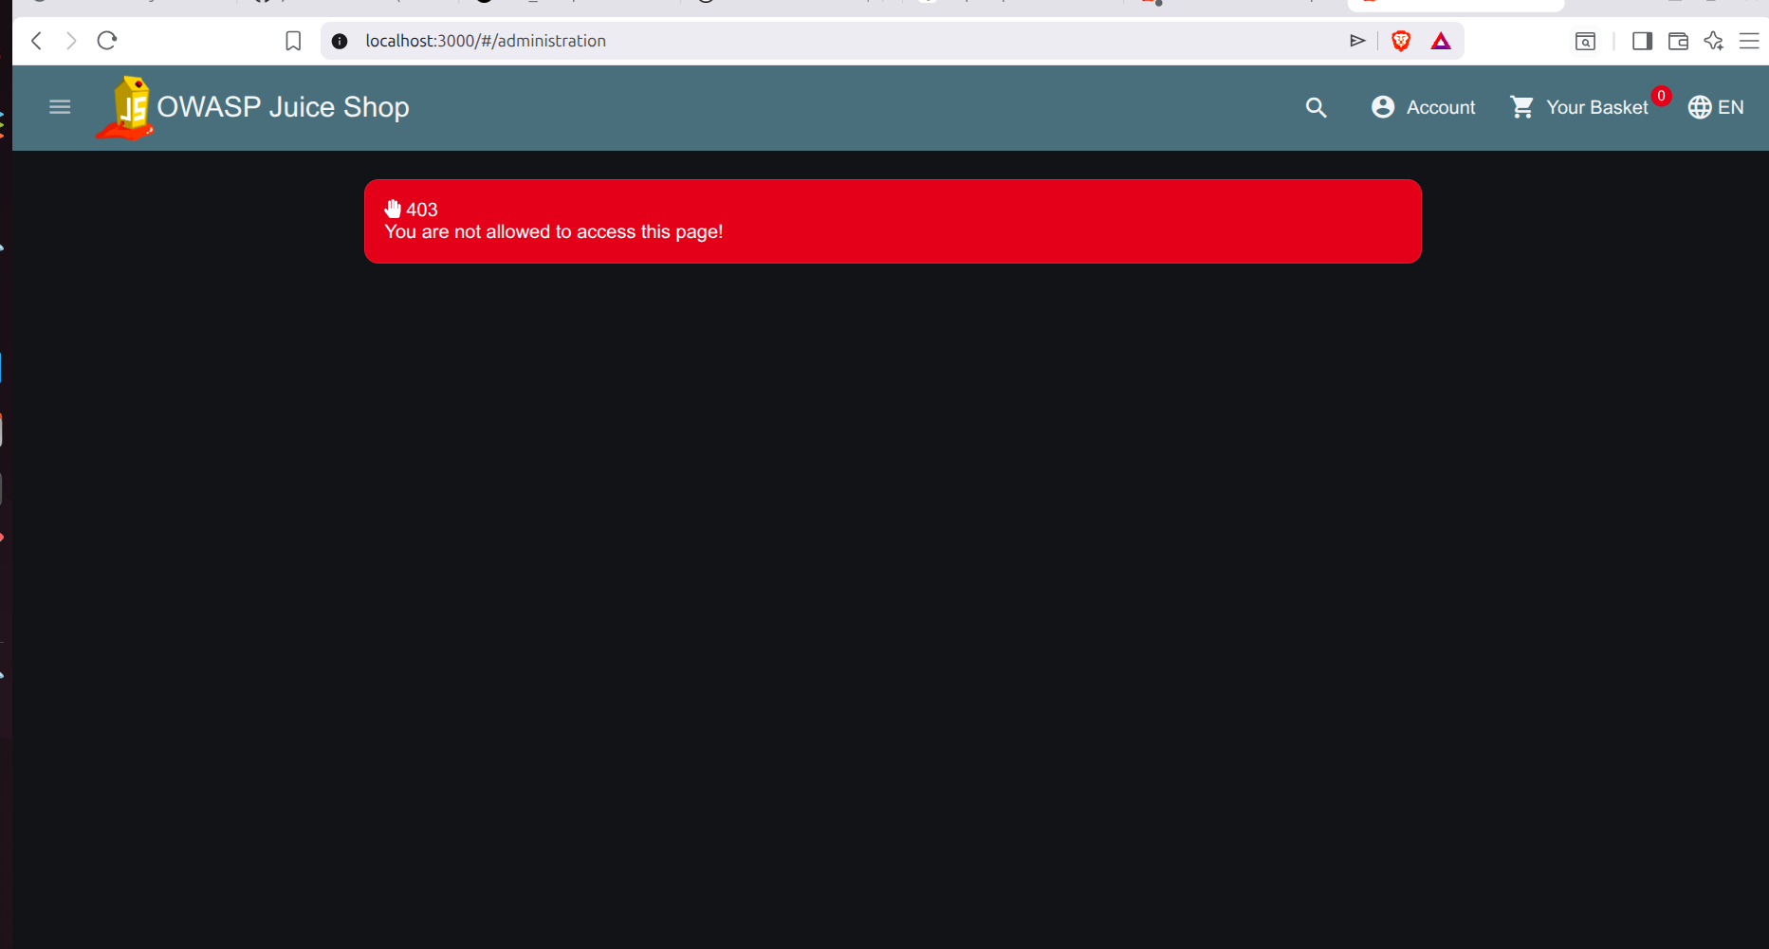Figure 7: Attempted access to restricted administrative panel demonstrating access control behavior.

