STUDENT DETAILS
Name: Barasa Job Roman
Admission Number:BSCCS/2024/42922
Unit Code: BIT4139
Unit Name:Ethical Hacking and Counter Measures
Lecturer Name: Mr Michael Nyoro
Academic Year:4.2

PROJECT DETAILS
Project Title: Steps In Ethical Hacking

Selected Technologies
- Nmap/ Zenmap
- DNSDumpster
- Wappalyzer
- Whois

Online Portfolio: https://github.com/jobb-commits

Table of Contents
Task 1: Information Gathering 3
Target Identification 3
Domain Information 3
IP Address Identification 4
Subdomains 5
Technology Used 8
Open Services Enumeration 9
Task 2: Scanning and Enumeration 10
Scan Ports 10
Detect Running Services 11
Identify OS Version 11
Shared Folders 11
Reflection 12

Task 1: Information Gathering

Target Identification
Selected Organization: Machakos Institute of Technology (MIT)
Website: https://www.mit.ac.ke/

Domain Information
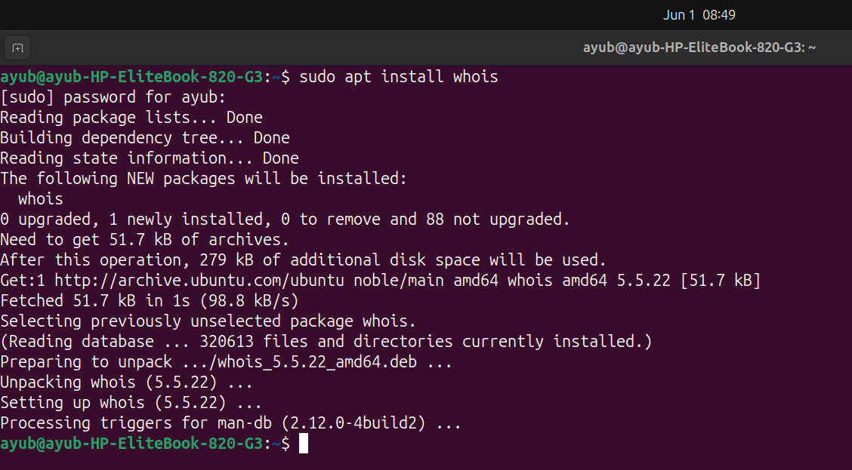Figure 1: Installation of WHOis

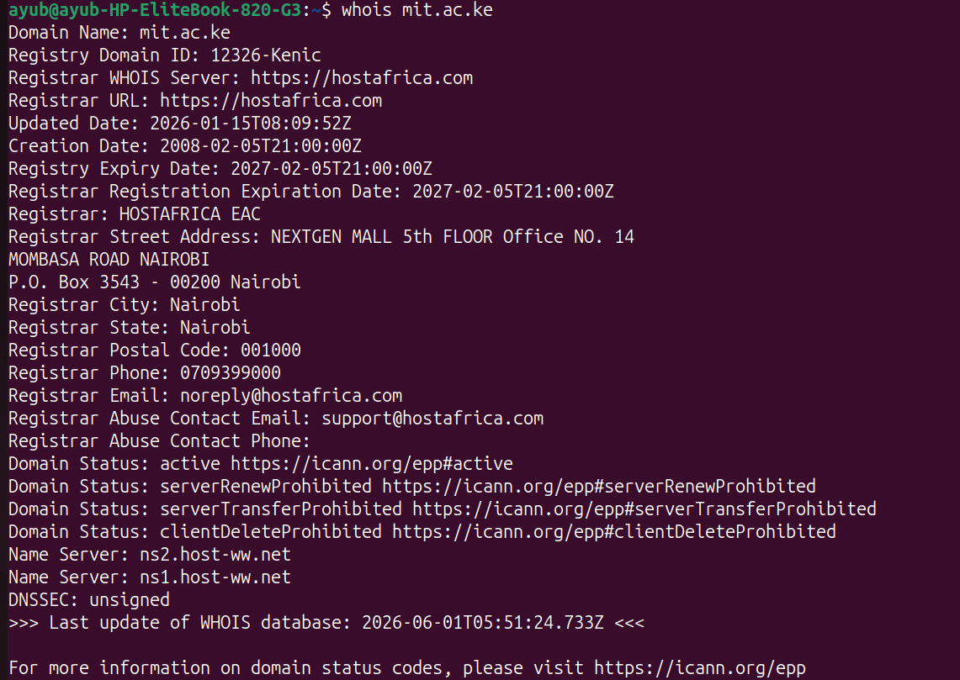Figure 2: Obtain Domain Information Using WHOis

IP Address Identification
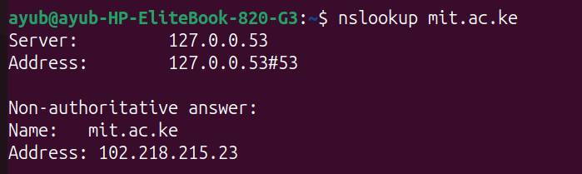Figure 3: Address Identification

Subdomains
A site called DNSDumpster was used to get a list of all subdomains present
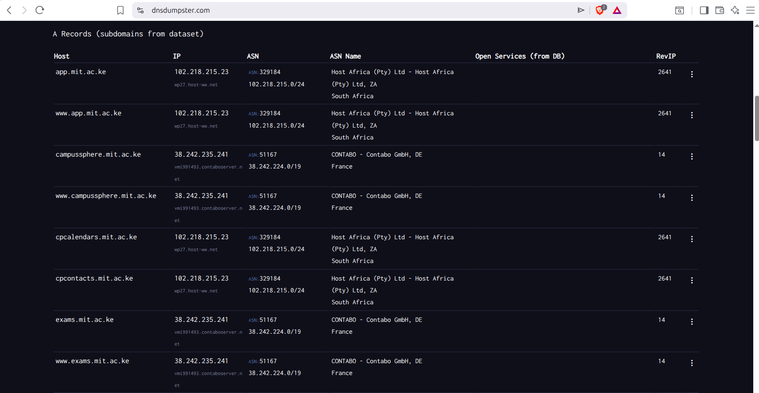Figure 4: Subdomains 1
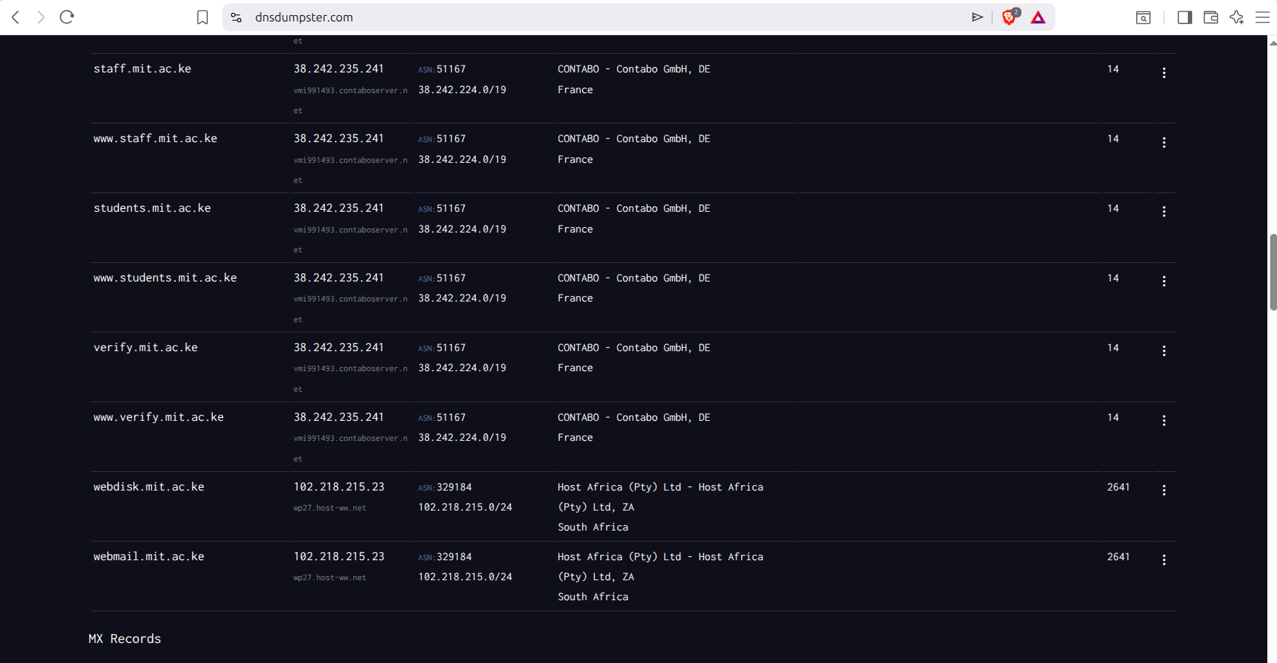Figure 5: Subdomains 2
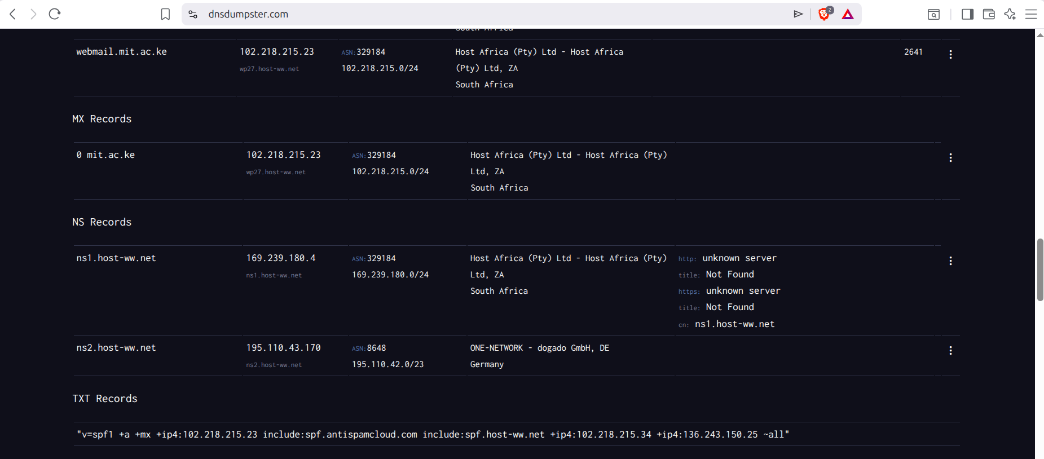Figure 6: Subdomains 3
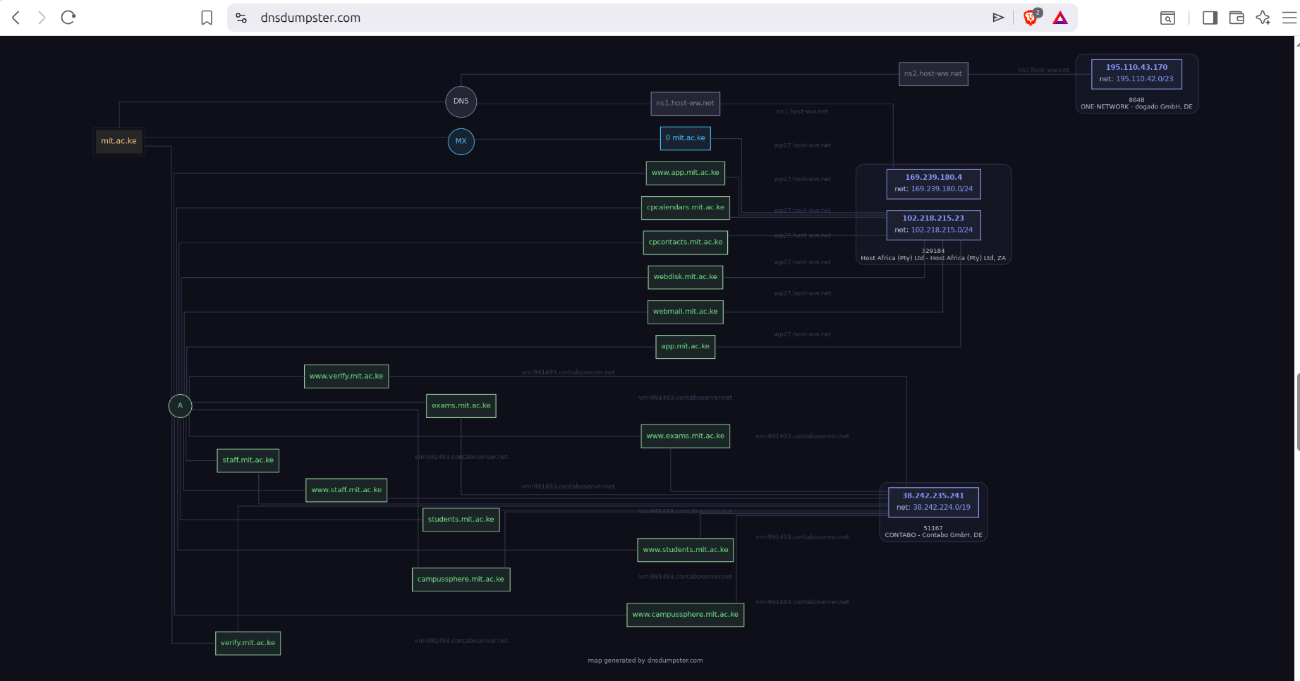Figure 7: Mapping of all interrelations

Technology Used
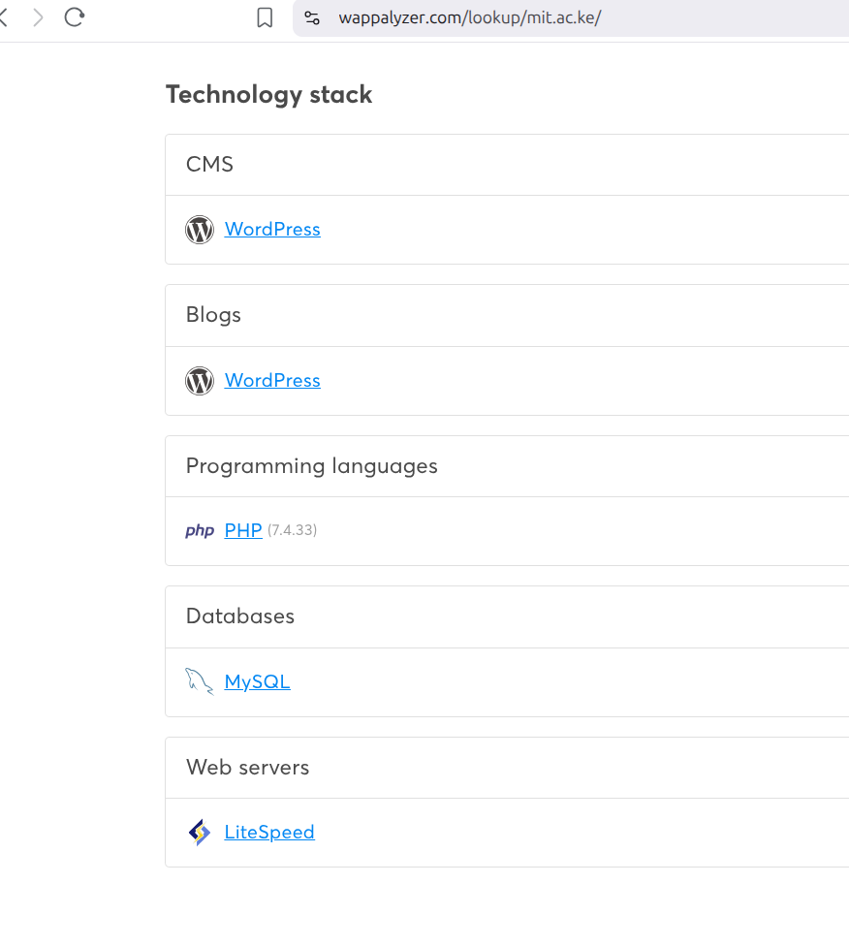Figure 8: Wappalyzer screen showing all technologies used for the website
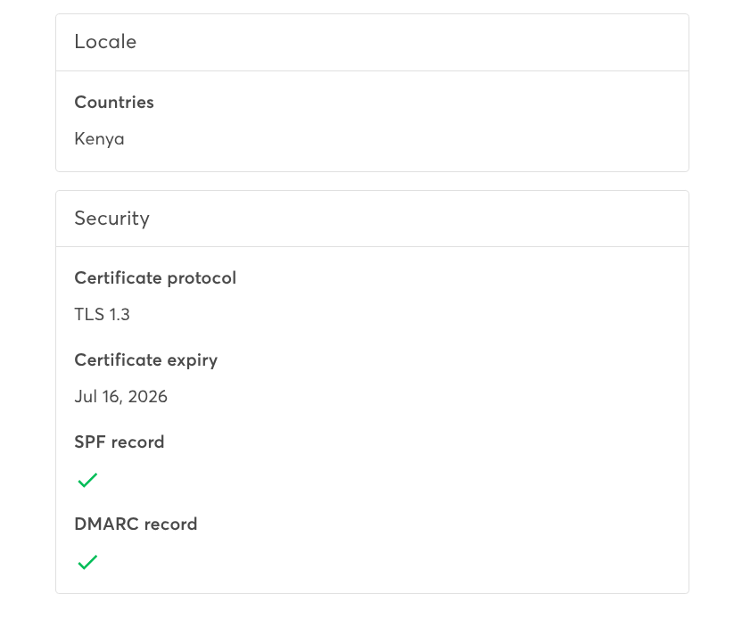Figure 9: Wappalyzer image showing more details on technology used

Open Services Enumeration
You can do the following without logging in:
- View home page
- View list of courses
- Access enrollment section and download application form
- View images of previous events
- Get links to respective student or staff portals
- Obtain contact information

Task 2: Scanning and Enumeration

Scan Ports
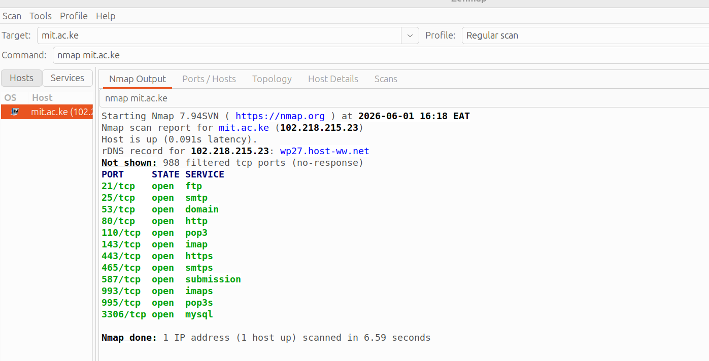Figure 10: Regular nmap port scan

Detect Running Services
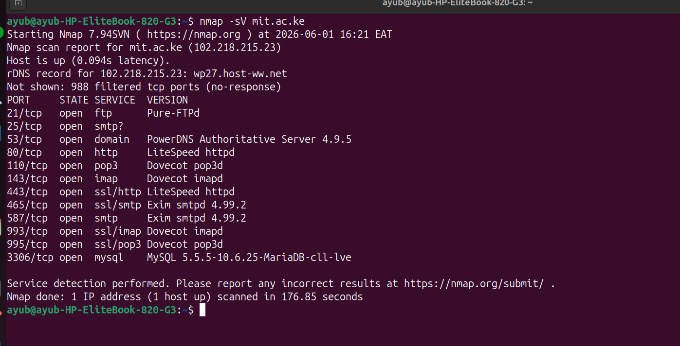Figure 11: Identification of running services

Identify OS Version
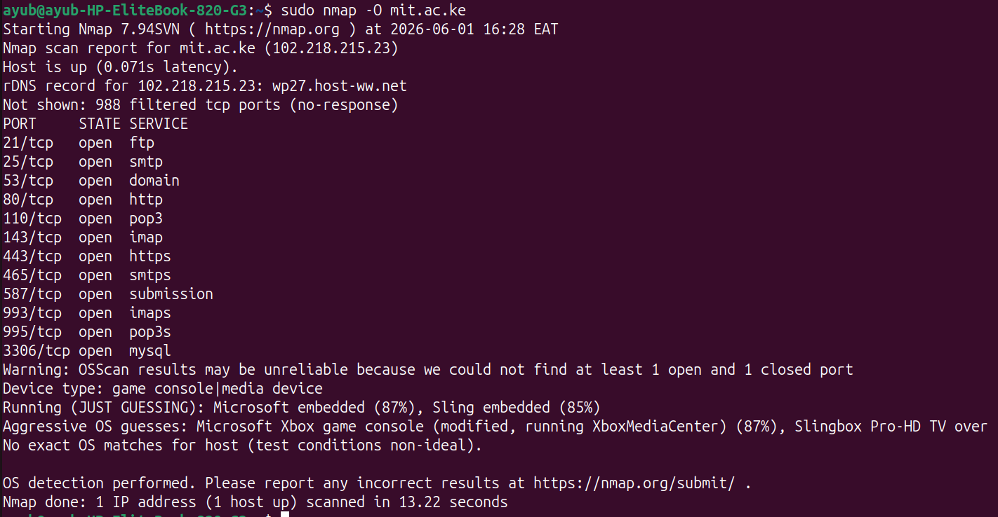Figure 12: Attempts of identifying the version of OS used

Shared Folders
No SMB services were detected and thus shared folder enumeration could not be performed

Reflection
Through this task I gained hands on experience in scanning techniques used in penetration testing. The exercise helped me understand the importance of information gathering and the potential security risks associated with exposed services and info that is publicly available

