SQL Assignment - Employee & Department Queries

1. Top 5 Highest Salary Employees
SELECT TOP 5 * FROM Employee ORDER BY Salary DESC;
Output Screenshot:
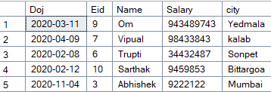

2. Department Wise Employee Count
SELECT d.Dname, COUNT(e.Eid) AS Employee_Count FROM Employee e INNER JOIN Department d ON e.Eid=d.emid GROUP BY d.Dname;
Output Screenshot:
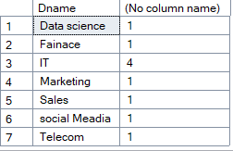

3. Second Highest Salary
SELECT MAX(Salary) FROM Employee WHERE Salary < (SELECT MAX(Salary) FROM Employee);
Output Screenshot:
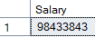

4. Employees Whose Salary is Greater Than Average Salary
SELECT * FROM Employee WHERE Salary > (SELECT AVG(Salary) FROM Employee);
Output Screenshot:
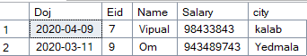

5. Inner Join
SELECT e.Eid,e.Name,e.Salary,d.Dname FROM Employee e INNER JOIN Department d ON e.Eid=d.emid;
Output Screenshot:
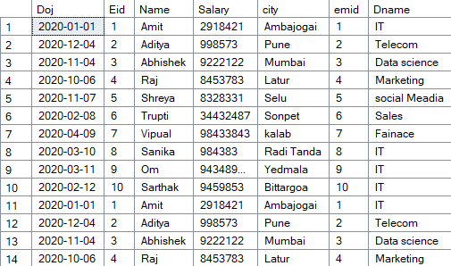

6. Left Join
SELECT e.Eid,e.Name,e.Salary,d.Dname FROM Employee e LEFT JOIN Department d ON e.Eid=d.emid;
Output Screenshot:
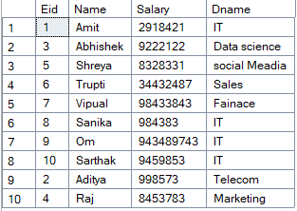

7. Group By With Having
SELECT d.Dname,COUNT(*) FROM Employee e INNER JOIN Department d ON e.Eid=d.emid GROUP BY d.Dname HAVING COUNT(*)>2;
Output Screenshot:


8. Employees Hired in Last 6 Months
SELECT * FROM Employee WHERE Doj >= DATEADD(MONTH,-6,GETDATE());
Output Screenshot:


9. Find Duplicate Records
SELECT Eid,Name,COUNT(*) FROM Employee GROUP BY Eid,Name HAVING COUNT(*)>1;
Output Screenshot:
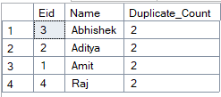

10. Remove Duplicate Records
WITH CTE AS (SELECT *, ROW_NUMBER() OVER(PARTITION BY Eid,Name,Salary,City,Doj ORDER BY Eid) RN FROM Employee) DELETE FROM CTE WHERE RN>1;
Output Screenshot:
