Splitting-based block preconditioners for Biot equations in bones and tissues

Prepared for Computer Methods in Biomechanics and Biomedical Engineering

J. B. Haga, K.-A. Mardal, J. M. Nordbotten

*Target journal: Journal of Computational Physics? This journal prefers LaTeX. And we need to check if there are constraints regarding number of pages, figures etc.*

# Abstract

We are interested in efficient solvers for the Biot’s equations in the context of coupled fluid flow and material deformation of human tissue and bone. In particular, we will consider iterative coupling strategies popularized in the geosciences communities. However, instead of applying these coupling strategies as fixed-point iterations, we instead view them as preconditioners for the monolithic discretization. Particular issues arising when modeling human tissues and bones relate to the large contrast in material parameters, both in the mechanical (Lamé parameters) and flow (permeability) equations. Theoretical results have previously shown that only two out of the four common splitting strategies are stable as iterative methods, however we are aware of no previous study considering their performance as preconditioners. Throughout the suite of test cases, we ultimately identify the so-called fixed stress split as the most robust preconditioner choice.

# 1. Introduction

Efficient preconditioners linear solvers remain a bottleneck in the application of monolithic discretizations of partial differential equations for internal organs and their interaction with the skeleton. Of particular interest herein are the Biot equations, which in many applications have sufficient resolution to capture essential processes within the brain (REF), spine (REF), and internal organs such as kidneys (REF). However, efficient solution of the Biot equations is also a necessary component when considering fluid-structure interaction as it appears in resolved hemodynamic simulation (Deparis, et al., 2013).

The Biot equations serve as a prototype for more general equations including non-Newtonian fluids and non-elastic material parameters (REF). The critical components include equations for the force balance in the solid

(1.1)

and the mass balance of the fluid phase

(1.2).

Here the Cauchy stress tensor is denoted by , fluid density is denoted by , void fraction of the solid (porosity) is denoted , while the fluid flux relative to the solid is denoted . The body force is given by and the fluid source term is given by .

These fundamental concepts are complemented by constitutive laws for material behavior, which we will herein take to be linear, isotropic and elastic with respect to the deformation and fluid pressure (following Biot):

(1.3),

and for the fluid filtration through the solid, which we will take herein as given by Darcy's law for a Newtonian fluid

(1.4).

The material parameters , , and are known as Lamé’s first and second parameter, the Biot coupling coefficient, and the permeability, respectively.

Equations (1.1-1.4) are closed by linearizing the dependence of density on pressure, and the dependence of the material porosity on the volumetric deformation

and (1.5).

Equations (1.1-1.5) combined form Biot's system of equations (Lewis & Schrefler, 1998). We recognize that Equations (1.1) and (1.3) are the equations of elasticity (including the pressure force from the internal fluid), while equations (1.2) and (1.4) are the equations of flow in porous media. This forms the basis of the two main strategies for addressing the solution to Biot's equations. The monolithic (or fully coupled) approach refers to strategies which seek to solve the coupled system directly (both in terms of discretization and subsequent solvers). Iterative coupling approaches allow for dedicated discretizations and solvers for the elastic and fluid sub-systems, and approximate the coupled system by passing information via the coupling terms given by the pressure in equation (1.3) and the dependence of porosity on deformation in equation (1.2). Coupled approaches can be further distinguished by their degree of coupling, but this distinction will not be required herein. (REFS)

Our interest herein is in efficient linear solvers for monolithic discretizations of the Biot equations. A key challenge in this respect is the saddle-point structure of equations (1.1-1.5). This makes the construction of direct multilevel (e.g. multigrid) strategies challenging. As an alternative we explore a two-stage preconditioning strategies, wherein the first stage of block preconditioning of the system addresses the saddle-point structure, while the second stage consists of standard preconditioners for the fluid and elastic sub-systems, respectively. Such strategies fall in the category of Schur-complement and block-Jacobi preconditioners (REFS). The novelty herein is to recognize the similarity of Schur-complement and block-Jacobi preconditioners to common iterative coupling strategies. Recent work on the convergence of iterative coupling thus motivates the use of iterative coupling as a new preconditioner for monolithic simulation.

This short communication is thus structured as follows: In section 2 we state the prototypical discrete linear system, and recall the standard Schur-complement and block-Jacobi preconditioners. In section 3 we review the four common iterative coupling strategies in the language of block preconditioners. Section 4 provides a suite of numerical examples wherein we address the stability and scaling of the preconditioners. Section 5 summarizes the main findings.

# 2. Linear Biot system

In this section we review the prototypical form of discrete Biot systems, together with the natural block preconditioners.

## 2.2. Prototypical Biot discretization

The Biot equation can be discretized using standard discretization methods such as finite elements (Lewis & Schrefler, 1998), finite difference (Gaspar, et al., 2008) or finite volume (Nordbotten, 2014) methods. We will herein only consider primal discretizations for displacement and pressure, and omit mixed discretizations introducing additional variables such as stress or fluid flux (Haga, et al., 2012; Badia, et al., 2009). The time discretization is commonly treated using a (semi)-implicit method (also referred to as backward Euler), which leads to a linear system of equations on the form

(2.1).

Here discretizes the linear elastic equations, and are discrete gradient and divergence, while discretizes the pressure equation, with being the Darcy terms. Primary variables are given as pressure and displacement . Commonly, the discretization methods will lead to diagonal blocks which are either symmetrical or nearly symmetrical, and likewise the off-diagonal blocks will be transposes.

Important issues with respect to the numerical discretization refer to robustness with respect to incompressible solids (limit of large ), and with respect to vanishing fluid system (small time-steps or limit of small ). We will in the following not address these issues directly, but assume that Equation (2.1) is the result of a robust discretization for the parameters of interest.

Our concern is with preconditioners for . We will denote a generic preconditioner formally as , with the understanding that by definition preconditioners in a certain sense satisfy .

## 2.2. Block-Jacobi and Gauss-Seidel preconditioning

In order to utilize efficient preconditioners for *A* and *B*, a two-stage approach wherein the full linear system in Equation (2.1) is resolved in the first stage can be employed. Our emphasis will be on this first stage. The simplest preconditioner for the block system is a Jacobi preconditioner (Haga, et al., 2011), which takes the form

(2.2)

Here, the notation implies that an approximation to may be applied in the setting of two-stage preconditioning. Note that applying this preconditioner in a Richards iteration is logically equivalent additive Schwartz iteration between the elastic and fluid domains. More rapid and robust convergence can be achieved by a multiplicative iteration, which leads to the Gauss-Seidel preconditioner

(2.3)

## 2.3. Schur-complement preconditioning

A more advanced approach is to view Equation (2.1) formally as a two-by two system of equations, where one variable can be explicitly eliminated to yield (pressure eliminated)

(2.4)

or (displacement eliminated)

(2.5)

Here the Schur complements are defined as

and (2.6)

These formal expressions have little value in practice as they involve calculating the full inverse of either or . However, they can form the basis of efficient preconditioners by choosing appropriate approximate inverses or . The simplest choice of approximate inverse is based on simply the diagonal components of (or ), however more advanced choices have been considered (REFS).

# 3. Iterative coupling as block preconditioning

The concept of iterative coupling has received significant attention in the subsurface flow community, where the availability of legacy codes for geomechanics and subsurface flow provides an added incentive for non-monolithic simulation. Iterative coupling schemes are in general considered based on four different splitting strategies (Kim, et al., 2011). The two simplest (Jacobi type) are referred to as Fixed Strain (SN) and Drained (D), while the two approaches with a predictor term (Schur-complement type) are referred to as Fixed Stress (SS) and Undrained (U). The former approaches are classical, while the latter two were introduced by (REF - Settari). While these splitting approaches have until now exclusively been considered in the context of iterative coupling, we will herein review them in the notation of preconditioning. Note that when applied as a preconditioner for a Richard’s iteration, this will be equivalent to the standard application as an iterative coupling scheme.

## 3.1 Drained split

The drained split is defined as a splitting of the original equations while keeping the fluid pressure constant over the splitting step, e.g.

Here is the (virtual) pressure after the splitting step. This leads to the mechanical system

Subsequently, the fluid system is solved normally

Combining the two steps in matrix form yields

Where the expression in curly brackets forms the preconditioner, and define

We recognize that the drained split is thus identical to a Gauss-Seidel iteration.

## 3.2 Undrained split

The undrained split is defined as a splitting of the original equations while keeping the fluid mass constant over the splitting step, e.g.

Here and are the (virtual) pressure and mass after the splitting step. Note that the pressure update can be interpreted as a predictor. This leads to the mechanical system

Subsequently, the fluid system is solved normally

Combining the two steps in matrix form yields

Where the expression in curly brackets forms the preconditioner, and we thus define

where

denotes an approximate Schur complement. Note that this is not the usual Schur-complement type formulation, as the right-hand side of the Schur-complement system is not consistent, as .

## 3.3 Fixed strain

The fixed strain split is defined as a splitting of the original equations while keeping the trace of the strain constant over the splitting step, e.g.

Here is the (virtual) displacement after the splitting step. This leads to the fluid system

Subsequently, the displacement system is solved normally

Combining the two steps in matrix form yields

Where the expression in curly brackets forms the preconditioner

The fixed strain split is a Gauss-Seidel iteration, and identical to the drained split, but offset by one-half splitting step.

## 3.4 Fixed stress

The fixed strain split is defined as a splitting of the original equations while keeping the trace of the stress constant over the splitting step, e.g.

Here and are the (virtual) displacement and volumetric stress after the splitting step, and is the bulk modulus and is the physical dimension of the problem. This leads to the fluid system

Subsequently, the displacement system is solved normally

Combining the two steps in matrix form yields

Where the expression in curly brackets forms the preconditioner,

Here the approximate Schur complement is given by

This last preconditioner is particularly appealing from a legacy code perspective, since the matrix structure of the Schur complement is identical to the original matrix (only the diagonal entries are affected).

# 4. Numerical assessment of splitting-based preconditioners

Splitting strategies of section 3 have been analyzed in terms of their stability and convergence (Kim, et al., 2011; Kim, et al., 2011; Mikelic & Wheeler, 2012). It is thus known that for the continuous problem, the two predictor-based splittings are unconditionally stable, and are thus also suited as preconditioners. The two Jacobi-type splittings are only conditionally stable. However, several issues are unresolved by analysis: A) The performance of the splittings as preconditioners for Krylov-based iterative methods. B) The performance of any splitting strategy for discrete systems, which may only inherit some of the properties of their continuous counterparts. C) The performance of the splitting strategies in a two-stage preconditioner, wherein the second stage itself may be inexact for the purpose of efficiency. We will address these issues in the following, using standard Jacobi-splitting and the pressure-Schur complement as benchmarks.

Our investigation uses three problems of progressively more complex character. These represent 1) A fractured (homogeneous) bone. 2) A 2D cross-section of the (heterogeneous) spine. 3) A 3D section of the (heterogeneous) spine. Through these test cases, we will be able to report on the issues A)-C) raised above.

## 4.1. 2D cross section of spinal chord

Our experience indicates that materials contrasts, which are common in the human bodies, are the source of challenges for block preconditioners. To investigate this phenomena, we first consider a 2D cross vertical section of the spinal cord. The geometry is a 1cm by 2cm rectangle parameters are taken from (REF) and illustrated in Figure 1 and Table 1. Note the contrast in the Young’s modulus, fluid storage coefficient and fluid mobility of order 1000. The boundary conditions are prescribed pressure and displacement on the left and right side (the pia mater) and stress free condition at the top and bottom. As our interest is the convergence properties of the different algorithms, the initial guess is a random vector, representing the worst case scenario, while the true solution is zero. With this setup we guarantee that the solution algorithms are exposed to both high, medium and low frequency errors. The mesh is a 64x64 division of Figure 1 where each square is divided in two triangles.

Figure 2 (a-c) shows the number of iterations for convergence for Richardson, BiCGStab and LGMRES when using exact preconditioners. For the Richardson iteration, only the fixed stress preconditioner ensure convergence. For BiCGStab and LGMRES, the fixed stress precondition is superior, but the Gauss-Seidel preconditioners are also reasonably efficient. Figure 3 (a-c) shows the corresponding results when using multilevel preconditioners for the individual blocks. Clearly, the introduction of inexact sub-solvers results in significant stagnation for the Richardson method, while the increase in number of iterations for both BiCGStab and LGMRES is less than a factor 2. It should however be remarked that one LGMRES iteration is roughly 15 times as computational expensive as one BiCGStab iteration which again is twice as expensive as a Richardson iteration. The condition numbers of and were estimated to 30 and 1.4, respectively, using a CG based eigenvalue estimation algorithms (Saad).

## 4.2. 3D section of spinal chord

The last example represents a realistic computational problem, taken from (REF). The domain is discretized by nearly half a million degrees of freedom, precluding the use of standard direct solvers. As such, all results in this section are in the setting of two-stage preconditioning as initially explored in Section 4.2.

We note from figures 4.5 that the 3D case is significantly more challenging than its 2D counterpart. Notably…

## 4.2. 2D contrast example

It is of interest to consider also more extreme contrasts in material parameters. We therefore consider a triangulation of the unit square where there is a sudden jump in the permeability at the midline (y=0.5) as shown in Figure 5 with the parameters given in Table 2. The mesh is a 160x160 division of the unit square and we use the same parameters in the preconditioner as in example 4.1.

Figure 5 (a-c) shows the convergence in terms of the Richardson, BiCGStab, and LGMRES methods. Comparing with the results in Example 4.1, we see that the fixed stress preconditioner behaves similarly, with a clear stagnation of the Gauss-Seidel variants. . The condition numbers of and were estimated to 30 and 50, respectively, but clearly the fixed stress preconditioner handles the jump robustly.

# 5. Conclusions

# 6. Tables

Table 1

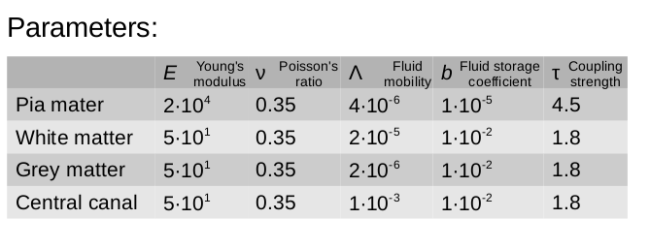

Table 2

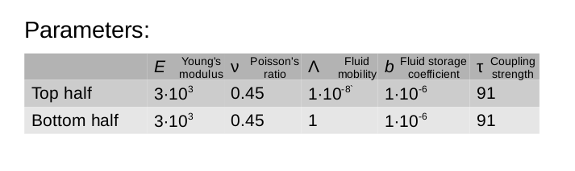

# 7. Figures

Figure 1

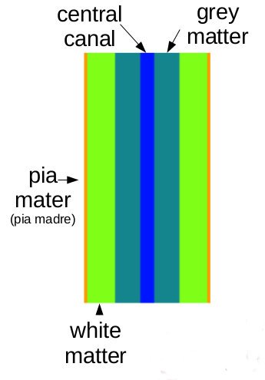

Figure 1. An idealized 2D spinal cord including different material properties in the white and grey matter, the pia mater, and the central canal.

Figure 2 a)



Figure 2b)



Figure 2 c)



Figure 2: The number of iterations used by Richardson (a), BiCGStab (b), and LGMRES (c) when using exact preconditioning. The L2 norm of the residuals are show as solid lines while the energy norm of the iterates are show as dotted lines of the same color. Notice that for LGMRES the lines overlap.

Figure 3 a)



Figure 3 b)



Figure 3 c)



Figure 3: The number of iterations used by Richardson (a), BiCGStab (b), and LGMRES (c) when using 2 multilevel sweeps. The L2 norm of the residuals are show as solid lines while the energy norm of the iterates are show as dotted lines of the same color. Notice that for LGMRES there is a close relation between the residual and error.

Figure 4

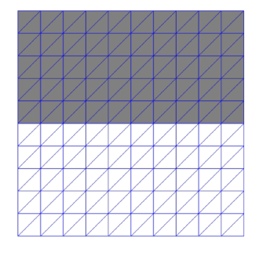

Figure 6 a)



Figure 5 b)



Figure 5 c)



Figure 5 (a-c) shows the number of iterations in Example 4.2 for the Richardson (a), BiCGStab (b) and LGMRES (c) methods when using multilevel preconditions.

# Bibliography

Badia, S., Quaini, A. & Quarteroni, A., 2009. Coupling Biot and Navier-Stokes equations for modeling fluid-poroelastic media interaction. *Journal of Computational Physics,* Volume 228, pp. 7986-8014.

Gaspar, F. J., Lisbona, F. J. & Oosterlee, C. W., 2008. A stabilized difference scheme for deformable porous media and its numerical resolution by multigrid methods. *Computation and Visualization in Science,* Volume 11, pp. 67-76.

Haga, J. B., Osnes, H. & Langtangen, H. P., 2011. Efficient block preconditioners for the coupled equations of pressure and deformation in highly discontinuous media. *International Journal for Numerical and Analytical Methods in Geomechanics,* Volume 35, pp. 1466-1482.

Haga, J. B., Osnes, H. & Langtangen, H. P., 2012. On the causes of pressure oscillations in low-permeable and low-compressible porous media. *International Journal for Numerical and Analytical Methods in Geomechanics,* Volume 36, pp. 1507-1522.

Kim, J., Tchelepi, H. A. & Juanes, R., 2011. Stability and convergence of sequential methods for coupled flow and geomechanics: Drained and undrained splits. *Computer Methods in Applied Mechanics and Engineering,* Volume 200, pp. 2094-2116.

Kim, J., Tchelepi, H. A. & Juanes, R., 2011. Stability and convergence of sequential methods for coupled flow and geomechanics: Fixed-stress and fixed-strain splits. *Computer Methods in Applied Mechanical Engineering,* Volume 200, pp. 1591-1606.

Kim, J., Tchelepi, H. A. & Juanes, R., 2011. Stability, accuracy and efficiency of sequential methods for coupled flow and geomechanics. *SPE Journal,* 16(2), pp. 249-262.

Lewis, R. W. & Schrefler, B. A., 1998. *The finite element method in the static and dynamic deformation and consolidation of porous media.* Chichester: John Wiley and Sons Ltd..

Mikelic, A. & Wheeler, M., 2012. Convergence of iterative coupling for coupled flow and mechanics. *Computational Geosciences,* 17(3), pp. 455-461.

Nordbotten, J. M., 2014. Finite volume hydro-mechanical simulation of porous media. *Water Resources Research,* Volume 50.