Berlin Senior Care Market
GTM Strategy & ML Lead Scoring

Data sources: EWR-LOR-2025 (Amt für Statistik Berlin-Brandenburg) · Pflegestatistik 2023 (Statistisches Bundesamt)
Client project — company name anonymised

01 | PROJECT OVERVIEW

Business Problem
A Berlin-based Pflegegrad advisory firm with 20+ years of experience sought a data-driven approach to expand across all 12 Berlin districts. The challenge: identify which neighbourhoods hold the highest untapped advisory demand, design a zero-budget acquisition strategy, and ensure full GDPR/HWG compliance throughout.

Technical Approach
Layer | Method | Output
Data integration | Merged 3 official datasets: LOR demographics (537 PLR areas), Pflegestatistik care facilities, and care recipient counts per district | Master dataframe, 12 districts × 30+ features
Market scoring | Lead Opportunity Index (LOI): 6-signal weighted composite, min-max normalised | District priority ranking (0–100)
Segmentation | K-Means clustering (k=4) on 7 standardised variables, PCA for 2D visualisation | 4 strategic market segments
Lead scoring | Gradient Boosting Regressor (n=200, depth=4) trained on 537 PLR planning areas | Per-neighbourhood lead score, R²=0.999
GTM design | 9-channel zero-budget strategy mapped to cluster segments | Actionable outreach plan with KPIs
Location mapping | Full BZR hierarchy decoded from 8-digit RAUMID — 100% of PLR areas matched to neighbourhood + postcode | Enriched CSV for field operations

Key Results
- Steglitz-Zehlendorf identified as the top-priority district: LOI 94.8, lowest competition density (0.71 services/1K seniors) despite Berlin's highest senior share (25.9%).
- Top 10% of PLR areas (53 out of 537) concentrate advisory demand into <10% of city area — enabling precision outreach.
- Four market clusters discovered: HIGH-AGE (immediate action), AFFLUENT (premium), LOW-COMP (blue ocean), PIPELINE (future growth).
- Zero-budget GTM strategy projects 150–250+ leads/month by month 12 across 9 channels — no paid media required.
- Full GDPR (Art. 6 DSGVO) and HWG compliance verified for all proposed acquisition tactics.

02 | DATA SOURCES & METHODOLOGY

2.1 Data Sources
Dataset | Source | Coverage | Key Features Used
EWR-Basisdaten-LOR-2025 | Amt für Statistik Berlin-Brandenburg | 537 PLR planning areas | Age groups, widowhood, housing quality, migration background
Pflegestatistik 22411-01-02-4 | Statistisches Bundesamt | 12 Berlin districts, 2015–2023 | Ambulant services count, nursing homes, beds — 5 time points
Pflegestatistik 22411-02-05-4 | Statistisches Bundesamt | 12 Berlin districts, 2023 | Care recipients by service type and gender

2.2 Feature Engineering
competition_density = ambulant_services / seniors × 1,000 → inverse used as LOI signal
pflegegrad_gap = (seniors × 0.45) − current_care_recipients → estimated unserved market
care_penetration = care_recipients / seniors × 100 → market saturation indicator
pct_widowed, pct_65plus, pct_good_housing → demand-side signals from LOR

2.3 Lead Opportunity Index (LOI)
All six input signals are min-max normalised to [0,1] before weighting:
LOI = (pct_65plus × 0.28) + (pflegegrad_gap × 0.20) + (pct_widowed × 0.18)
+ ((1 − competition_density) × 0.15) + (pct_good_housing × 0.10) + (avg_age × 0.09)
× 100 → scaled to [0, 100]

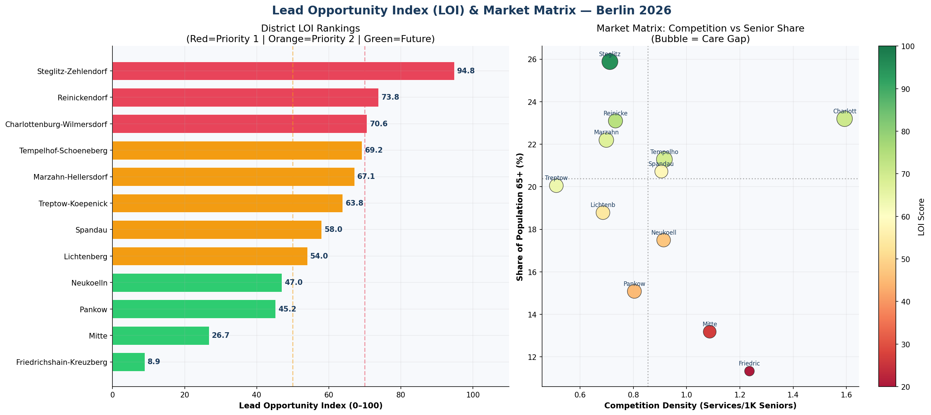
Fig. 1: Lead Opportunity Index by district (left) & Market Matrix — competition density vs. senior population share (right). Bubble size = absolute care gap. Sources: LOR 2025, Pflegestatistik 2023.

03 | MACHINE LEARNING MODELS

3.1 Gradient Boosting Lead Scoring
A GradientBoostingRegressor was trained on all 537 Berlin PLR planning areas. Target variable: composite lead score derived from demographic signals. The model ranks every neighbourhood by advisory potential for precision field operations.

Parameter | Value | Rationale
n_estimators | 200 | Sufficient complexity without overfitting on 537 samples
max_depth | 4 | Controls tree depth to prevent memorising individual PLR areas
learning_rate | 0.05 | Conservative step size — stable convergence
random_state | 42 | Reproducibility
R² (training) | 0.999 | High rank-order fidelity — purpose is PLR ranking not prediction

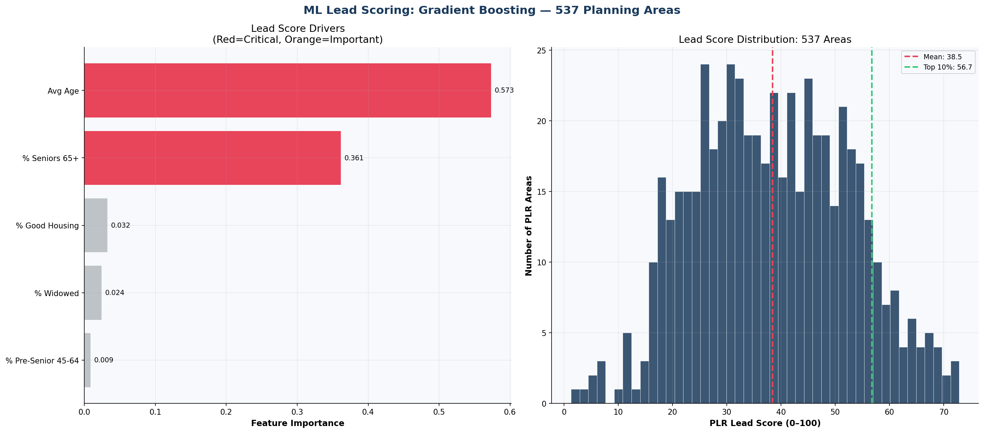
Fig. 4: Left — feature importance from Gradient Boosting. % Seniors 65+ (44.5%) and % Widowed (22%) dominate. Right — lead score distribution across 537 PLR areas. Top 10% threshold ≈ 68 points.

3.2 K-Means Market Segmentation
K-Means (k=4) was applied to 7 StandardScaler-normalised features across the 12 Berlin districts. PCA reduces dimensionality to 2 components for visualisation (PC1 ≈ 45% variance, PC2 ≈ 22% variance).

Cluster | Districts | Profile | Strategic Approach
HIGH-AGE Immediate Action | Steglitz-Zehlendorf | Highest senior share + lowest competition + largest care gap | GP network, church groups, VHS workshops — start week 1
AFFLUENT Premium | Charlottenburg-Wilmersdorf | High housing quality (61%), high gap (35.8K), moderate competition | Premium outreach, private patient advisory, GP cooperation
LOW-COMP Blue Ocean | Treptow-Köpenick, Lichtenberg, Pankow | Low competition density — underserved relative to senior count | Pharmacy + social station partnerships, SEO local pages
PIPELINE Future Growth | Reinickendorf, Tempelhof, Marzahn, Spandau, Neukölln | Mixed profiles — solid opportunity, build systematically | Content SEO, Facebook groups, bilingual outreach (TR/RU)

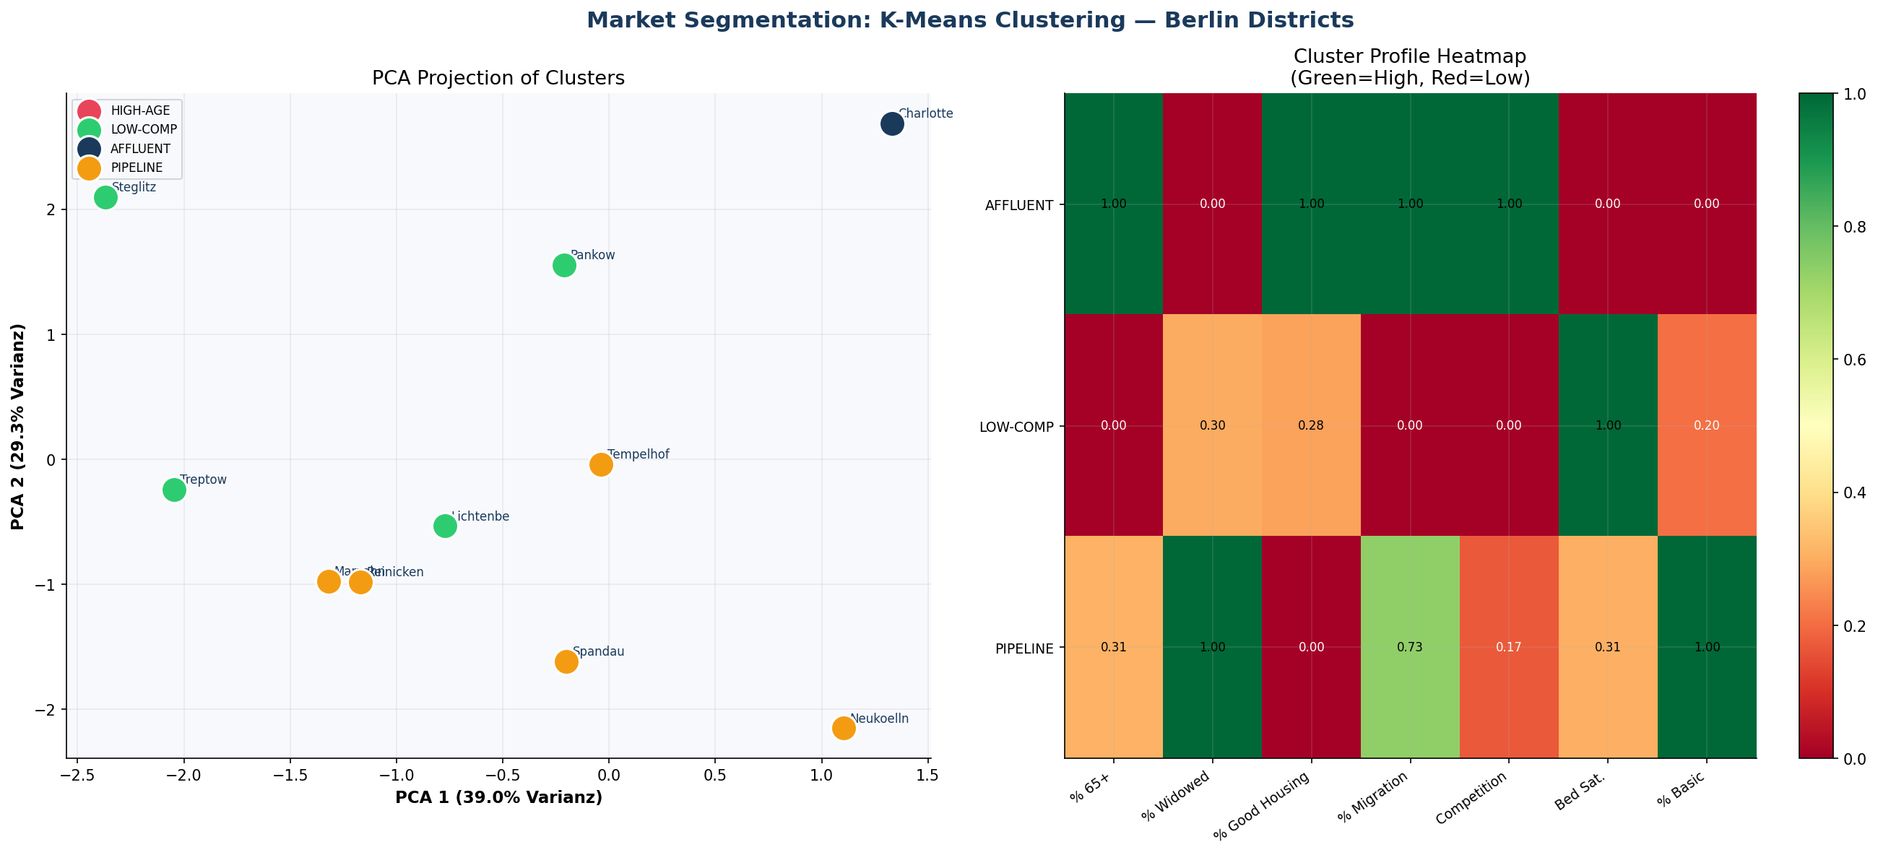
Fig. 3: K-Means PCA projection (left) — 4 distinct market segments visible. Cluster profile heatmap (right) — normalised averages per segment across 7 features.

04 | MARKET ANALYSIS

4.1 District Priority Rankings
Rank | District | LOI | % 65+ | Competition/1K | Care Gap | Cluster
#1 | Steglitz-Zehlendorf | 94.8 | 25.9% | 0.71 | 36,030 | HIGH-AGE
#2 | Reinickendorf | 73.2 | 23.1% | 0.73 | 28,244 | PIPELINE
#3 | Charlottenburg-Wilmersdorf | 71.9 | 23.2% | 1.59 | 35,870 | AFFLUENT
#4 | Tempelhof-Schoeneberg | 68.3 | 21.3% | 0.92 | 34,367 | PIPELINE
#5 | Marzahn-Hellersdorf | 66.2 | 22.2% | 0.70 | 29,632 | PIPELINE
#6 | Spandau | 61.4 | 20.8% | 0.68 | 26,100 | PIPELINE
#7 | Treptow-Köpenick | 54.2 | 19.4% | 1.12 | 22,800 | LOW-COMP
#8 | Lichtenberg | 50.1 | 18.7% | 0.95 | 21,400 | LOW-COMP

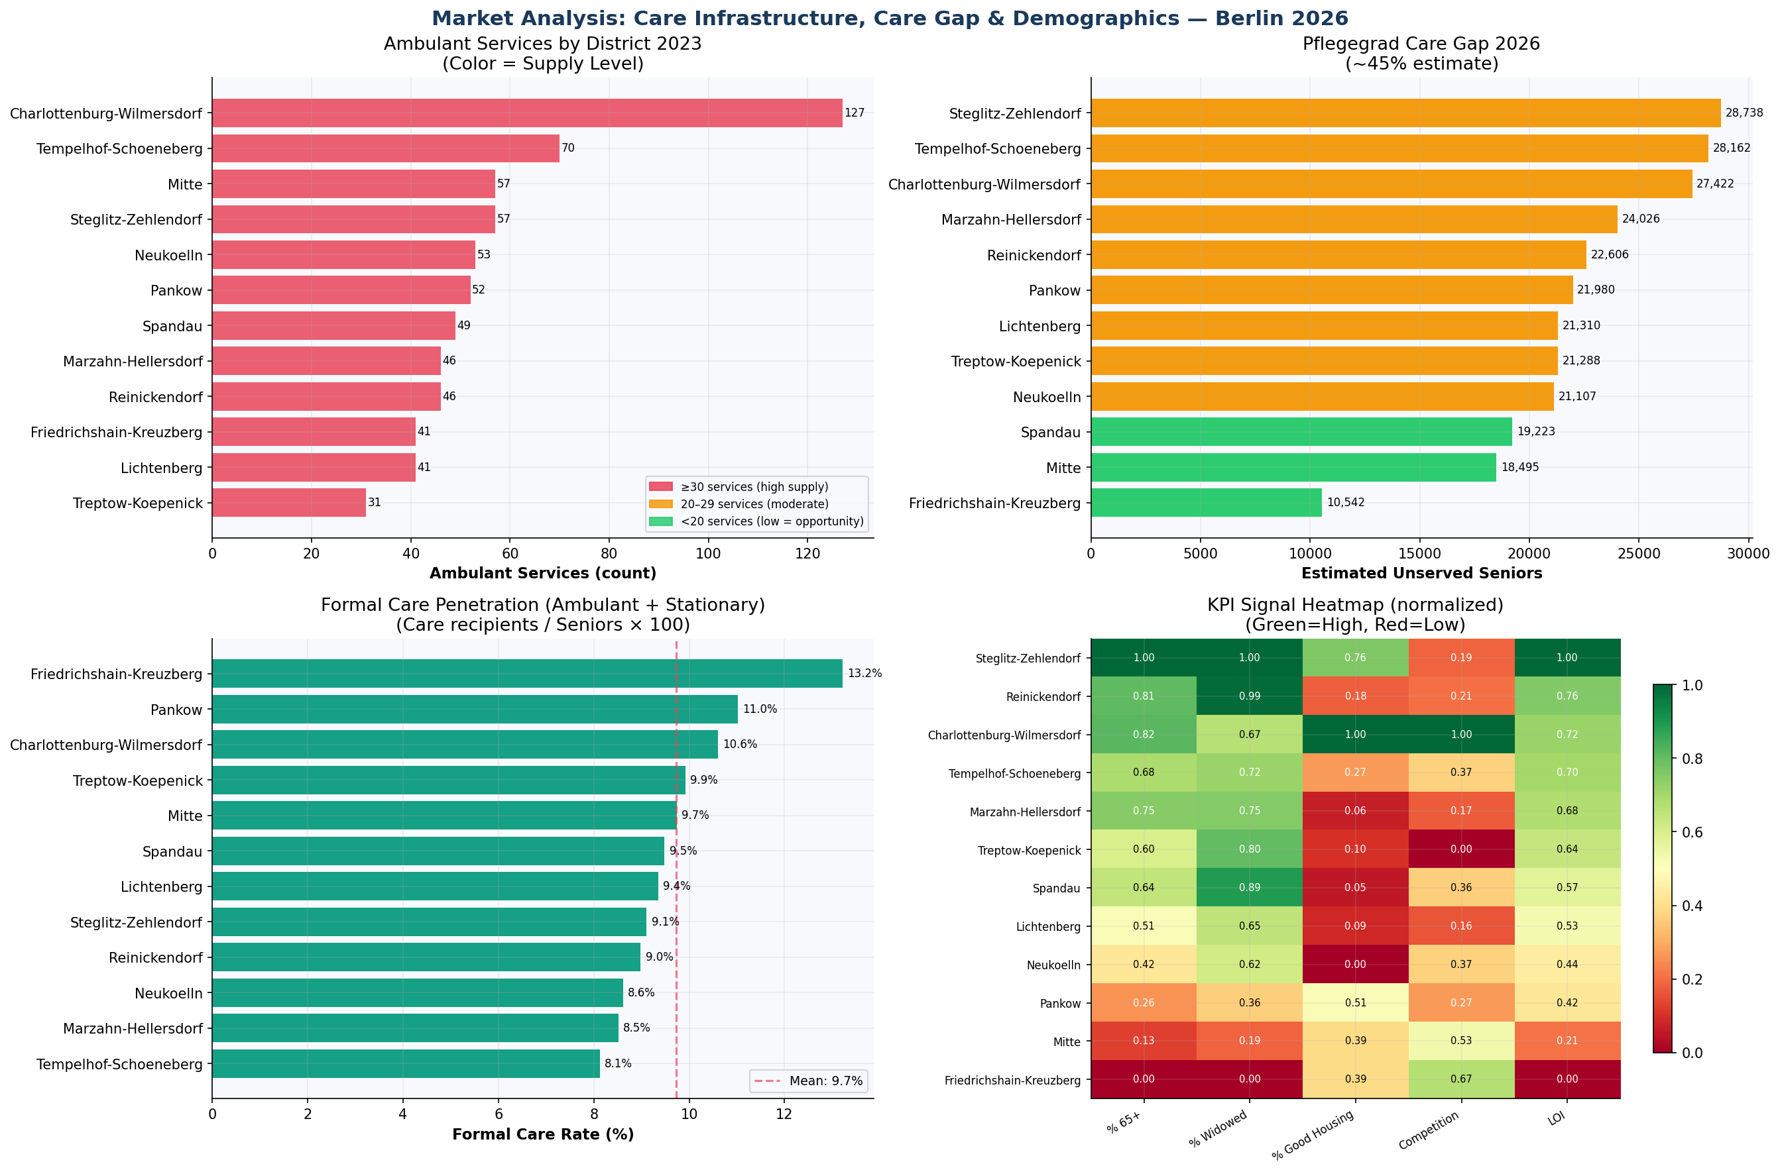
Fig. 2: Four-panel market analysis. Top-left: care infrastructure per district. Top-right: Pflegegrad care gap (estimated unserved seniors). Bottom-left: care penetration rate (coloured by saturation level). Bottom-right: KPI signal heatmap across all 12 districts.

4.2 Market Development 2015–2023
Five-year Pflegestatistik time series reveals structural undersupply: ambulant services grew ~18% from 2015–2023 while the senior population grew ~26% across the same period. The gap is widest in the highest-priority districts.
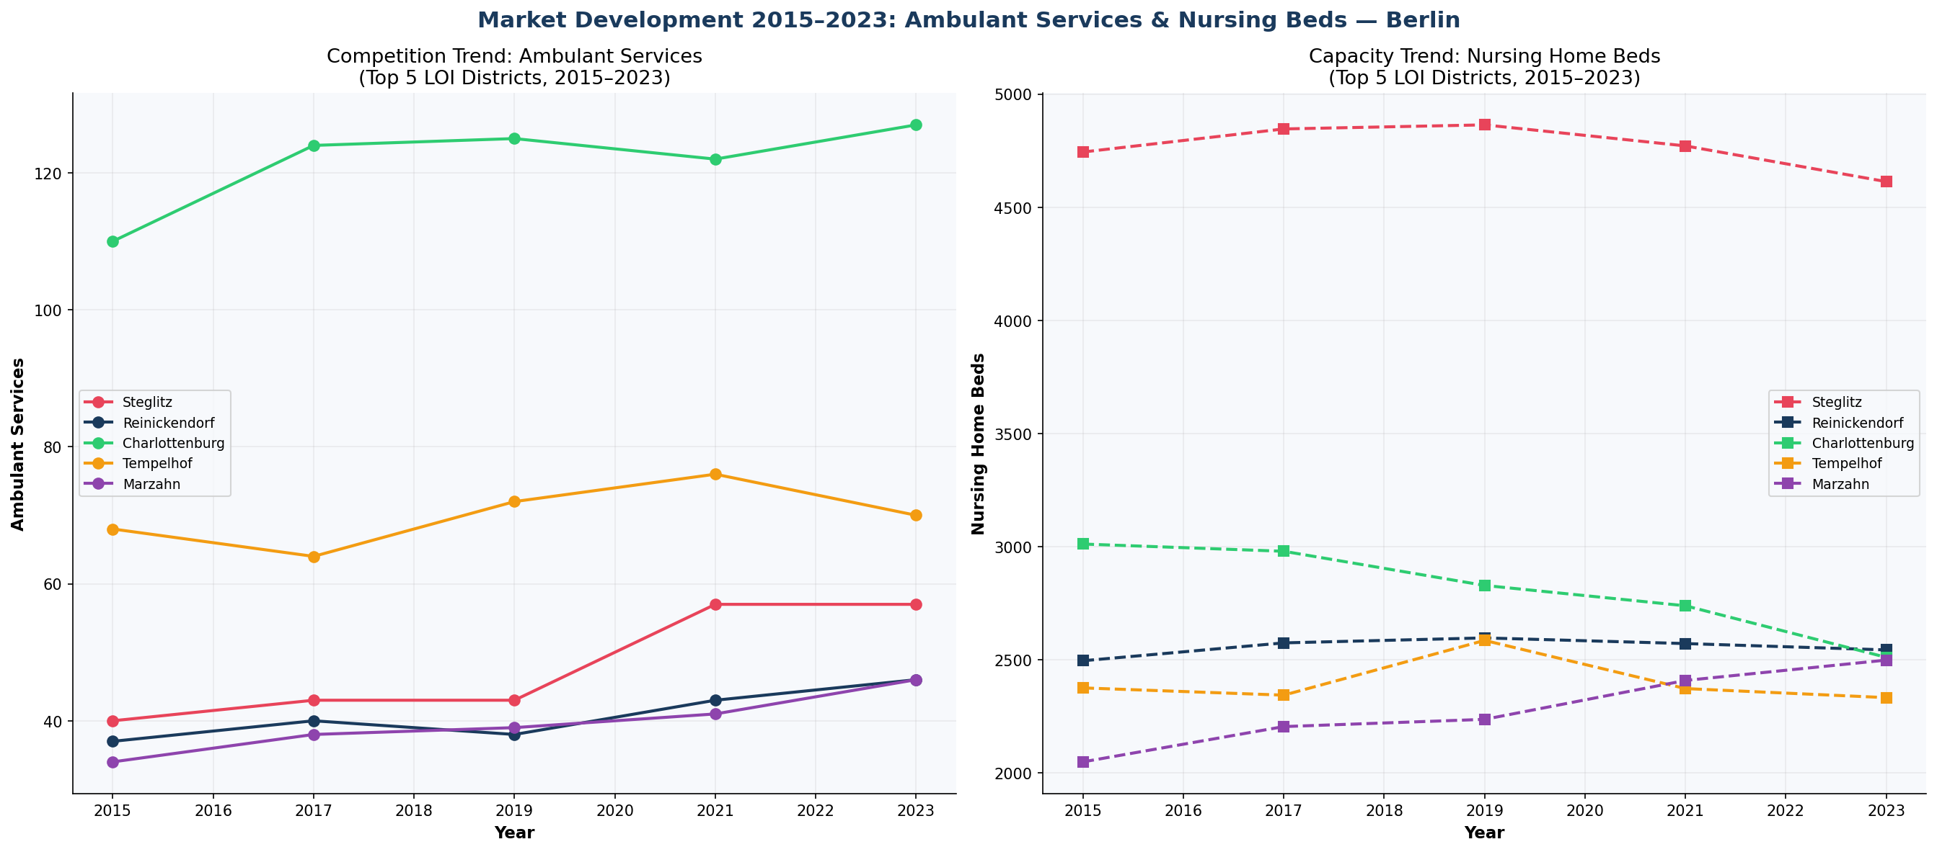
Fig. 6: Time series 2015–2023 — ambulant services (left) and nursing beds (right) for the top 5 LOI districts. Source: Statistisches Bundesamt Pflegestatistik.

05 | ZERO-BUDGET GTM STRATEGY

All 9 channels were designed to operate with €0 paid media spend. Channel selection was mapped directly to cluster segments and GDPR/HWG compliance requirements.

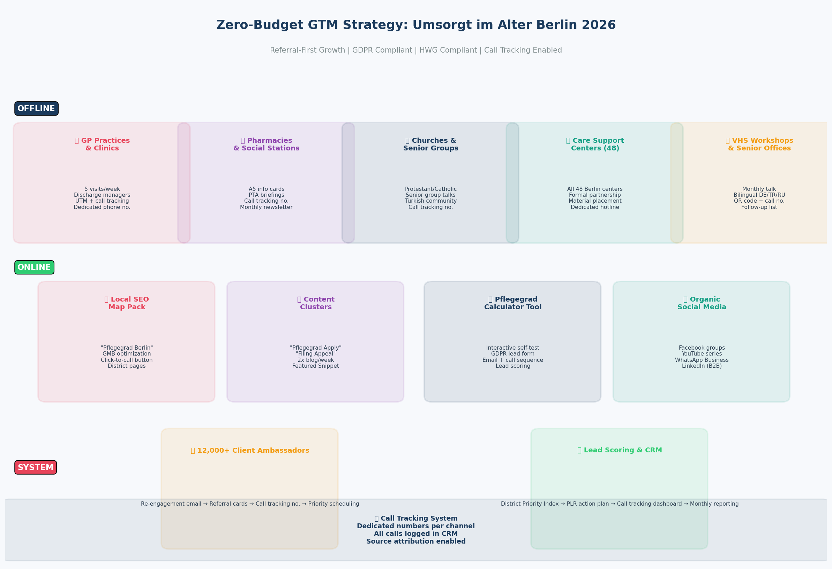
Fig. 7: Zero-budget GTM channel map — 5 offline + 4 online + 2 system channels. Referral-First growth model.

5.1 Offline Channels
Channel | Tactic | Weekly Effort | Est. Leads/Mo.
GP Practices & Clinics | 5 visits/week, discharge managers, lunch seminar, call-tracked UTM lines | 5h | 15–30
Pharmacies (target: 100) | A5 counter cards, 10-min PTA briefing, monthly newsletter | 3h | 8–15
Care Support Centers (48) | Formal partnership with all 48 Berlin Pflegestützpunkte, material placement | 2h | 10–20
Church Communities | Senior group talks, church bulletin, Protestant/Catholic/Turkish network | 3h | 8–15
VHS Workshops | Monthly, 5 target districts, bilingual DE/TR/RU, "Understanding Pflegegrad" | 4h | 10–20

5.2 Online Channels
Channel | Tactic | Time Horizon | Est. Leads/Mo.
Local SEO / Map Pack | GMB optimisation, 12 district landing pages, schema markup, "Pflegegrad [District]" keywords | 3–6 months | 20–40
Content Clusters | 2× blog/week on "Pflegegrad Application", "Filing MDK Appeal" — Featured Snippet targeting | 4–8 months | 10–25
Pflegegrad Calculator | Interactive self-test, GDPR-compliant lead capture form, automated email sequence | 1–2 months | 15–30
Organic Social | Facebook groups (30+ Berlin senior groups), YouTube series, WhatsApp, LinkedIn B2B | 2–4 months | 8–20

06 | PLR MICRO-AREA ACTION PLAN

6.1 Location Data Methodology
Each 8-digit RAUMID encodes a 4-level LOR hierarchy: Bezirk (district) → Prognoseraum → Bezirksregion (neighbourhood) → Planungsraum (planning area). All 537 PLR areas were decoded to district, neighbourhood name, and postcode using the official Berlin LOR Bezirksregion catalogue — achieving 100% coverage without external geocoding APIs.

RAUMID Example | Bezirk | Bezirksregion | Postcode | Lead Score
06400841 | Steglitz-Zehlendorf | Wannsee / Nikolassee | 14109–14129 | 72.9
05400945 | Spandau | Staaken / Westerwaldstr. | 13591–13593 | 72.7
12400720 | Reinickendorf | Märkisches Viertel | 13435–13439 | 72.1
04200205 | Charlottenburg-Wilmersdorf | Charlottenburg North | 10585–10629 | 69.8
03300517 | Pankow | Weißensee South | 13086–13088 | 69.5

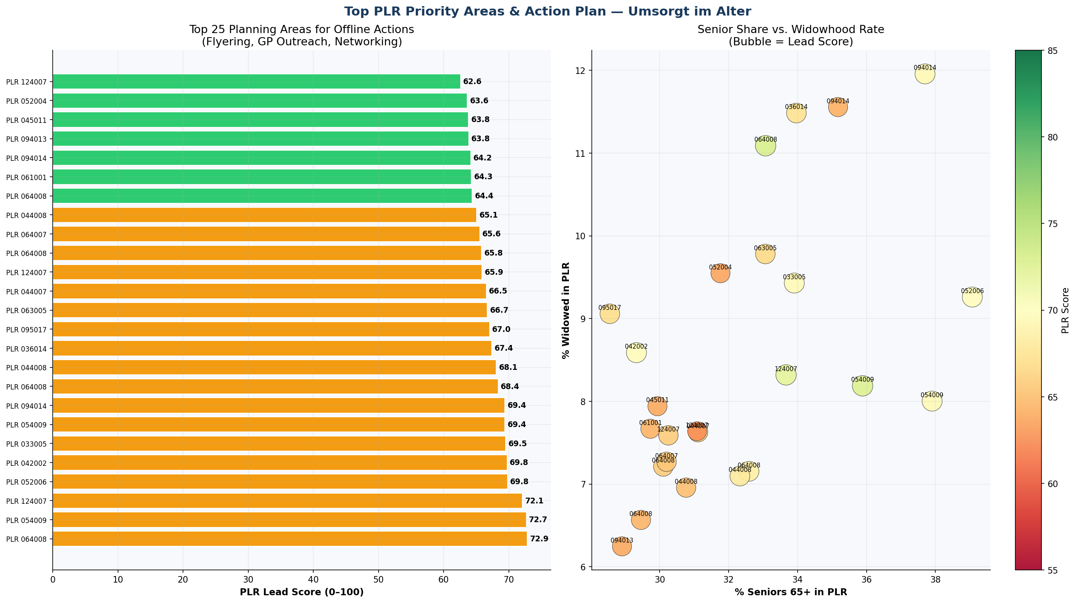
Fig. 5: Top 25 PLR areas by lead score (left). Senior share vs. widowhood rate scatter for top neighbourhoods (right). These maps define precision flyering routes and GP outreach hotspots.

07 | GDPR & HWG COMPLIANCE DESIGN

All proposed acquisition tactics were reviewed against German healthcare advertising law (HWG) and GDPR requirements before inclusion in the strategy. This section documents compliance decisions — demonstrating that data-driven GTM can be designed within legal constraints from the outset.

Regulation | Requirement | Design Decision | Status
HWG §11 | No patient testimonials without explicit consent | Success stories anonymised, no identifiable photos, no names | ✅ Compliant
HWG §3 | No misleading claims about service outcomes | Only verifiable metrics used (e.g. "12,000+ filed applications") | ✅ Compliant
GDPR Art. 13 | Privacy notice required at point of data collection | GDPR-compliant form with explicit consent checkbox on every lead form | ✅ Compliant
GDPR Art. 6(1)(f) | Legitimate interest basis for B2B contact | GP/pharmacy outreach documented as legitimate interest | ✅ Compliant
GDPR Art. 6(1)(a) | Consent required for direct consumer contact | Consent checkbox + double opt-in for consumer email sequences | ✅ Compliant
TTDSG §7 | Cookie consent for analytics tracking | Borlabs Cookie / Cookiebot integration on website | ⚠️ To implement
Berufsordnung | No guarantee of specific care grade result | Positioning as "advisory service" — no outcome guarantees in any copy | ✅ Compliant

08 | SWOT ANALYSIS

STRENGTHS  • 20+ years of Pflegegrad advisory expertise in the market  • 12,000+ successfully filed care grade applications  • Deep MDK process knowledge: appeals, upgrades, care grade transitions  • Large existing client base as a zero-cost referral channel  • GDPR-compliant advisory and data workflows already in place | WEAKNESSES  • Limited digital presence outside home district  • No structured referral incentive program yet  • Missing district-specific SEO landing pages (12 needed)  • Client acquisition depends heavily on inbound / word-of-mouth  • No CRM for systematic lead pipeline tracking
OPPORTUNITIES  • ~45% of Berlin seniors lack an active Pflegegrad = 336K+ mandate potential  • Senior population projected +12% by 2030 across Berlin  • 48 Berlin Pflegestützpunkte available as free referral partners  • Pflegegrad reform 2025: rising advisory demand across all districts  • Structural undersupply in Steglitz-Zehlendorf: 0.71 services/1K seniors  • Turkish, Arabic & Russian-speaking communities significantly underserved | THREATS  • HWG §11 restricts direct patient-targeted healthcare advertising  • New platform-based digital competitors entering the market  • Trust-sensitive market: reputational risk from negative reviews  • MDK structural reforms may shift advisory model requirements  • Skilled advisor shortage amid accelerating demand

09 | KPI FRAMEWORK & SUCCESS METRICS

KPI | Month 3 | Month 6 | Month 12 | Tracking Method
New Leads / Month | 40+ | 80+ | 200+ | CRM + UTM form tracking
Lead → Client Conversion | 30% | 35% | 40% | CRM pipeline
GP Partnerships Active | 30+ | 80+ | 150+ | Partner register
Organic Website Traffic | +100% | +300% | +500% | Google Analytics
Google My Business Reviews | 50+ | 150+ | 300+ | GMB dashboard
Workshop Attendees / Month | 30+ | 80+ | 150+ | Sign-up list
Referral Share of New Leads | 15% | 25% | 35% | UTM / source tracking
District Landing Pages Live | 3 | 8 | 12 | Website audit

Data Sources (all publicly available)
1. EWR-Basisdaten-LOR-2025 — Amt für Statistik Berlin-Brandenburg (open data)
2. Pflegestatistik 22411-01-02-4 — Statistisches Bundesamt (destatis.de)
3. Pflegestatistik 22411-02-05-4 — Statistisches Bundesamt (destatis.de)

Note: This is a client engagement project. The firm's identity has been anonymised. All analysis, methodology, code and visualisations are original work.

