**RULE BOOK**

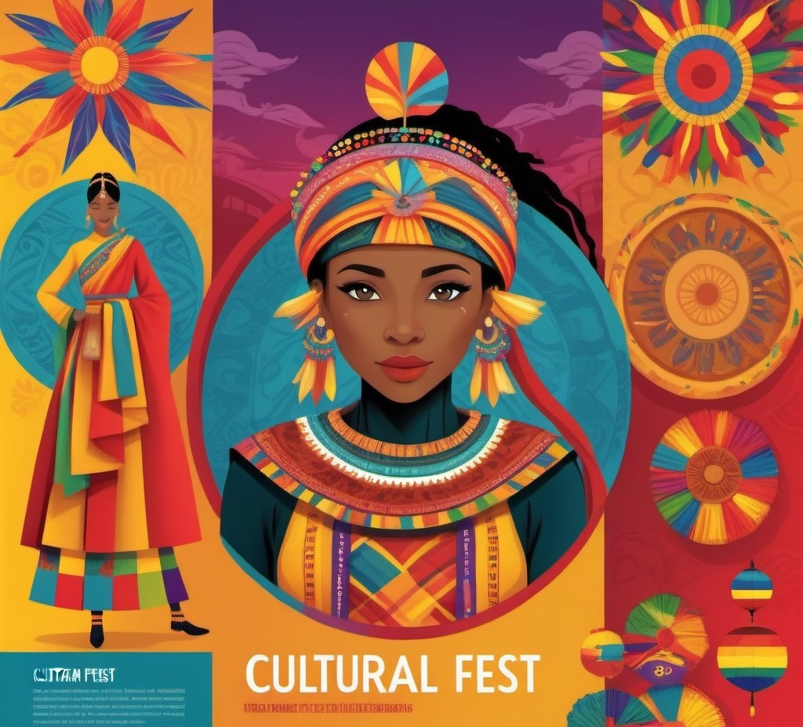

**GROUP DANCE – Freestyle (Footloose):**

Participants can perform dance on any song/s or music of their choice

The song/music should be handed well in advance to the coordinators

Time limit for Dance is 5-7 MINUTES

Number of participants is minimum 6 and maximum 10 in one team

|  |  |  |
| --- | --- | --- |
| Event coordinators |  |  |

GROUP DANCE – Folk (Swadesam):

Participants can perform dance on any folk song or music

The song/music should be handed well in advance to the coordinators

Time limit for Dance is 5-7 MINUTES

Number of participants is minimum 6 and maximum 10 in one team

SOLO DANCE – Classical (Naatyam):

Participant can perform dance on any of the Indian Classical Dance Forms

Classical-Fusion is allowed.

The song/music should be handed well in advance to the coordinators.

Time: 5-7 minutes

DUET DANCE – Freestyle (Hum-Tum)

Participants can perform dance on Western, Indian, folk and movie song/s or music

The son/music should be handed well in advance to the coordinators

Time limit for Dance is 4-5 MINUTES

Number of participants is two in one team

GROUP SONG – Indian (Swargam):

Participants can sing any folk, movie or any song of their choice

Time limit is 5-7 MINUTES

Participant must bring instruments or instrumental music to perform.

Inform well in advance to the coordinators.

DUET SONG – Western (Solfege):

Participants can sing any folk song/s of their choice

Time Limit is 5-7 MINUTES

Participant must bring instruments or instrumental music to perform.

Inform well in advance to the coordinators.

Creative Writing Hindi/English:

1 member per team

Topic will be given on the spot and duration for writing will be 45-50 minutes.

Bandistaan – THE BATTLE OF BANDS:

Team event (6-12 members)

Participants have to carry their own materials

Time – 15-20 minutes

The participants should refrain from making personal/community/religion/political/offending/derogatory comments and

The participants should refrain from using inappropriate language.

The play must convey a social message

|  |  |  |
| --- | --- | --- |
| Event coordinators |  |  |

ONE ACT PLAY (Ek Ank):

Team event (Max. 18 members)

Participants have to carry their own materials

Time – 15-20 minutes

The participants should refrain from making personal/community/religion/political/offending/derogatory comments and

The participants should refrain from using inappropriate language.

The play must convey a social message

|  |  |  |
| --- | --- | --- |
| Event coordinators |  |  |

MONO ACT (Ekam):

Solo event

Participant has to carry their own materials

Time – 8-10 minutes

The participants should refrain from making personal/community/religion/political/offending/derogatory comments and

The participants should refrain from using inappropriate language.

The play must convey a social message

|  |  |  |
| --- | --- | --- |
| Event coordinators |  |  |

MIME (Mimo):

Team event (4-5 members)

Participants have to carry their own materials

Time – 12-15 minutes

|  |  |  |
| --- | --- | --- |
| Event coordinators |  |  |

ART AND CRAFT EVENTS

FACE PAINTING

Team event (2 participants – the one who will paint and the other whose face will be painted)

Theme will be given on the spot

Participant have to carry their own materials

Time – 1 hour

RANGOLI (Aalpona):

Team event (4 members)

Participants have to carry their own materials

Time – 1 hour

|  |  |  |
| --- | --- | --- |
| Event coordinators |  |  |

CLAY MODELLING (Mitti Da Putla):

Solo event

Participant has to carry own materials.

Time – 1 hour

|  |  |  |
| --- | --- | --- |
| Event coordinators |  |  |

POSTER MAKING (Ardham):

Every college may send maximum four participants.

Theme for the competition is UNITY IN DIVERSITY.

Each participant will be given 90 minutes to complete his poster.

Drawing charts will be provided on the spot by the college.

Participants must bring their own art material & stationery such as pencil, colours, scale, erasers etc.

|  |  |  |
| --- | --- | --- |
| Event coordinators |  |  |

SKETCHING/PAINTING (Chitra):

Solo event

Drawing Sheets will be provided by the coordinators

Size of drawing sheet – A2 size.

All the drawing materials will have to be brought by the participants.

The Name of the College should not be mentioned.

Only the student’s name is to be mentioned.

|  |  |  |
| --- | --- | --- |
| Event coordinators |  |  |

LITERATURE EVENTS

QUIZ (Prashna-Samadhanam):

Team size: 3 members

General knowledge related questions will be asked

Rules will be announced on the spot

|  |  |  |
| --- | --- | --- |
| Event coordinators |  |  |

Poetry recitation in English/Hindi (Pathan):

Solo event

Time duration: 3-5 minutes

|  |  |  |
| --- | --- | --- |
| Event coordinators |  |  |

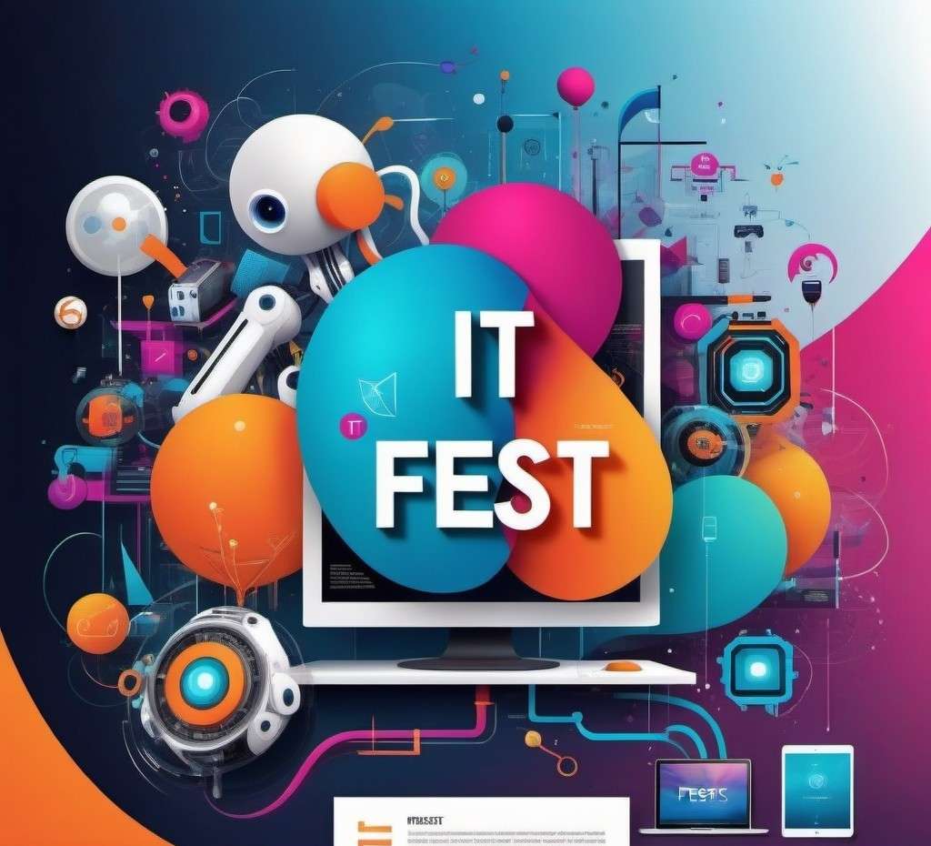

IT EVENTS

IT Debate ( Tackneeke Vad-Vivad ):

Team size: 2 members

Time limit 4 minutes for each team (i.e. 2 min for the motion and 2 min against the motion)

Cross questioning can be done by the judges

Debate can only be given in English as language

Topic:- “ Should net neutrality be blocked and choked?”

Decision taken by the Judges will be final.

Branics (Coding):

Team Size: 2 Members

Time Duration: 40 minutes

All teams will be given the same set of problems to solve.

Code optimization/complexity will be an important parameter in judgement.

Gamify (LAN Gaming):

Team Size: 1 Member

Time Duration: 40-50 minutes

Games will be played in both the categories, i.e. PC and Mobilephones.

The course and direction will be decided by the referee

Players have to check the controls before playing the match. Complaints about the change of control will not be entertained

Upon judgment by the referee, any offending player shall be disqualified

The decision of the referee will be full and final

Digital Poster Presentation:

Team Size: 1 Members

Time Duration: 45 -50 minutes

Topic will be given on the spot

The posters will be judged based on the visual presentation, organization, creativity, and clarity

The technical content development of the subject matter, research, and applicability will be seen

All text on the poster must be in English.

Flip Back Competition:

Team Size: 1 Members

Time Duration: 2 minutes

Topic will be given on the spot.

Participant is required to speak for 1 minute for the motion and 1 minute against the motion.

Khoj-e-Khas (Treasure Hunt):

All teams must have at least 3 members and no more than 4 members.

Time Duration: will be announced before the commencement of each round.

In total there will be three rounds and certain dues will be given to reach the final solution.

First and Second rounds will be elimination round.

Teams must stay together during the Treasure Hunt and are encouraged to work together to solve the clues and retrieve the coins from each location.

Each team will be given a “Clue Booklet” at the beginning of the treasure hunt. All of the treasure hunt clues will be in the booklet. It will be up to the teams to decipher the clues and safely acquire the coin from each of the locations. Each clue once solved will lead you to a location where you will be able to collect a “Treasure Hunt Coin”

Teams will be scored on the total value of the coins collected and the amount of time taken. Once all coins are collected teams must return to the finish in order to be counted as finished. Coin values will be determined based on the difficulty of the clue.

Mindmaze (Quiz):

Team Size: 1 Members

Time Duration: 40 minutes

MCQ’s will be given on the spot related to IT and its emerging trends.

Ideathon (Promoting Innovative Ideas):

All teams must have at least 3 members and no more than 4 members.

Time Duration: 40-50 minutes

Participants file their ideas on the topic/case study given to them on the spot

Web Designing:

All teams must have at the max. 2 students.

Time Duration: 40-50 minutes

Topic will be given on the spot.

GENERAL RULES FOR ALL EVENTS:

Registration Charges for all Events varies from Rs 50 to 900/- per participant.

Maximum four teams/ Participants per event per outside college.

All participating and visiting students must carry their college ID cards.

Vulgarity, in any form, is strongly prohibited. Any form of obscenity will lead to debarring the team from the contest.

Any unfair means, including smoking and consumption of alcohol etc. is strictly prohibited

Decisions of the Judges will be final and binding.

Top two winners of all event will get prizes.

Participation Certificate will be awarded to all participants.

Prior registration is mandatory and can be done over phone or email id given