Hands on Lab - Building Java EE application using JDeveloper 12C
This tutorial shows you how to build Java EE application that interacts with a database using JDeveloper. You'll be using Oracle JDeveloper 12C Version 12.1.2.0.0 and HR schema which comes with Oracle database.
- If you don’t have JDeveloper 12C installed, download and install JDeveloper 12C. You may find the installer here http://www.oracle.com/technetwork/developer-tools/jdev/downloads/index.html
- If you don’t have any Oracle database available for use, download and install Oracle XE database. We will use HR schema from this database for building this sample. Steps for installing Oracle XE here:
  - You can download Oracle XE from here http://www.oracle.com/technetwork/database/database-technologies/express-edition/downloads/index.html
  - Your database should have the HR schema unlocked.
    - To do this, from a command line issue the command: sqlplus system
    - Provide the password for the system user.
    - In the SQLPLUS prompt write the following command Alter user HR account unlock ;
    - Alter user HR identified by HR;

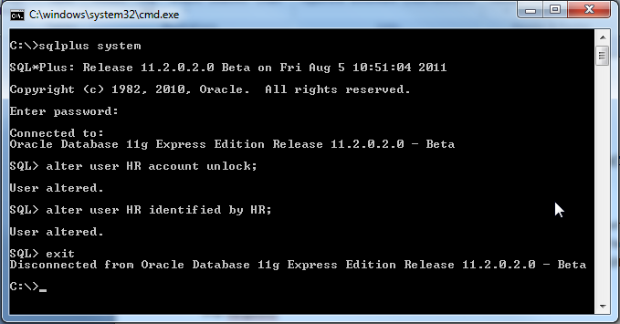
- Before starting building the application, let us set up essential environment properties for the IDE which includes proxy setting for the IDE (if you are working behind corporate firewall), build tool and source control. In this lab we will focus only on maven and SVN as build tool and source control, respectively although JDeveloper supports many other tools.
- You can skip proxy settings for JDeveloper if you are not working behind a firewall. To set up the proxy for the JDeveloper, open JDeveloper and navigate to ,main menu, choose Tools > Preferences. In the Preferences dialog select Web Browser and Proxy and then select Proxy Settings tab. Specify the proxy as appropriate.
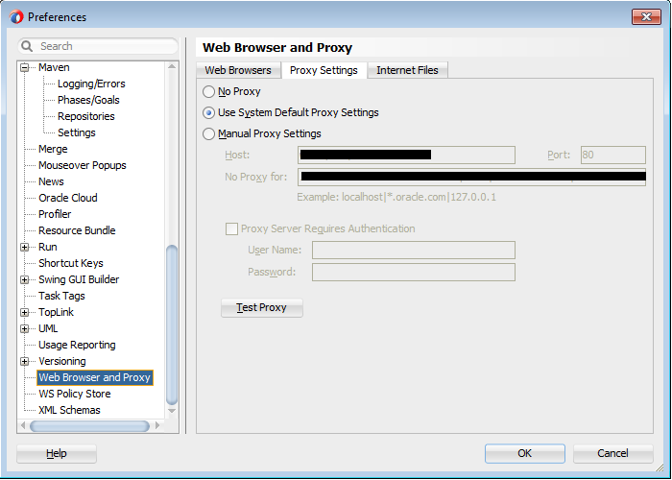
- JDeveloper 12C comes with built in maven located at <JDev_Home>\oracle_common\modules\org.apache.maven_3.0.4.
- You can skip the below steps and proceed to Step 7 if you don’t prefer to use your local maven installation from JDeveloper. If you want to use a external maven installation (that you may have already set up in your machine) from JDeveloper IDE, then do the following:
  - In JDeveloper, navigate to main menu, choose Tools > Preference. In the Preferences dialog choose Maven and click on Load Extension on right pane(this needs to be done only if this is the first time you are accessing this option)
  - In the Preferences dialog, choose the external version and set the path to your local maven home. Do not close the dialog now; we do have few more settings to add.
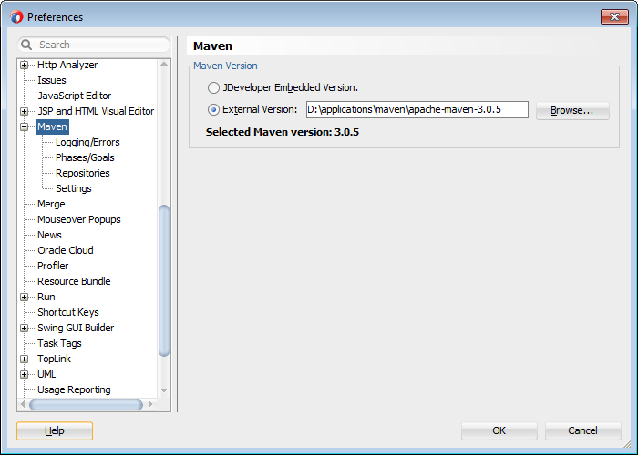
  - To set up a custom local repository for maven tool when used in the IDE, choose Repositories displayed below the Maven node on left pane in the Preference dialog window and then set the local repository path on right hand side panel as appropriate. Even you can specify different central repositories using this screen.
  - To use custom settings.xml for maven tool when you build from IDE, choose Settings displayed below the Maven node on left pane in the Preference dialog and set the path to your settings.xml. Optionally set additional setting using Additional Settings tab. Click OK to dismiss the dialog.
- You are done with all basic setups. Now, let us start building a simple Java EE application. In the main menu, choose File > New>Application
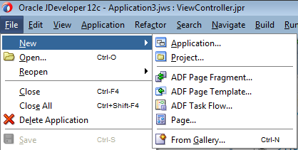
- In the New Gallery choose Java EE Web application. In the Step 1 of the dialog, enter application name as JavaEEDemo and set a directory for storing the application source. Click Next.
- In Step 2 of the dialog, you can specify Model project name and directory. For this demo, accept the default values populated by the IDE as is. Click Next.
- In Step 3 of the dialog, you can specify package for the Model project and Output directory. For this demo, leave the default values populated by the IDE as is and click Next.
- In Step 4 of the dialog, you can configure EJB. Make sure you have the selected the following settings. Click Next.
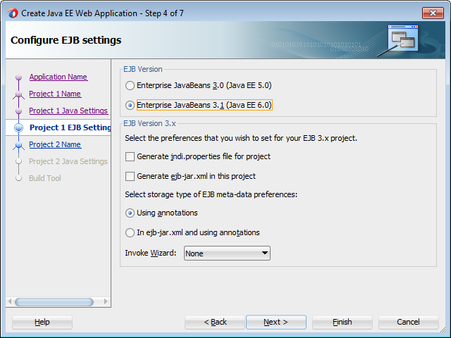
- In Step 5 of the dialog, you can specify the UI project name and source directory. For this demo, leave the default values populated by the IDE as is and click Next.
- In Step 6 of the dialog, you can specify the package name for UI project name and source path. For this demo, leave the default values populated by the IDE and click Next.
- In Step 7, you can specify the build environment. Choose the Maven option in the dialog and leave the default values populated by the IDE without any change. Click Finish.
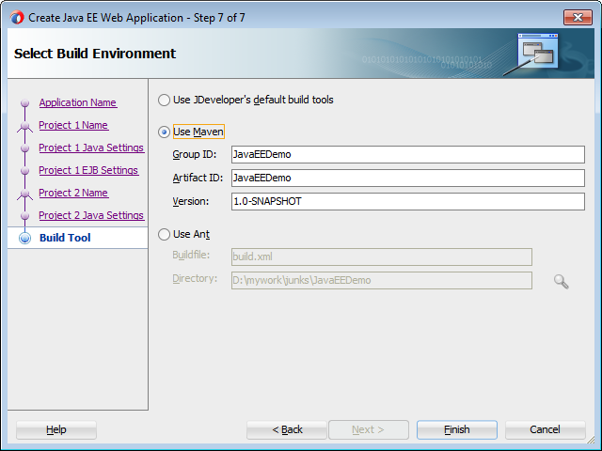
The generated workspace may now look like as shown below.
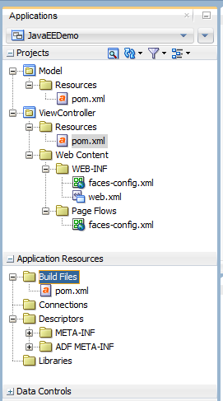
The basic structure is in place now, with two projects: Model and View Controller. Model is supposed to hold business service implementation and ViewController holds UI pages and UI centric logic.
- You may see pom.xml file generated under each project. By default dependency entries in these pom files are in synch with dependencies that you set for a project using dependency editor window offered by the IDE. To view the editor option for setting dependency, right click on a project, choose Project Properties > choose Libraries and Classpath. Do not add anything for this lab. Click OK to dismiss this dialog.
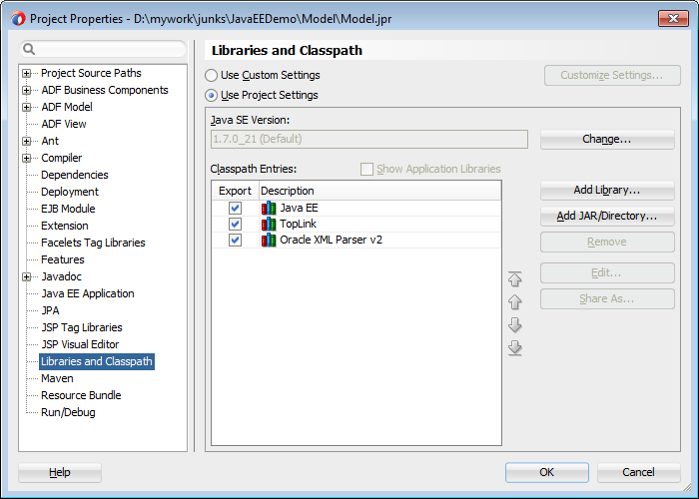
- To turn off the automated synchronization of dependency entries between pom.xml and IDE editor (that you have seen in last step), you can do the following.
  - Right click the project for which you want to turn off the auto- synchronization and then choose Project Properties
  - In the Project Properties dialog, select Maven and remove the Project POM file entry. Please do not remove any entry this for this lab. Click OK to dismiss the dialog.
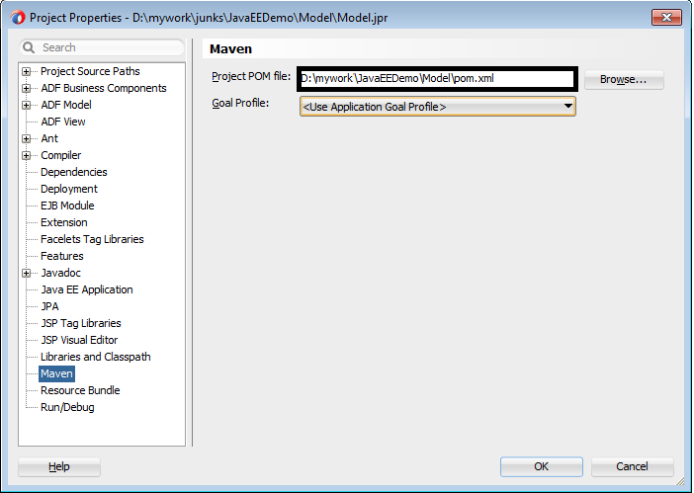
- Next is build the logic for reading and storing data to database using JPA and EJB. Right click the Model project, choose New > Entities from Tables.
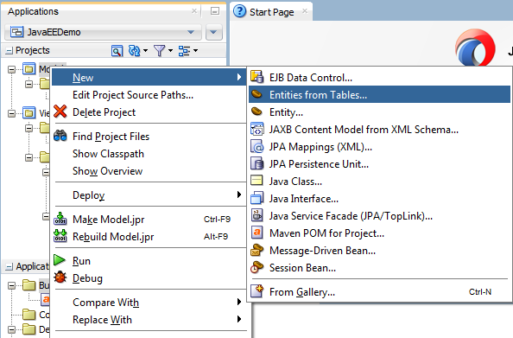

- In Step 2 of Create Entities from Tables, accept the default name populated by the IDE for the Persistence Unit and click Next.
- In Step 3 of Create Entities from Tables, choose Online Database Connection and click Next.
- In Step 4 of Create Entities from Tables, click green plus icon to create a DB connection. In the Create Database Connection dialog, enter connection name, user name, password and JDBC settings. This example uses HR schema, so entries should be based on the database that you are using.
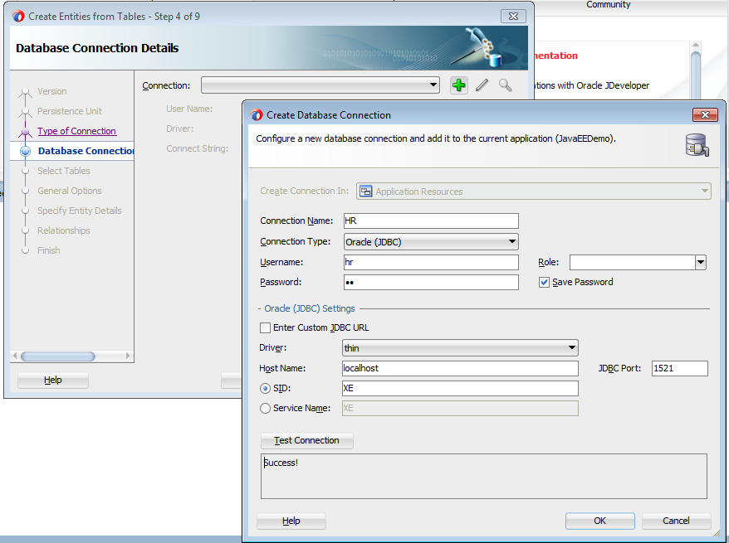
Click OK to close the Create Database Connection dialog and then click Next on Create Entities from Tables wizard.
- In Step 5, click Query button to display the tables from the database schema. For this example, select DEPARTMENTS and EMPLOYEES and shuttle them to right. Click Next
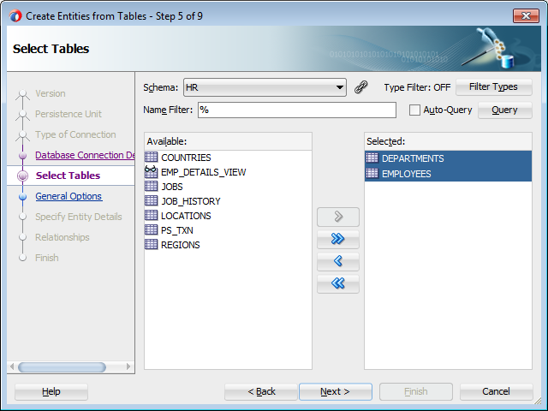

- In Step 6, you can set the common properties for the entities that are being generated in the next steps. For this demo application, you can accept the default values set by IDE and click Next.
- In Step 7, specify the entity details that are generated for the Table that you selected in Step 5 of this dialog window. Accept the default settings and Click Next.
- In Step 8, IDE reads data dictionary for the selected tables and offers associations based on the foreign key constraints for the tables. Accept the default settings and click Next.
- Click Finish to generate entities and related metadata. Your Model project may look like as shown in the following screen shot.
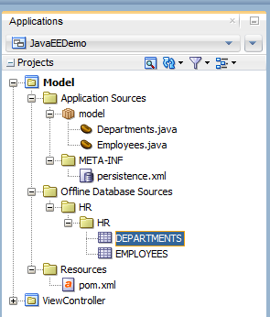
- Next is to build a stateless session bean exposing operations on entities for use by the client. To do this, right click the Model project, choose New > Session Bean. You may see Create Session Bean wizard dialog now which may help to generate stateless session bean effortlessly.
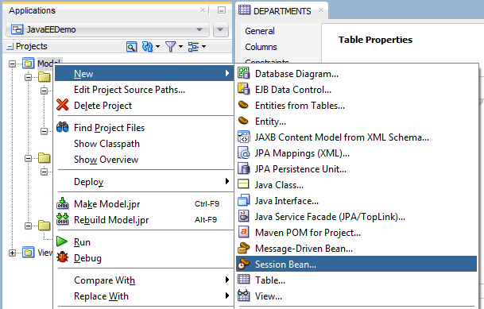

- In Step 2 of Create Session Bean wizard, set the general properties such as name, session type, entity type, persistence unit etc. For this demo application, accept the default values populated by the IDE and click Next.
- In Step 3, you can select the default methods offered by the wizard for the session bean. Select all the methods and click Next.
- In Step 4, specify the bean class name and directory. Accept the default values and click Next.
- In Step 5, deselect Remote Interface, we do not need it. Check “Implement Local Interface” option and click Next.
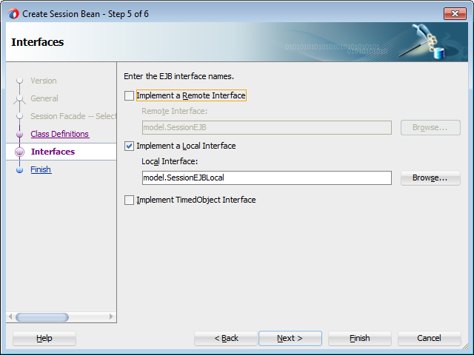
- Click Finish. IDE then generates session bean based on the settings.
- The basic business service implementation is ready for use now. Now let us enable CDI(Contexts and Dependency Injection) for this project so that client can consume the session bean that we created using CDI.
Right click the META-INF folder in the model project, choose New > From Gallery > General | XML > XML Document. Set the name as beans.xml. Copy and paste the below contents to this xml file.
<?xml version = '1.0' encoding = 'windows-1252'?>
<beans xmlns:xsi="http://www.w3.org/2001/XMLSchema-instance"
xsi:schemaLocation="http://java.sun.com/xml/ns/javaee http://java.sun.com/xml/ns/javaee/beans_1_0.xsd"
xmlns="http://java.sun.com/xml/ns/javaee"></beans>

Note that New Gallery window has option to generate the beans.xml visually. To do this, in the New Gallery window choose Context and Dependency Injection > beans.xml option, which will help you to generate the beans.xml. We are not using that option here because IDE adds the xml to WEB-INF folder (irrespective of the project type) which may not work for jar archive, rather meant for the web projects (war archive). It is a bug in 12C.

You can add more CDI features visually using the JDeveloper IDE. To use this IDE support, you must right click the project and then choose New > From Gallery > Contexts and Dependency Injection. You can choose the option from the right side pane as appropriate. We are not going to discuss these options as they are purely Java EE CDI features and IDE just makes your life easier by generating the appropriate classes.
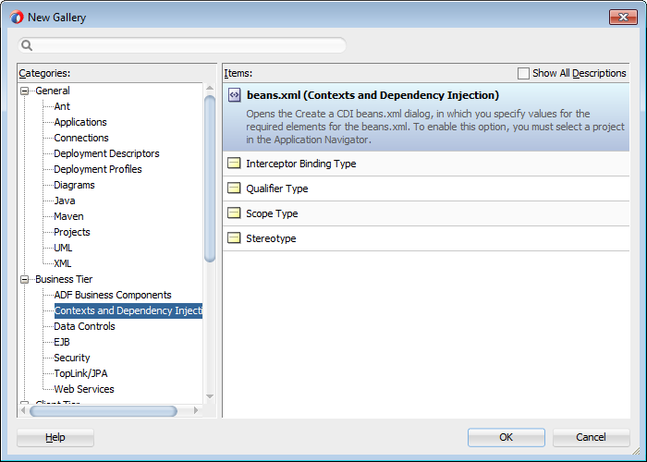

- We are done with model project for this demo application. Let us build the UI now. As we are going to use CDI to grab session bean from client, let us enable CDI for this project as first step. Right click the ViewController project, and choose New > From Gallery > Contexts and Dependency Injection > beans.xml. This action adds beans.xml to the WEB-INF folder.
- Let us define two JSF pages to display department and employee data and defined navigation rules between them. In the View Controller project, double click the faces-config.xml file displayed under Web Content folder. Drag and drop the JSF page from components palette (displayed on right hand side of the IDE) to faces-config.xml editor and name it as dept.jsf. Double click the dept.jsf in the faces-config.xml editor to generate the physical file.
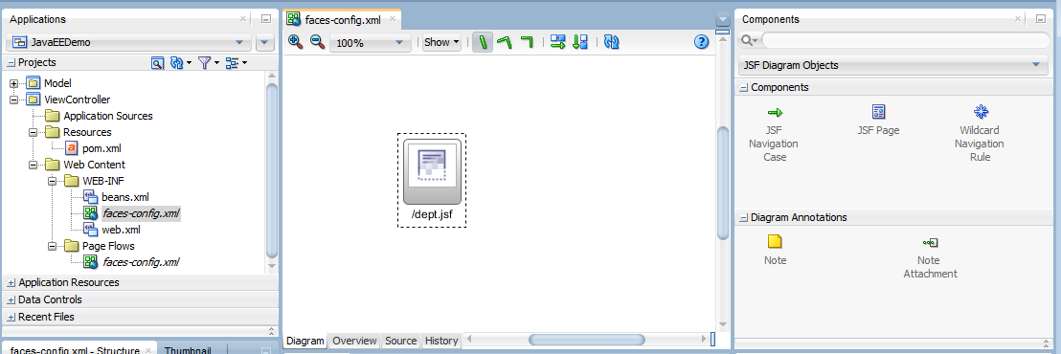
Switch back to faces-config.xml editor and drop another JSF Page and name it as emp.jsf. Double click the emp.jsf in the faces-config.xml editor to generate the physical file.
- Switch back to the faces-config.xml editor, draw navigation between dept.jsf and emp.jsf by choosing JSF Navigation option from components palette. Label the navigation case as viewEmp as shown below. This is stored in faces-config.xml as navigation-case.

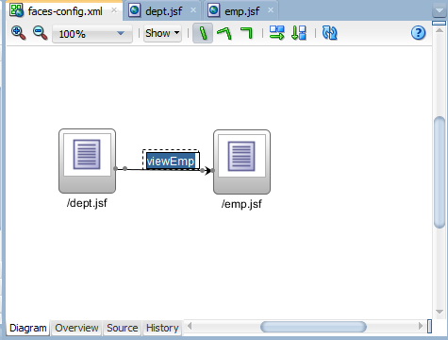

- Define a CDI bean in the view controller project to access the session bean defined in the model project. This bean will be holding client side logic also code for accessing session bean that we created. To do this, right click the ViewController project, choose New > From Gallery > Java> Class. In the Create Java Class dialog, specify the name of the class as DeptBean and accept the default values for other fields and click OK. This bean will act as client side abstraction (proxy) for the service layer. Add @SessionScoped annotation to mark it as CDI session scoped bean and a method to return department collection for use from the dept.jsf. You can copy and paste the following code to save time.
package view;

import java.io.Serializable;

import javax.ejb.EJB;
import javax.enterprise.context.SessionScoped;
import javax.faces.model.DataModel;
import javax.faces.model.ListDataModel;
import javax.inject.Named;
import model.SessionEJBBean;
import model.SessionEJBLocal;

@SessionScoped
@Named("deptBean")
public class DeptBean implements Serializable {
@EJB
private SessionEJBLocal sessionEJBBean;
private DataModel depts = null;

public DeptBean() {
super();
}

public DataModel getDepartments() {
if (depts == null) {
depts = new ListDataModel(sessionEJBBean.getDepartmentsFindAll());
}
return depts;
}

}
Similarly, define EmpBean.Java CDI bean in the ViewController project for returning employee collection. Source code for EmpBean.Java is shown below.
package view;

import java.io.Serializable;

import javax.ejb.EJB;

import javax.enterprise.context.SessionScoped;

import javax.faces.model.DataModel;
import javax.faces.model.ListDataModel;

import javax.inject.Named;

import model.SessionEJBBean;
import model.SessionEJBLocal;

@SessionScoped
@Named("empBean")
public class EmpBean implements Serializable {
@EJB
private SessionEJBLocal sessionEJBBean;
private DataModel emps = null;

public EmpBean() {
super();
}

public DataModel getEmployees() {
if (emps == null) {
emps = new ListDataModel(sessionEJBBean.getEmployeesFindAll());
}
return emps;
}
}
- Open the dept.jsf that we built a while ago, and add a table to display department data returned by DeptBean. Add a button to navigate to emp.jsf as well. The page source may look like as given below.
<?xml version='1.0' encoding='windows-1252'?>
<!DOCTYPE html>
<f:view xmlns:f="http://java.sun.com/jsf/core" xmlns:h="http://java.sun.com/jsf/html">
<html xmlns="http://www.w3.org/1999/xhtml">
<h:head></h:head>
<h:body>
<h:form>
<h:panelGroup>
<h:dataTable value="#{deptBean.departments}" var="item" border="0"
cellpadding="2" cellspacing="0"
rules="all" style="border:solid 1px">
<h:column>
<f:facet name="header">
<h:outputText value="Department Id"/>
</f:facet>
<h:outputText value="#{item.departmentId}"/>
</h:column>
<h:column>
<f:facet name="header">
<h:outputText value="Department Name"/>
</f:facet>
<h:outputText value="#{item.departmentName}"/>
</h:column>
<h:column>
<f:facet name="header">
<h:outputText value="Manager Id"/>
</f:facet>
<h:outputText value="#{item.employees1.employeeId}"/>
</h:column>
</h:dataTable>
<h:commandButton value="View Employees" action="viewEmp"/>
</h:panelGroup>
</h:form>
</h:body>
</html>
</f:view>

Similarly open emp.jsf and add code for displaying employee’s data. Source is given below for a quick reference.

<?xml version='1.0' encoding='windows-1252'?>
<!DOCTYPE html>
<f:view xmlns:f="http://java.sun.com/jsf/core" xmlns:h="http://java.sun.com/jsf/html">
<html xmlns="http://www.w3.org/1999/xhtml">
<h:head></h:head>
<h:body>
<h:form>
<h:panelGroup>
<h:dataTable value="#{empBean.employees}" var="item" border="0" cellpadding="2" cellspacing="0"
rules="all" style="border:solid 1px">
<h:column>
<f:facet name="header">
<h:outputText value="Employee Id"/>
</f:facet>
<h:outputText value="#{item.employeeId}"/>
</h:column>
<h:column>
<f:facet name="header">
<h:outputText value="First Name"/>
</f:facet>
<h:outputText value="#{item.firstName}"/>
</h:column>
<h:column>
<f:facet name="header">
<h:outputText value="Last Name"/>
</f:facet>
<h:outputText value="#{item.lastName}"/>
</h:column>
<h:column>
<f:facet name="header">
<h:outputText value="Email"/>
</f:facet>
<h:outputText value="#{item.email}"/>
</h:column>
<h:column>
<f:facet name="header">
<h:outputText value="Phone Number"/>
</f:facet>
<h:outputText value="#{item.phoneNumber}"/>
</h:column>
<h:column>
<f:facet name="header">
<h:outputText value="Hire Date"/>
</f:facet>
<h:outputText value="#{item.hireDate}">
<f:convertDateTime pattern="MM/dd/yyyy HH:mm:ss" />
</h:outputText>
</h:column>
</h:dataTable>
</h:panelGroup>
</h:form>
</h:body>
</html>
</f:view>
- You are done with the basic application. Right click dept.jsf and choose Run to run the application. Now, IDE will start integrated WLS instance (if not running) and deploy the application and will run the page.
- You can enhance this application to add more features such as CRUD (Create Read Update Delete) operations on departments and employees and many more.

