Hands on Lab – Using SVN with JDeveloper
JDeveloper is integrated with the popular team development solution Subversion (SVN). If you are part of a team that uses Subversion, JDeveloper's Team menu contains commands for using Subversion to manage the content you are working on while maintaining a connection to your team's repository and tracking changes, merges, and more. This hands on lab will help you to get a feel of the subversion support in JDeveloper IDE.
- Before moving on to SVN options in the IDE, you may need to set up the proxy if you are working behind a corporate firewall. To set up the proxy for the JDeveloper, open JDeveloper and navigate to Main menu, choose Tools > Preferences. In the Preferences dialog select Web Browser and Proxy and then select Proxy Settings tab. specify the proxy as appropriate.
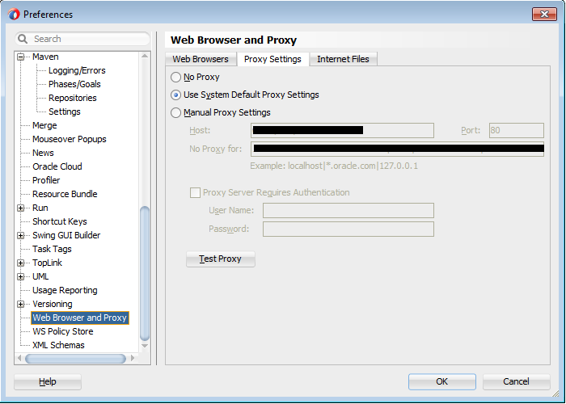
- Let us get back to the SVN now. To configure SVN client that comes with IDE, navigate to main menu and choose Tools > Preferences > Versioning > Subversion > General. All the settings are given here. For example, to automatically add new files on commit, select Automatically Add New Files On Committing Working Copy. Click OK to save the changes and dismiss dialog.
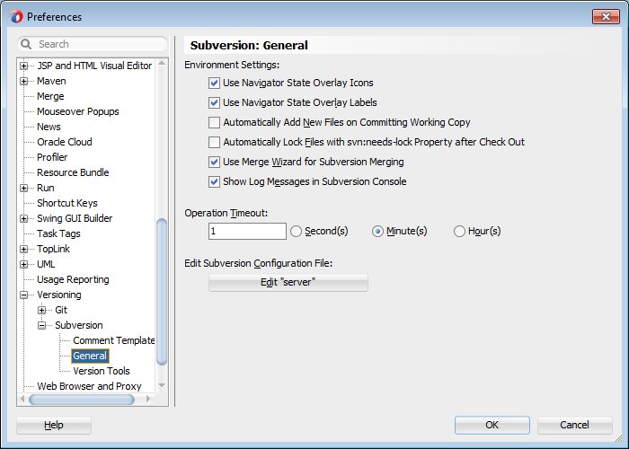
- Next is creating connection to SVN. To do this navigate to the main menu, choose Team > Create Connection. In the Create Subversion Connection dialog, choose Manually Create Subversion Connection option and click OK.
- In the Create Subversion Connection dialog, enter server URL, connection name and user credentials.
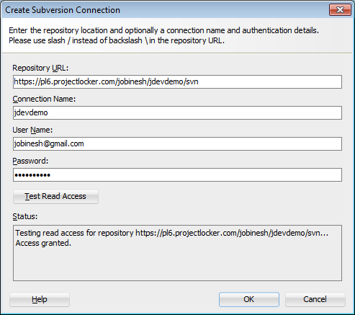
- Click OK in Create Subversion Connection dialog to create the SVN connection. You may see the connection created in Version window in the IDE.
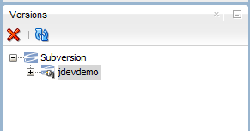
- Open the application that needs to be versioned in the IDE. Navigate to main menu, choose Team > Version Application. In the Version Application dialog, choose Subversion and click OK.
- In the Import to Subversion dialog, click Next in the Welcome screen.
- Choose the appropriate repository connection on the next screen and finish the wizard. The application source will get imported to the repository.
- Now make some changes in any of the source files. To commit the changes to SVN, right click on the project( or navigate to main menu, choose Team > Subversion ), and choose Versioning > Commit Working Copy. 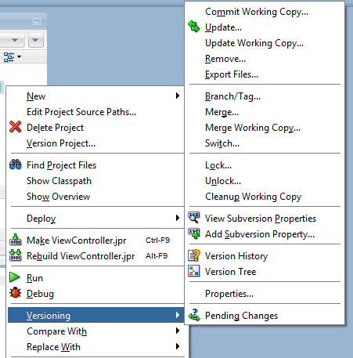
- Click OK in Commit Working Copy dialog to finish the task. This is a simple lab, you are free to explore all the options available in Subversion menu(navigate to main menu, choose Team > Subversion) at your leisure.
To learn more on using Subversion with JDeveloper visit the following link: http://docs.oracle.com/middleware/1212/jdev/OJDUG/dev_apps_teams.htm#OJDUG5465

