Hands on Lab – Using Shared Library
The shared Java EE library feature in WebLogic Server provides an easy way to share one or more different types of Java EE modules among multiple enterprise applications. A shared Java EE library is a single module or collection of modules that is registered with the Java EE application container upon deployment. This hands-on -lab will help you to get a feel of this concept. In this lab, we will build a producer application with a project which will be deployed as shared library in WLS. Then we will build consumer app which consumes classes from this shared library.
- Create a simple Custom Application containing a project. We will deploy this project as shared library JAR for use by other applications. To create the application, navigate to main menu, choose File > New > Application. In the New Gallery, choose Applications > Custom Application.
- In the Create Custom Application dialog, enter the application name as ProducerApp. Click Next.
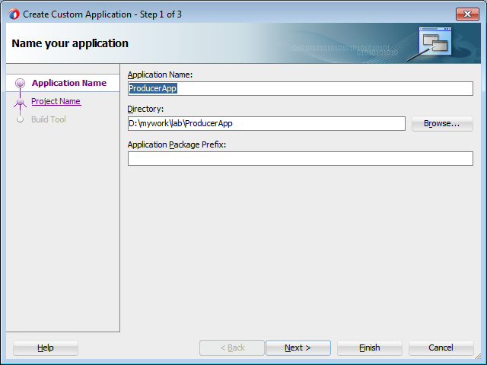
- In Step 2 of the Create Custom Application wizard, enter project name as MyCommonUtil and click Finish to create the application.
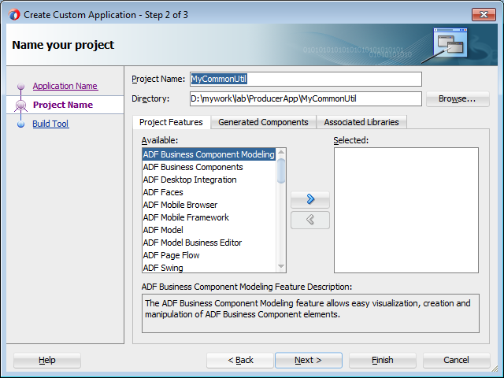
- Right click on MyCommonUtil project, choose New > From Gallery. 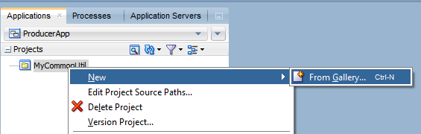
- In the New Gallery, choose Java > Class. Give the class name as CommonTimeUtil and package as demo.util and then Finish the wizard.
- Open CommonTimeUtil .java in the editor and add a method public String getCurrentDateTime() to return current date and time. The source of CommonTimeUtil may look like as shown below.
package demo.util;
import java.text.SimpleDateFormat;
import java.util.Calendar;
public class CommonTimeUtil {
public CommonTimeUtil() {
super();
}
public String getCurrentDateTime() {
SimpleDateFormat sdf = new SimpleDateFormat("dd-MM-yy:HH:mm:SS");
return sdf.format(Calendar.getInstance().getTime());
}
}
- Now open any text editor(e.g: Notepad) and create a MANIFEST.MF file. Add the following entries to it. (This file will be used as manifest file for the shared library that we will build in the coming step. These entries are used to describe the shared library artefact, which will be used by the container (WLs) and also by the consuming client applications to refer the right library).
Manifest-Version: 1.0
Extension-Name: TimeUtilExtension
Specification-Title: TimeUtilExtension
Specification-Version: 1.1
Implementation-Title: TimeUtilExtension Implementation
Implementation-Version: 1.1
Implementation-Vendor: Demo
- Now we need to create a deployment profile for MyCommonUtil project to deploy it as shared library. To do this, right click MyCommonUtil project and choose Properties.
- In the Project Properties, choose Deployment and then click New. In the Create Deployment Profile window, choose Shared Library Jar File in Profile Type drop down list and set MySharedUtil as Deployment Profile Name. Click OK to close the dialog
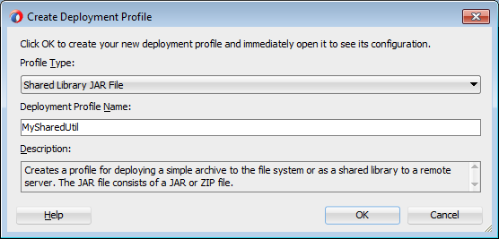
- In the Edit JAR Deployment Profile Properties dialog, select JAR Options and then click Add button to add the MANIFEST.MF that we created a while ago(See Step 7) to this library. Click OK to close the dialog
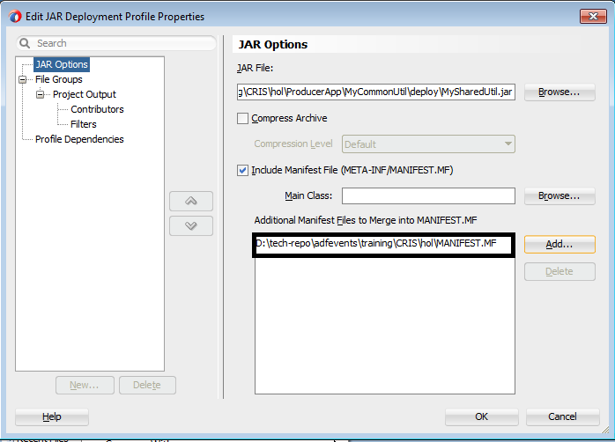
- Now let us deploy this to integrated WLS. You should run the integrated WLS before deploying the JAR file. You can do this by choosing Run > Start Server Instance (Integrated Weblogic Server). To deploy this jar to WLS as shared library, you should right click the project and choose Deploy > MySharedUtil.
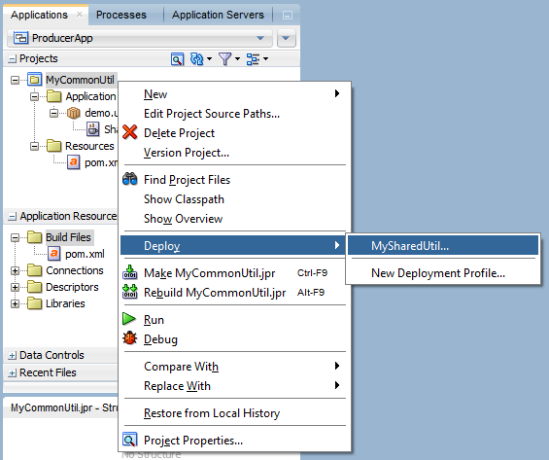
- In the Deployment Action dialog window, choose Deploy to an Oracle Weblogic Server and click Next.
- On the Select Server screen choose IntegratedWeblogicServer and click Finish. Your project has been deployed as shared JAR library in to the IntegratedWeblogicServer now.
- Now, let us build a Java EE Web application to consume the shared library that we created. To do this choose File > New > Java EE Web Application in New Gallery. Set the application name as ConsumerApp. Click Finish.
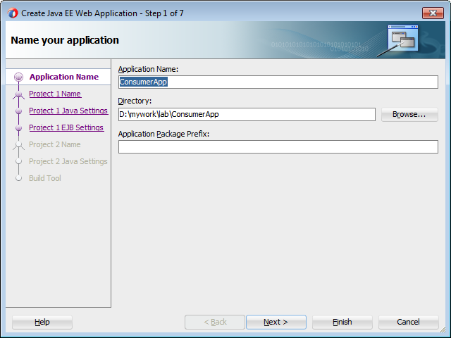
- In this lab, we will see how to make the ViewController project in the ConsumerApp to use the CommonTimeUtil class from the shared library that we deployed a while ago. To do this, the first step is to add the appropriate shared library references in the weblogic.xml. If the weblogic.xml is missing in your ViewController project, you may need to add one. To add weblogic.xml to the ViewController(if not existing), right click on the ViewController, choose New. In the New Gallery, choose Deployment Descriptors > Weblogic Deployment Descriptor and click OK. 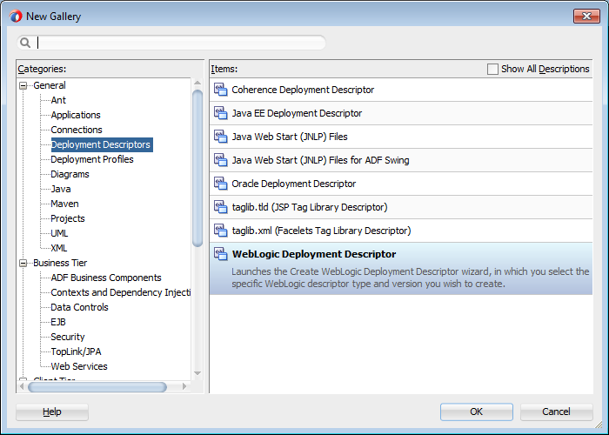
- In the Create Weblogic Deployment Descriptor window, choose weblogic.xml and click Next.
- Select 12.1.1 as the version of WLS and click Finish.
Now add the desired shared library reference to weblogic.xml so that you can consume the classes from the shared library from this project. We will consume TimeUtilExtension library that we created at the beginning of this tutorial. The reference entries for TimeUtilExtension look like as shown below. Note that the library-ref entries used here are derived from the MANIFEST.MF of the shared library (See Step 7).
<?xml version = '1.0' encoding = 'windows-1252'?>
<weblogic-web-app xmlns:xsi="http://www.w3.org/2001/XMLSchema-instance"
xsi:schemaLocation="http://xmlns.oracle.com/weblogic/weblogic-web-app http://xmlns.oracle.com/weblogic/weblogic-web-app/1.4/weblogic-web-app.xsd"
xmlns="http://xmlns.oracle.com/weblogic/weblogic-web-app">
<library-ref>
<library-name>TimeUtilExtension</library-name>
<specification-version>1.1</specification-version>
<implementation-version>1.1</implementation-version>
<exact-match>false</exact-match>
</library-ref>
</weblogic-web-app>
- This is enough to consume the classes from TimeUtilExtensionlibrary. Now, to test this, let us try consuming the CommonTimeUtil class from TimeUtilExtension library as managed bean from a JSF. Open the faces-config.xml and define demo.util.CommonTimeUtil as managed bean as shown below.
<?xml version="1.0" encoding="windows-1252"?>
<faces-config version="2.1" xmlns="http://java.sun.com/xml/ns/javaee">
<managed-bean>
<managed-bean-name>timeUtil</managed-bean-name>
<managed-bean-class>demo.util.CommonTimeUtil</managed-bean-class>
<managed-bean-scope>session</managed-bean-scope>
</managed-bean>
</faces-config>
- Add new JSF page with name test.jsf and add an h:outputText to display the currentDateTime value returned by CommonTimeUtil bean. The source may look like as shown below
<?xml version='1.0' encoding='windows-1252'?>
<!DOCTYPE html>
<f:view xmlns:f="http://java.sun.com/jsf/core" xmlns:h="http://java.sun.com/jsf/html">
<html xmlns="http://www.w3.org/1999/xhtml">
<h:head></h:head>
<h:body>
<h:form>
<h:outputText value="Current Date and Time: #{timeUtil.currentDateTime}"/>
</h:form>
</h:body>
</html>
</f:view>
- Right click the test.jsf and choose Run. You will see the page prints current date and time. Here, the bean class used is actually referenced from the shared library.
- To learn more about shared libraries, visit the following links: http://docs.oracle.com/middleware/1212/wls/WLPRG/libraries.htm#i1064656

