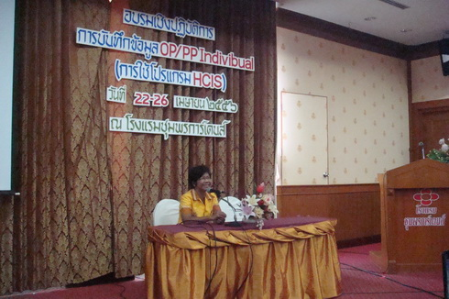

<http://localhost/itsite/images/s5imageandcontentfaderv3/DSC02754.JPG> 1 01

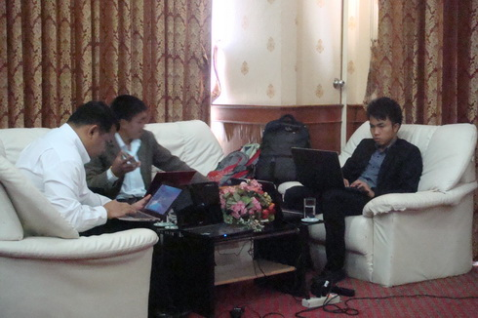

<http://localhost/itsite/images/s5imageandcontentfaderv3/DSC02755.JPG>

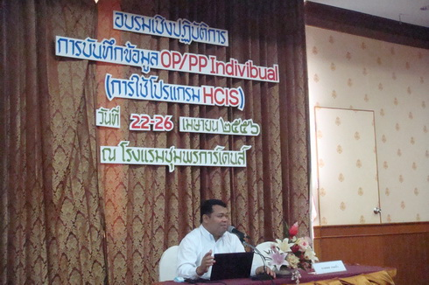

<http://localhost/itsite/images/s5imageandcontentfaderv3/DSC02757.JPG> 2

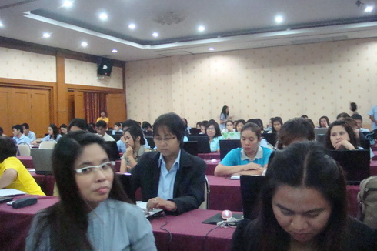

<http://localhost/itsite/images/s5imageandcontentfaderv3/DSC02758.JPG> 02

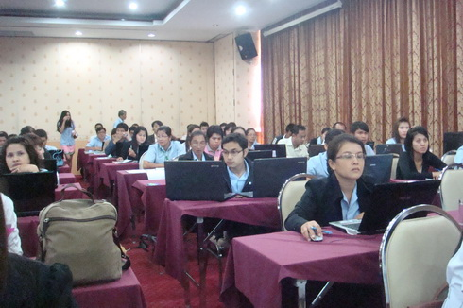

<http://localhost/itsite/images/s5imageandcontentfaderv3/DSC02759.JPG> 03

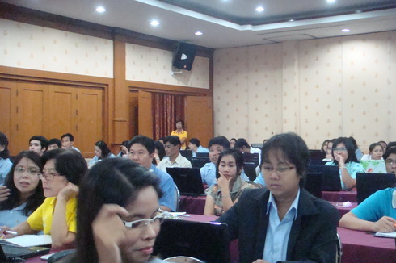

<http://localhost/itsite/images/s5imageandcontentfaderv3/DSC02760.JPG> 6

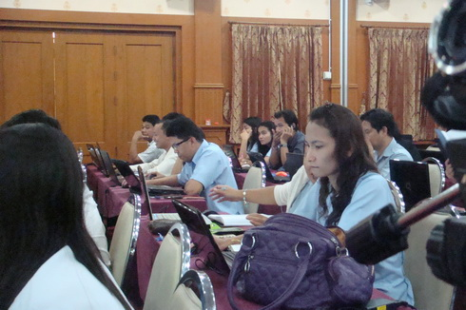

<http://localhost/itsite/images/s5imageandcontentfaderv3/DSC02761.JPG> 06

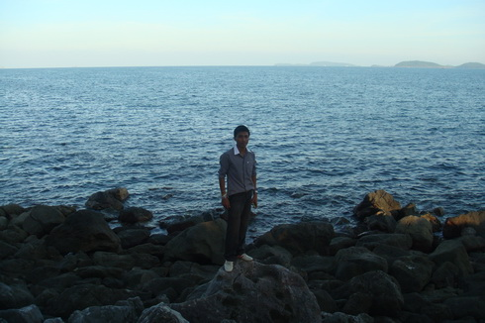

<http://localhost/itsite/images/s5imageandcontentfaderv3/DSC02762.JPG>

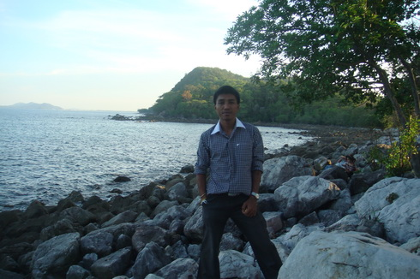

<http://localhost/itsite/images/s5imageandcontentfaderv3/DSC02763.JPG>

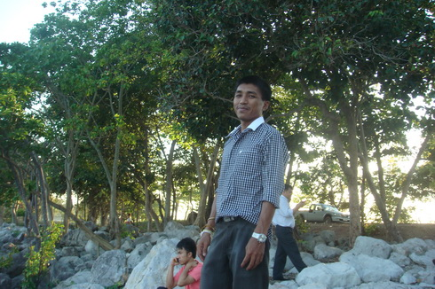

<http://localhost/itsite/images/s5imageandcontentfaderv3/DSC02764.JPG>

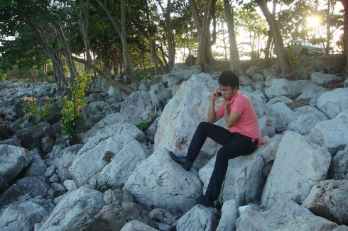

<http://localhost/itsite/images/s5imageandcontentfaderv3/DSC02765.JPG>

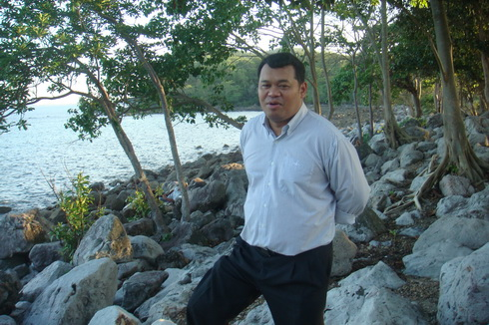

<http://localhost/itsite/images/s5imageandcontentfaderv3/DSC02766.JPG>

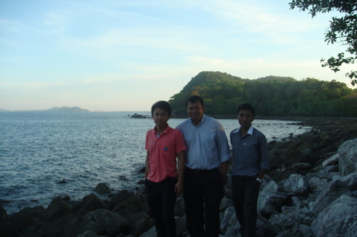

<http://localhost/itsite/images/s5imageandcontentfaderv3/DSC02767.JPG>

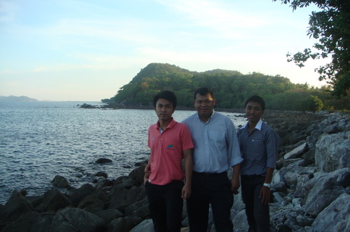

<http://localhost/itsite/images/s5imageandcontentfaderv3/DSC02768.JPG> 010

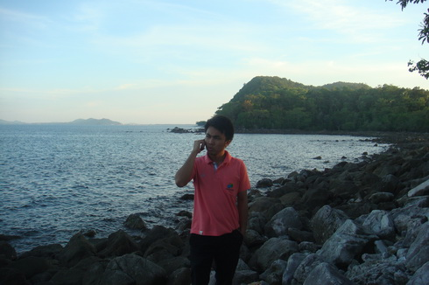

<http://localhost/itsite/images/s5imageandcontentfaderv3/DSC02769.JPG>

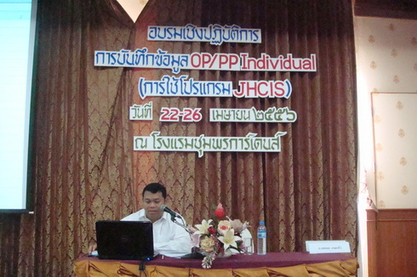

<http://localhost/itsite/images/s5imageandcontentfaderv3/DSC02771.JPG> 04

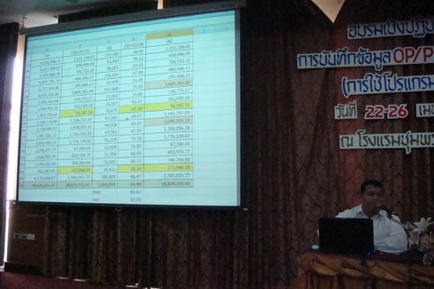

<http://localhost/itsite/images/s5imageandcontentfaderv3/DSC02772.JPG>

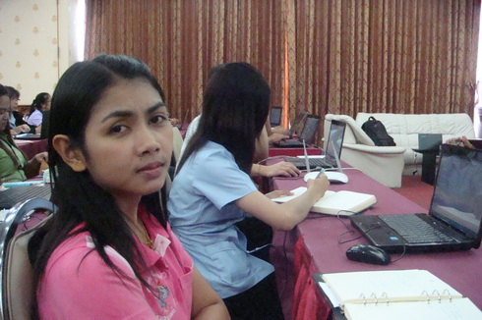

<http://localhost/itsite/images/s5imageandcontentfaderv3/DSC02773.JPG> 7

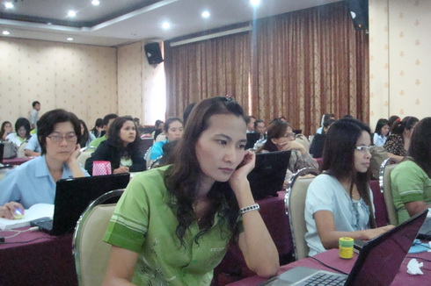

<http://localhost/itsite/images/s5imageandcontentfaderv3/DSC02774.JPG> 05

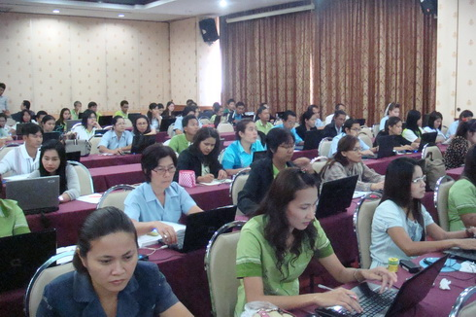

<http://localhost/itsite/images/s5imageandcontentfaderv3/DSC02775.JPG> 8

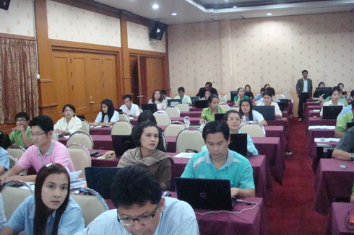

<http://localhost/itsite/images/s5imageandcontentfaderv3/DSC02776.JPG> 5

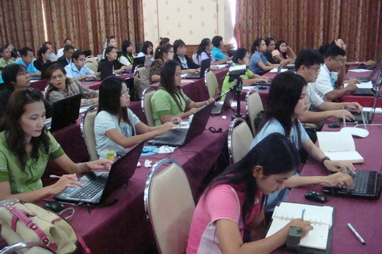

<http://localhost/itsite/images/s5imageandcontentfaderv3/DSC02777.JPG> 4

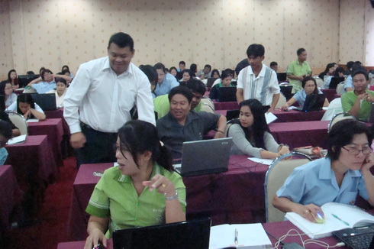

<http://localhost/itsite/images/s5imageandcontentfaderv3/DSC02778.JPG> 07

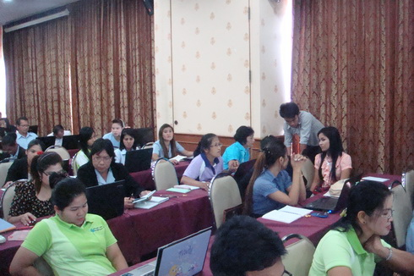

<http://localhost/itsite/images/s5imageandcontentfaderv3/DSC02779.JPG> 08

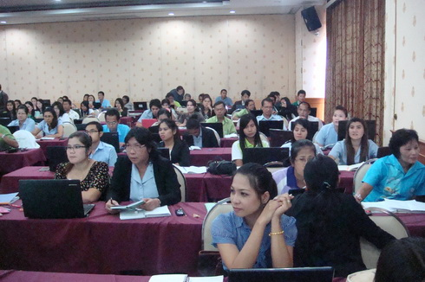

<http://localhost/itsite/images/s5imageandcontentfaderv3/DSC02780.JPG> 9

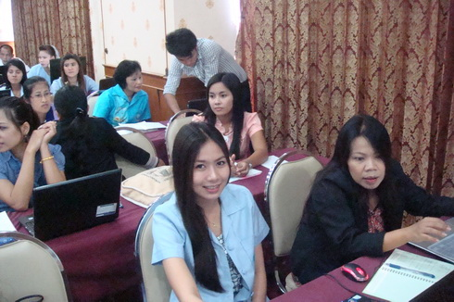

<http://localhost/itsite/images/s5imageandcontentfaderv3/DSC02781.JPG> 10

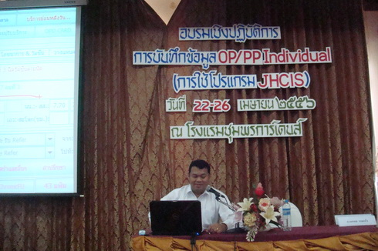

<http://localhost/itsite/images/s5imageandcontentfaderv3/DSC02782.JPG>

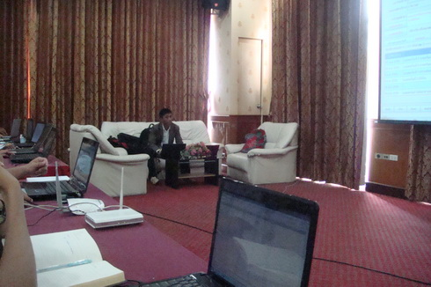

<http://localhost/itsite/images/s5imageandcontentfaderv3/DSC02783.JPG>

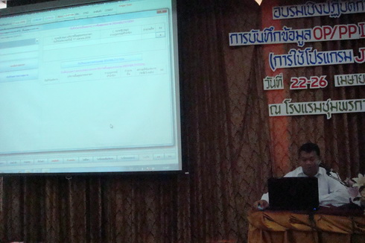

<http://localhost/itsite/images/s5imageandcontentfaderv3/DSC02784.JPG>

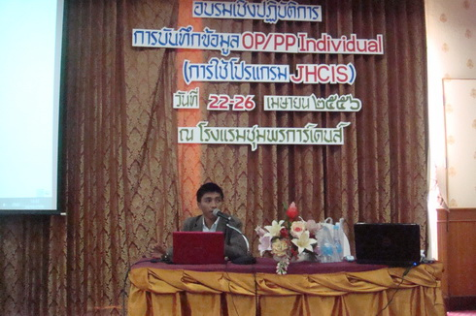

<http://localhost/itsite/images/s5imageandcontentfaderv3/DSC02785.JPG>

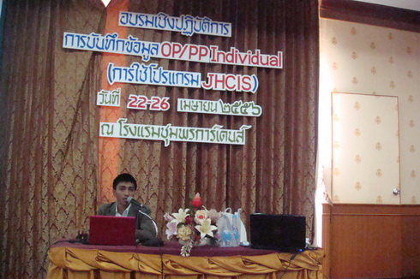

<http://localhost/itsite/images/s5imageandcontentfaderv3/DSC02786.JPG>

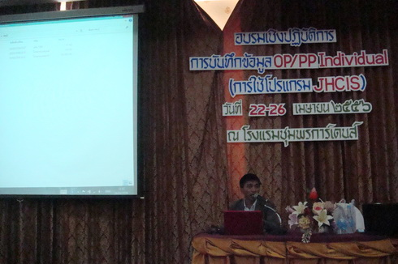

<http://localhost/itsite/images/s5imageandcontentfaderv3/DSC02787.JPG>

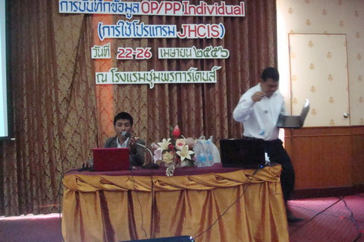

<http://localhost/itsite/images/s5imageandcontentfaderv3/DSC02788.JPG>

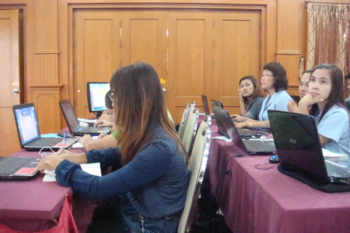

<http://localhost/itsite/images/s5imageandcontentfaderv3/DSC02789.JPG> 08

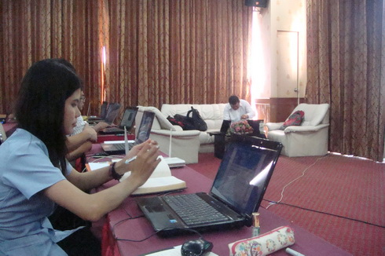

<http://localhost/itsite/images/s5imageandcontentfaderv3/DSC02790.JPG> 09

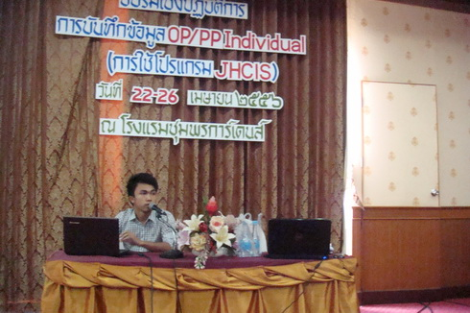

<http://localhost/itsite/images/s5imageandcontentfaderv3/DSC02791.JPG>

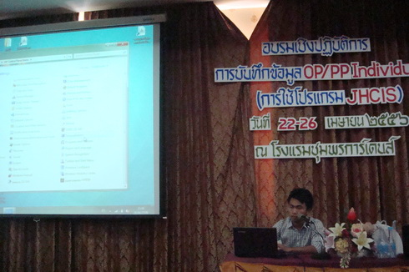

<http://localhost/itsite/images/s5imageandcontentfaderv3/DSC02792.JPG>

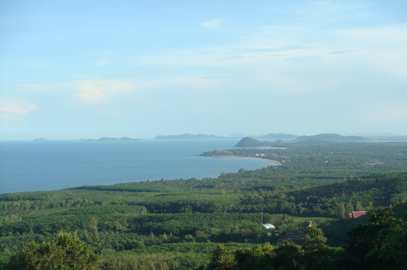

<http://localhost/itsite/images/s5imageandcontentfaderv3/DSC02795.JPG>

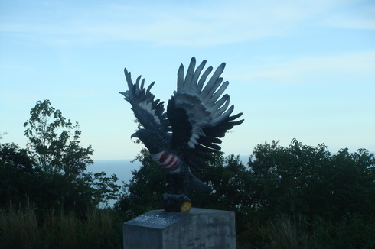

<http://localhost/itsite/images/s5imageandcontentfaderv3/DSC02796.JPG>

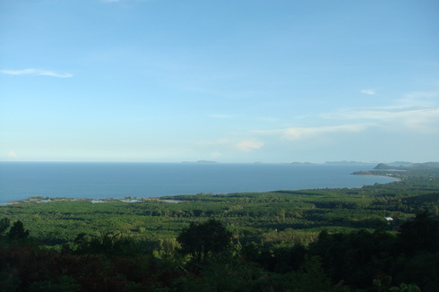

<http://localhost/itsite/images/s5imageandcontentfaderv3/DSC02797.JPG>

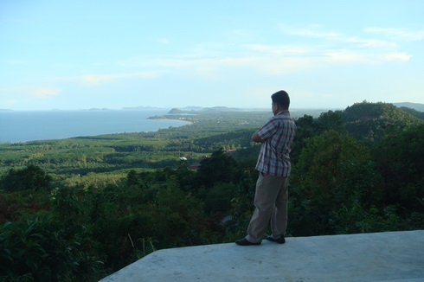

<http://localhost/itsite/images/s5imageandcontentfaderv3/DSC02798.JPG>

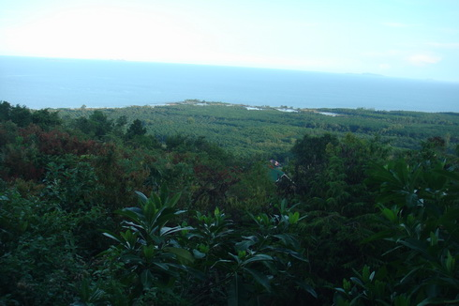

<http://localhost/itsite/images/s5imageandcontentfaderv3/DSC02799.JPG>

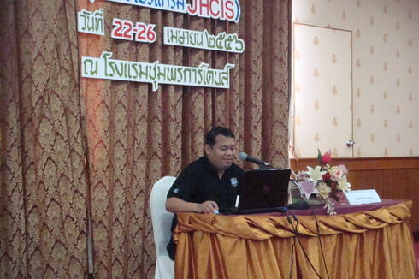

<http://localhost/itsite/images/s5imageandcontentfaderv3/DSC02800.JPG>

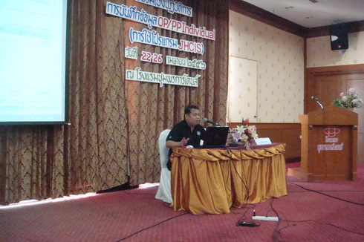

<http://localhost/itsite/images/s5imageandcontentfaderv3/DSC02801.JPG>

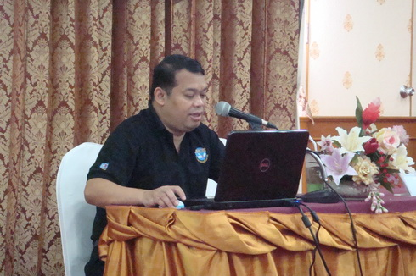

<http://localhost/itsite/images/s5imageandcontentfaderv3/DSC02803.JPG>

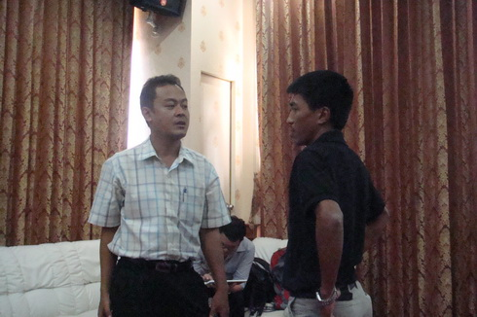

<http://localhost/itsite/images/s5imageandcontentfaderv3/DSC02804.JPG>

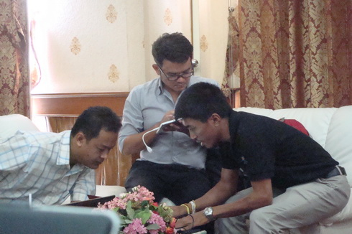

<http://localhost/itsite/images/s5imageandcontentfaderv3/DSC02806.JPG> 3