# 10

For This exercise, a non-homogeneous material profile is considered in which a defined middle section has different $ρ$ and $c$ values. An ideal and approximated version of this material is visible in Figure 1.

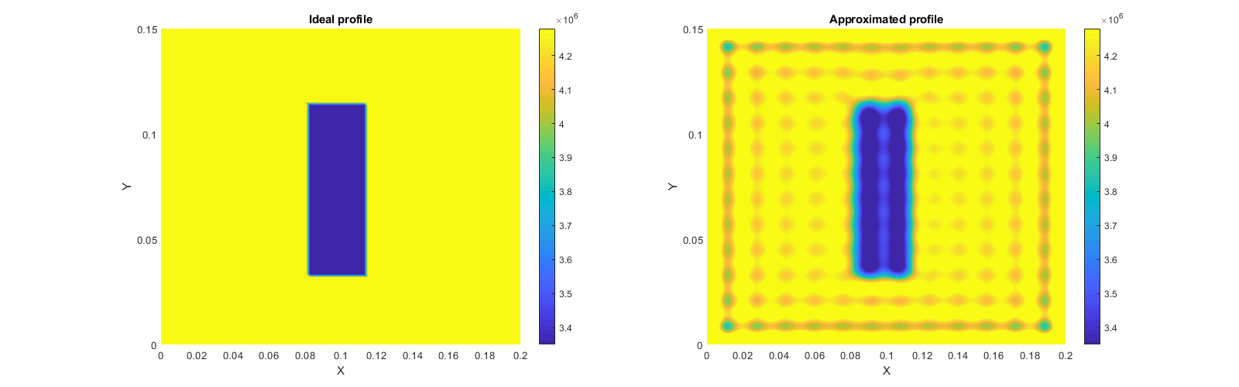

Figure : non-homogeneous material profile

The approximation of this material profile is made using a Fourier expansion according to $(1)$, with the same basis functions as used for the homogeneous model.

$$\begin{aligned}ρ\left(x,y\right)c\left(x,y\right)=\sum_{i=0}^{r}{e_{i}ϕ_{i}\left(x,y\right)}\#\left(1\right)\end{aligned}$$

Now this approximation can be used to simulate the non-homogeneous model which can now be written as $(2)$ and can be rewritten into equation $(3)$.

$$\begin{aligned}〈\sum_{i2=0}^{r}{e_{i2}ϕ_{i2}}\sum_{i=0}^{r}{{\dot{a}}_{i}ϕ_{i}},ϕ_{j}〉= 〈κ\sum_{i=0}^{r}{a_{i}{\ddot{ϕ}}_{i}^{\left(x\right)}},ϕ_{j}〉+〈κ\sum_{i=0}^{r}{a_{i}{\ddot{ϕ}}_{i}^{\left(y\right)}},ϕ_{j}〉+〈u,ϕ_{j}〉\#\left(2\right)\end{aligned}$$

$$\begin{aligned}\sum_{i=0}^{r}{{\dot{a}}_{i}\sum_{i2=0}^{r}{e_{i2}〈ϕ_{i2}ϕ_{i},ϕ_{j}〉}}= \sum_{i=0}^{∞}{κa_{i}\left(〈{\ddot{ϕ}}_{i}^{\left(x\right)},ϕ_{j}〉+〈{\ddot{ϕ}}_{i}^{\left(y\right)},ϕ_{j}〉\right)}+〈u,ϕ_{j}〉\#\left(3\right)\end{aligned}$$

This can now be used to simulate the non-homogeneous model in the same way as the homogeneous model, only instead of dividing the right side of the equation by the constant $ρc$, it is now multiplied with the inverse of the approximated $ρ(x,y)c(x,y)$ matrix.