5LMA0 – Project heat diffusion

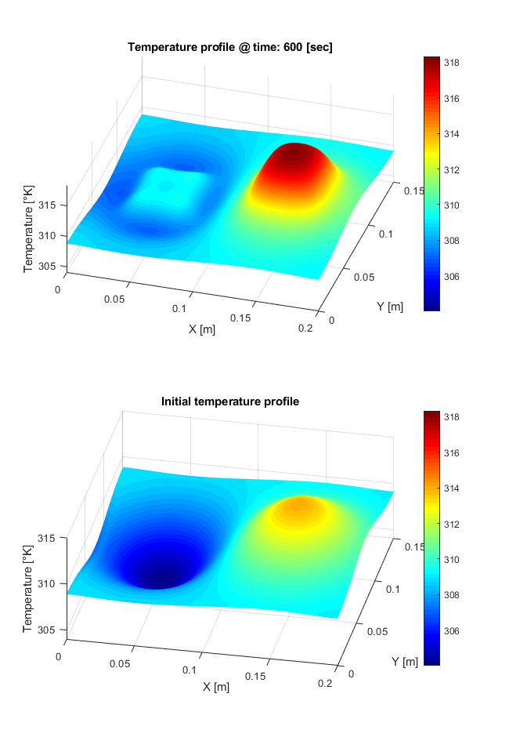

**Date:**

3 February 2019

**Names: Student number:**

Bob Clephas 1271431

Job Meijer 1268155

Table of contents

Introduction 3

Exercise 1 3

Exercise 2 4

Exercise 3 5

Exercise 4 6

Exercise 5 8

Exercise 6 9

Exercise 7 12

Exercise 8 12

Exercise 9 12

Exercise 10 14

# Introduction

In this project a model for hyperthermia is considered which describes how a temperature distribution on a locally heated surface evolves over time. A rectangular area is considered of dimension $L_{x}×L_{y}$ as shown in Figure 1. Here the green areas $u1$ and $u2$ are defined as inputs where the heat fluxes are applied, the yellow area is normal tissue and the orange area is tumor tissue with dimensions $l_{x}×l_{y}$.

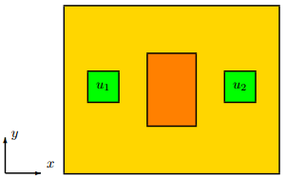

Figure 1 – Configuration of surface with heat flux locations

The model is described by the following parabolic partial differential equation:

$$ρ\left(x,y\right)c\left(x,y\right)\frac{δT}{δt}\left(x,y,t\right)=\left[\begin{matrix}\frac{δ}{δx} & \frac{δ}{δy}\end{matrix}\right]K\left(x,y\right)\left[\begin{matrix}\frac{δT\left(x,y\right)}{δx} \\ \frac{δT\left(x,y\right)}{δy}\end{matrix}\right]+u(x,y,t)$$

where

|  |  |  |  |
| --- | --- | --- | --- |
| **Symbol** | **Description** | **Unit** | **Value** |
| Lx | Length | [m] | 0.2 |
| Ly | Width | [m] | 0.15 |
| $$ρ$$ | Material densities (yellow, orange area) | [kg/m3] | 1100, 1000 |
| $$c$$ | Heat capacities (yellow, orange area) | [J/(kg K)] | 3890, 3350 |
| $$κ$$ | Thermal conductivities (yellow, orange area) | [W/(m K)] | 0.31, 0.31 |
| (X1,Y1) | Location heat flux 1 | ([m],[m]) | (Lx/4, Ly/2) |
| (X2,Y2) | Location heat flux 2 | ([m],[m]) | (3Lx/4, Ly/2) |
| W | Actuator width | [m] | 0.05 |
| Tambient | Ambient temperature | [K] | 309 |

Table 1 – Model properties

Furthermore, the output of the model is the temperature of the surface in degrees Kelvin defined by $T_{ambient}+T(x,y,t)$.

The purpose of this project is to derive a fast and simple model that accurately describes the temperature evolution of this system, as explained in the following ten exercises.

# Exercise 1

In this exercise is proven whether the system is linear or nonlinear and whether the system is time-variant or time-invariant. While doing so, the two cases where the model is homogeneous or non-homogeneous are distinguished.

If the model is **homogeneous**, $ρ$, c and K do not depend on the position (x,y). The system is linear because $ρ$, c and K remain constant over time and position, resulting in the same temperature when the position of the input heat flux changes. The system is time-invariant because the output is the same to the same input at different moments in time.

When the model is **non-homogeneous**, $ρ$, c and K do depend on the position (x,y). The system is now non-linear because $ρ$, c and K are changing over position, resulting in different temperatures when the position of the input heat flux changes. The system is still time-invariant.

# Exercise 2

For now it is assumed that the model is homogeneous, meaning that $l_{x}=l_{y}=0$ (no orange area) and the model is homogeneous meaning that $ρ\left(x,y\right)=ρ, c\left(x,y\right)=c$ and $κ\left(x,y\right)=κ$ are positive constants.

Show that under these conditions, (equation 1 from exercise) admits a solution of the form $T\left(x,y,t\right)=a\left(t\right)ϕ^{\left(x\right)}ϕ^{\left(y\right)}$ whenever $u\left(x,y,t\right)=0$. Here $a, ϕ^{(x)}$ and $ϕ^{(y)}$ are scalar-valued functions on $R$, $[0,L_{x}]$ and $[0,L_{y}]$, respectively, that satisfy the separated differential equations

$${\ddot{ϕ}}^{(x)}-λ_{x}ϕ^{\left(x\right)}=0, {\ddot{ϕ}}^{\left(y\right)}-λ_{y}ϕ^{\left(y\right)}=0, \dot{a}-λ_{a}a=0$$

for suitable constants $λ_{x}, λ_{y}$ and $λ$.

When $u\left(x,y,t\right)=0$, this results in the following equation:

$$\frac{δT}{δt}=\frac{κ}{ρc}\left(\frac{δ^{2}T}{δx^{2}}+\frac{δ^{2}T}{δy^{2}}\right)$$

Now $T\left(x,y,t\right)$ is substituted by $a\left(t\right)ϕ^{\left(x\right)}ϕ^{\left(y\right)}$, resulting in the following equation:

$$\frac{δ(a\left(t\right)ϕ^{\left(x\right)}ϕ^{\left(y\right)})}{δt}=\frac{κ}{ρc}\left(\frac{δ^{2}\left(a\left(t\right)ϕ^{(x)}ϕ^{(y)}\right)}{δx^{2}}+\frac{δ^{2}(a\left(t\right)ϕ^{(x)}ϕ^{(y)})}{δy^{2}}\right)$$

$$\dot{a}ϕ^{(x)}ϕ^{(y)}=\frac{κ}{ρc}\left({\ddot{ϕ}}^{(x)}aϕ^{(y)}+{\ddot{ϕ}}^{(y)}aϕ^{(x)}\right)$$

Which can be rewritten in the following three equations:

$${\ddot{ϕ}}^{(x)}-\left(\frac{ρc}{κa}\dot{a}-\frac{{\ddot{ϕ}}^{\left(y\right)}}{ϕ^{(y)}}\right)ϕ^{\left(x\right)}=0$$

$${\ddot{ϕ}}^{(y)}-\left(\frac{ρc}{κa}\dot{a}-\frac{{\ddot{ϕ}}^{\left(x\right)}}{ϕ^{(x)}}\right)ϕ^{\left(y\right)}=0$$

$$\dot{a}-\frac{κ}{ρc}\left(\frac{{\ddot{ϕ}}^{\left(x\right)}}{ϕ^{\left(x\right)}}+\frac{{\ddot{ϕ}}^{\left(y\right)}}{ϕ^{\left(y\right)}}\right)a=0$$

Now the following lambdas are defined:

$λ_{x}=\frac{{\ddot{ϕ}}^{\left(x\right)}}{ϕ^{(x)}}$ $λ_{y}=\frac{{\ddot{ϕ}}^{\left(y\right)}}{ϕ^{(y)}}$ $λ_{a}=\frac{\dot{a}}{a}$

Using these lambdas results in the following equations:

$${\ddot{ϕ}}^{(x)}-\left(\frac{ρc}{κ}λ_{a}-λ_{y}\right)ϕ^{\left(x\right)}=0$$

$${\ddot{ϕ}}^{(y)}-\left(\frac{ρc}{κ}λ_{a}-λ_{x}\right)ϕ^{\left(y\right)}=0$$

$$\dot{a}-\frac{κ}{ρc}\left(λ_{x}+λ_{y}\right)a=0$$

These can be substituted which results in:

$\frac{ρc}{κ}λ_{a}-λ_{y}=λ_{x}$ $\frac{ρc}{κ}λ_{a}-λ_{x}=λ_{y}$ $\frac{κ}{ρc}\left(λ_{x}+λ_{y}\right)=λ_{a}$

These lambdas are the initial conditions of the simplified model.

# Exercise 3

In this exercise is shown that for any $K>0$ and $L>0$ the set $\left\{ϕ_{k,l} \right|0≤k≤K, 0≤l≤L\}$ is an orthonormal set of functions in $L_{2}$. Because $k$ and $l$ have the values $\{0,1,2,…\}$ this indicates that $K≥1$ and $L≥1$.

First the functions for $ϕ_{k}^{\left(x\right)}(x)$ and $ϕ_{l}^{\left(y\right)}\left(y\right)$ are defined:

$ϕ_{k}^{\left(x\right)}(x)=\left\{\begin{aligned}\frac{1}{\sqrt{L_{x}}} if k=0 \\ \sqrt{\frac{2}{L_{x}}}\cos\left(\frac{kπx}{L_{x}}\right)if k>0\end{aligned}\right.$ $ϕ_{l}^{\left(y\right)}\left(y\right)=\left\{\begin{aligned}\frac{1}{\sqrt{L_{y}}} if l=0 \\ \sqrt{\frac{2}{L_{y}}}\cos\left(\frac{lπy}{L_{y}}\right) if l>0\end{aligned}\right. (1)$

With these functions can be defined that:

$$\begin{aligned}ϕ_{k,l}\left(x,y\right)=ϕ_{k}^{\left(x\right)}\left(x\right)ϕ_{l}^{\left(y\right)}\left(y\right)\#\left(2\right)\end{aligned}$$

Now the inner product space $L_{2}$, based on $ϕ_{k,l}\left(x,y\right)$, is computed:

$$\begin{aligned}〈ϕ_{i},ϕ_{j}〉=\int_{0}^{L_{x}}{\int_{0}^{L_{y}}{ϕ_{i}\left(x,y\right)ϕ_{j}\left(x,y\right)dydx}}\#\left(3\right)\end{aligned}$$

To proof that $ϕ_{k,l}$ is an orthonormal set of functions in $L_{2}$ the following statement has to hold:

$$\begin{aligned}〈ϕ_{i},ϕ_{j}〉=\left\{\begin{aligned}1 if i=j \\ 0 if i≠j\end{aligned}\right.\#\left(4\right)\end{aligned}$$

The following is defined for any $K>0$ and $L>0$ and $0≤k≤K, 0≤l≤L$:

$k_{i}=mod(i,K)$

$k_{j}=mod(j,K)$

$l_{i}=floor\left(\frac{i}{L}\right)$

$l_{j}=floor\left(\frac{j}{L}\right)$

Where $mod(x)$ is the remainder of a division of x and $floor(y)$ returns the nearest integer less than or equal to y.

The next step is to define $ϕ_{i}\left(x,y\right)$, which is done for different conditions based on $k_{i}$ and $l_{i}$:

* If $k_{i}=l_{i}=0$: $ϕ_{i}\left(x,y\right)=\frac{1}{\sqrt{L_{x}L_{y}}}$
* If $k_{i}=0$ and $l_{i}>0$: $ϕ_{i}\left(x,y\right)=\left(\frac{1}{\sqrt{L_{x}}}\right)\sqrt{\frac{2}{L_{y}}}\cos\left(\frac{l_{i}πy}{L_{y}}\right)$
* If $k_{i}>0$ and $l_{i}=0$: $ϕ_{i}\left(x,y\right)=\left(\frac{1}{\sqrt{L_{y}}}\right)\sqrt{\frac{2}{L_{x}}}\cos\left(\frac{k_{i}πx}{L_{x}}\right)$
* If $k_{i}>0$ and $l_{i}>0$: $ϕ_{i}\left(x,y\right)=\left(\frac{2}{\sqrt{L_{x}L_{y}}}\right)\cos\left(\frac{k_{i}πx}{L_{x}}\right)\cos\left(\frac{l_{i}πy}{L_{y}}\right)$

Also $ϕ_{j}(x,y)$ is defined for different conditions based on $k_{j}$ and $l_{j}$:

* If $k_{j}=l_{j}=0$: $ϕ_{j}\left(x,y\right)=\frac{1}{\sqrt{L_{x}L_{y}}}$
* If $k_{j}=0$ and $l_{j}>0$: $ϕ_{j}\left(x,y\right)=\left(\frac{1}{\sqrt{L_{x}}}\right)\sqrt{\frac{2}{L_{y}}}\cos\left(\frac{l_{j}πy}{L_{y}}\right)$
* If $k_{j}>0$ and $l_{j}=0$: $ϕ_{j}\left(x,y\right)=\left(\frac{1}{\sqrt{L_{y}}}\right)\sqrt{\frac{2}{L_{x}}}\cos\left(\frac{k_{j}πx}{L_{x}}\right)$
* If $k_{j}>0$ and $l_{j}>0$: $ϕ_{j}\left(x,y\right)=\left(\frac{2}{\sqrt{L_{x}L_{y}}}\right)\cos\left(\frac{k_{j}πx}{L_{x}}\right)\cos\left(\frac{l_{j}πy}{L_{y}}\right)$

When computing the inner product space (3, fix automatische verwijzing) the outcome is 1 if $i=j$ and 0 when $i≠j$, leading to the conclusion that the set $\left\{ϕ_{k,l} \right|0≤k≤K, 0≤l≤L\}$ is an orthonormal set of functions in $L_{2}$ for any $K>0$ and $L>0$.

# Exercise 4

To be able to simulate the model, The Galerkin projection is used to transform the homogeneous and isotropic form of the model $(1)$ into an ordinary differential equation.

$$\begin{aligned}ρc\frac{δT}{δt}\left(x,y,t\right)=κ\left(\frac{δ^{2}T\left(x,y\right)}{δx^{2}}+\frac{δ^{2}T\left(x,y\right)}{δy^{2}}\right)+u\left(x,y,t\right)\#\left(1\right)\end{aligned}$$

Using the spectral decomposition of the temperature evolution $(2)$ and the definition for the combined spectral components $(3)$, the spectra decomposition of the temperature evolution $(4)$ is defined.

$$\begin{aligned}T\left(x,y,t\right)=\sum_{k=0}^{∞}{\sum_{l=0}^{∞}{a_{k,l}\left(t\right)ϕ_{k}^{\left(x\right)}\left(x\right)ϕ_{l}^{\left(y\right)}\left(y\right)}} \#\left(2\right)\end{aligned}$$

$$\begin{aligned}ϕ_{k,l}\left(x,y\right)∶=ϕ_{k}^{\left(x\right)}\left(x\right)ϕ_{l}^{\left(y\right)}\left(y\right) \#\left(3\right)\end{aligned}$$

$$\begin{aligned}T\left(x,y,t\right)=\sum_{k=0}^{∞}{\sum_{l=0}^{∞}{a_{k,l}\left(t\right)ϕ_{k,l}\left(x,y\right)}}\#\left(4\right)\end{aligned}$$

Replacing the double indexing $k,l$ with $i$ results in the spectral decomposition of the temperature evolution $(5)$.

$$\begin{aligned}T\left(x,y,t\right)=\sum_{i=0}^{∞}{a_{i}\left(t\right)ϕ_{i}\left(x,y\right)} \#\left(5\right)\end{aligned}$$

To calculate the Galerkin projection, the inner product of the model and the defined basis function $ϕ_{j}$ is calculated using a standard inner product as defined in $(6)$ which results in equation $(7)$.

$$\begin{aligned}〈ϕ_{i},ϕ_{j}〉∶=\int_{0}^{L_{x}}{\int_{0}^{L_{y}}{ϕ_{i}\left(x,y\right)ϕ_{j}\left(x,y\right)dydx}}\#\left(6\right)\end{aligned}$$

$$\begin{aligned}〈ρc\frac{δT}{δt},ϕ_{j}〉=〈κ\left(\frac{δ^{2}T}{δx^{2}}+\frac{δ^{2}T}{δy^{2}}\right)+u,ϕ_{j}〉\#\left(7\right)\end{aligned}$$

Substituting the spectral decomposition of the temperature evolution results in equation $(8)$

$$\begin{aligned}〈ρc\sum_{i=0}^{∞}{{\dot{a}}_{i}ϕ_{i}},ϕ_{j}〉=〈κ\left(\sum_{i=0}^{∞}{a_{i}{\ddot{ϕ}}_{i}^{\left(x\right)}}+\sum_{i=0}^{∞}{a_{i}{\ddot{ϕ}}_{i}^{\left(y\right)}}\right)+u,ϕ_{j}〉\#\left(8\right)\end{aligned}$$

Because the defined inner product $\left(6\right)$ is a linear operator, the equation can be rewritten into equation $\left(9\right)$ and subsequently equation $(10)$. From the definition it can also be seen that everything that is not a function of $x$ or $y$ can be treated as a constant which results in equation $(11)$.

$$\begin{aligned}〈ρc\sum_{i=0}^{∞}{{\dot{a}}_{i}ϕ_{i}},ϕ_{j}〉= 〈κ\sum_{i=0}^{∞}{a_{i}{\ddot{ϕ}}_{i}^{\left(x\right)}},ϕ_{j}〉+〈κ\sum_{i=0}^{∞}{a_{i}{\ddot{ϕ}}_{i}^{\left(y\right)}},ϕ_{j}〉+〈u,ϕ_{j}〉\#\left(9\right)\end{aligned}$$

$$\begin{aligned}\sum_{i=0}^{∞}{〈ρc{\dot{a}}_{i}ϕ_{i},ϕ_{j}〉}= \sum_{i=0}^{∞}{〈κa_{i}{\ddot{ϕ}}_{i}^{\left(x\right)},ϕ_{j}〉}+\sum_{i=0}^{∞}{〈κa_{i}{\ddot{ϕ}}_{i}^{\left(y\right)},ϕ_{j}〉}+〈u,ϕ_{j}〉\#\left(10\right)\end{aligned}$$

$$\begin{aligned}\sum_{i=0}^{∞}{ρc{\dot{a}}_{i}〈ϕ_{i},ϕ_{j}〉}= \sum_{i=0}^{∞}{κa_{i}\left(〈{\ddot{ϕ}}_{i}^{\left(x\right)},ϕ_{j}〉+〈{\ddot{ϕ}}_{i}^{\left(y\right)},ϕ_{j}〉\right)}+〈u,ϕ_{j}〉\#\left(11\right)\end{aligned}$$

Due to the orthonormality of the basis function the equation can be rewritten into equation $(12)$.

$$\begin{aligned}\sum_{i=0}^{∞}{ρc{\dot{a}}_{i}}= \sum_{i=0}^{∞}{κa_{i}\left(〈{\ddot{ϕ}}_{i}^{\left(x\right)},ϕ_{j}〉+〈{\ddot{ϕ}}_{i}^{\left(y\right)},ϕ_{j}〉\right)}+〈u,ϕ_{j}〉\#\left(12\right)\end{aligned}$$

Rewriting this into matrix form for $j ϵ N$ gives an ordinary differential equation $(13)$.

$$\begin{aligned}\left[\begin{matrix}{\dot{a}}_{0} \\ ⋮ \\ a_{i} \\ ⋮ \\ {\dot{a}}_{∞}\end{matrix}\right]=\frac{κ}{ρc}\left[\begin{matrix}〈{\ddot{ϕ}}_{0}^{\left(x\right)},ϕ_{0}〉+〈{\ddot{ϕ}}_{0}^{\left(y\right)},ϕ_{0}〉 & … & 〈{\ddot{ϕ}}_{i}^{\left(x\right)},ϕ_{0}〉+〈{\ddot{ϕ}}_{i}^{\left(y\right)},ϕ_{0}〉 & … & 〈{\ddot{ϕ}}_{∞}^{\left(x\right)},ϕ_{0}〉+〈{\ddot{ϕ}}_{∞}^{\left(y\right)},ϕ_{0}〉 \\ ⋮ & ⋱ & ⋮ & ⋱ & ⋮ \\ 〈{\ddot{ϕ}}_{0}^{\left(x\right)},ϕ_{j}〉+〈{\ddot{ϕ}}_{0}^{\left(y\right)},ϕ_{j}〉 & … & 〈{\ddot{ϕ}}_{i}^{\left(x\right)},ϕ_{j}〉+〈{\ddot{ϕ}}_{i}^{\left(y\right)},ϕ_{j}〉 & … & 〈{\ddot{ϕ}}_{∞}^{\left(x\right)},ϕ_{j}〉+〈{\ddot{ϕ}}_{∞}^{\left(y\right)},ϕ_{j}〉 \\ ⋮ & ⋱ & ⋮ & ⋱ & ⋮ \\ 〈{\ddot{ϕ}}_{0}^{\left(x\right)},ϕ_{∞}〉+〈{\ddot{ϕ}}_{0}^{\left(y\right)},ϕ_{∞}〉 & … & 〈{\ddot{ϕ}}_{i}^{\left(x\right)},ϕ_{∞}〉+〈{\ddot{ϕ}}_{i}^{\left(y\right)},ϕ_{∞}〉 & … & 〈{\ddot{ϕ}}_{∞}^{\left(x\right)},ϕ_{∞}〉+〈{\ddot{ϕ}}_{∞}^{\left(y\right)},ϕ_{∞}〉\end{matrix}\right]\left[\begin{matrix}a_{0} \\ ⋮ \\ a_{i} \\ ⋮ \\ a_{∞}\end{matrix}\right]+\frac{1}{ρc}\left[\begin{matrix}〈u,ϕ_{0}〉 \\ ⋮ \\ 〈u,ϕ_{j}〉 \\ ⋮ \\ 〈u,ϕ_{∞}〉\end{matrix}\right]\#\left(13\right)\end{aligned}$$

Substituting the basis functions results in equation $\left(14\right)$.

$$\begin{aligned}\left[\begin{matrix}{\dot{a}}_{0} \\ ⋮ \\ a_{i} \\ ⋮ \\ {\dot{a}}_{∞}\end{matrix}\right]=\frac{κ}{ρc}\left[\begin{matrix}0 & … & 0 & … & 0 \\ ⋮ & ⋱ & ⋮ & ⋱ & ⋮ \\ 0 & … & -\left({\left(\frac{k_{i}π}{Lx}\right)}^{2}+{\left(\frac{l_{i}π}{Ly}\right)}^{2}\right) & … & 0 \\ ⋮ & ⋱ & ⋮ & ⋱ & ⋮ \\ 0 & … & 0 & … & -\left({\left(\frac{∞π}{Lx}\right)}^{2}{\left(\frac{∞π}{Ly}\right)}^{2}\right) \end{matrix}\right]\left[\begin{matrix}a_{0} \\ ⋮ \\ a_{i} \\ ⋮ \\ a_{∞}\end{matrix}\right]+\frac{1}{ρc}\left[\begin{matrix}〈u,ϕ_{0}〉 \\ ⋮ \\ 〈u,ϕ_{j}〉 \\ ⋮ \\ 〈u,ϕ_{∞}〉\end{matrix}\right]\#\left(14\right)\end{aligned}$$

To derive the equilibrium solution of the model, the input is set to 0, leading to equation $\left(15\right)$.

$$\begin{aligned}\left[\begin{matrix}{\dot{a}}_{0} \\ ⋮ \\ a_{i} \\ ⋮ \\ {\dot{a}}_{∞}\end{matrix}\right]=\frac{κ}{ρc}\left[\begin{matrix}0 & … & 0 & … & 0 \\ ⋮ & ⋱ & ⋮ & ⋱ & ⋮ \\ 0 & … & -\left({\left(\frac{k_{i}π}{Lx}\right)}^{2}+{\left(\frac{l_{i}π}{Ly}\right)}^{2}\right) & … & 0 \\ ⋮ & ⋱ & ⋮ & ⋱ & ⋮ \\ 0 & … & 0 & … & -\left({\left(\frac{∞π}{Lx}\right)}^{2}{\left(\frac{∞π}{Ly}\right)}^{2}\right) \end{matrix}\right]\left[\begin{matrix}a_{0} \\ ⋮ \\ a_{i} \\ ⋮ \\ a_{∞}\end{matrix}\right]\#\left(15\right)\end{aligned}$$

The free response of the model, which is in the form $\dot{a}=Aa$, can be calculated using equation $(16)$ resulting in equation $\left(17\right)$.

$$\begin{aligned}a\left(t\right)=e^{At}a\left(0\right)\#\left(16\right)\end{aligned}$$

$$\begin{aligned}a\left(t\right)=\left[\begin{matrix}e^{0} & … & 0 & … & 0 \\ ⋮ & ⋱ & ⋮ & ⋱ & ⋮ \\ 0 & … & e^{-\frac{κ}{ρc}\left({\left(\frac{k_{i}π}{Lx}\right)}^{2}+{\left(\frac{l_{i}π}{Ly}\right)}^{2}\right)t} & … & 0 \\ ⋮ & ⋱ & ⋮ & ⋱ & ⋮ \\ 0 & … & 0 & … & e^{-\frac{κ}{ρc}\left({\left(\frac{∞π}{Lx}\right)}^{2}{\left(\frac{∞π}{Ly}\right)}^{2}\right)t} \end{matrix}\right]a\left(0\right)\#\left(17\right)\end{aligned}$$

The equilibrium solution can be obtained by equating the solution at $t=∞$, which results in the $a$ coefficients as can be seen in $(18)$.

$$\begin{aligned}a\left(∞\right)=\left[\begin{matrix}\begin{matrix}a_{0}\left(0\right) \\ 0\end{matrix} \\ ⋮ \\ 0\end{matrix}\right]\#\left(18\right)\end{aligned}$$

Filling in the coefficients $(18)$ in equation $(5)$ gives the equilibrium solution $\left(19\right)$ of the model. Substituting the basis function $ϕ_{0}$ and replacing $a_{0}(0)$ with the Initial temperature for the model results in equation $(20)$. Which is as expected the average temperature of the initial temperature profile .

$$\begin{aligned}T\left(x,y,∞\right)=a_{0}\left(0\right)ϕ_{0}\left(x,y\right)\#\left(19\right)\end{aligned}$$

$$\begin{aligned}T\left(x,y,∞\right)=\frac{1}{LxLy}\int_{0}^{L_{x}}{\int_{0}^{L_{y}}{T\left(x,y,0\right)dydx}}\#\left(20\right)\end{aligned}$$

# Exercise 5

During this exercise the model is simulated using model parameters of Table 1 and no input heat fluxes. The initial temperature profile is a 2D Bell curve with height +5 [°K] and a width of 0.02 [m]. The simulation is executed with $K=L=3, 5, 10, 20$ as shown in Figure 2, Figure 3, Figure 4 and Figure 5.

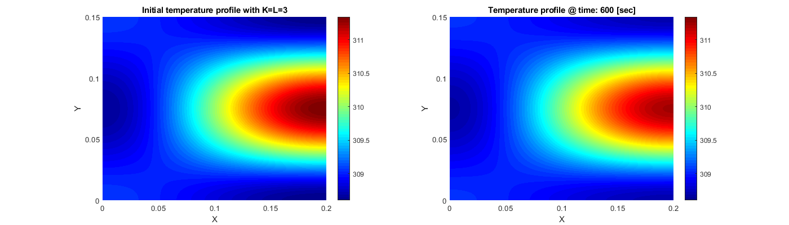

Figure 2 – Initial temperature profile over time with K=L=3

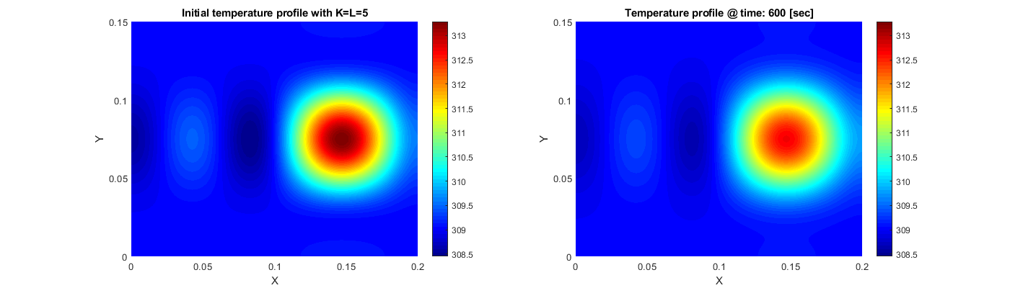

Figure 3 – Initial temperature profile over time with K=L=5

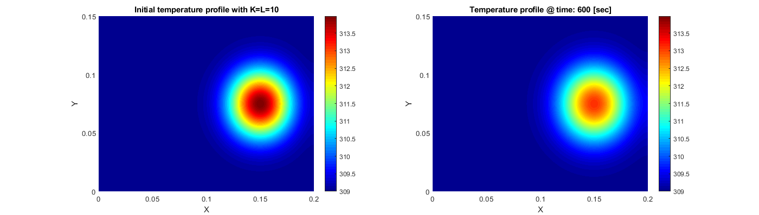

Figure 4 – Initial temperature profile over time with K=L=10

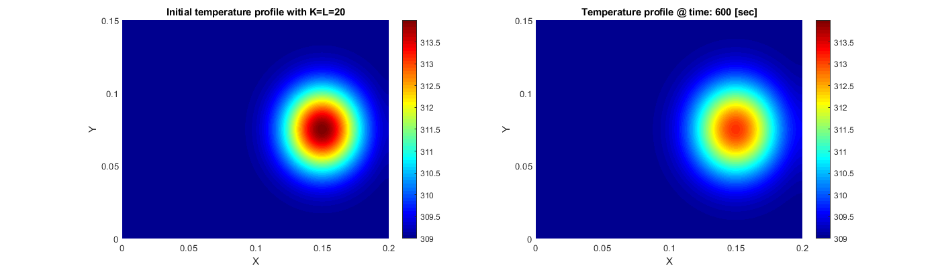

Figure 5 – Initial temperature profile over time with K=L=20

# Exercise 6

During this exercise the simulation is executed with

* Different initial temperature profiles
* Inputs for the heat fluxes $u_{1}(t)$ and $u_{2}(t)$

while varying with the approximation orders $K$ and $L$.

The initial temperature profile is now changed to two 2D Bell curves at the location of $u_{1}(t)$ and $u_{2}(t)$ and a radius of 0.03 [m]. The Bell curve at the location of $u_{1}(t)$ has an initial peak temperature of +5 [°K] and the Bell curve at location $u_{2}\left(t\right)$ has an initial peak temperature of -5 [°K]. This initial profile is simulated with the same approximation orders of exercise 5. The results of these simulations are shown in Figure 6, Figure 7, Figure 8 and Figure 9.

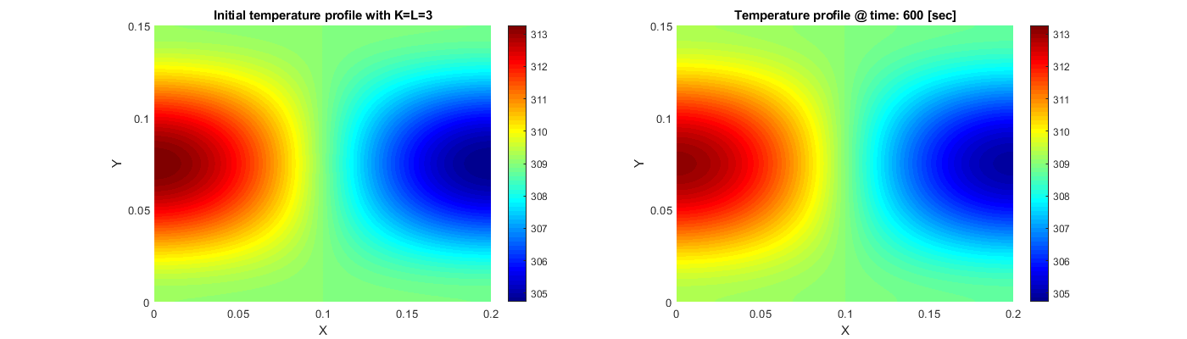

Figure 6 – Double Bell curve initial profile with K=L=3

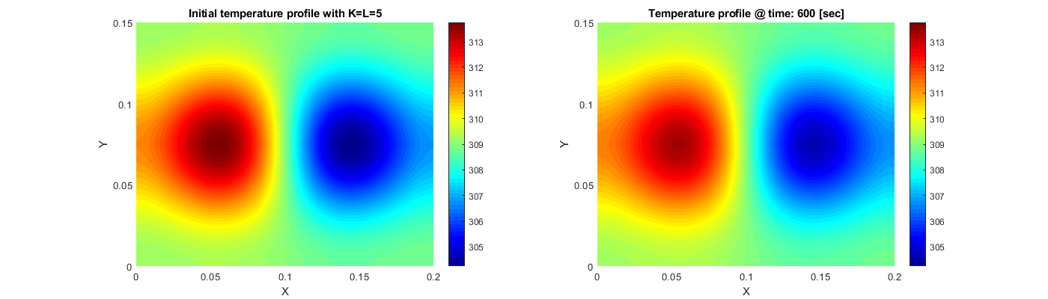

Figure 7 – Double Bell curve initial profile with K=L=5

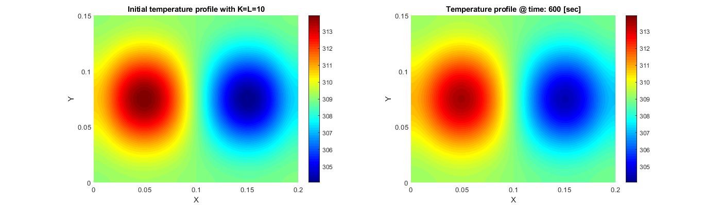

Figure 8 – Double Bell curve initial profile with K=L=10

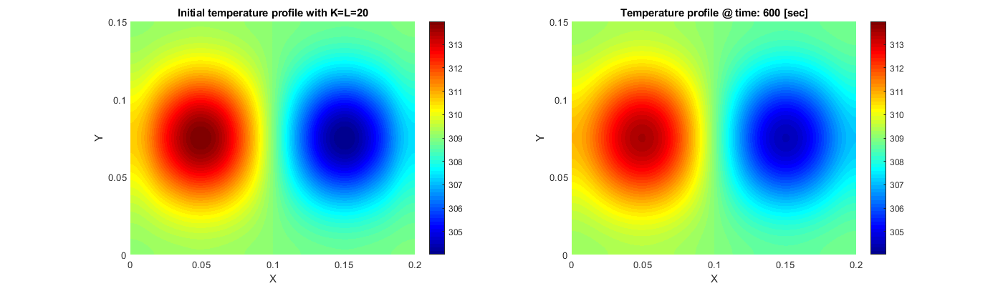

Figure 9 – Double Bell curve initial profile with K=L=20

Now the inputs $u_{1}(t)$ and $u_{2}(t)$ are added to the simulation with the following properties:

* Start at t=30
* Stop at t=330
* Heat flux = 60,000

and with the same initial temperature profile and values for $K$ and $L$ as in exercise 5, resulting in Figure 10, Figure 11, Figure 12 and Figure 13.

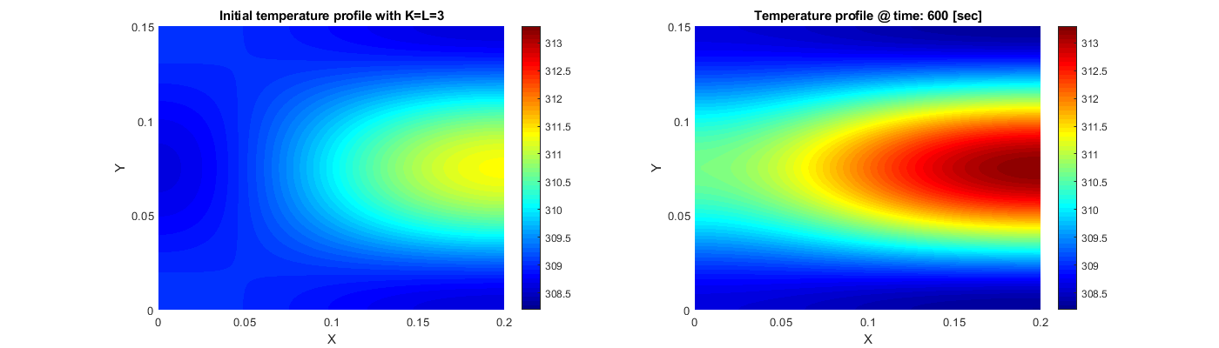

Figure 10 – Initial temperature profile with inputs u1 and u2 over time with K=L=3

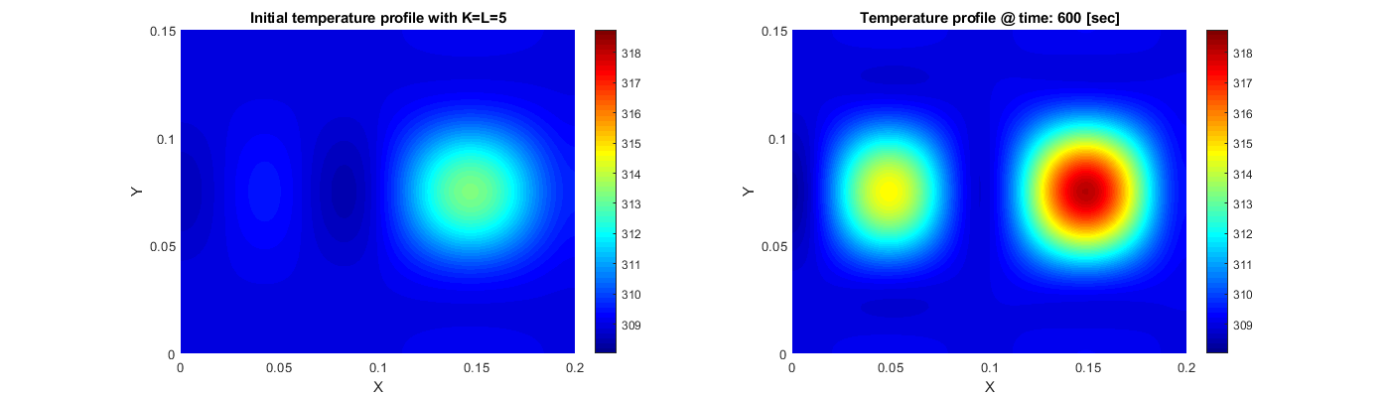

Figure 11 – Initial temperature profile with inputs u1 and u2 over time with K=L=5

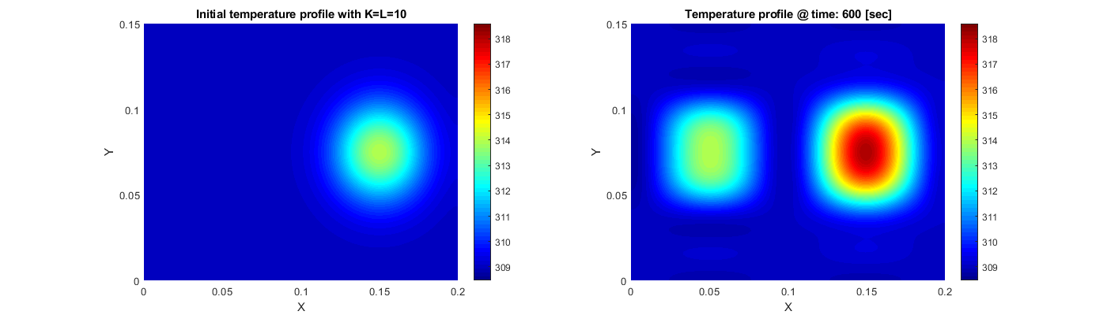

Figure 12 – Initial temperature profile with inputs u1 and u2 over time with K=L=10

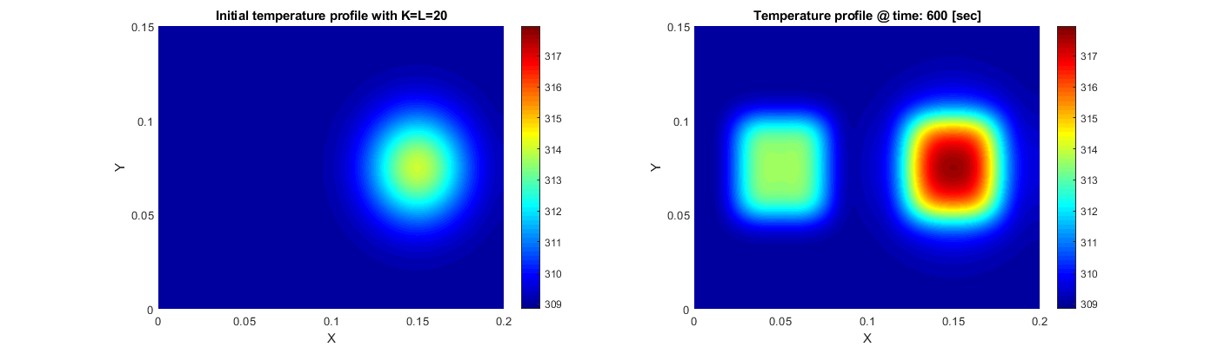

Figure 13 – Initial temperature profile with inputs u1 and u2 over time with K=L=20

From these simulations can be concluded that with higher approximation orders for $K$ and $L$ the results are more accurate. If the approximation order is low, harmonics are visible in the temperature profile. With an approximation order of 3 or lower the result is inaccurate.

# Exercise 7

In this exercise the output of the simulation is taken with an high approximation order $K=L=50$ and this data is used to compute a POD basis ${\left\{ϕ_{i}\right\}}_{i=1,…,R}$ in $L_{2}$ of order $R$.

This POD basis is created using the Singular Value Decomposition (SVD) of the data $T\left(x,y,t\right)$ from an simulation.

$$\left[U,S,Y\right]=svd(T\left(x,y,t\right))$$

Now $U=(ϕ_{1},…, ϕ_{R})$ where $\left\{ϕ_{i},i=1,…,R\right\}$ define the POD basis.

# Exercise 8

Now the POD basis $ϕ_{i}$ from exercise 7 is used to create a reduced order POD model that takes the heat fluxes $u_{1}(t)$ and $u_{2}(t)$ as inputs and outputs the coefficients $a_{i}(t)$ in the truncated expansion:

$$T_{R}\left(x,y,t\right)=\sum_{i=1}^{R}{a_{i}\left(t\right)ϕ_{i}(x,y)}$$

# Exercise 9

The next step is to validate the quality of the reduced order POD model from exercise 8 by simulating with different orders of $R$, different initial temperature profiles and different heat fluxes $u_{1}(t)$ and $u_{2}(t)$. To compare the POD basis to the earlier determined basis, the same orders for $R$ are used as for $K$ and $L$.

First the reduced order POD model is simulated with the same initial temperature profile as during exercise 5 with varying $R$:

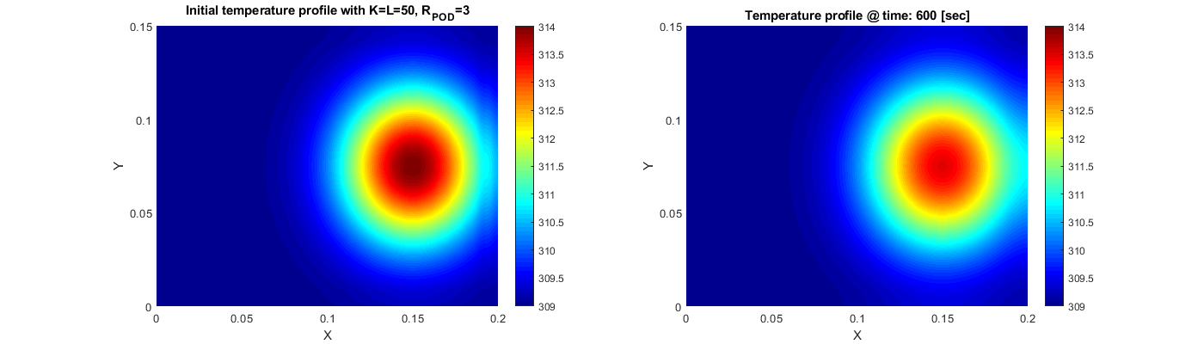

Figure 14 – POD basis initial profile over time with order R=3

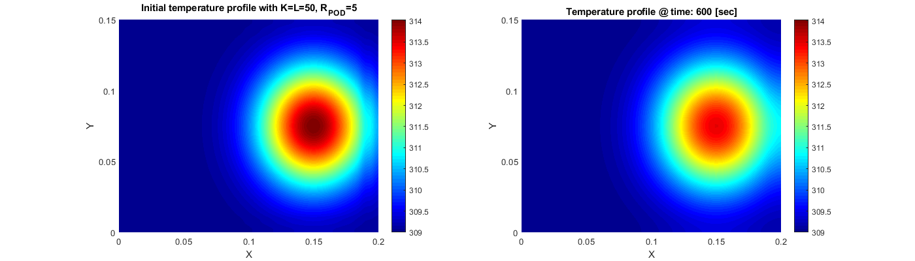

Figure 15 – POD basis initial profile over time with order R=5

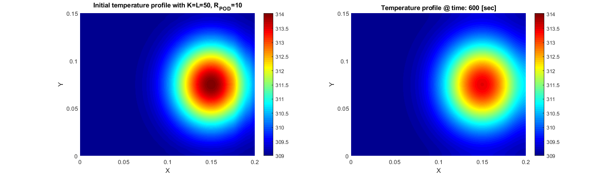

Figure 16 –POD basis initial profile over time with order R=10

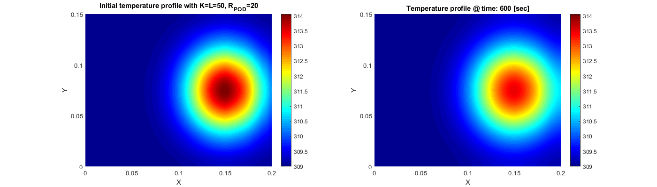

Figure 17 – POD basis initial profile over time with order R=20

Next the reduced order POD model is simulated with the same heat fluxes as during exercise 6 while varying $R$:

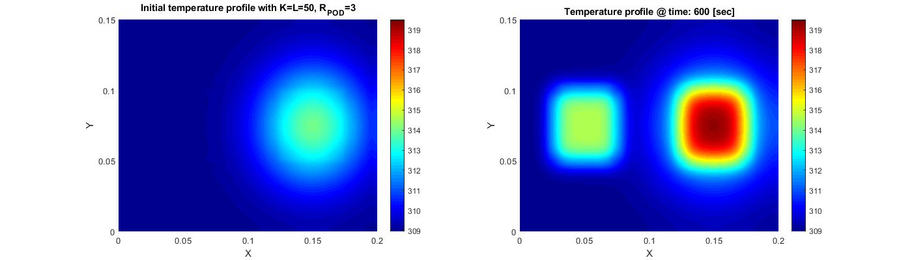

Figure 18 – POD basis initial temperature profile with inputs u1 and u2 over time with R=3

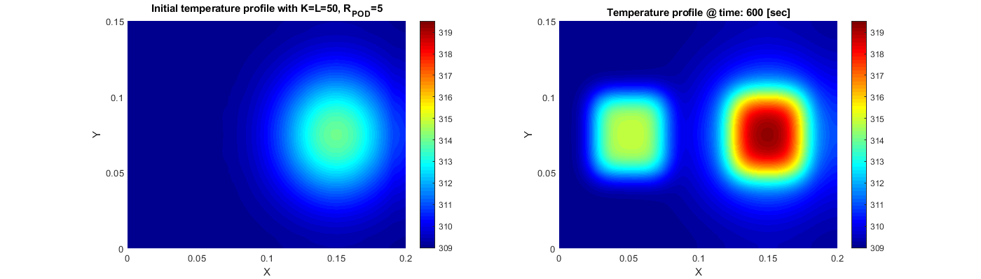

Figure 19 – POD basis initial temperature profile with inputs u1 and u2 over time with R=5

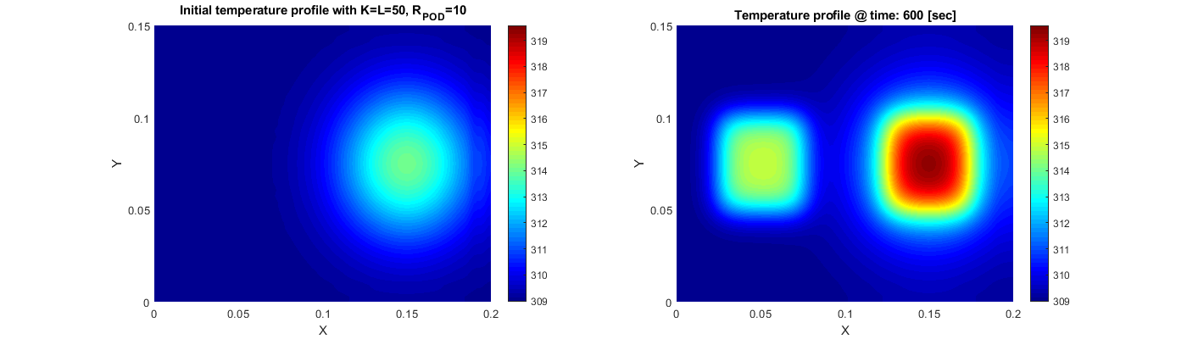

Figure 20 – POD basis initial temperature profile with inputs u1 and u2 over time with R=10

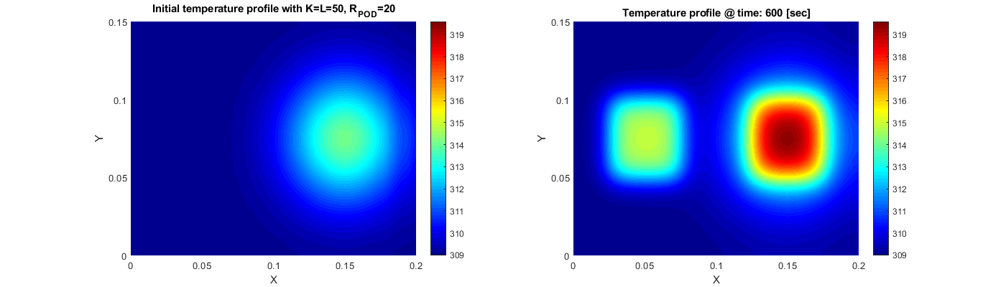

Figure 21 – POD basis initial temperature profile with inputs u1 and u2 over time with R=20

From the figures above can be concluded that the results are almost equal to each other, indicating that a low POD order already has a high accuracy in comparison to the earlier determined basis.

# Exercise 10