**5.1** To further assess the choice of model class and order, the earlier designed PRBS input is applied again on the system. Now the Box-Jenkins model is determined again but with the orders for $G(q,θ)$ shown in Table 1.

Table 1 – OE model orders for validation

|  |  |  |
| --- | --- | --- |
| Model | $$n_{b}$$ | $$n_{f}$$ |
| $$M_{1}$$ | 2 | 3 |
| $$M_{2}$$ | 2 | 4 |
| $$M_{3}$$ | 3 | 3 |
| $$M_{4}$$ | 3 | 4 |
| $$M_{5}$$ | 5 | 5 |
| $$M_{6}$$ | 8 | 8 |
| $$M_{7}$$ | 9 | 10 |
| $$M_{8}$$ | 11 | 12 |

**5.2** Now the identified models are simulated using both the old PRBS input signal used for determining the model and a newly generated PRBS input signal. The results are plotted in Figure 2, where the model number is plotted on the horizontal axis and the cost $V_{N}({\hat{θ}}_{i})$ in the vertical axis.

The curve has a peak before the optimal model number, while overall $V_{N}({\hat{θ}}_{i})$ decreases over an increasing model number and increases after the optimum. When a new data set is loaded, the curve and peak is varying. Most of the time model 5 has the lowest cost, indicating that this is the best fitting model.

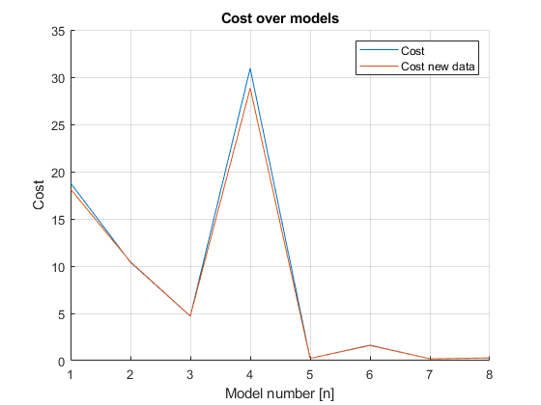

Figure 2 – Cost over different models

**5.3** The model does almost correspond to the earlier determined model, where model number 5 has an order of 5 instead of the determined 7.