The Efficacy of International Environmental Policy: Empirically Assessing Climate Policy Outcomes

by

Jonathan Vasquez

College of Arts and Sciences
The University of British Columbia
December

TABLE OF CONTENTS
1 LITERATURE REVIEW 3
1.1 The Kyoto Protocol: Impacts and Critiques 3
1.2 The Paris Agreement: Aspirations Versus Outcomes 8
1.3 Comparative Analyses of Kyoto and Paris 10
1.4 Persistent challenges to climate policy 11
1.5 Theory & Hypotheses 12
1.6 Hypotheses 13
2 DATA 14
2.1 Data Sourcing 14
2.2 Data Cleaning 15
2.3 Data Missingness 15
2.4 Measures 16
2.4.1 Dependent Variable 16
2.4.2 Predictor Variable 17
2.4.3 Control Variables 18
3 METHODS 19
3.1 Linear Models 20
3.2 Panel Corrected Standard Errors (PCSE) Model 21
3.3 Generalized Estimating Equations (GEE) 22
4 Model Summaries 22
4.1 PCSE Regression Model Summaries 22
4.2 GEE Regression Model Summaries 23
5 References 24
APPENDICES 39
Appendix A 39
Appendix A.1 40
Appendix A.2 41
Appendix B 42
Appendix B.1 42
Appendix B.2 43

LITERATURE REVIEW

The Kyoto Protocol: Impacts and Critiques
The Kyoto Protocol represents a pivotal moment in international climate policy, emerging from the framework established by the United Nations Framework Convention on Climate Change (UNFCCC) during the Rio Earth Summit in 1992. Following comprehensive negotiations, the Kyoto Protocol was adopted on 11 December 1997 in Kyoto, Japan. It was subsequently opened for signature from 16 March 1998 to 15 March 1999 at the United Nations Headquarters in New York (UNFCCC. Kyoto Protocol. 1997). The implementation details were finalized in 2001 with the adoption of the Marrakech Accords during COP7 in Marrakech, Morocco (UNFCCC. Conference of the Parties (COP) 2002). The Protocol officially entered into force on 16 February 2005, following Russia's ratification, which allowed the agreement to meet the requisite threshold of at least 55 Parties to the Convention, incorporating Parties included in Annex I, which accounted in total for at least 55% of the total carbon dioxide emissions for 1990 of the Annex I countries (UNFCCC. n.d.)
During the first commitment period from 2005 to 2012, developed nations were obligated to reduce their greenhouse gas (GHG) emissions by an average of 5% relative to 1990 levels. (Gillenwater and Seres 2011; UNFCCC. Kyoto Protocol. 1997). A second commitment period was established under the Doha Amendment in 2012, intended to take effect between 2012 and 2020; however, the amendment was never ratified, preventing its official implementation. (Breidenich et al. 1998; UNFCCC. Kyoto Protocol. 1997). By 2012, several participating countries, particularly in Europe, achieved a notable reduction in emissions, averaging approximately 12% (Aichele and Felbermayr 2013). However, this success did not extend universally, as global emissions continued to rise despite the efforts of the Kyoto Protocol. (Costantini et al. 2024; Wang, Li, and Pisarenko 2020).
Scholars have extensively analyzed the Kyoto Protocol, particularly its design, implementation, and impact on global greenhouse gas (GHG) emissions. Quantitative analyses have demonstrated a statistically significant reduction in emissions among participating Annex I countries, primarily attributed to Kyoto's legally binding targets and innovative mechanisms such as emissions trading, Joint Implementation (JI), and the Clean Development Mechanism (CDM) (Grubb 2016; Maamoun 2019; Zhang and Wei 2010).
Other studies, focused primarily on the legally binding nature of the Kyoto Protocol, have come to similar conclusions, finding that countries with binding commitments reduced their emissions by about 7% compared to those without such commitments. (Bassetti 2022; Grunewald and Martínez-Zarzoso 2016; Grunewald and Martínez-Zarzoso 2009; Maamoun 2019). This suggests that, despite criticisms, the Kyoto Protocol did lead to measurable reductions in emissions. Scholars have also taken these findings as evidence for the presence of Kuznets’s Curve. (Breidenich et al. 1998; Grunewald and Martinez-Zarzoso 2016; Tulpulé et al. 1999). The Environmental Kuznets Curve (EKC) Hypothesis suggests that environmental degradation increases as countries industrialize and their economies develop. However, these findings have encountered challenges in illustrating the strengths and limitations of the Kyoto Protocol's top-down, legally binding approach.
Many studies have criticized the Kyoto Protocol by focusing on its economic aspects and internal and external economic relationships. Scholars have questioned the Kyoto Protocol's impact on emissions reductions, arguing that economic downturns in the late 1990s and early 2000s may be the underlying mechanism driving them. (Grunewald and Martinez-Zarzoso 2016). While the logic of this argument is compelling, it may be relevant only to studies that have used emission intensity rather than total emissions as the dependent variable. Using a construct combining GDP per capita and carbon emissions per capita may alter results by tying greenhouse gas emissions to GDP.
Other critiques have focused on the interaction of political and economic interests. A rationalist framework has been used to explain whether countries elected to ratify the Kyoto Protocol. Unlike the broader and less binding UNFCCC, the Kyoto Protocol placed strict demands on its signatories, making participation more dependent on countries' domestic economic calculations. The rationalist perspective argues that political and economic interests, rather than purely environmental considerations, are the primary drivers of the varying levels of adoption and compliance in developed nations (Yamagata, Yang, and Galaskiewicz 2013).
The economic implications of the Kyoto Protocol may have played a more critical role for the United States and other developing nations. Meeting emissions reduction targets would have required significant economic sacrifices, such as a projected 14% annual increase in energy prices or a 5% decrease in economic growth. (Sutherland 2000). Even with advanced technologies, achieving these reductions would have required substantial interventions, such as prematurely retiring existing infrastructure. The prohibitively high compliance costs, particularly for developed nations heavily reliant on fossil fuels, reduced the policy's effectiveness. International emissions trading could only alleviate some of these costs if a critical mass of nations participated. These dynamics underscore the challenges in implementing stringent climate agreements and imply that, without significant changes to the structure of commitments, future international climate agreements risk failing to establish an effective long-term climate strategy. (Manne and Richels 2000).
Other critiques of the Kyoto Protocol have focused on governance and international relations. International networks may play a pivotal role in climate agreement outcomes. Nations with greater connectivity to other environmental regimes experienced more effective coordination and compliance under the Kyoto Protocol. This interconnectedness acted as "social capital," allowing better information flow and enhancing cooperative efforts. Such dynamics underscore the importance of broader institutional linkages in supporting treaty implementation and the potential benefits of fostering international networks that can facilitate knowledge-sharing and capacity-building (Ward 2006).
The interconnectedness of nations can also undermine the effectiveness of international agreements. The United States' withdrawal from the Kyoto Protocol may have significantly reduced the demand for global emission permits. This reduction led to lower carbon prices and diminished incentives for climate-friendly investment. This emphasizes the ripple effect that the participation or lack thereof by significant players like the U.S. can have across the entire regime. Furthermore, the U.S. withdrawal underscores the challenges of maintaining momentum in international agreements when key stakeholders disengage, underscoring the importance of designing resilient frameworks that withstand such disruptions. (Buchner and Carraro 2006).
The power dynamics between developed and developing nations have been the focus of other critiques. This framework challenges findings of emission reductions, especially in developed nations. Neoliberalism and the Global Development Project often force developing countries to open their markets to foreign companies in exchange for loans and debt relief. These unequal treaties allow developed nations to export their production and emissions to developing countries, which often have less stringent environmental protections. This framework not only challenges indicators of GHG emission reduction but also challenges studies that have asserted the existence of a Kuznet curve, a trend toward global environmental homeostasis. (Arrighi et al. 2003; Cirman et al. 2009; Tulpulé et al. 1999).
Much of the debate over the Kyoto Protocol's effectiveness centers on its binding aspects; some scholars have also highlighted its flexibility mechanisms. Although Kyoto's emissions trading reduced compliance costs, it also highlighted regional disparities in abatement costs, with some economies bearing disproportionate burdens. This uneven distribution of costs points to the need for more equitable burden-sharing mechanisms to enhance participation and effectiveness. Such inequities can undermine the collective spirit necessary for effective climate action, suggesting that future agreements must proactively address these disparities (Cirman et al. 2009; Tulpulé et al. 1999).
Critiques of the Kyoto Protocol, focusing on economic, political, and international relations, all have a common underlying aspect. Each of these studies has made its analysis by focusing on the top-down binding nature of the Kyoto Protocol, arguing either for or against this approach to policy. Ultimately, the mixed results of the Kyoto Protocol also underscore the difficulty of achieving both environmental and economic objectives simultaneously. (Swinton and Sarkar 2008). While its binding targets provided accountability, the economic sacrifices required, particularly by industrialized nations, raised concerns about the broader feasibility of such a stringent approach. The introduction of flexibility mechanisms, such as emissions trading, was intended to mitigate these costs, yet it also introduced inequalities and complexities that affected overall compliance and participation. These lessons are crucial for understanding subsequent climate frameworks, particularly the Paris Agreement, which sought to address some of the shortcomings of the Kyoto Protocol by emphasizing inclusivity and flexibility.

The Paris Agreement: Aspirations Versus Outcomes
The necessity for the Paris Agreement became evident in 2009 following the Copenhagen Summit (COP15), which ultimately failed to produce a legally binding framework to succeed the Kyoto Protocol (Falkner 2016). In 2011, during COP17 in Durban, nations agreed to pursue a new universal climate agreement to adopt such a policy by 2015 (UNFCCC. Paris Agreement, 2015). This goal was successfully realized when the Paris Agreement was adopted at COP21 in Paris in 2015, resulting in 196 countries committing to limit the increase in global temperatures to below 2°C above pre-industrial levels while striving to limit the rise to 1.5°C (IPCC 2018; UNFCCC. Paris Agreement. 2015) The Agreement was opened for signature in 2016, garnering the support of 175 countries on its first day. Subsequently, in November 2016, the Paris Agreement officially entered into force, achieving ratification by a minimum of 55 countries representing at least 55% of global emissions within less than a year of its adoption (Bodansky 2016; UNFCC. Paris Agreement. C.N.63.2016.TREATIES-XXVII.7.d 2016).
From 2016 to 2019, countries developed and communicated their early nationally determined contributions (NDCs); however, global emissions continued to rise, reflecting limited progress in preventing global warming from exceeding 1.5°C (Rogelj et al. 2016; UNEP Emissions Gap Report 2019). The first global stock take was initially scheduled for 2020; however, the COVID-19 pandemic temporarily disrupted economic activities, leading to a short-lived reduction in emissions. (Le Quéré et al. 2020). At COP26 in Glasgow in 2021, countries reaffirmed their commitments under the Agreement and updated their NDCs, acknowledging the urgency of limiting warming to 1.5°C (UNFCC. Glasgow Climate Pact. 2021). The first global stock take, anticipated between 2023 and 2025, assessed progress and revealed that while specific policies have effectively mitigated emissions, global temperatures remain projected to exceed the 1.5°C threshold unless more ambitious action is taken. (IPCC. CLIMATE CHANGE 2023; UNFCCC. Conference of the Parties serving as the meeting of the Parties to the Paris Agreement (CMA) 2023).
The Paris Agreement signifies a significant shift in international climate policy, emphasizing inclusivity and flexibility through Nationally Determined Contributions (NDCs). This bottom-up approach accommodated developed and developing countries by allowing nations to set their climate targets (Bodansky 2016). However, some scholars argue that this voluntary framework lacks enforceable mechanisms, leading to mixed, and often underwhelming, emission-reduction outcomes (Cadman et al. 2018; Mukherjee and Mathew 2023).
Tosun (2022) elaborates on this challenge, noting that while the flexibility of NDCs promotes inclusivity, it simultaneously undermines the enforceability of ambitious climate action. Developing nations face challenges in balancing mitigation with economic growth, as they often lack the resources for substantial climate action without external support. This tension between development needs and climate obligations is a recurring theme in international climate policy, highlighting the difficulties of achieving equity in global climate action.
The flexibility offered by the Paris Agreement allows countries to tailor their climate action plans to their specific circumstances, thereby broadening participation. However, it also challenges the ability to ensure these plans are ambitious enough to meet global climate goals. The voluntary nature of NDCs results in considerable variation in the stringency and scope of commitments, making it difficult to assess collective progress. This variability poses significant challenges for global coordination, as the success of the Paris Agreement depends heavily on individual countries' willingness to align their national interests with broader climate objectives.

Comparative Analyses of Kyoto and Paris
The comparative literature on Kyoto and Paris often revolves around the debate between binding and non-binding commitments. While Kyoto’s legally enforceable targets created accountability, Paris' bottom-up model offers greater flexibility, though sometimes at the cost of reduced overall ambition.
Nordhaus (2006) criticizes Kyoto's quantity-based mechanisms, such as emissions trading, and suggests that price-based approaches, such as harmonized carbon taxes, could be more efficient. His perspective on Kyoto as an example of “institutional overreach” underscores the limitations of enforcing uniform targets across diverse economies.
By contrast, Paris’s flexibility is seen as a strength and a weakness. The emphasis on NDCs allows for broader participation, particularly from developing nations that were previously exempt under the Kyoto Protocol. However, this approach also leaves much of the climate action to individual nations’ discretion, resulting in uneven levels of ambition and progress. Comparative analyses thus far suggest that while Paris may foster greater participation, it lacks the accountability mechanisms that made Kyoto’s approach more directly enforceable, albeit economically burdensome.
In comparing the Kyoto Protocol and the Paris Agreement, the literature is sparse; research using quantitative methods to measure the effects of the two agreements directly is even rarer. Most research has been done through legal analysis or other qualitative methods. The study of Balogh and Mizik (2023) is a notable exception. This study found a small but statistically significant reduction in carbon-emission intensity among countries that signed the Kyoto Protocol, and claimed this supports the existence of a Kuznets Curve. The literature also lacks a distinct sociological contribution to the field, both quantitative and qualitative, and the existing body would be enriched by considering socioeconomic factors and other social factors, such as governance and politics.

Persistent challenges to climate policy
The literature highlights several persistent challenges in international climate policy, including the voluntary nature of the Paris Agreement's commitments, financing mechanisms, and accountability issues. There is also significant debate around climate justice, particularly regarding the role of the Global South, which has often been marginalized in both the negotiation and implementation phases of international climate agreements.
Tosun (2022) and Desai and Desai (2024) strongly advocate immediate, urgent climate action, arguing that gradual policy shifts are insufficient to address the accelerating impacts of climate change. Similarly, Bisare Bitire (2023) underscores the importance of legally binding national policies to provide a stable foundation for international cooperation and highlights the need for swift and decisive action.
Gobezie and Boka (2023) emphasize the link between greenhouse gas emissions and food security in Sub-Saharan Africa, highlighting that increased emissions directly undermine food availability and stability in the region. This highlights the interconnected nature of climate change impacts, extending beyond environmental degradation to affect broader human well-being, particularly in vulnerable areas.
To effectively address these challenges, it is essential to integrate theories that offer an alternative perspective for analyzing these phenomena and elucidating the anthropogenic mechanisms driving climate change. These theories should clarify the motivations behind national actors' prioritization of climate change mitigation and adaptation, and evaluate international policy, providing insights into the mechanisms that contribute to the success or failure of such initiatives.

Theory & Hypotheses
In line with the existing literature, I will frame the Kyoto Protocol and the Paris Agreement as top-down and bottom-up policies. Top-down approaches are characterized by rigid, legally binding commitments established and enforced by an international body comprised of national actors. In contrast, bottom-up approaches are marked by more flexible obligations that, while still legally binding, include a greater proportion of non-binding or ambiguous clauses. Unlike top-down policies, bottom-up frameworks, while still negotiated by an international body of national actors, allow countries to set their own Nationally Determined Contributions (NDCs).

Hypotheses
My hypotheses draw on the research by Jorgenson and Clark (2012), in which GDP was operationalized into income categories and used to represent development. Additionally, my hypotheses build on the theoretical insights of Arrighi et al. (2003), who illustrated the enduring income disparities between developed and developing nations despite significant advances in industrialization. Within this study's scope, the operationalized income and the Human Development Index (HDI) are thus considered more effective indicators of the global North-South divide than the conventional understanding of development. My hypotheses focus on the structure of climate agreements and the systemic elements of the international climate regime. Specifically, I will examine the top-down and bottom-up frameworks of climate agreements and evaluate the influence of concentrated hegemonic power versus a more diffuse multipolar system within the global climate regime.
- H1: Posits that climate agreements with a top-down framework will be more effective at reducing carbon emissions. As such, I expect the Kyoto Protocol to have lower carbon emissions than the Paris Agreement.
- The theoretical frameworks discussed above will serve as the foundation for my hypotheses and for interpreting the results. The first hypothesis I will test, comparing the Paris Agreement and the Kyoto Protocol, is H2: Posits that concentrated hegemonic power is the driving factor behind the efficacy of climate agreements. Therefore, I expect the Kyoto Protocol to have lower carbon emissions than the Paris Agreement.
For this analysis, I require longitudinal country-level data that includes annual greenhouse gas emissions (measured in CO2 equivalents), participation status in the Kyoto Protocol and the Paris Agreement, and GDP and population figures. Additionally, I sought a dataset covering all years in which both agreements were active, with minimal data gaps. Minimizing gaps is critical to ensure the robustness and accuracy of longitudinal modeling, as extensive missing data can compromise statistical power, introduce bias, and hinder the reliable estimation of temporal dynamics and policy effects. (Garcia and Marder 2017; Mazen, Tong, and Taylor 2019; Niako et al. 2024; Peugh and Mara 2024; Slipetz, Falk, and Henry 2025).

DATA

Data Sourcing
This analysis will utilize three datasets: emissions data, socioeconomic factors, and policy information. The emissions data is sourced from Our World in Data (OWID) (Ritchie, Rosado, and Roser 2023), chosen for its quality and comprehensiveness. Socioeconomic factors, including GDP, are obtained from the World Bank and World Development Indicators. (World Bsank n.d.). Information regarding international climate treaties, including participation and ratification dates, is also drawn from the United Nations Treaties Collection (UNTC).

Data Cleaning
For the years of interest in this study, the OWID data exhibited relatively low levels of missing values for my dependent variable compared to other publicly available datasets. However, the OWID data had missing values for my independent variable, primarily GDP. This prompted me to utilize GDP observations from the World Bank dataset instead. To ensure consistency among various GDP measures, I converted them to GDP (current LCU). This measure is particularly beneficial for my analysis as it captures GDP at purchasers' prices, encompassing the total gross value added by all resident producers in the economy, adjusted for product taxes and subsidies. Converting GDP to a consistent local currency unit (LCU) ensures comparability across countries over time, facilitating accurate and meaningful longitudinal comparisons. Notably, this measure excludes depreciation of fabricated assets and depletion and degradation of natural resources, maintaining consistency and transparency in the economic analysis. After converting the GDP measures to the current LCU format, I verified that the country naming conventions remained consistent across the two datasets and that their respective ISO codes aligned.

Data Missingness
After ensuring consistency in my measures and naming conventions across both data sets, I merged the datasets based on country name, year, and ISO code. Ensuring consistency in country naming conventions and ISO codes is critical to dataset integrity, as discrepancies can lead to data mismatches, incorrect merges, or the loss of relevant information, thereby compromising the reliability and validity of subsequent analyses. Following the merge, I began studying missingness. My initial inspection revealed that three countries in my dataset were unsuitable for analysis. Specifically, I determined that San Marino and Monaco were inappropriate for inclusion because my dependent variable contained missing values for all years covered in this study. The third country, the British Virgin Islands, was also deemed unsuitable due to missing values in one of my independent variables, which was included in this analysis every year.
After excluding these three countries from my dataset, I found that the remaining missing values were only partial and exhibited no discernible pattern. Moreover, the remaining countries with missing values were unlikely to introduce substantial bias into my dataset, as they collectively account for a tiny fraction of global emissions. Their minimal contribution means that any potential inaccuracies resulting from their exclusion would have negligible effects on the overall analysis, thereby preserving the findings' validity and reliability, particularly given that these countries account for between 0.001 and 0.022 of the total annual CO2 emissions. The lack of discernible patterns in the missingness and the minimal risk of bias support the designation of my dataset as Missing at Random (MAR). Once I established this classification, I removed the remaining missing values.
Initially, the merged dataset comprised 206 countries and 6150 observations. Excluding the three unsuitable countries brought the total to 203 countries. After removing the remaining missing values, I was left with 203 countries and 6,008 observations from 1990 to 2019.

Measures

Dependent Variable
The dependent variable in my regression models is annual carbon emissions. Carbon emissions are not normally distributed, and the variable exhibits extreme values. I normalised the variable by taking its logarithm, and afterwards I standardised the logarithm. The variable was standardised to maintain consistent interpretation across interval-ratio-level measures, as my independent variables were standardised to reduce multicollinearity.

Predictor Variable
The predictor variables in my regression models consist of dummy variables and interaction terms. The dummy variables indicate whether a country is a party to the Kyoto Protocol (KP) or the Paris Agreement (PA). They assign a value of 0 to non-participating countries, while countries that ratified the treaties are assigned a value of 1 from the year of ratification onward. This approach was applied to both agreements. The interaction terms were created to capture the effects of the policies over time by multiplying the policy variable by a time variable ranging from 1 to 31, reflecting the 29 years included in this analysis. In later models, I use categorical variables for income and the categorised Human Development Index (HDI). The categorical income variable was taken from the 2023-2024 definition and list of countries provided by the World Bank. The categorical HDI variable was taken from the 2023-2024 definition and list of countries provided by the United Nations. I categorised these variables rather than using continuous measures because categories facilitate transparent, interpretable comparisons across countries with similar socioeconomic statuses. Categorisation simplifies the interpretation of interactions between policy variables and socioeconomic factors, and it enhances analytical clarity by clearly defining socioeconomic thresholds relevant to policy effects. The categorical HDI and income variables serve as a proxy for development.

Control Variables
The principal control variable employed across all models in this analysis is the lagged dependent variable (LDV). Optimal time lags were assessed#_ftn1 by testing up to seven distinct temporal lags against established recommendations in the literature, which advocate for this range to capture temporal dynamics while minimising unnecessary complexity (Gujarati and Porter 2009; Wooldridge 2010). A singular time lag consistently demonstrated statistical significance across these evaluations, suggesting its efficacy in capturing the immediate temporal dependency of emissions without introducing redundant complexity. (Baltagi 2021).
Economic indicators, specifically GDP, were measured on an interval/ratio scale and normalised via a logarithmic transformation to address skewness and the frequent occurrence of extreme values in economic data. Following this transformation, the logged GDP variable underwent standardisation to facilitate direct comparisons with other standardised variables within the model, ensuring consistency and clarity in interpreting the relative impact of economic activity across diverse countries and temporal contexts. Similarly, the population, measured on an interval/ratio scale, was normalised through a logarithmic transformation and standardisation.
While integrating two-way fixed effects could enhance the robustness of causal inferences at the unit level, I opted to exclude fixed effects from my models. This decision is predicated on my primary research interest in elucidating differences between nations rather than variations within individual countries. Including entity-fixed effects would obscure unique country-specific characteristics central to my analysis. Specifically, the inherent distinctions among nations, including variations in economic structure, policy frameworks, and implementation capacity, are critical for understanding differential policy outcomes and thus form the essence of my research focus.
Time-fixed effects were intentionally omitted due to theoretical considerations related to the nature of policy variables, which are often binary, either active or inactive. Once activated, these policies typically remain in effect throughout their designated validity periods. The incorporation of fixed time effects would consequently obscure the visibility of policy-induced variations within the dataset, theoretically complicating the identification and interpretation of policy impacts, particularly given my focus on dissecting emissions, driven by policy independent of broader temporal trends or external shocks that uniformly affect all nations.

METHODS
Model selection was guided by my initial assumptions concerning the nature of the data and the challenges posed by the included variables, particularly about linear regression. Linear models often encounter significant issues, such as multicollinearity, autocorrelation, non-normality, and heteroscedasticity. (Fox 2016; Gujarati and Porter 2009).
To address the challenges associated with linear regression assumptions, I selected two linear models that exhibit varying degrees of resistance to heteroscedasticity, serial autocorrelation, multicollinearity, and non-normal distributions. While these models remain linear and are designed to mitigate these issues to some extent, they may still carry certain biases.(Freedman 2009; Greene 2012). Nonetheless, linear models are highly interpretable and relatively straightforward to implement. To further address the limitations that linear models cannot fully resolve, I also included one non-linear ensemble model that does not rely on the assumptions inherent to linear regression. While these models demonstrate exceptional predictive accuracy and robust statistical inference (Breiman 2001; Caruana and Niculescu-Mizil 2006; Hastie, Tibshirani, and Friedman 2017), they lack the interpretability of linear regressions. (Doshi-Velez and Kim 2017; Rudin 2019).

Linear Models
I have selected two linear models for this analysis: Generalized Estimating Equations (GEE) and Panel-Corrected Standard Errors (PCSE). GEE was chosen for its robust framework, which explicitly accounts for serial correlation via defined correlation structures. This model directly captures autocorrelation instead of merely adjusting standard errors. Furthermore, GEE regression offers options across multiple generalized linear model families, thereby relaxing normality assumptions. In this study, the Gaussian family was selected to accommodate data resembling normal distributions, given its flexibility and ease of interpretation.
PCSE was chosen for its ability to handle heteroscedasticity within its model framework, explicitly correcting this issue by employing robust standard errors. While its base model does not directly account for serial autocorrelation, it can be augmented to consider it by specifying the model's covariance matrix. Although PCSE is robust to non-normal distributions thanks to its robust standard errors, it relies more on the assumption of normality for statistical inference than GEE models do.
GEE and PCSE regressions have their strengths; however, they also face limitations due to multicollinearity. Despite demonstrating varying degrees of resistance, moderate multicollinearity remains a significant obstacle for both models. Given the potential for multicollinearity among my variables of interest, I have decided to employ an ensemble model in addition to my linear models; the ensemble model will serve as a validation method for my linear models.
Regarding model diagnostics I will employ various evaluation tools, including Q-Q plots, Variance Inflation Factor (VIF) assessments, condition number calculations, and Durbin-Watson tests. These metrics will play a pivotal role in assessing the models' goodness-of-fit. Additionally, comparisons between the models will take into account a range of pertinent statistical indicators, such as R-squared values, Bayesian Information Criterion (BIC), -2 log-likelihood, QIC, and the condition number in conjunction with the Durbin-Watson test statistic.

Panel Corrected Standard Errors (PCSE) Model
The PCSE model with AR1 correction is specified as:
$CO2_{it}= β_{0}+ ρCO2_{it}-1 + β_{1}Kyoto_{it}+ β_{2}Paris_{it}+ β_{3}{\left(Kyoto ×Paris\right)}_{it}+ β_{4}{\left(Kyoto ×Time\right)}_{it}+ β_{5}{\left(Paris ×Time\right)}_{it}+ β_{6}Time_{it}+ β_{7}GDP_{it}+ β_{8}Population_{it}+ ϵ_{it}$
$CO2it$ Is the Annual carbon emissions (dependent variable)
$CO2it-1$ Is the lagged carbon emissions
$β_{0}$ The Intercept
$ρ$ The Coefficient for the lagged dependent variable
$β_{1}- β_{8}$ Regression coefficients for each variable
$ϵ_{it}$ Error term

Generalized Estimating Equations (GEE)
The GEE regression model equation:
$g\left(E\left[CO2_{i}t\right]\right)=β_{0}+ρCO2_{i}t-1+β_{1}Kyoto_{i}t+β_{2}Paris_{i}t+β_{3}{\left(Kyoto×Paris\right)}_{i}t+β_{4}{\left(Kyoto×Time\right)}_{i}t+β_{5}{\left(Paris×Time\right)}_{i}t+β_{6}Time_{i}t+β_{7}GDP_{i}t+β_{8}Population_{i}t$
$g\left(E\left[CO2_{it}\right]\right)$Link function specifying the expected value of CO2 emissions.

Model Summaries

PCSE Regression Model Summaries
 | Model 1 | Model 2 | Model 3 | Model 4 | Model 5 | Model 6 | Model 7 | Model 8 | Model 9
Intercept | 0.0099*** | 0.010*** | 0.0097*** | 0.0097*** | 0.0097*** | 0.0034 | 0.0069** | -0.05*** | 0.0046
Co2_{it}-1 | 0.993*** | 0.993*** | 0.993*** | 0.993*** | 0.993*** | 0.993*** | 0.986*** |  | 0.982***
 | (0.0011) | (0.0011) | (0.0011) | (0.0011) | (0.0011) | (0.0011) | (0.0014) |  | (0.0021)
Kyoto | -0.0020 | -0.00012 | 0.00052 | 0.0076* | 0.0053 | 0.012** | 0.013** | 0.012 | 0.014**
 | (0.0018) | (0.0019) | (0.0019) | (0.004) | (0.0052) | (0.0058) | (0.0057) | (0.020) | (0.0056)
Paris |  | -0.0064*** | 0.012 | 0.012 | 0.014 | 0.014 | 0.011 | 0.24*** | 0.016
 |  | (0.0021) | (0.0096) | (0.0095) | (0.010) | (0.010) | (0.0097) | (0.060) | (0.0098)
Kyoto & Paris |  |  | -0.0195** | -0.0171* | -0.0136 | -0.0129 | -0.0104 | -0.00198 | -0.00304
 |  |  | (0.0099) | (0.0099) | (0.011) | (0.011) | (0.011) | (0.036) | (0.011)
Time*Kyoto |  |  |  | -0.00036* | -0.00024 | -0.0010** | -0.0010** | -0.00068 | -0.0010**
 |  |  |  | (0.00019) | (0.00026) | (0.00049) | (0.00048) | (0.0016) | (0.00047)
Time*Paris |  |  |  |  | -0.00024 | -0.00025 | -0.00018 | -0.09*** | -0.0006
 |  |  |  |  | (0.00036) | (0.00036) | (0.00035) | (0.0019) | (0.00036)
Time |  |  |  |  |  | 0.0008* | 0.0005 | 0.0032** | 0.00056
 |  |  |  |  |  | (0.00041) | (0.00042) | (0.0013) | (0.00042)
GDP |  |  |  |  |  |  | 0.011*** | 0.12*** | 0.0051**
 |  |  |  |  |  |  | (0.0014) | (0.022) | (0.0021)
Population |  |  |  |  |  |  |  | 0.68*** | 0.010***
 |  |  |  |  |  |  |  | (0.019) | (0.0026)
Observations | 6,006 | 6,006 | 6,006 | 6,006 | 6,006 | 6,006 | 6,006 | 6,209 | 6,006
R² | 0.996 | 0.996 | 0.996 | 0.996 | 0.996 | 0.996 | 0.996 | 0.344 | 0.996
Adjusted R² | 0.996 | 0.996 | 0.996 | 0.996 | 0.996 | 0.996 | 0.996 | 0.344 | 0.996
Residual Std. Error | 0.06 | 0.06 | 0.06 | 0.06 | 0.06 | 0.06 | 0.06 | 0.614 | 0.06
F Statistic | 812468*** | 542362*** | 406966*** | 325697*** | 271386*** | 232845*** | 206903*** | 1284*** | 185150***
Note: | *p<0.1; **p<0.05; ***p<0.01

GEE Regression Model Summaries
 | Model 1 | Model 2 | Model 3 | Model 4 | Model 5 | Model 6 | Model 7 | Model 8
Intercept | 0.010*** | 0.010*** | 0.010*** | 0.010*** | 0.010*** | 0.003 | 0.007* | 0.005
 | (-0.002) | (-0.002) | (-0.002) | (-0.002) | (-0.002) | (-0.004) | (-0.004) | (-0.004)
Co2_{it-1} | 0.994*** | 0.994*** | 0.994*** | 0.994*** | 0.994*** | 0.994*** | 0.987*** | 0.983***
 | (-0.002) | (-0.002) | (-0.002) | (-0.002) | (-0.002) | (-0.002) | (-0.003) | (-0.004)
Kyoto | -0.002 | 0.00 | 0.00 | 0.007 | 0.005 | 0.011** | 0.013** | 0.014**
 | (-0.003) | (-0.002) | (-0.002) | (-0.005) | (-0.004) | (-0.006) | (-0.006) | (-0.006)
Paris |  | -0.006 | 0.012** | 0.011** | 0.013** | 0.013* | 0.01 | 0.015**
 |  | (-0.0050 | (-0.005) | (-0.0050 | (-0.007) | (-0.0070 | (-0.007) | (-0.007)
Kyoto & Paris |  |  | -0.019** | -0.016** | -0.013 | -0.013 | -0.011 | -0.004
 |  |  | (-0.008) | (-0.007) | (-0.009) | (-0.009) | (-0.0090 | (-0.009)
Time*Kyoto |  |  |  | 0.00 | 0.00 | -0.001** | -0.001** | -0.001**
 |  |  |  | (0.00) | (0.00) | (0.00) | (0.00) | (0.00)
Time*Paris |  |  |  |  | 0.00 | 0.00 | 0.00 | -0.001
 |  |  |  |  | (-0.001) | (-0.001) | (-0.001) | (-0.001)
Time |  |  |  |  |  | 0.001* | 0.001 | 0.001
 |  |  |  |  |  | (0.00) | (0.00) | (0.00)
GDP |  |  |  |  |  |  | 0.011*** | 0.005**
 |  |  |  |  |  |  | (-0.001) | (-0.002)
Population |  |  |  |  |  |  |  | 0.010***
 |  |  |  |  |  |  |  | (-0.004)
Observations | 6006 | 6006 | 6006 | 6006 | 6006 | 6006 | 6006 | 6006
Residual Std. Error | 0.060 | 0.060 | 0.060 | 0.060 | 0.060 | 0.060 | 0.060 | 0.060
Note: | *p<0.1; **p<0.05; ***p<0.01

References
Aichele, Rahel, and Gabriel Felbermayr. 2013. “The Effect of the Kyoto Protocol on Carbon Emissions.” Journal of Policy Analysis and Management 32(4):731–57. doi: 10.1002/pam.21720.
Arrighi, Giovanni, Beverly J. Silver, and Iftikhar Ahmad, eds. 2002. Chaos and Governance in the Modern World System. Nachdr. Minneapolis: Univ. of Minnesota Press.
Arrighi, Giovanni, Beverly J. Silver, and Benjamin D. Brewer. 2003. “Industrial Convergence, Globalization, and the Persistence of the North-South Divide.” Studies in Comparative International Development 38(1):3–31. doi: 10.1007/BF02686319.
Ball, William T., Justin Alsing, Daniel J. Mortlock, Johannes Staehelin, Joanna D. Haigh, Thomas Peter, Fiona Tummon, Rene Stübi, Andrea Stenke, John Anderson, Adam Bourassa, Sean M. Davis, Doug Degenstein, Stacey Frith, Lucien Froidevaux, Chris Roth, Viktoria Sofieva, Ray Wang, Jeannette Wild, Pengfei Yu, Jerald R. Ziemke, and Eugene V. Rozanov. 2018. “Evidence for a Continuous Decline in Lower Stratospheric Ozone Offsetting Ozone Layer Recovery.” Atmospheric Chemistry and Physics 18(2):1379–94. doi: 10.5194/acp-18-1379-2018.
Balogh, Jeremiás Máté, and Tamás Mizik. 2023. “Global Impacts of Climate Policy and Trade Agreements on Greenhouse Gas Emissions.” Agriculture 13(2):424. doi: 10.3390/agriculture13020424.
Baltagi, Badi H. 2021. Econometric Analysis of Panel Data. Cham: Springer International Publishing.
Bassetti, Francesco. 2022. “Success or Failure? The Kyoto Protocol’s Troubled Legacy.” Foresight. Retrieved April 3, 2025 (https://www.climateforesight.eu/articles/success-or-failure-the-kyoto-protocols-troubled-legacy/).
Biau, Gérard, and Erwan Scornet. 2016. “A Random Forest Guided Tour.” TEST 25(2):197–227. doi: 10.1007/s11749-016-0481-7.
Bisare Bitire, Bilate. 2023. “Appraisal of Climate Change Mitigation and Adaptation Regulatory Frameworks in Ethiopia and Their Congruency with the UN Climate Change Convention.” International Journal of Climate Change Strategies and Management 15(5):638–51. doi: 10.1108/IJCCSM-03-2022-0036.
Bodansky, Daniel. 2016. “The Legal Character of the Paris Agreement.” Review of European, Comparative & International Environmental Law 25(2):142–50. doi: 10.1111/reel.12154.
Breidenich, Clare, Daniel Magraw, Anne Rowley, and James W. Rubin. 1998. “The Kyoto Protocol to the United Nations Framework Convention on Climate Change.” American Journal of International Law 92(2):315–31. doi: 10.2307/2998044.
Breiman, Leo. 2001. “Random Forests. Machine Learning.” Machine Learning 45(1):5–32. doi: 10.1023/A:1010933404324.
Breusch, T. S., and A. R. Pagan. 1979. “A Simple Test for Heteroscedasticity and Random Coefficient Variation.” Econometrica 47(5):1287. doi: 10.2307/1911963.
Buchner, Barbara, and Carlo Carraro. 2006. “‘US, China and the Economics of Climate Negotiations.’” International Environmental Agreements: Politics, Law and Economics 6(1):63–89. doi: 10.1007/s10784-005-1555-2.
Cadman, Tim, Klaus Radunsky, Andrea Simonelli, and Tek Maraseni. 2018. “From Paris to Poland.” The International Journal of Social Quality 8(2):27–46. doi: 10.3167/IJSQ.2018.080203.
Caruana, Rich, and Alexandru Niculescu-Mizil. 2006. “An Empirical Comparison of Supervised Learning Algorithms.” Pp. 161–68 in Proceedings of the 23rd international conference on Machine learning - ICML ’06. Pittsburgh, Pennsylvania: ACM Press.
Chase-Dunn, Christopher, Andrew K. Jorgenson, Thomas E. Reifer, and Shoon Lio. 2005. “The Trajectory of the United States in the World-System: A Quantitative Reflection.” Sociological Perspectives 48(2):233–54. doi: 10.1525/sop.2005.48.2.233.
Chipperfield, M. P., S. S. Dhomse, W. Feng, R. L. McKenzie, G. J. M. Velders, and J. A. Pyle. 2015. “Quantifying the Ozone and Ultraviolet Benefits Already Achieved by the Montreal Protocol.” Nature Communications 6(1):7233. doi: 10.1038/ncomms8233.
Cirman, Andreja, Polona Domadenik, Matjaz Koman, and Tjasa Redek. 2009. “THE KYOTO PROTOCOL IN A GLOBAL PERSPECTIVE+.” Economic and Business Review 11(1):29-54,101-102.
Costantini, Lorenzo, Francesco Laio, Manuel Sebastian Mariani, Luca Ridolfi, and Carla Sciarra. 2024. “Forecasting National CO2 Emissions Worldwide.” Scientific Reports 14(1):22438. doi: 10.1038/s41598-024-73060-0.
Desai, Bharat H., and Jay B. Desai. 2024. “The Climate Change Conundrum: A Case for Course Correction in the Global Regulatory Approach.” Environmental Policy and Law 54(1):3–14. doi: 10.3233/EPL-239028.
Dietz, Thomas, and Eugene A. Rosa. 1997. “Effects of Population and Affluence on CO₂ Emissions.” Proceedings of the National Academy of Sciences 94(1):175–79. doi: 10.1073/pnas.94.1.175.
Doshi-Velez, Finale, and Been Kim. 2017. “Towards A Rigorous Science of Interpretable Machine Learning.”
Dunlap, R. E., and W. R. Catton. 1979. “Environmental Sociology.” Annual Review of Sociology 5(1):243–73. doi: 10.1146/annurev.so.05.080179.001331.
Durbin, J., and G. S. Watson. 1950. “TESTING FOR SERIAL CORRELATION IN LEAST SQUARES REGRESSION. I.” Biometrika 37(3–4):409–28. doi: 10.1093/biomet/37.3-4.409.
Ehrlich, Paul R., and John P. Holdren. 1971. “Impact of Population Growth: Complacency Concerning This Component of Man’s Predicament Is Unjustified and Counterproductive.” Science 171(3977):1212–17. doi: 10.1126/science.171.3977.1212.
Eklund, A. Gwen, Samuel L. Altshuler, Paulina C. Altshuler, Judith C. Chow, George M. Hidy, Alan C. Lloyd, Michael J. Prather, John G. Watson, Peter Zalzal, Stephen O. Andersen, Marcel L. Halberstadt, and Nathan Borgford-Parnell. 2013. “Stratospheric Ozone, Global Warming, and the Principle of Unintended Consequences—An Ongoing Science and Policy Story.” Journal of the Air & Waste Management Association 63(11):1235–44. doi: 10.1080/10962247.2013.847317.
Engel, Andreas, Matthew Rigby, Stephen A. Montzka, Guus J. M. Velders, Peter Braesicke, Jessica Neu, Ulrike Langematz, Matthew B. Tully, Alexey Yu. Karpechko, Amanda C. Maycock, Lucy J. Carpenter, John S. Daniel, Ross J. Salawitch, and James B. Burkholder. 2018. Scientific Assessment of Ozone Depletion. 58. Geneva, Switzerland: World Meteorological Organization.
Falkner, Robert. 2016. “The Paris Agreement and the New Logic of International Climate Politics.” International Affairs 92(5):1107–25. doi: 10.1111/1468-2346.12708.
Fox, John. 2016. Applied Regression Analysis and Generalized Linear Models. Third edition. Los Angeles: SAGE.
Freedman, David. 2009. Statistical Models: Theory and Practice. Cambridge ; New York: Cambridge University Press.
Garcia, Tanya P., and Karen Marder. 2017. “Statistical Approaches to Longitudinal Data Analysis in Neurodegenerative Diseases: Huntington’s Disease as a Model.” Current Neurology and Neuroscience Reports 17(2):14. doi: 10.1007/s11910-017-0723-4.
Giddens, Anthony. 2009. The Politics of Climate Change. Cambridge ; Malden, MA: Polity.
Gill, Stephen. 2008. Power and Resistance in the New World Order. London: Palgrave Macmillan UK.
Gillenwater, Michael, and Stephen Seres. 2011. “The Clean Development Mechanism: A Review of the First International Offset Programme.” Greenhouse Gas Measurement and Management 1(3–4):179–203. doi: 10.1080/20430779.2011.647014.
Gobezie, Yezihalem Mebrie, and Jonse Bane Boka. 2023. “The Nexus between Greenhouse Gas Emissions and Food Security in Sub-Saharan Africa: A System GMM Analysis.” Cogent Economics & Finance 11(2):2273590. doi: 10.1080/23322039.2023.2273590.
Gramsci, Antonio. 1999. Antonio Gramsci. London, UK: ElecBook, the Electric Book Co.
Greene, William H. 2012. Econometric Analysis. 7th ed. Boston: Prentice Hall.
Gregorutti, Baptiste, Bertrand Michel, and Philippe Saint-Pierre. 2017. “Correlation and Variable Importance in Random Forests.” Statistics and Computing 27(3):659–78. doi: 10.1007/s11222-016-9646-1.
Grimes, Peter, and Jeffrey Kentor. 2003. “Exporting the Greenhouse: Foreign Capital Penetration and CO? Emissions 19801996.” Journal of World-Systems Research 261–75. doi: 10.5195/jwsr.2003.244.
Grubb, Michael. 2016. “Full Legal Compliance with the Kyoto Protocol’s First Commitment Period – Some Lessons.” Climate Policy 16(6):673–81. doi: 10.1080/14693062.2016.1194005.
Grunewald, Nicole, and Inmaculada Martínez-Zarzoso. 2009. “Driving Factors of Carbon Dioxide Emissions and the Impact from Kyoto Protocol.” SSRN Electronic Journal. doi: 10.2139/ssrn.1458885.
Grunewald, Nicole, and Inmaculada Martinez-Zarzoso. 2016. “Did the Kyoto Protocol Fail? An Evaluation of the Effect of the Kyoto Protocol on CO ₂ Emissions.” Environment and Development Economics 21(1):1–22. doi: 10.1017/S1355770X15000091.
Gujarati, Damodar N., and Dawn C. Porter. 2009. Basic Econometrics. 5th ed. Boston: McGraw-Hill Irwin.
Harlan, Sharon L., David N. Pellow, J. Timmons Roberts, Shannon Elizabeth Bell, William G. Holt, and Joane Nagel. 2015. “Climate Justice and Inequality.” Pp. 127–63 in Climate Change and Society, edited by R. E. Dunlap and R. J. Brulle. Oxford University Press.
Harper, Charles L. 2004. Environment and Society: Human Perspectives on Environmental Issues. 3rd ed. Upper Saddle River, N.J: Pearson Prentice Hall.
Harvey, David. 2014. Seventeen Contradictions and the End of Capitalism. Oxford ; New York: Oxford University Press, USA.
Harvey, David. 2019. Spaces of Neoliberalization: Towards a Theory of Uneven Geographical Development. 2. Auflage. Stuttgart: Franz Steiner Verlag.
Harvey, David A. 2005. A Brief History of Neoliberalism. Oxford: Oxford University Press.
Hastie, Trevor, Robert Tibshirani, and Jerome H. Friedman. 2017. The Elements of Statistical Learning: Data Mining, Inference, and Prediction. Second edition. New York, NY: Springer.
Hornborg, Alf. 2009. “Zero-Sum World: Challenges in Conceptualizing Environmental Load Displacement and Ecologically Unequal Exchange in the World-System.” International Journal of Comparative Sociology 50(3–4):237–62. doi: 10.1177/0020715209105141.
Im, Ulas, Camilla Geels, Risto Hanninen, Jaakko Kukkonen, Shilpa Rao, Reija Ruuhela, Mikhail Sofiev, Nathalie Schaller, Øivind Hodnebrog, Jana Sillmann, Clemens Schwingshackl, Jesper H. Christensen, Roxana Bojariu, and Kristin Aunan. 2022. “Reviewing the Links and Feedbacks between Climate Change and Air Pollution in Europe.” Frontiers in Environmental Science 10:19. doi: 10.3389/fenvs.2022.954045.
IPCC. 2018. Global Warming of 1.5°C. Geneva, Switzerland: IPCC.
IPCC. 2023. Climate Change 2023: Synthesis Report. Contribution of Working Groups I, II and III to the Sixth Assessment Report of the Intergovernmental Panel on Climate Change.
IPCC. CLIMATE CHANGE. 2023. CLIMATE CHANGE 2023.
Islam, Md Saidul. 2013. Development, Power, and the Environment: Neoliberal Paradox in the Age of Vulnerability. First Edition. New York: Routledge, Taylor & Francis Group.
James, Gareth, Daniela Witten, Trevor Hastie, and Robert Tibshirani, eds. 2013. An Introduction to Statistical Learning: With Applications in R. New York: Springer.
Jorgenson, Andrew. 2016. “The Sociology of Ecologically Unequal Exchange, Foreign Investment Dependence and Environmental Load Displacement: Summary of the Literature and Implications for Sustainability.” Journal of Political Ecology 23(1). doi: 10.2458/v23i1.20221.
Jorgenson, Andrew K. 2006. “Unequal Ecological Exchange and Environmental Degradation: A Theoretical Proposition and Cross‐National Study of Deforestation, 1990–2000*.” Rural Sociology 71(4):685–712. doi: 10.1526/003601106781262016.
Jorgenson, Andrew K. 2014. “Economic Development and the Carbon Intensity of Human Well-Being.” Nature Climate Change 4(3):186–89. doi: 10.1038/nclimate2110.
Jorgenson, Andrew K., and Brett Clark. 2012. “Are the Economy and the Environment Decoupling? A Comparative International Study, 1960–2005.” American Journal of Sociology 118(1):1–44. doi: 10.1086/665990.
Karatasli, Sahan Savas, Sefika Kumral, Daniel Pasciuti, and Beverly J. Silver. 2017. “World Hegemonies and Global Inequalities.” Pp. 23–37 in Mapping a New World Order: The Rest Beyond the West, edited by V. Popov and P. Dutkiewicz. Edward Elgar Publishing.
Kuhn, Max, and Kjell Johnson. 2013. Applied Predictive Modeling. New York: Springer.
Le Quéré, Corinne, Robert B. Jackson, Matthew W. Jones, Adam J. P. Smith, Sam Abernethy, Robbie M. Andrew, Anthony J. De-Gol, David R. Willis, Yuli Shan, Josep G. Canadell, Pierre Friedlingstein, Felix Creutzig, and Glen P. Peters. 2020. “Temporary Reduction in Daily Global CO2 Emissions during the COVID-19 Forced Confinement.” Nature Climate Change 10(7):647–53. doi: 10.1038/s41558-020-0797-x.
Lee, Ching Kwan. 2017. The Specter of Global China: Politics, Labor, and Foreign Investment in Africa. University of Chicago Press.
Liaw, Andy, and Matthew Wiener. 2001. “Classification and Regression by RandomForest.” Forest 23.
Luken, Ralph, and Tamas Grof. 2006. “The Montreal Protocol’s Multilateral Fund and Sustainable Development.” Ecological Economics 56(2):241–55. doi: 10.1016/j.ecolecon.2004.04.013.
Maamoun, Nada. 2019. “The Kyoto Protocol: Empirical Evidence of a Hidden Success.” Journal of Environmental Economics and Management 95:227–56. doi: 10.1016/j.jeem.2019.04.001.
Manne, Alan S., and Richard G. Richels. 2000. “The Kyoto Protocol: A Cost-Effective Strategy for Meeting Environmental Objectives?” Pp. 43–61 in Efficiency and Equity of Climate Change Policy, edited by C. Carraro. Dordrecht: Springer Netherlands.
Mazen, Jessica A. M., Xin Tong, and Laura K. Taylor. 2019. “Evaluation of Supplemental Samples in Longitudinal Research with Non-Normal Missing Data.” Behavior Research Methods 51(3):1321–35. doi: 10.3758/s13428-018-1070-3.
McMichael, Philip. 2008. Development and Social Change: A Global Perspective. 4th ed. Los Angeles: Pine Forge Press.
Montzka, Stephen A., Geoff S. Dutton, Pengfei Yu, Eric Ray, Robert W. Portmann, John S. Daniel, Lambert Kuijpers, Brad D. Hall, Debra Mondeel, Carolina Siso, J. David Nance, Matt Rigby, Alistair J. Manning, Lei Hu, Fred Moore, Ben R. Miller, and James W. Elkins. 2018. “An Unexpected and Persistent Increase in Global Emissions of Ozone-Depleting CFC-11.” Nature 557(7705):413–17. doi: 10.1038/s41586-018-0106-2.
Mukherjee, Baidyanath, and Meera Mathew. 2023. “GLOBAL CLIMATE CHANGE GOVERNANCE: A RETHINKING.” Journal of Liberty and International Affairs, Institute for Research and European Studies - Bitola 9(1):282–93. doi: 10.47305/JLIA2391282m.
Niako, Nicholas, Jesus D. Melgarejo, Gladys E. Maestre, and Kristina P. Vatcheva. 2024. “Effects of Missing Data Imputation Methods on Univariate Blood Pressure Time Series Data Analysis and Forecasting with ARIMA and LSTM.” BMC Medical Research Methodology 24(1):320. doi: 10.1186/s12874-024-02448-3.
Nixon, Rob. 2011. Slow Violence and the Environmentalism of the Poor. Harvard University Press.
Nordhaus, William D. 2006. “After Kyoto: Alternative Mechanisms to Control Global Warming.” American Economic Review 96(2):31–34. doi: 10.1257/000282806777211964.
Oberthür, Sebastian. 2001. “Linkages Between the Montreal Protocol and Global Climate Change: Effects and Interactions.” International Environmental Agreements 1(3):357–77. doi: 10.1023/A:1011535823228.
O’Sullivan, Aidan, Jessica Omukuti, and Stacia S. Ryder. 2023. “Global Surpluses of Extraction and Slow Climate Violence: A Sociological Framework.” Sociological Inquiry 93(2):320–40. doi: 10.1111/soin.12518.
Parson, Edward A. 2003. Protecting the Ozone Layer: Science and Strategy. 1st ed. Oxford University PressNew York.
Paterson, Matthew. 2009. “Post-Hegemonic Climate Politics?” The British Journal of Politics and International Relations 11(1):140–58. doi: 10.1111/j.1467-856x.2008.00354.x.
Peters, Glen P., Jan C. Minx, Christopher L. Weber, and Ottmar Edenhofer. 2011. “Growth in Emission Transfers via International Trade from 1990 to 2008.” Proceedings of the National Academy of Sciences 108(21):8903–8. doi: 10.1073/pnas.1006388108.
Peugh, James, and Constance Mara. 2024. “Handling Missing Data in Longitudinal Clinical Trials: Three Examples from the Pediatric Psychology Literature.” Journal of Pediatric Psychology jsae070. doi: 10.1093/jpepsy/jsae070.
Purohit, Pallav, Lena Höglund-Isaksson, and Fabian Wagner. n.d. “Impacts of the Kigali Amendment to Phase- down Hydrofluorocarbons (HFCs) in Asia.”
Rice, James. 2009. “The Transnational Organization of Production and Uneven Environmental Degradation and Change in the World Economy.” International Journal of Comparative Sociology 50(3–4):215–36. doi: 10.1177/0020715209105140.
Ritchie, Hannah, Pablo Rosado, and Max Roser. 2023. “CO₂ and Greenhouse Gas Emissions.” Our World in Data.
Roberts, J. Timmons. 2011. “Multipolarity and the New World (Dis)Order: US Hegemonic Decline and the Fragmentation of the Global Climate Regime.” Global Environmental Change 21(3):776–84. doi: 10.1016/j.gloenvcha.2011.03.017.
Roberts, J. Timmons. 2015. “Multipolarity and the New World [Dis]Order: US Hegemonic Decline and the Fragmentation of the Global Climate Regime (2011).” in The globalization and development reader: perspectives on development and global change, edited by J. T. Roberts, A. Hite, and N. Chorev. Chichester, West Sussex, UK: Wiley Blackwell.
Rogelj, Joeri, Michel Den Elzen, Niklas Höhne, Taryn Fransen, Hanna Fekete, Harald Winkler, Roberto Schaeffer, Fu Sha, Keywan Riahi, and Malte Meinshausen. 2016. “Paris Agreement Climate Proposals Need a Boost to Keep Warming Well below 2 °C.” Nature 534(7609):631–39. doi: 10.1038/nature18307.
Rosa, Eugene A., and Thomas Dietz. 2012. “Human Drivers of National Greenhouse-Gas Emissions.” Nature Climate Change 2(8):581–86. doi: 10.1038/nclimate1506.
Rudin, Cynthia. 2019. “Stop Explaining Black Box Machine Learning Models for High Stakes Decisions and Use Interpretable Models Instead.” Nature Machine Intelligence 1(5):206–15. doi: 10.1038/s42256-019-0048-x.
Schnaiberg, Allan. 1980. The Environment: From Surplus to Scarcity. New York, NY: Oxford Univ. Press.
Slipetz, L. R., A. Falk, and T. R. Henry. 2025. “Missing Data in Discrete Time State-Space Modeling of Ecological Momentary Assessment Data: A Monte-Carlo Study of Imputation Methods.” Multivariate Behavioral Research 1–16. doi: 10.1080/00273171.2025.2469055.
Sutherland, Ronald J. 2000. “ACHIEVING THE KYOTO PROTOCOL IN THE U.S.: HOW GREAT ARE THE NEEDED CHANGES?” Mitigation and Adaptation Strategies for Global Change 5(2):123–42. doi: 10.1023/A:1009697416321.
Swinton, John R., and Amin Sarkar. 2008. “The Benefits of the Kyoto Protocol to Developing Countries.” Environment, Development and Sustainability 10(6):731–43. doi: 10.1007/s10668-007-9082-7.
Tosun, Jale. 2022. “Addressing Climate Change through Climate Action.” Climate Action 1(1):1, s44168-022-00003–00008. doi: 10.1007/s44168-022-00003-8.
Tulpulé, Vivek, Stephen Brown, Jaekyu Lim, Cain Polidano, Hom Pant, and Brian S. Fisher. 1999. “The Kyoto Protocol: An Economic Analysis Using GTEM.” The Energy Journal 20(1_suppl):257–85. doi: 10.5547/ISSN0195-6574-EJ-Vol20-NoSI-11.
UNEP. 2024. Emissions Gap Report 2024. United Nations Environment Programme.
UNEP Emissions Gap Report. 2019. Emissions Gap Report 2019. UNEP.
UNEP. The Montreal Protocol. 1987. The Montreal Protocol on Substances That Deplete the Ozone Layer.
UNFCC. Glasgow Climate Pact. 2021. Report of the Conference of the Parties Serving as the Meeting of the Parties to the Paris Agreement on Its Third Session, Held in Glasgow from 31 October to 13 November 2021.
UNFCC. Paris Agreement. C.N.63.2016.TREATIES-XXVII.7.d. 2016. United Nations Framework Convention on Climate Change (UNFCCC). 2016. Paris Agreement – Status of Ratification.
UNFCCC. n.d. “What Is the Kyoto Protocol? | UNFCCC.” Retrieved April 3, 2025 (https://unfccc.int/kyoto_protocol).
UNFCCC. Conference of the Parties (COP). 2002. Report of the Conference of the Parties on Its Seventh Session, Held at Marrakesh from 29 October to 10 November 2001. Addendum. Part Two: Action Taken by the Conference of the Parties. Volume I. Session and meeting reports. CP.7. Marrakech Morocco.
UNFCCC. Conference of the Parties serving as the meeting of the Parties to the Paris Agreement (CMA). 2023. Report of the Conference of the Parties Serving as the Meeting of the Parties to the Paris Agreement on Its Fifth Session, Held in the United Arab Emirates from 30 November to 13 December 2023. Addendum. Part Two: Action Taken by the Conference of the Parties Serving as the Meeting of the Parties to the Paris Agreement at Its Fifth Session.
UNFCCC. Kyoto Protocol. 1997. Kyoto Protocol to the United Nations Framework Convention on Climate Change.
UNFCCC. Paris Agreement. 2015. Paris Agreement.
Velders, Guus J. M., Stephen O. Andersen, John S. Daniel, David W. Fahey, and Mack McFarland. 2007. “The Importance of the Montreal Protocol in Protecting Climate.” Proceedings of the National Academy of Sciences 104(12):4814–19. doi: 10.1073/pnas.0610328104.
Wallerstein, Immanuel Maurice. 2004. World-Systems Analysis: An Introduction. Durham: Duke University Press.
Wang, Qiang, Shuyu Li, and Zhanna Pisarenko. 2020. “Modeling Carbon Emission Trajectory of China, US and India.” Journal of Cleaner Production 258:120723. doi: 10.1016/j.jclepro.2020.120723.
Ward, Hugh. 2006. “International Linkages and Environmental Sustainability: The Effectiveness of the Regime Network.” Journal of Peace Research 43(2):149–66. doi: 10.1177/0022343306061545.
Wooldridge, Jefrey M. 2010. Econometric Analysis of Cross Section and Panel Data. The MIT Press.
World Bsank, World Bank. n.d. “World Bank Open Data.” World Bank Open Data. Retrieved April 12, 2024 (https://data.worldbank.org).
Yamagata, Yoshiki, Jue Yang, and Joseph Galaskiewicz. 2013. “A Contingency Theory of Policy Innovation: How Different Theories Explain the Ratification of the UNFCCC and Kyoto Protocol.” International Environmental Agreements: Politics, Law and Economics 13(3):251–70. doi: 10.1007/s10784-012-9185-y.
York, Richard, Eugene A. Rosa, and Thomas Dietz. 2003. “STIRPAT, IPAT and ImPACT: Analytic Tools for Unpacking the Driving Forces of Environmental Impacts.” Ecological Economics 46(3):351–65. doi: 10.1016/S0921-8009(03)00188-5.
Zhang, Yue-Jun, and Yi-Ming Wei. 2010. “An Overview of Current Research on EU ETS: Evidence from Its Operating Mechanism and Economic Effect.” Applied Energy 87(6):1804–14. doi: 10.1016/j.apenergy.2009.12.019.

APPENDICES

Appendix A
Table 10. Lagged Co2 AIC Values
Lags | AIC | BIC
1 | -54.54 | -40.52
2 | -51.45 | -30.94
3 | -57.3 | -30.66
4 | -82.75 | -51.65
5 | -1217.5 | -1184.8
6 | -1486.96 | -1456.49
7 | -1284.14 | -1255.87
8 | -1327.18 | -1301.07
9 | -1225.97 | -1201.97
10 | -1196.24 | -1174.3

Appendix A.1
Table 11 LDV Coefficients
 | Dependent variable: co2
 | Model 1 | Model 2 | Model 3
Co2_{it-1} | 1.001*** | 0.979*** | 0.994***
 | -0.016 | -0.015 | -0.001
Co2_{it-2} | 0.012 | 0.036*
 | -0.022 | -0.02
Co2_{it-3} | 0.019 | -0.034*
 | -0.022 | -0.018
Co2_{it-4} | 0.036* | 0.084***
 | -0.021 | -0.015
Co2_{it-5} | -0.018 | -0.040***
 | -0.021 | -0.014
Co2_{it-6} | -0.004 | 0.02
 | -0.018 | -0.013
Co2_{it-7} | -0.051*** | -0.049***
 | -0.015 | -0.009
Co2_{it-8} | -0.002
 | -0.015
Co2_{it-9} | 0.014
 | -0.014
Co2_{it-10} | -0.01
 | -0.01
Observations | 4181 | 4788 | 6006
R² | 0.998 | 0.998 | 0.996
Adjusted R² | 0.998 | 0.998 | 0.996
AIC | -14770.02 | -16760.6 | -16648.3
Residual Std. Error | 0.041 | 0.042 | 0.061
F Statistic | 233818.8*** | 373090.7*** | 1624807.1***
Note: | *p<0.1; **p<0.05; ***p<0.01

Appendix A.2
Table 12 EKC Model Summary
Regression Results: Kyoto vs Paris Agreements
 | Dependent variable: zln_co2
 | Model
Co2it-1 | 0.983***
 | -0.001
Time | -0.000***
 | 0
GDP | -25.845
 | -110.5
GDP^2 | 1.164
 | -4.977
GDP^3 | 1.747
 | -7.466
Population | 0.009***
 | -0.002
Observations | 6006
R² | 0.996
Adjusted R² | 0.996
Residual Std. Error | 0.06
F Statistic | 332310.765***
Note: | *p<0.1; **p<0.05; ***p<0.01

Appendix B

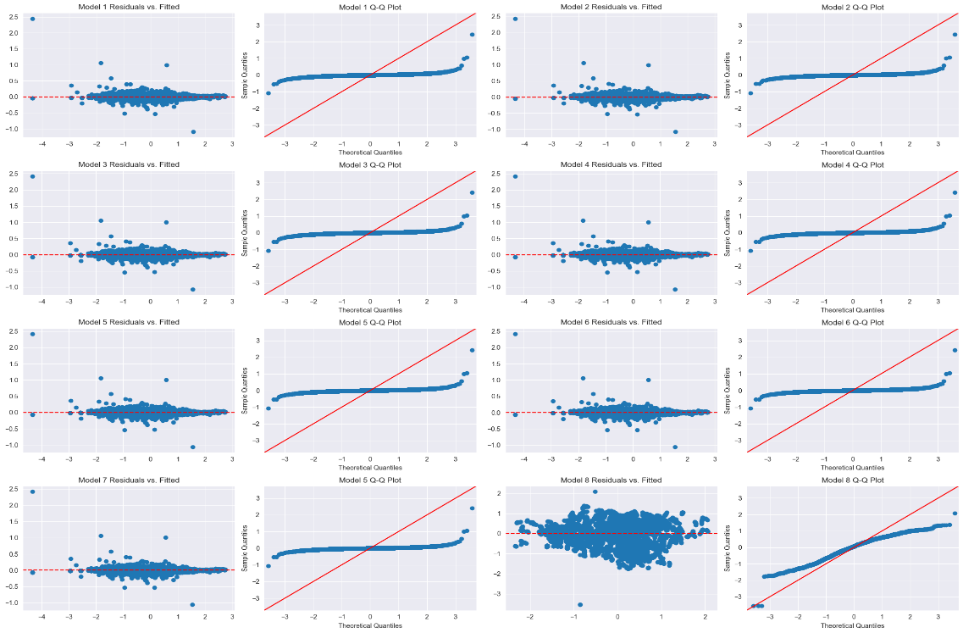
Figure 5 OLS Residuals and Q-Q Plots

Appendix B.1

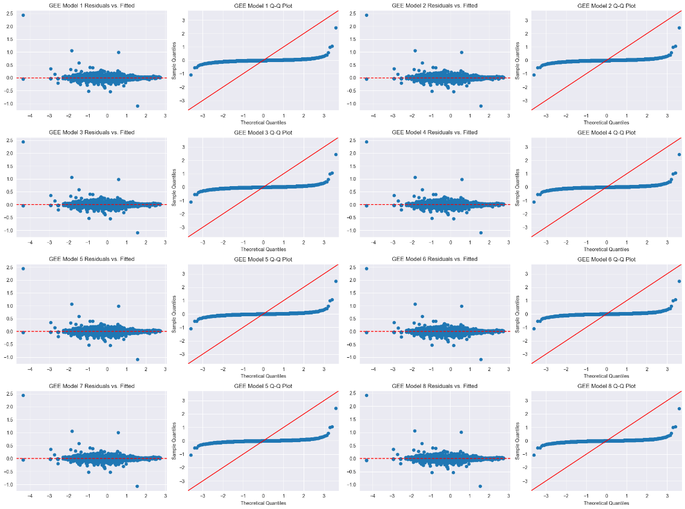
Figure 6 GEE Model Residuals and Q-Q Plots
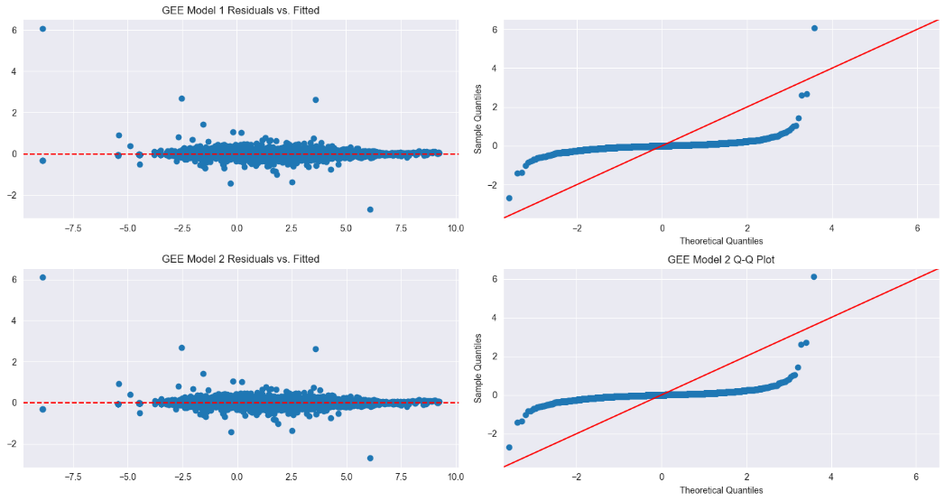
Figure 7 Categorical GEE Model Residuals and Q-Q Plots

Appendix B.2
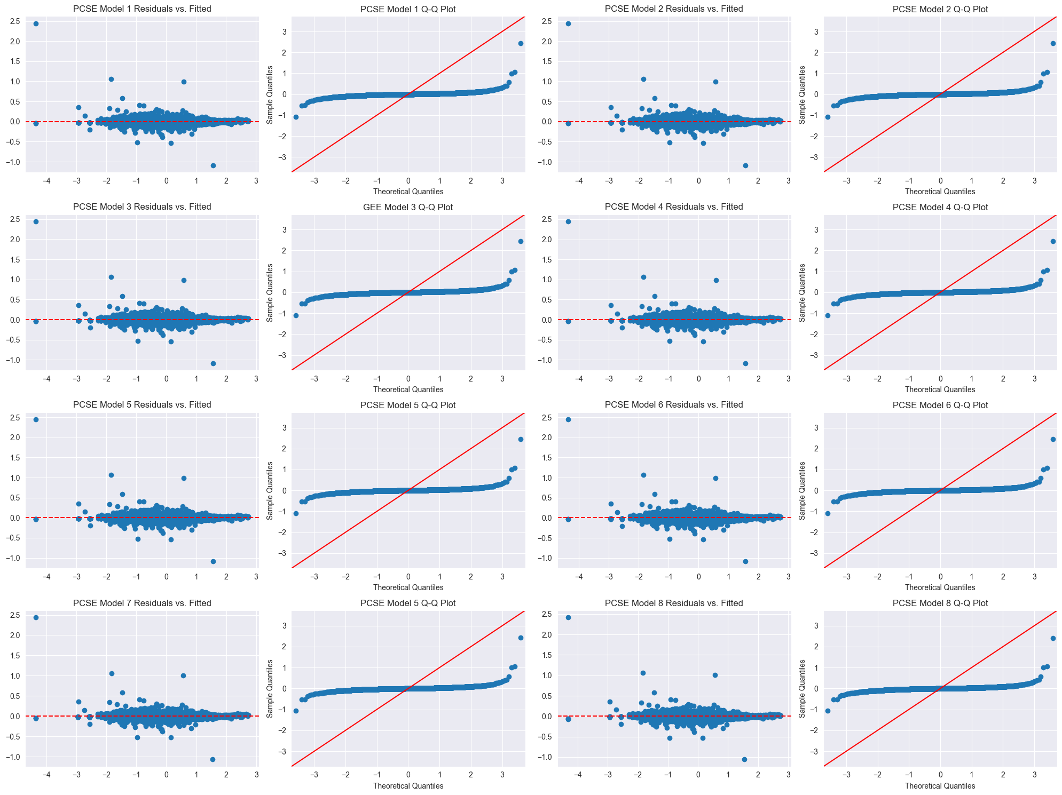
Figure 8 PCSE Model Residuals and Q-Q plots

A total of ten lags were evaluated, among which seven lags exhibited compelling potential. Nonetheless, considering the constraints of data availability and the duration of the policy under study, a singular lag emerged as the most practical option. This conclusion is further substantiated by the AIC values and the significance of the tested LDV coefficients (see Appendix A Table 7. Lagged Co2 AIC Values and Appendix A.1Table 8 LDV Coefficients)
For Model Diagnostics, please refer to Appendix B for Figure 5 OLS Residuals and Q-Q Plots, Appendix B.1 for Figure 6 GEE Model Residuals and Q-Q Plots, and Appendix B.2 for Figure 8 PCSE Model Residuals and Q-Q Plots

