**CSC316 – Advanced Web Development – In-Class Activity – 28th October 2020**

1. **You have a database server setup on the localhost, the user csc316_student has access via the password ‘secretpassword’. There exists a database called ‘widget_corp’ that has tables, columns and rows. Create a database connection, run a query that lists all records in the ‘subjects’ table in ascending order, where the column visible has the value 1. Release the returned data and finally, close the database connection. Follow the comments (//#) and question marks (?#) to show you where you need to add code snippets. [15 Marks]**

<?php

//# 1. Create a database connection

?#

// Test if connection succeeded

if(mysqli_connect_errno()) {

die("Database connection failed: " .

mysqli_connect_error() .

" (" . mysqli_connect_errno() . ")"

);

}

?>

<?php

//# 2. Perform database query

?#

$result = mysqli_query($connection, $query);

// Test if there was a query error

if (!$result) {

die("Database query failed.");

}

?>

<!DOCTYPE html PUBLIC "-//W3C//DTD HTML 4.01 Transitional//EN"

"http://www.w3.org/TR/html4/loose.dtd">

<html lang="en">

<head>

<title>Databases</title>

</head>

<body>

<ul>

<?php

//# 3. Use returned data (if any) using the while loop and an associative array

while(?) {

//# output data from each row only listing the values

//# in the columns menu_name and id

?>

<li><?php

?#

?>

</li>

<?php

}

?>

</ul>

<?php

//# 4. Release returned data

?#

?>

</body>

</html>

<?php

//# 5. Close database connection

?#

?>

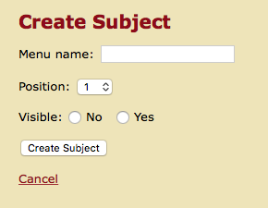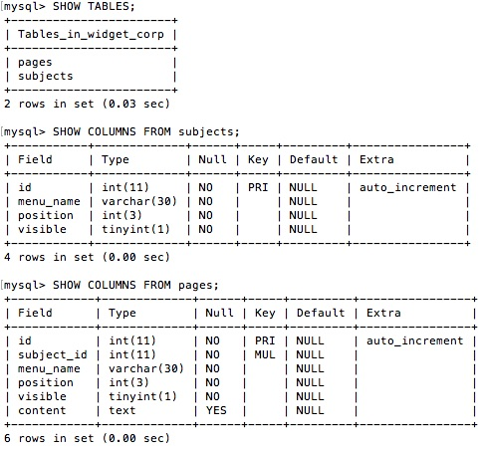

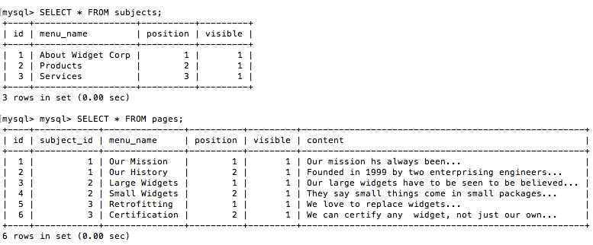

1. **Create a form in new_subject.php, which submits to create_subject.php. The form should allow for a text box for the Menu name, a dropdown button that takes the values 1, 2, 3 and 4, and finally an option that allows for either a No or Yes for the visible attribute. This form should output like the one the one shown above. Also have in mind how the tables in the widget_corp database looks like (See MySQL queries and their output above as well – See the page above). [15 Marks]**

**To generate values for the position dropdown menu you will need to do the following**

* 1. **Connect to the database and select all subjects**
  2. **Use msqli_num_rows() to count the record set/resource obtained from the above**
  3. **Use a for loop with the counter being <= the count obtained in 2 above + 1**
  4. **Echo the count during the loop**

<!DOCTYPE html>

<html>

<div id="main">

<div id="navigation">

<?php echo navigation($current_subject, $current_page); ?>

</div>

<div id="page">

<h2>Create Subject</h2>

--------------> Your form should come here

<br />

<a href="manage_content.php">Cancel</a>

</div>

</div>

</html>