Markdown, Mermaid, Chicago Style & Local AI Models — Complete Session Archive
Original Gemini Link: https://gemini.google.com/
Date: Sunday, November 8, 2026
BIKE 6:45a to 7:38a
Summary Caption: Complete verbatim conversation archive and structured technical reference starting with Markdown formats, Mermaid diagramming syntax, and Chicago Manual of Style (CMOS) rules, continuing through Windows 11 local Retrieval-Augmented Generation (RAG) architectures, cloud AI retention policies, Google storage quota rules, individual subscription pricing, and open-weights Small Language Models (Google Gemma and Microsoft Phi).

Table of Contents
(Right-click the Table of Contents field below in Microsoft Word and select 'Update Field' to populate page numbers.)
1 Table of Contents 1
2 1. Verbatim Conversation Transcript [Top] 3
3 This section preserves the full conversation starting from the opening inquiries regarding Markdown formats, Mermaid diagrams, and the Chicago Manual of Style, followed by local RAG toolkits, cloud AI data retention policies, and open-weights model deployment. User prompts are formatted in Maroon (#800000) inside bordered bounding boxes. 3
3.1 Prompt 1: Markdown Flavors and Technical Specifications [Top] 3
3.2 Prompt 2: Mermaid Diagram Integration in Markdown [Top] 3
3.3 Prompt 3: Chicago Manual of Style (CMOS) Formatting & Acronym Rules [Top] 4
3.4 Prompt 4: Local AI & RAG Toolkits on Windows 11 [Top] 4
3.5 Prompt 5: Gemini Free-Tier Default Retention (18 Months) [Top] 5
3.6 Prompt 6: Verbatim Activity Logging [Top] 5
3.7 Prompt 7: Google Account Storage Quota Impact [Top] 5
3.8 Prompt 8: Cross-Platform Free-Tier Data Retention Policies [Top] 5
3.9 Prompt 9: Most Popular Free Consumer AI Platforms [Top] 6
3.10 Prompt 10: Top-Rated Paid and Reasoning Models [Top] 6
3.11 Prompt 11: Gemini Individual Pricing Tiers vs. Gemma Open Weights [Top] 6
3.12 Prompt 12: Definition and Meaning of 'Open Weights' [Top] 6
3.13 Prompt 13: Vendor Open-Weights Landscape (OpenAI, Anthropic, Microsoft) [Top] 6
3.14 Prompt 14: Microsoft's Open-Weights Offerings [Top] 7
3.15 Prompt 15: Spelling Confirmation: Phi [Top] 7
3.16 Prompt 16: Overview of Microsoft Phi Small Language Models (SLMs) [Top] 7
3.17 Prompt 17: Licensing and Cost of Open-Weights Models [Top] 7
3.18 Prompt 18: History and Design Philosophy of SLMs [Top] 7
3.19 Prompt 19: Free-Tier Model Access on OpenAI, Anthropic, and Grok [Top] 7
3.20 Prompt 20: Updating and Customizing Open-Weights Models (Fine-Tuning & RAG) [Top] 8
3.21 Prompt 21: Privacy and Knowledge Base Control Benefits [Top] 8
3.22 Prompt 22: Closing Acknowledgment [Top] 8
4 2. Detailed Condensation of Topics, Products, and Tools [Top] 9
4.1 2.1 Technical Documentation Standards: Markdown, Mermaid & Chicago Style [Top] 9
4.1.1 2.1.1 Markdown Dialects & Toolchain Matrix [Top] 9
4.1.2 2.1.2 Mermaid Diagramming Syntax Reference [Top] 9
4.1.3 2.1.3 Chicago Manual of Style (CMOS) Editorial Checklist [Top] 10
4.2 2.2 Cloud AI Retention Policies, Storage Quotas & Pricing [Top] 11
4.3 2.3 Local Windows 11 RAG Tools & Open-Weights Models [Top] 13
4.3.1 2.3.1 Open-Weights Model Families (Gemma & Microsoft Phi) [Top] 13
4.3.2 2.3.2 Local RAG Toolkits & Orchestration Frameworks [Top] 13
4.4 2.4 How-To Guides: Local RAG & Model Customization [Top] 14
4.4.1 2.4.1 How to Set Up a Private Local RAG Pipeline on Windows 11 [Top] 14
4.4.2 2.4.2 How to Update or Fine-Tune Open-Weights Models [Top] 14
4.5 2.5 Reading List & Official Technical Resources [Top] 14
5 3. Glossary of Key Terms [Top] 15

1. Verbatim Conversation Transcript [Top]

This section preserves the full conversation starting from the opening inquiries regarding Markdown formats, Mermaid diagrams, and the Chicago Manual of Style, followed by local RAG toolkits, cloud AI data retention policies, and open-weights model deployment. User prompts are formatted in Maroon (#800000) inside bordered bounding boxes.

Prompt 1: Markdown Flavors and Technical Specifications [Top]
User Prompt 1: What are the primary Markdown formats and flavors used in technical documentation, and how do they differ?

Gemini Response: Markdown exists in several standardized and extended dialects. CommonMark serves as the strict, unambiguous baseline specification that resolves edge-case parsing differences across implementations. GitHub Flavored Markdown (GFM) extends CommonMark with task lists, strikethroughs, autolinks, fenced code blocks with syntax highlighting, and pipe-delimited tables.
For long-form technical publishing and academic workflows, Pandoc Markdown adds footnotes, definition lists, YAML front-matter metadata blocks, citation keys, and LaTeX math passthroughs. Knowledge-base tools like Obsidian use a hybrid dialect combining GFM with wikilinks ([[Page Name]]), callout admonitions (> [!NOTE]), and inline tags.
Example — GitHub Flavored Markdown (GFM) Table & Task Syntax:
| Dialect | Key Extensions | Primary Ecosystem |
| :--- | :--- | :--- |
| CommonMark | Strict core syntax specification | Parsers, static site generators |
| GFM | Tables, task lists, fenced code | GitHub, VS Code, Azure DevOps |
| Pandoc | YAML metadata, citations, footnotes | Academic & DOCX/PDF pipelines |
| Obsidian | Wikilinks, callouts, canvas embeds | Local PKM & Markdown vaults |
- [x] Standardize repository READMEs on GFM
- [ ] Configure Pandoc YAML headers for DOCX/PDF export

Prompt 2: Mermaid Diagram Integration in Markdown [Top]
User Prompt 2: How does Mermaid syntax integrate into Markdown for creating flowcharts and sequence diagrams?

Gemini Response: Mermaid integrates directly inside Markdown documents using fenced code blocks labeled with the `mermaid` language identifier. Native renderers in GitHub, GitLab, Azure DevOps, Obsidian, and VS Code (via preview extensions) parse the text block at render time into scalable vector graphics (SVG) without requiring external binary image files.
This text-first approach allows diagrams to be diffed, version-controlled in Git, and generated programmatically alongside documentation.
Example — Mermaid Flowchart & Sequence Diagram Blocks:
```mermaid
flowchart TD
A[Raw Markdown Docs] --> B{Pandoc / Renderer}
B -->|HTML/SVG| C[Web Documentation]
B -->|DOCX/PDF| D[Distributable Report]
```
```mermaid
sequenceDiagram
participant User
participant LocalRAG as Local RAG Engine
participant SLM as Phi / Gemma Weights
User->>LocalRAG: Query local Markdown vault
LocalRAG->>SLM: Inject retrieved context chunks
SLM-->>User: Grounded offline response
```

Prompt 3: Chicago Manual of Style (CMOS) Formatting & Acronym Rules [Top]
User Prompt 3: What are the core rules in the Chicago Manual of Style (CMOS) for technical headings, acronyms, and citations?

Gemini Response: Under the Chicago Manual of Style (17th/18th editions), title-case capitalization (headline style) is standard for document titles and major headings: capitalize the first and last words, as well as all nouns, pronouns, verbs, adjectives, and adverbs, while lowercasing articles (a, an, the), coordinating conjunctions, and prepositions regardless of length unless they begin or end the title.
For acronyms and initialisms, spell out the full term upon first appearance followed by the abbreviation in parentheses—for example, Retrieval-Augmented Generation (RAG)—and form plurals by adding a lowercase 's' without an apostrophe (e.g., SLMs, APIs, URLs). For citations, CMOS supports two primary systems: Notes and Bibliography (footnotes/endnotes paired with a bibliography, preferred in humanities) and Author-Date (in-text parenthetical citations paired with a reference list, standard in technical and scientific writing).

Prompt 4: Local AI & RAG Toolkits on Windows 11 [Top]
User Prompt 4: How can I implement a local AI RAG setup on Windows 11 using my Markdown notes, and what tools are available?

Gemini Response: To run Retrieval-Augmented Generation (RAG) locally on Windows 11, you pair a local inference runtime with a document-indexing client that embeds your Markdown vault into a local vector database. Popular turn-key desktop applications include AnythingLLM, GPT4All, and Open WebUI (often paired with Ollama as the backend model runner).
For custom programmatic pipelines, frameworks such as LangChain and LlamaIndex allow you to parse Markdown headers cleanly, chunk text semantically, store embeddings locally (e.g., in Chroma or FAISS), and query open-weights models without sending files to external cloud servers.
Example — CLI Workflow for Local Ollama + Pandoc Markdown Preparation:
# 1. Convert Word or HTML notes into clean GitHub Flavored Markdown
pandoc source_notes.docx -t gfm --wrap=none -o clean_notes.md
# 2. Pull compact open-weights models locally via Ollama
ollama pull phi3
ollama pull gemma2
# 3. Verify locally available model checkpoints
ollama list

Prompt 5: Gemini Free-Tier Default Retention (18 Months) [Top]
User Prompt 5: So how long are the conversations kept in Google Gemini for the free version?

Gemini Response: By default, Gemini activity is saved to your Google Account for up to 18 months, though you can adjust this auto-delete timeframe or turn history off entirely at any time.

Prompt 6: Verbatim Activity Logging [Top]
User Prompt 6: So the whole conversation is saved verbatim?

Gemini Response: Yes, your prompts and the responses are logged verbatim in your activity history to maintain the conversation context.

Prompt 7: Google Account Storage Quota Impact [Top]
User Prompt 7: Is it out count against my storage? For Gmail, for example?

Gemini Response: No, Gemini chat history does not count against your Google storage limit for services like Gmail or Google Drive.

Prompt 8: Cross-Platform Free-Tier Data Retention Policies [Top]
User Prompt 8: That's good. That's better than other services. How long does Copilot and Claude and OpenAI and Grok store things? On the free accounts?

Gemini Response: Retention policies vary by service. For consumer Copilot and ChatGPT free tiers, your history is generally saved until you manually delete it or turn off chat history. Anthropic's Claude typically retains data for a limited period for safety and compliance before deletion. Grok on X generally stores interactions to improve models unless you adjust your privacy settings to opt out.

Prompt 9: Most Popular Free Consumer AI Platforms [Top]
User Prompt 9: What are the most popular free models in terms of users and conversations?

Gemini Response: ChatGPT, Microsoft Copilot, Gemini, and Claude currently lead in active users and conversation volume across their free and consumer tiers.

Prompt 10: Top-Rated Paid and Reasoning Models [Top]
User Prompt 10: And for the paid versions or the higher thinking levels? Which of those are maybe the best or rated the best?

Gemini Response: Models like OpenAI's o series, Anthropic's Claude 3.5 Sonnet, and Google's Gemini Advanced are widely considered the top performers for complex reasoning, coding, and nuanced tasks. Rankings often shift depending on specific benchmarks, but these frontier models currently lead the industry.

Prompt 11: Gemini Individual Pricing Tiers vs. Gemma Open Weights [Top]
User Prompt 11: What are the pricing ranges for a single user for the Gemini options and also Gemma?

Gemini Response: Gemini starts at no cost for the standard version. Paid individual plans range from four ninety-nine a month for the Plus tier, up to nineteen ninety-nine a month for the Pro plan which includes extensive cloud storage. Higher-end Ultra tiers exist for power users. Gemma, on the other hand, is an open-weights model family, meaning the weights are free to download and use under its license, though running them requires your own compute resources.

Prompt 12: Definition and Meaning of 'Open Weights' [Top]
User Prompt 12: Why are you called open weights?

Gemini Response: The term refers to releasing the internal parameters of a trained model. This allows developers to download and run the model on their own hardware without relying on external APIs.

Prompt 13: Vendor Open-Weights Landscape (OpenAI, Anthropic, Microsoft) [Top]
User Prompt 13: Yes, I saw the Gemma choices. What are the top choices? For other vendors including the ones you mentioned, OpenAI, Anthropic, and Microsoft?

Gemini Response: OpenAI offers Gemma competitors like their smaller Phi series models. Anthropic and OpenAI primarily focus on proprietary closed models, though OpenAI historically released earlier versions like GPT-2.

Prompt 14: Microsoft's Open-Weights Offerings [Top]
User Prompt 14: How about Microsoft?

Gemini Response: Microsoft offers the Phi series, which are compact, open-weights models designed for high performance on constrained devices.

Prompt 15: Spelling Confirmation: Phi [Top]
User Prompt 15: How is that spelled, P-H-I?

Gemini Response: Yes, it is spelled P-H-I.

Prompt 16: Overview of Microsoft Phi Small Language Models (SLMs) [Top]
User Prompt 16: I didn't know about that. Tell me more about that.

Gemini Response: Microsoft's Phi series consists of Small Language Models designed for high efficiency. They pack impressive reasoning and coding capabilities into smaller sizes, making them ideal for running locally on devices with limited memory and compute.

Prompt 17: Licensing and Cost of Open-Weights Models [Top]
User Prompt 17: That's good. Is that free then? All the open weights are free?

Gemini Response: They are free to download and use under their specific licenses, though terms can vary regarding commercial use depending on the provider.

Prompt 18: History and Design Philosophy of SLMs [Top]
User Prompt 18: No, I never heard of it. Is that formerly new?

Gemini Response: They are relatively recent additions to the AI landscape, developed to focus on high efficiency and compact size rather than sheer parameter scale.

Prompt 19: Free-Tier Model Access on OpenAI, Anthropic, and Grok [Top]
User Prompt 19: And what's available with OpenAI, Anthropic, Grok also free?

Gemini Response: OpenAI offers free access to lighter models like GPT-4o mini. Anthropic provides limited access to Claude 3.5 Sonnet, and Grok on X typically requires a subscription for its primary models.

Prompt 20: Updating and Customizing Open-Weights Models (Fine-Tuning & RAG) [Top]
User Prompt 20: So these models and all these open weights need to be updated? Or can I update myself? Can I have my own topics?

Gemini Response: You download new versions when released, but you can also customize models with your own data or topics through techniques like fine-tuning or by connecting them to your own documents using RAG.

Prompt 21: Privacy and Knowledge Base Control Benefits [Top]
User Prompt 21: Wow, I didn't know that.

Gemini Response: It gives you complete control over the model's knowledge base and ensuring it stays private.

Prompt 22: Closing Acknowledgment [Top]
User Prompt 22: Great, thanks.

Gemini Response: You're very welcome. Feel free to reach out anytime you need more technical insights.

2. Detailed Condensation of Topics, Products, and Tools [Top]

2.1 Technical Documentation Standards: Markdown, Mermaid & Chicago Style [Top]

2.1.1 Markdown Dialects & Toolchain Matrix [Top]
Structured plain-text documentation relies on standardized Markdown flavors paired with conversion and authoring tools. Selecting the appropriate dialect ensures deterministic rendering across Git repositories, local knowledge vaults, and automated publishing pipelines:
Dialect / Tool | Core Capabilities | Best Use Case | Key Syntax / Command
CommonMark | Unambiguous core Markdown specification; strict nesting rules. | Cross-platform parser compatibility. | Standard ATX headings (#), fenced blocks (```).
GitHub Flavored (GFM) | Pipe tables, task lists, strikethrough, autolinks, alert blocks. | Repository READMEs, PRs, Issues, Azure DevOps. | - [x] Completed task | | Col 1 | Col 2 |
Pandoc Markdown | YAML front matter, BibTeX citations, footnotes, LaTeX math. | Converting Markdown to DOCX, PDF, or LaTeX. | pandoc input.md -o output.docx --toc
Obsidian + VS Code | Wikilinks, callout admonitions, live Mermaid preview. | Local PKM vaults & RAG source repositories. | [[Internal Note]] and > [!IMPORTANT]

2.1.2 Mermaid Diagramming Syntax Reference [Top]
Mermaid renders text-based definitions directly into SVG diagrams inside Markdown viewers without binary assets. Below are the primary diagram types used in software architecture and systems documentation:
- Flowcharts (flowchart TD / LR): Model decision trees, ETL ingestion pipelines, and governance workflows using directional nodes (-->), decision diamonds ({}), and subgraphs.
- Sequence Diagrams (sequenceDiagram): Illustrate chronological message passing between actors, APIs, vector databases, and local LLM runtimes.
- Entity-Relationship & Class Diagrams (erDiagram / classDiagram): Document database schemas, SharePoint list relationships, and object-oriented code structures directly in version control.
- Gantt Charts (gantt): Track engineering milestones, rollout schedules, and dependency timelines using ISO date formatting.
Mermaid Reference Template — End-to-End Document Governance & AI Ingestion Flow:
```mermaid
gantt
title Documentation & Local RAG Rollout Schedule
dateFormat YYYY-MM-DD
section Standards
Markdown & CMOS Style Guide :done, s1, 2026-10-01, 7d
Mermaid Diagram Templates :active, s2, 2026-10-08, 7d
section Local AI
Ollama + Phi/Gemma Setup : a1, 2026-10-15, 5d
AnythingLLM Vault Indexing : a2, after a1, 5d
```

2.1.3 Chicago Manual of Style (CMOS) Editorial Checklist [Top]
- Headline-Style Capitalization: Capitalize the first and last words of titles/headings and all major words (nouns, pronouns, verbs, adjectives, adverbs). Lowercase articles (a, an, the), coordinating conjunctions (and, but, for, or, nor), and prepositions (in, on, to, with, through) regardless of length unless used adverbially or as the first/last word.
- Acronyms & Initialisms: Introduce the full term on first mention with the abbreviation in parentheses—e.g., Small Language Model (SLM)—then use the abbreviation consistently. Form plurals with a lowercase 's' and no apostrophe (SLMs, APIs, RAG pipelines).
- Numbers & Punctuation: Spell out whole numbers from zero through one hundred in general prose (use numerals for technical measurements, percentages, and version numbers). Use serial (Oxford) commas in lists of three or more items, and use unspaced em dashes (—) for parenthetical breaks.
- Citation Systems: Use Author-Date in-text citations (Author Year, Page) paired with an alphabetical Reference List for technical and scientific documents, or Notes and Bibliography for humanities.

2.2 Cloud AI Retention Policies, Storage Quotas & Pricing [Top]
Consumer AI services differ substantially in default conversation retention, account storage accounting, and subscription tiers:
Vendor / Service | Free Tier Models | Default Retention | Storage Impact | Paid Individual Tiers
Google Gemini | Gemini Standard (Free) | Up to 18 months (verbatim); configurable 3/18/36 mos or off. | Zero impact on Gmail, Drive, or Google One quota. | Plus (~$4.99/mo); Pro / Advanced (~$19.99/mo + storage); Ultra tiers.
OpenAI ChatGPT | GPT-4o mini (Free) + limited flagship turns | Retained indefinitely until manually deleted. | Cloud-hosted; no local/Google quota impact. | ChatGPT Plus ($20/mo) unlocks full access to 'o' reasoning series.
Anthropic Claude | Claude 3.5 Sonnet (rate-limited free tier) | Retained for a limited window for safety/compliance before deletion. | Cloud-hosted; no personal storage quota impact. | Claude Pro ($20/mo) for higher throughput and priority access.
Microsoft Copilot | Consumer Copilot models (Free) | Retained until manually deleted or history toggled off. | No impact on OneDrive personal storage quota. | Copilot Pro ($20/mo) with Microsoft 365 app integration.
xAI Grok (on X) | Limited free access in select regions | Stored for model improvement unless opted out in X privacy settings. | Tied to X account; no separate storage quota. | X Premium / Premium+ subscriptions required for primary models.

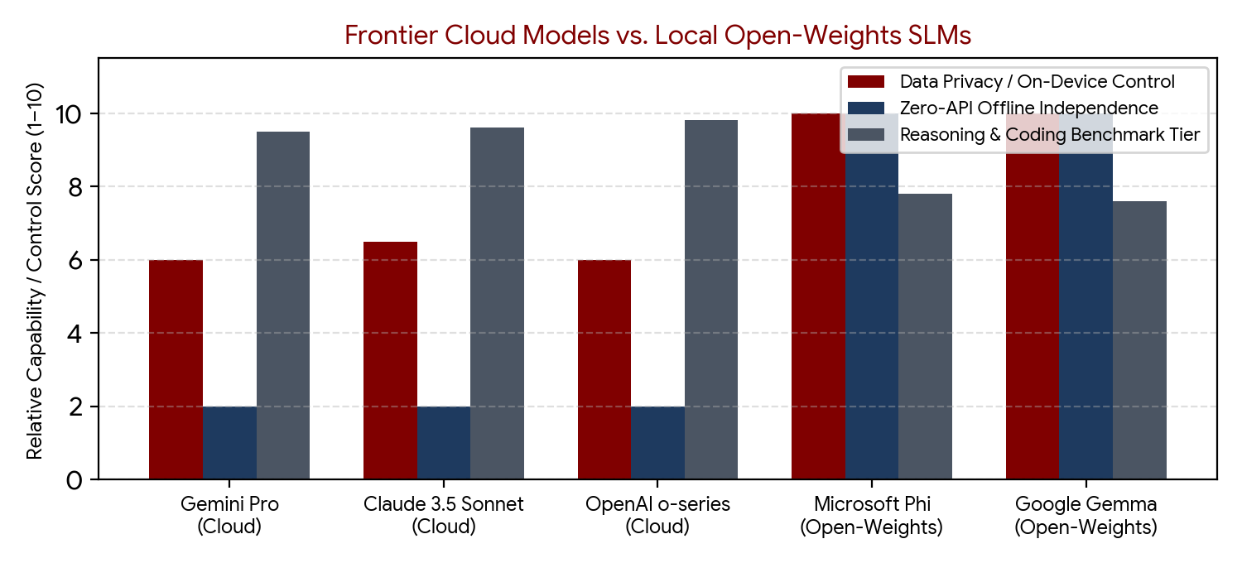
Figure 1: Trade-off comparison between Frontier Cloud LLMs and Local Open-Weights SLMs across privacy, offline control, and reasoning.

2.3 Local Windows 11 RAG Tools & Open-Weights Models [Top]
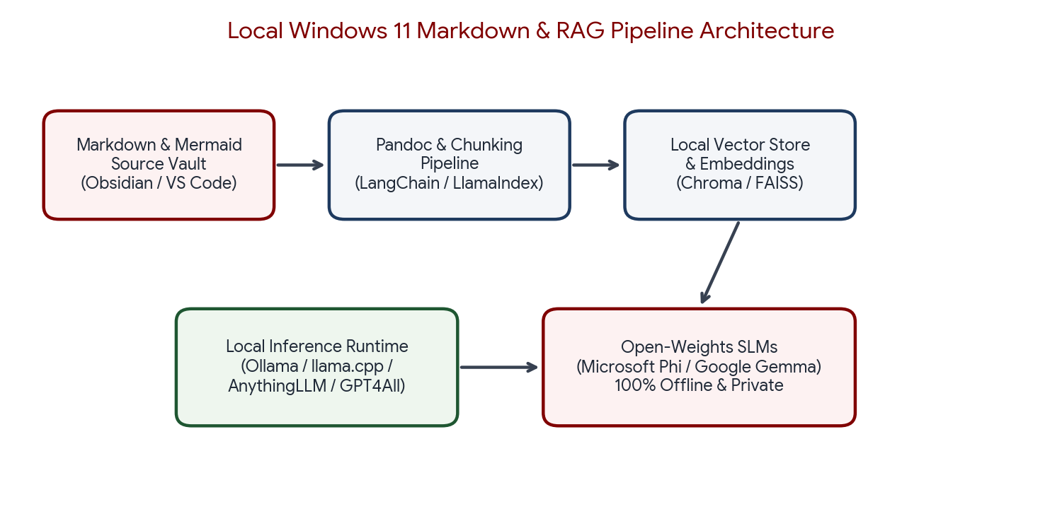
Figure 2: End-to-end offline Windows 11 RAG pipeline integrating Markdown vaults with open-weights SLMs.

2.3.1 Open-Weights Model Families (Gemma & Microsoft Phi) [Top]
- Open-Weights Architecture: Unlike closed proprietary APIs, open-weights releases publish the trained neural network parameters (weights) so developers can download and execute inference locally on personal CPUs/GPUs without internet connectivity or external telemetry.
- Google Gemma: Lightweight open-weights models built from Gemini research. Free to download and run locally under Google's Gemma license terms.
- Microsoft Phi (P-H-I): Compact Small Language Models (SLMs) trained on high-density synthetic and curated textbook-grade datasets. Phi models deliver strong coding and logical reasoning within small parameter footprints (e.g., 3.8B to 14B parameters), making them well-suited for laptops with constrained RAM/VRAM.
- Commercial vs. Personal Licensing: While open-weights models are free to download, each model family carries specific license terms governing commercial redistribution, acceptable use, and derivative works.

2.3.2 Local RAG Toolkits & Orchestration Frameworks [Top]
- AnythingLLM: All-in-one desktop RAG application for Windows 11 that ingests Markdown, PDF, and DOCX files into isolated workspaces backed by local vector stores and local model runners.
- GPT4All: Privacy-first desktop client offering one-click downloads of quantized open-weights models and local folder indexing ('LocalDocs') with zero cloud dependency.
- Open WebUI + Ollama: Browser-based ChatGPT-style interface paired with Ollama's local model runtime, supporting custom RAG document collections, system prompts, and multi-model switching.
- LangChain & LlamaIndex: Developer frameworks for building custom Python/TypeScript ingestion pipelines with Markdown-aware text splitters, hybrid keyword/vector retrieval, and local embeddings.

2.4 How-To Guides: Local RAG & Model Customization [Top]

2.4.1 How to Set Up a Private Local RAG Pipeline on Windows 11 [Top]
- Install a Local Model Runtime: Download and install Ollama or LM Studio on Windows 11 to manage quantized GGUF model checkpoints locally.
- Pull Compact Open-Weights Models: Download a lightweight model suited to your hardware memory—such as Microsoft Phi or Google Gemma—via CLI (`ollama pull phi3` or `ollama pull gemma2`).
- Prepare Clean Markdown Source Files: Organize notes in Obsidian or VS Code using clear ATX headings (`#`, `##`, `###`) and standardized YAML front matter so chunkers split sections cleanly.
- Index Documents in a Local RAG Client: Point AnythingLLM, GPT4All, or Open WebUI to your Markdown directory to generate local embeddings inside an on-device vector database.
- Query & Verify Grounding: Ask domain-specific questions and inspect cited source chunks to verify that responses stay grounded in your private notes without external network traffic.

2.4.2 How to Update or Fine-Tune Open-Weights Models [Top]
- Pull Upstream Weight Releases: Open-weights checkpoints are static once downloaded; periodically check vendor repositories (Hugging Face, Google AI, Microsoft) and download newer model versions when released.
- Use RAG for Dynamic Knowledge Updates: Whenever your personal documents or project topics change, re-index the updated Markdown files in your RAG vector store—no model retraining required.
- Apply Fine-Tuning for Specialized Behavior: If you need the model to adopt a custom output schema, coding convention, or domain vocabulary permanently, prepare a curated JSONL dataset of instruction-response pairs and run LoRA/QLoRA parameter-efficient fine-tuning.

2.5 Reading List & Official Technical Resources [Top]
- CommonMark Markdown Specification: https://spec.commonmark.org/
- GitHub Flavored Markdown (GFM) Spec: https://github.github.com/gfm/
- Mermaid.js Official Diagramming Documentation: https://mermaid.js.org/intro/
- Pandoc User's Guide (Markdown Conversion): https://pandoc.org/MANUAL.html
- The Chicago Manual of Style Online: https://www.chicagomanualofstyle.org/
- Google Gemini Apps Privacy Hub: https://support.google.com/gemini/answer/13594961
- Google Gemma Open Models Documentation: https://ai.google.dev/gemma
- Microsoft Phi Small Language Models Overview: https://azure.microsoft.com/en-us/products/phi
- OpenAI Models & Pricing Documentation: https://platform.openai.com/docs/models
- Anthropic Claude Documentation: https://docs.anthropic.com/

3. Glossary of Key Terms [Top]
Term | Definition
Chicago Manual of Style (CMOS) | An authoritative American English style and citation guide governing headline capitalization, acronym formatting, punctuation, and Author-Date vs. Notes-Bibliography citations.
CommonMark | A strongly defined, unambiguous specification of Markdown syntax designed to ensure consistent parsing across different software implementations.
Fine-Tuning | The process of continuing training on a pre-trained language model using a curated domain dataset (often via LoRA/QLoRA) to adapt its style, formatting, or specialized knowledge.
Frontier Model | A large-scale, state-of-the-art foundation model capable of advanced multi-step reasoning, code generation, and complex analytical tasks.
Gemma | Google's family of lightweight, open-weights language models derived from the same research and architecture as the Gemini family.
GitHub Flavored Markdown (GFM) | A widely adopted superset of CommonMark adding pipe tables, task-list checkboxes, strikethroughs, and syntax-highlighted fenced code blocks.
Mermaid | A JavaScript-based diagramming and charting tool that renders Markdown-inspired text definitions into SVG flowcharts, sequence diagrams, and Gantt charts.
Open-Weights Model | An AI model whose trained internal numerical parameters (weights) are publicly distributed for download and local execution under a specific license.
Pandoc | An open-source universal document converter capable of transforming extended Markdown (with YAML metadata and citations) into DOCX, PDF, HTML, and LaTeX.
Parameters (Weights) | The learned numerical coefficients inside a neural network that govern how input tokens are processed into generated output.
Phi (P-H-I) | Microsoft's series of compact Small Language Models (SLMs) engineered for high reasoning and coding efficiency on resource-constrained local hardware.
RAG (Retrieval-Augmented Generation) | A technique that pairs an LLM with an external, private document index (vector store) so relevant context is retrieved at query time without modifying base model weights.
Small Language Model (SLM) | A compact language model (typically 1B to 14B parameters) optimized for low-latency, low-memory local or edge execution.

