Database Schema Implementation

By Keith Wall

7/17/2024

IT481M2

Ahmad Kassem

Northwind Database:

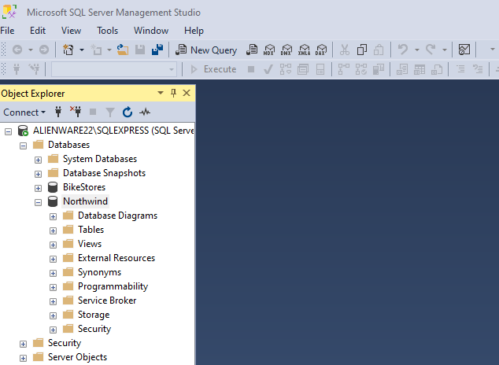

DataAccess Layer:

Business Layer:

GUI Layer:

