Jocelyne Walker

Professor Gutierrez

OM 337

31 August 2017

Assignment 1

1. Write an R command to create the following matrix.

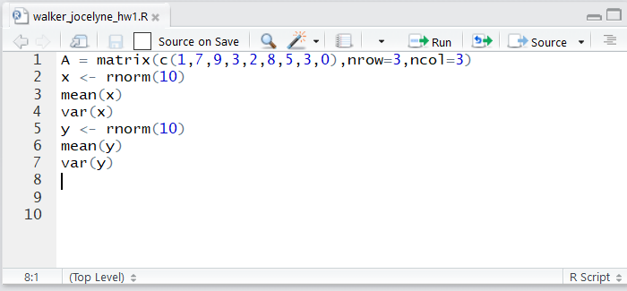

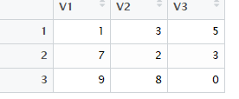

1. Why did you not get the same values for the mean and variance of 𝑥 and 𝑦 if they were obtained using the same command sequence?

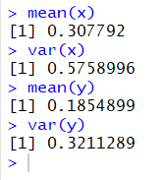

The function rnorm(10) creates 10 random numbers. The x variable is a set of 10 random numbers different from the set of 10 random numbers called y. Each time rnorm is called, a different “seed” value is used. Because a different seed value is used for each variable creation, the set of 10 random numbers is different. Thus, when R calculates the mean and variance of 2 different sets of 10 numbers, the means and variances will be different.

1. Why did you now get the same values for the mean and variance of 𝑥 and 𝑦?

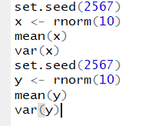

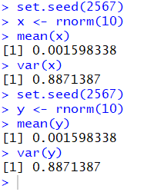

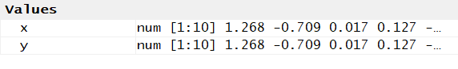

The seed is a pseudo-random number generating technique in which a single number determines the sequence of random numbers that will be produced. When we manually set the seed value, we create an identical series of random numbers. If you set the same seed twice, you will get the same sequence of random numbers twice. By repeating the same seed value, the values in x and y become the same. Thus, when we calculate the mean and variance of 2 sets of numbers that are identical, we get identical means and variances.

1. Define 𝑦=𝑒^(−𝑥/8)sin(𝑥) and use R Studio to plot 𝑦 vs 𝑥 for 𝑥 = 1,2,…,20. Then save this plot as a “jpeg” file and include it in your report.

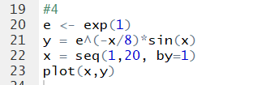

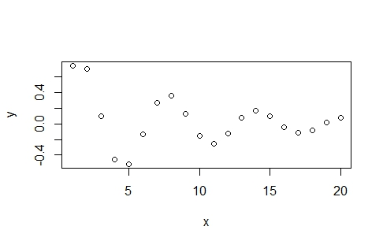

1. Write an R command to extract the matrix shown below from the 𝐵 matrix generated above:

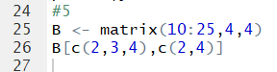

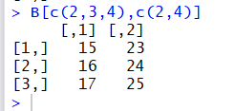

Copy the files Auto.data and Auto.csv into your homework project folder and answer the following questions:

1. What is the name of the car in record number 38 of the Auto data set?

I imported the dataset as a .csv file and entered this code:



The name of the car in record 38 is amc matador.

1. Use the pairs() function in R to create a scatterplot matrix showing the scatterplots of the variables mpg, horsepower, weight and acceleration in the Auto dataset. Include the command and the resulting plot in your report.

First, I had to change the data type for horsepower from character to integer.

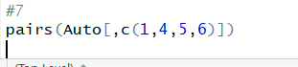

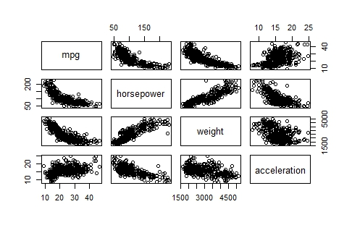

1. By looking at the plots produced in question (7) indicate what pairs of variables seem to be positively correlated? Which pairs of variables seem to be negatively correlated?

Positively Correlated – sloping up

* Mpg and acceleration
* Horsepower and weight

Negatively Correlated – sloping down

* Mpg and horsepower
* Mpg and weight
* Horsepower and acceleration
* Weight and acceleration